### To be inserted after Site:GroundDomain:Slab (About pg 60 in I/O Ref.)

### Site:GroundDomain:Basement

This section documents the input object used to simulate ground coupled heat transfer with underground zones within EnergyPlus. Zone surfaces within EnergyPlus interact with the Site:GroundDomain:Basement object by utilizing the SurfaceProperty:OtherSideConditionsModel object. Two separate OSCM are required for the basement vertical and horizontal surfaces. Vertical wall surfaces will interact with the first OSCM while the horizontal floor surface will interact with the second OSCM. Basement floor and wall surfaces are constructed normally by using the BuildingSurface:Detailed object, with the outside boundary condition being the OtherSideConditionsModel for the basement floor or wall. The outside surface of the wall being the interface between the ground domain and the EnergyPlus zone. Horizontal and vertical ground insulation are simulated by the ground domain, and therefore should not be included in the wall and floor construction objects.

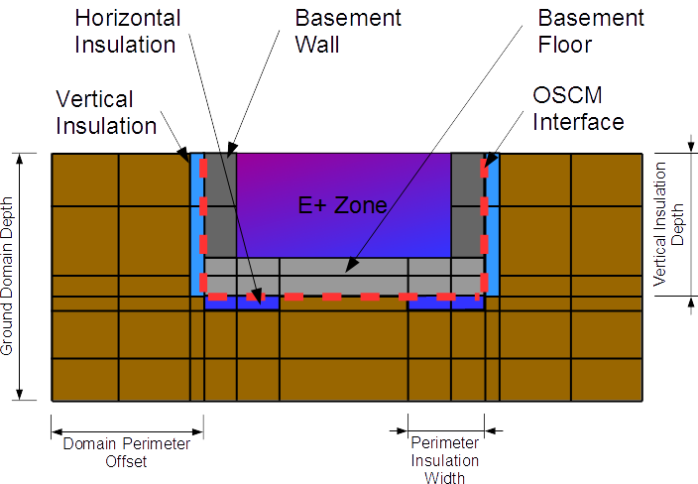

Figure 1: Basement Configuration

|  |
| --- |
| Site:GroundDomain:Basement,  CoupledBasement, !- Name  10, !- Ground Domain Depth {m}  1, !- Aspect ratio  5, !- Perimeter offset {m}  1.8, !- Soil Thermal Conductivity {W/m-K}  3200, !- Soil Density {kg/m3}  836, !- Soil Specific Heat {J/kg-K}  30, !- Soil Moisture Content Volume Fraction {percent}  50, !- Soil Moisture Content Volume Fraction at Saturation {percent}  15.5, !- Kusuda-Achenbach Average Surface Temperature {C}  12.8, !- Kusuda-Achenbach Average Amplitude of Surface Temperature {C}  17.3, !- Kusuda-Achenbach Phase Shift of Minimum Surface Temperature {days}  1, !- Evapotranspiration Ground Cover Parameter  BasementFloorOSCM, !- Name of Basement Floor Boundary Condition Model  Yes, !- Basement Horizontal Underfloor Insulation Present (Yes/No)  Basement Insulation, !- Basement Horizontal Insulation Underfloor Material Name  Full, !- Full Horizontal or Perimeter Only (Full/Perimeter)  , !- Perimeter width (m)  2.5, !- Depth of Basement Wall In Ground Domain {m}  BasementWallOSCM, !- Name of Basement Wall Boundary Condition Model  Yes, !- Basement Wall Vertical Insulation Present(Yes/No)  Basement Insulation, !- Basement Wall Vertical Insulation Material Name  2.5, !- Vertical insulation depth from surface (m)  Hourly; !- Domain Update interval. (Timestep, Hourly)  4; ! Mesh Density Parameter |

#### Field: Name

Alpha field used as a unique identifier for each basement domain. Multiple basements domains can be simulated simultaneously, however, each domain must have a unique name. Additionally, despite the ability to simulate multiple domains simultaneously, these domains do not interact with each other and are treated as independent domains with boundary conditions given by the model parameters below.

#### Field: Ground Domain Depth

Numeric field used to determine the depth of the simulation domain, in meters. A value of 10 meters is the default.

#### Field: Aspect Ratio

Numeric field, which is the ratio of basement length to width, used to determine the aspect ratio of the basement. This field along with the total basement floor area, which is taken as the combination of all surfaces connected to the floor OtherSideConditionsModel, are used to determine the size and shape of the basement domain. Aspect ratios and the inverse of aspect ratios should produce identical results. i.e. AR = 2 equals AR = 0.5. This field has units of meters/meters.

#### Field: Domain Perimeter Offset

Numeric field used to determine the distance from the basement perimeter to the domain perimeter, in meters. A value of 5 is default.

#### Field: Soil Thermal Conductivity

The thermal conductivity of the soil, in W/m-K.

#### Field: Soil Density

The bulk density of the soil, in kg/m3.

#### Field: Soil Specific Heat

The specific heat of dry soil, in J/kg-K. If moisture is defined in this object, moisture and freezing effects are accounted for by varying the specific heat value.

#### Field: Soil Moisture Content Volume Fraction

A nominal value of soil moisture content to be used when evaluating soil thermal properties.

#### Field: Soil Moisture Content Volume Fraction at Saturation

A nominal value of soil moisture content when the soil is saturated, this is used in evaluating thermal properties of freezing soil.

#### Field: Kusuda-Achebach Average Ground Surface Temperature

The annual average ground surface temperature to be applied to the Kusuda-Achenbach far-field boundary temperature correlation, in °C. This parameter and the subsequent two parameters may be determined by using the CalcSoilSurfTemp preprocessor; or, it may be determined by including the Site:GroundTemperature:Shallow object in the input. This object is used to provide monthly ground surface temperatures to the simulation. From these temperatures, the model can determine this, and the following two parameters for the simulation. In which case, this field and the following two can be left blank.

#### Field: Kusuda-Achebach Average Amplitude of Ground Surface Temperature

The annual mean ground surface temperature variation from average used in determining the far-field boundary conditions, in °C. This parameter, as well as the previous and following parameters may be determined by using the CalcSoilSurfTemp preprocessor; or, it may be determined by including the Site:GroundTemperature:Shallow object in the input. This object is used to provide monthly ground surface temperatures to the simulation. From these temperatures, the model can determine this parameter, as well as the previous and following parameters. In which case, this field, the previous field, and the following field can be left blank.

#### Field: Kusuda-Achenbach Phase Shift of Minimum Ground Surface Temperature

The phase shift of minimum ground surface temperature, or the day of the year when the minimum ground surface temperature occurs. This parameter, as well as the previous two parameters may be determined by using the CalcSoilSurfTemp preprocessor; or, it may be determined by including the Site:GroundTemperature:Shallow object in the input. This object is used to provide monthly ground surface temperatures to the simulation. From these temperatures, the model can determine this parameter, as well as the previous two parameters. In which case, this field, the previous two fields can be left blank.

#### Field: Evapotranspiration Ground Cover Parameter

Numeric field specifies the ground cover effects used in the evapotranspiration model at the ground surface heat balance. The values range from 0 (solid, non-permeable ground surface) to 1.5 (wild growth). Model can be sensitive to variations in this parameter, especially in dry climates.

#### Field: Basement Floor Boundary Condition Model Name

This is the name of the other side boundary condition model used for the basement floor surface.

#### Field: Horizontal Insulation

Alpha field indicates whether horizontal insulation is present. Options include “YES” and “NO”.

#### Field: Horizontal Insulation Name

Name of material object representing the horizontal underfloor basement insulation. Optional argument only required if horizontal insulation is present.

#### Field: Horizontal Insulation Extents

Alpha field indicates whether the horizontal underfloor insulation extends to cover the full horizontal area of the basement floor, or only covers the basement floor perimeter. Optional argument only required if horizontal insulation is present. Options include “FULL” and “PERIMETER”.

#### Field: Perimeter Insulation Width

Numeric field indicating the width of the perimeter insulation measured from the basement floor edge. Valid range from > 0 to < half of smallest basement floor width.

#### Field: Basement Depth

Depth of basement floor surface referenced from the ground surface, in meters. This domain should be the distance from the ground surface down to the basement floor surface. In cases where the ground surface is below the main above-ground building level, a separate wall surface should be employed between the basement walls and the main level walls.

#### Field: Basement Wall Boundary Condition Model Name

Name of the other side condition boundary model used for the basement walls.

#### Field: Vertical Insulation

Alpha field indicates whether vertical insulation is present. Options include “YES” and “NO”.

#### Field: Vertical Insulation Name

Name of material object representing the vertical slab insulation. Optional argument only required if vertical insulation is present.

#### Field: Vertical Insulation Depth

Numeric field indicates the depth measured in meters from the ground surface to which the vertical perimeter insulation extends. Valid range from > 0 to < Basement Depth.

#### Field: Simulation Timestep

Alpha field indicating whether the domain will update temperatures at each zone timestep, or at hourly intervals. Options include “timestep” and “hourly”.

#### Mesh Density Parameter

Integer field indicating the density of the finite difference ground domain cells between the basement and the far field boundaries. Default value is 4. Total number of ground domain cells, insulation cells, and ground surface cells are indicated as outputs to the eio file.

### Site:GroundDomain:Basement Output Variables

The following output variables are available.

|  |
| --- |
| Wall Interface Heat Flux  Wall Interface Temperature  Floor Interface Heat Flux  Floor Interface Temperature |

#### Wall Interface Heat Flux [W/m2]

This is the value of the heat flux provided to ground domain as a boundary condition for the basement walls. Should be equal to the basement wall outside heat flux.

#### Wall Interface Temperature [C]

This is the value of the OthersideConditionModel surface temperature. This is the temperature provided to the basement wall surfaces as an outside boundary condition.

#### Floor Interface Heat Flux [W/m2]

This is the value of the heat flux provided to ground domain as a boundary condition for the basement floor. Should be equal to the basement floor outside heat flux.

#### Floor Interface Temperature [C]

This is the value of the OthersideConditionModel surface temperature. This is the temperature provided to the ground coupled floor surfaces as an outside boundary condition.