### To be inserted after the GroundHeatExchanger:Vertical section (about page 1004 in Eng. Ref.)

### GroundHeatExchanger:Slinky

This model reuses much of the same code including the load aggregation and temperature response caluclations which are described above in the GroundHeatExchanger:Vertical model. As a result, that section can also be used as reference material. This model is unique in that it generates it’s own temperature response factor g-functions, rather than relying on the other software or data to generate the g-functions. These are generated based on the work by Xiong et al. 2015.

#### Horizontal Slinky Temperature Response Functions

Equation used for calculating the g-function temperature response factors for the horizontal Slinky HX are seen below.

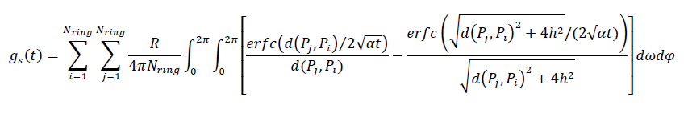

Where:

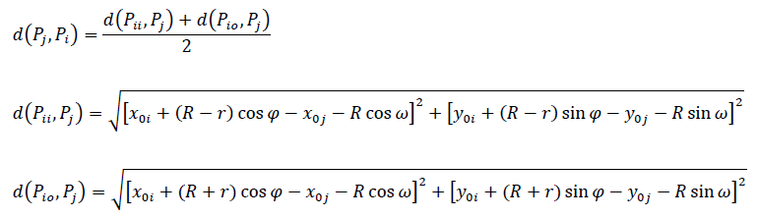

**Vertical Slinky Terperature Response Functions**

Equations used for calculating the g-function temperature response factors for the vertical Slinky HX are seen below.

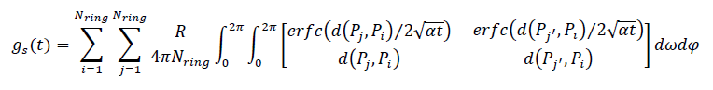

Where:

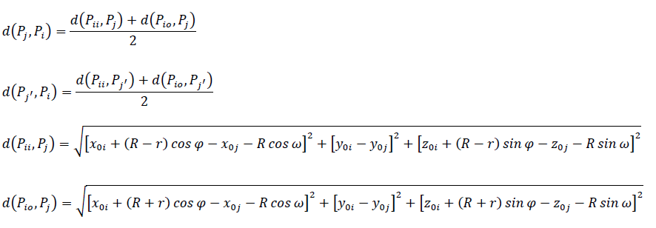

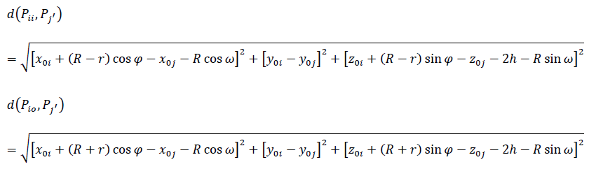

#### Model Simplifications for Computational Efficiency

Several simplifications were used to ensure the g-function temperature response factors are computationally efficient. The first simplification is achieved by taking advantage of symmetry. In Figure 1 we can see that by taking advantage of symmettry the temperature response for only one quarter of the rings needs be calculated.

The second simplification occurs by realizing that the effect between two rings decreases exponentially as the distance between the rings increases. Near-field rings are defined as rings whose centers are within 2.5m + D distance from the center of ring i as is seen in Figure 1. Far-field rings are defined as rings whose centers are beyond 10m + D, with middle-field rings occupying the space in between the near-field and far-field rings. Near-field ring temperature response factors are determined as indicated above for horzontal or vertical slinkys. Middle-field rings are considerably simplified – the interaction between ring is approximated as that of two point sources at their centers. Thermal effect of far-field rings are ignored.

The third and final simplification takes advantatge of geometric similarity that ring share. Ring pairs that are geometrically similar do not require recalculation of distances or reponse factors. Thus the calculations for geometrically similar ring pairs can be reused.

For more information, see Xiong et al. 2015.

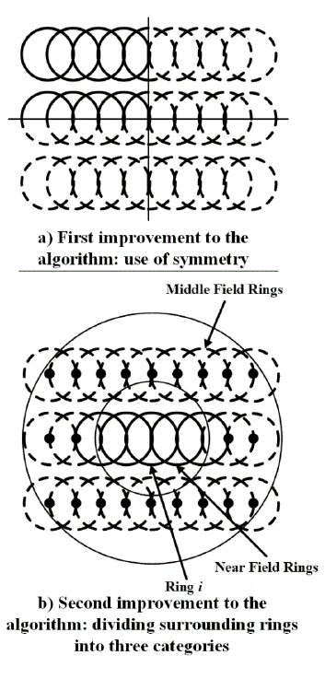

Figure 3: Schematic of first and second improvements to the algorithm for computational efficiency.

#### References

Xiong, Z., D.E. Fisher, and J.D. Spitler. 2015. Development and Validation of a SlinkyTM Ground Heat Exchanger Model. Applied Energy 141: 57-69.