### To be inserted after GroundHeatExhanger:Vertical (About pg 784 in I/O Ref.)

### GroundHeatExchanger:Slinky

The GroundHeatExchanger:Slinky use the g-functions to calculate the GHX temperature respons, similar to the GroundHeatExchanger:Vertical model, however for this model g-functions are automatically calculated by EnergyPlus without the need of external software or data.

Horizontal slinky-loop ground heat exchangers (GHXs) consist of coiled tubing, with the individual rings spread out along the direction of the trench either horizontally or vertically, as shown in Figure 1. A schematic of a slinky GHX can be seen in Figure 2. Compared to conventional straight tube horizontal GHXs, slinky loops have a higher tube density; hence, with the same cooling/heating loads, slinky-loop GHXs require less land area and excavation work than straight tube HGHXs.

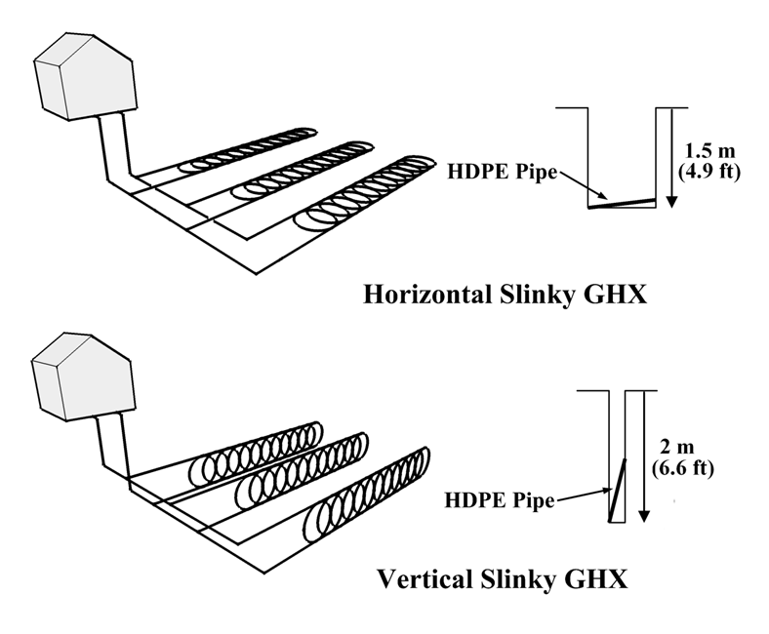

Figure 1: Slinky Ground Heat Exchanger Configurations.



Figure 2: Schematic of Slinky HX.

An example GroundHeatExchanger:Slinky object is shown below.

|  |
| --- |
| GroundHeatExchanger:Slinky,  Slinky GHX, !- Name  GHE Inlet Node, !- Inlet Node  GHE Outlet Node, !- Outlet Node  0.0033, !- Design Flow Rate [m3/s]  1.2, !- Soil Thermal Conductivity [W/m-K]  3200, !- Soil Density [kg/m3]  850, !- Soil Specific Heat [J/kg-K]  1.8, !- Pipe Thermal Conductivity [W/m-K]  920, !- Pipe Density [kg/m3]  2200, !- Pipe Specific Heat [J/kg-K]  0.02667, !- Pipe Outside Diameter [m]  0.002413, !- Pipe Wall Thickness [m]  Vertical, !- Heat Exchanger Configuration (Vertical, Horizontal)  1, !- Coil Diameter [m]  0.2, !- Coil Pitch [m]  2.5, !- Trench Depth [m]  40, !- Trench Length [m]  15, !- Number of Parallel Trenches  2, !- Trench Spacing [m]  15.5, !- Kusuda-Achenbach Average Surface Temp [C]  3.2, !- Kusuda-Achenbach Average Surface Temp Amplitude [C]  8, !- Kusuda-Achenbach Phase Shift [C]  10; !- Maximum length of simulation [years] |

#### Field: Name

Alpha field used as identifying field for heat exchanger

#### Field: Inlet Node

This alpha field is the name of the inlet node of the component on a plant loop.

#### Field: Outlet Node

This alpha field is the name of the outlet node of the component on a plant loop.

#### Field: Design Flow Rate

This numeric field is the design flow rate in m3/s for the heat exchanger. The plant loop will attempt to meet this request based on loop and flow conditions.

#### Field: Soil Thermal Conductivity

This numeric field is the thermal conductivity of the soil, in W/m-K.

#### Field: Soil Density

This numeric field is the density of the soil, in kg/m3.

#### Field: Soil Specific Heat

This numeric field is the specific heat of the soil, in J/kg-K.

#### Field: Pipe Thermal Conductivity

This numeric field is the thermal conductivity of the heat exchanger pipe.

#### Field: Pipe Density

This numeric field is the density of the heat exchanger pipe, in kg/m3.

#### Field: Pipe Specific Heat

This numeric field is the specific heat of the heat exchanger pipe, in J/kg-K.

#### Field: Pipe Outside Diameter

This numeric field is the outside pipe diameter, in meters.

#### Field: Pipe Wall Thickness

This numeric field is the pipe wall thickness, in meters.

#### Field: Heat Exchanger Configuration

This alpha field is heat exchanger configuration, either Vertical or Horizontal.

#### Field: Coil Diameter

This numeric is the diameter of the slinky coil, in meters.

#### Field: Coil Pitch

This numeric field is the center-to-center distance between heat exchanger coils, in meters.

#### Field: Trench Depth

This numeric field is the distance from the bottom of the trench to the ground surface, in meters.

#### Field: Trench Length

This numeric field is the length of the heat exchanger trench, in meters. This assumes the heat exchanger runs the full length of the trench.

#### Field: Number of Parallel Trenches

This numeric field is the number of parallel trenches. Design flow rate will be equally divided among all parallel trenches.

#### Field: Trench Spacing

This numeric field is the center-to-center distance in between parallel trenches, in meters.

#### Field: Kusuda-Achenbach Average Annual Surface Temperature

The annual average ground surface temperature to be applied to the Kusuda-Achenbach ground temperature boundary temperature correlation, in °C. This parameter and the subsequent two parameters may be determined by using the CalcSoilSurfTemp preprocessor

#### Field: Kusuda-Achenbach Amplitude of Average Surface Temperature

The annual mean ground surface temperature variation from average used in determining the far-field boundary conditions, in °C. This parameter, as well as the previous and following parameters may be determined by using the CalcSoilSurfTemp preprocessor

#### Field: Kusuda-Achenbach Phase Shift

The phase shift of minimum ground surface temperature, or the day of the year when the minimum ground surface temperature occurs. This parameter, as well as the previous two parameters may be determined by using the CalcSoilSurfTemp preprocessor

#### Field: Maximum Length of Simulation

This numeric field contains the maximum number of years of simulation to be carried out.

### GroundHeatExchanger:Slinky Outputs

The following output variables are available.

|  |
| --- |
| HVAC,Average,Ground Heat Exchanger Average Borehole Temperature [C]  HVAC,Average,Ground Heat Exchanger Heat Transfer Rate [W]  HVAC,Average,Ground Heat Exchanger Inlet Temperature [C]  HVAC,Average,Ground Heat Exchanger Outlet Temperature [C]  HVAC,Average,Ground Heat Exchanger Mass Flow Rate [kg/s]  HVAC,Average,Ground Heat Exchanger Average Fluid Temperature [C] |

#### Ground Heat Exchanger Average Borehole Temperature [C]

This is the model result for the average temperature of the borehole heat exchanger.

#### Ground Heat Exchanger Heat Transfer Rate [W]

This is the rate of heat transfer between the working fluid and the ground heat exchanger, in Watts.

#### Ground Heat Exchanger Inlet Temperature [C]

This is the temperature of the working fluid entering the ground heat exchanger.

#### Ground Heat Exchanger Outlet Temperature [C]

This is the temperature of the working fluid leaving the ground heat exchanger.

#### Ground Heat Exchanger Mass Flow Rate [kg/s]

This is the mass flow rate of the working fluid through the heat exchanger.

#### Ground Heat Exchanger Average Fluid Temperature [C]

This is the average temperature of the working fluid inside the heat exchanger.