## Chilled Water Supply Temperature Reset

### Description

This energy efficiency measure (EEM) adds a set point reset to all chilled water loops present in the OpenStudio model. The chilled water supply temperature reset will be based on outdoor-air temperature (OAT). The specific sequence is that as outdoor-air temperature (OAT) rises from 60°F (15.6°C) up to 100°F (37.8°C), the chilled water supply temperature set point will decrease from 55°F (12.8°C) down to 45°F (7.22°C). This sequence provides a 10°F (15.6°C) change in the Chilled Water Set Point, over a 40°F (22.2°C) temperature change in the OAT.

### Modeler Description

This EEM applies an OS:SetpointManager:OutdoorAirReset controller to the supply outlet node of all PlantLoop objects where OS:Sizing:Plant.LoopType = “Cooling”

### Use Case Types

Model Articulation, Retrofit EE, New Construction EE

### Arguments

No arguments

### Initial Condition Message

### There are {X} eligible cooling loops out of {Y} plant loops.

### Eligible loops name(s): {A, B, C….}

### Final Condition Message

### Cold Water Supply Temperature Reset has been applied to {X} plant loop(s).

### Plant Loops affected are: {A, B, C…}

### Not Applicable Messages

### No Cooling PlantLoop objects found. EEM is not applicable.

### Warning Messages

None

### Information Messages

Information about new OA: reset setpoint manager as info message

### Error Messages

N/A

### Code Outline

* Loop through the model and identify each OS:PlantLoop where LoopType = “cooling”
* For each qualified loop:
  + Remove any existing setpoint manager objects from the supply outlet node
  + Add and configure an OS:SetpointManagerOutdoorAirReset object to the supply outlet node as follows:
  + Name
  + SetpointatOutdoorHighTemperature = 7.22
  + SetpointatOutdoorLowTemperature = 12.8
  + outdoorHighTemperature = 37.8
  + outdoorLowTemperature = 15.6
* Comment source of values used

### Tests

**This measure applies to:**

1. Secondary School

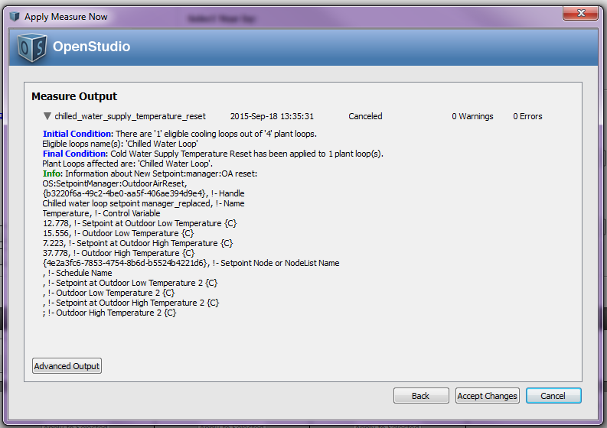

1. Large Hotel

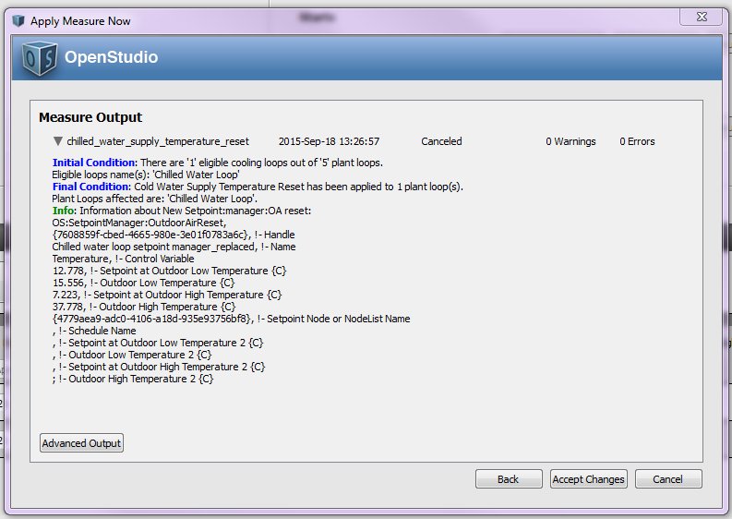

1. Large Office

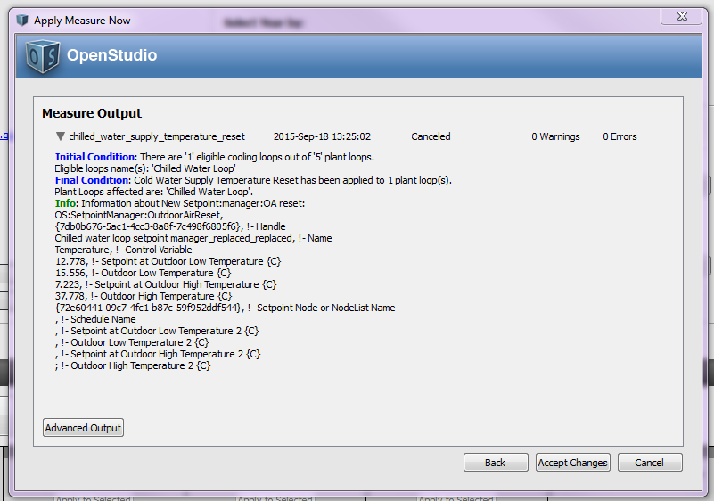

1. Hospital

**This measure does not apply to:**

1. Warehouse
2. Midrise Apartment
3. Outpatient Healthcare
4. Small Office

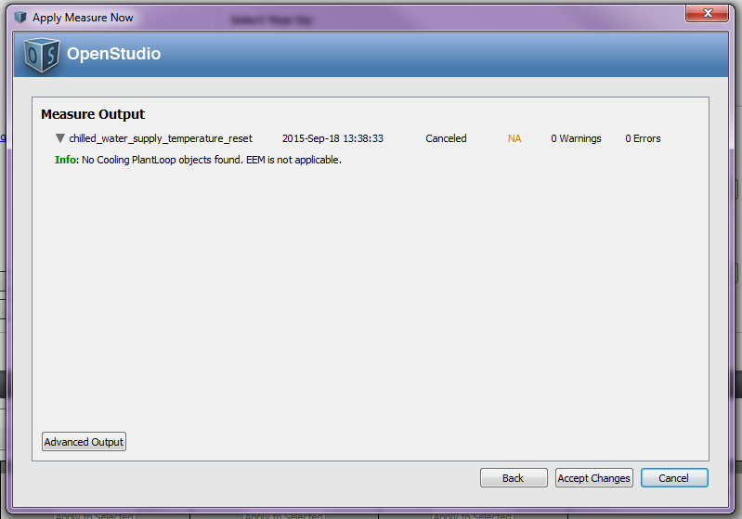

1. Medium Office

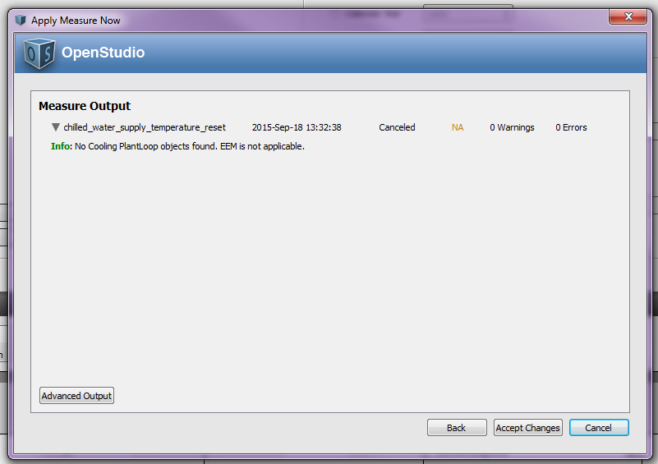

1. Primary School

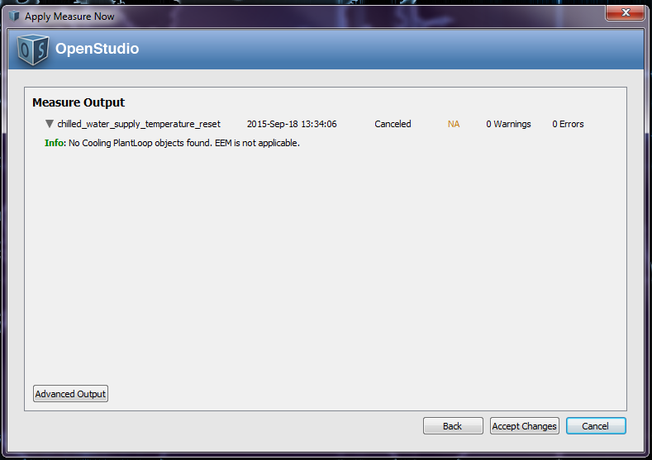

1. Stand-Alone Retail
2. Strip Mall
3. Supermarket
4. Quick Service Restaurant
5. Full Service Restaurant
6. Small Hotel

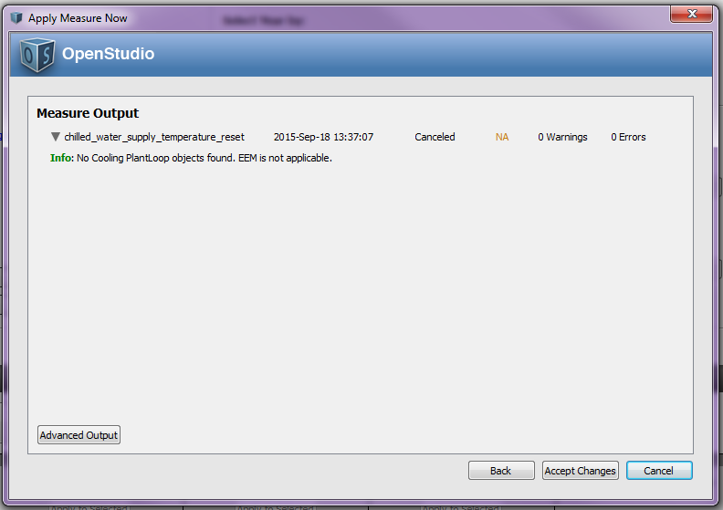

**Test results:**

Run the simulation using prototype .osm files, examine the results, cut and paste some before/after screenshots/evidence that makes you think that the measure is working correctly, including generating messages.