## Cold Climate Heat Pumps

### Description

This energy efficiency measure (EEM) adds cold-climate Air-Source Heat Pumps (ccASHP) to all air loops in a model having heat pump heating coils. The measure modifies all existing CoilHeatingDXSingleSpeed coils in a model by replacing performance curves with those representing the heating performance of a cold-climate Air-Source Heat Pumps (ccASHP). ccASHP are defined as ducted or ductless, air-to-air, split system heat pumps serving either single-zone or multi-zone, best suited to heat efficiently in cold climates (IECC climate zone 4 and higher). ccASHP DOES NOT include ground-source or air-to-water heat pump systems. This measure also sets the Min. OADB Temperature for ccASHP operation to -4°F.

### Modeler Description

This measure replaces the coefficients for OS:PerformanceCurve objects associated with all OS:CoilHeatingDXSingleSpeed objects. These performance curve objects are modified:

1. TotalHeatingCapacityFunctionofTemperature
2. TotalHeatingCapacityFunctionofFlowFraction
3. EnergyInputRatioFunctionofTemperature
4. EnergyInputRatioFunctionofFlowFraction
5. PartLoadFractionCorrelationCurve.

In addition, the setting for the MinimumOutdoorDryBulbTemperatureforCompressorOperation will be changed to -4°F.

The replacement curves have been developed by using the 3rd stage of a 4 stage heat pump description of performance curve data used in BeOpt v2.4 for low temperature dx heat pump heating coils.

### Use Case Types

Model Articulation, Retrofit EE, New Construction EE

### Arguments

No arguments

### Initial Condition Message

### The initial model contains {X} applicable 'OS:CoilHeatingDXSingleSpeed' objects for which this measure is applicable.

### Final Condition Message

### Performance curves representing 'ccASHP heating technology' has been applied to {X} 'OS:CoilHeatingDXSingleSpeed' objects in the model.

### Not Applicable Messages

### The measure is not applicable due to absence of valid object 'OS:CoilHeatingDXSingleSpeed' .

### Warning Messages

N/A

### Information Messages

* For each OS:CoilHeatingDXSingleSpeed object, write an info message displaying original and new performance curve coefficients.
* Write info message displaying old and new values for MinimumOutdoorDryBulbTemperatureforCompressorOperation

### Error Messages

N/A

### Code Outline

Loop through each air loop in the model and identify all OS:CoilHeatingDXSingleSpeed object

For each qualified OS:CoilHeatingDXSingleSpeed object:

* Read and store the value for ratedTotalHeatingCapacity which will be used to potentially trigger a warning message if not Autosized
* Read, store and set the ratedCOP from the original value to 4.0776
* Read, store and set the coefficient values associated with these curve objects:
  + TotalHeatingCapacityFunctionofTemperature
  + TotalHeatingCapacityFunctionofFlowFraction
  + EnergyInputRatioFunctionofTemperature
  + EnergyInputRatioFunctionofFlowFraction
  + PartLoadFractionCorrelationCurve.
  + Regression techniques will be used to develop generalized performance curves for autosized ccASHP based on data published here: <http://www.neep.org/initiatives/high-efficiency-products/emerging-technologies/ashp/cold-climate-air-source-heat-pump>
* Read, store and change the Minimum Outdoor Dry-Bulb Temperature for Compressor Operation to be -4°F

### Tests

**This measure applies to:**

1. **Small Office**

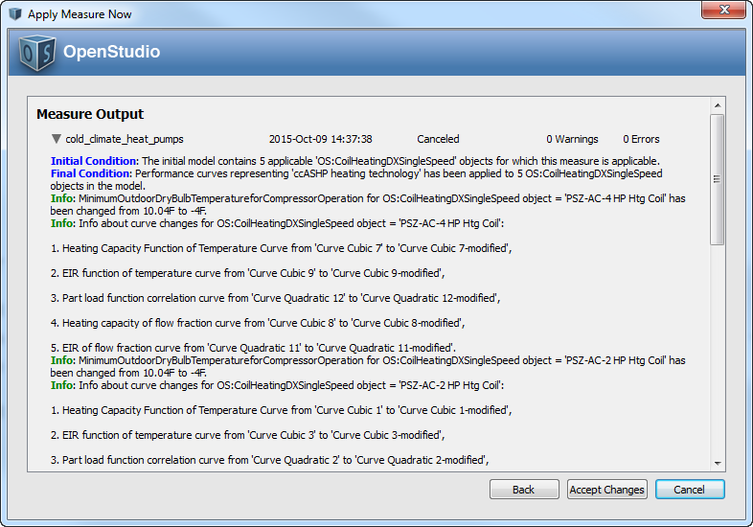

**This measure does not apply to:**

1. Secondary School

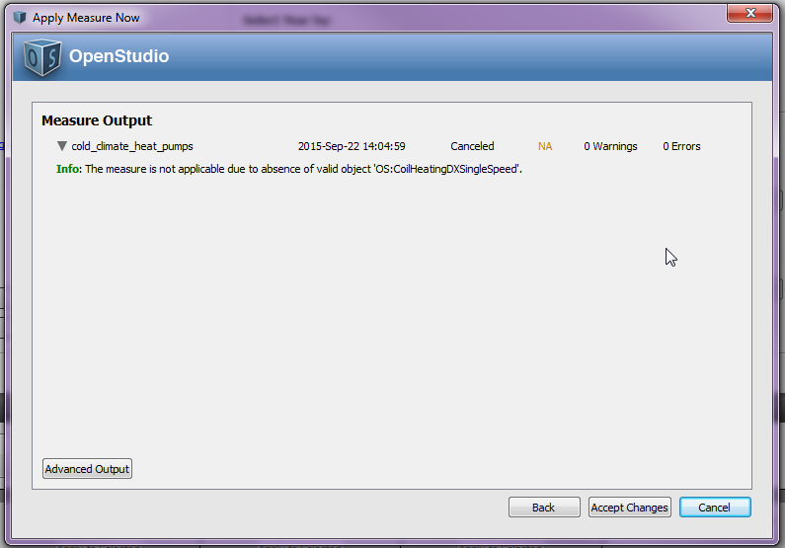

1. Large Hotel

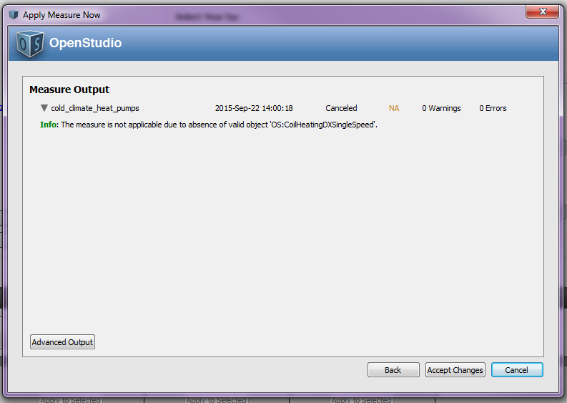

1. Hospital
2. Warehouse
3. Midrise Apartment
4. Outpatient Healthcare
5. Medium Office

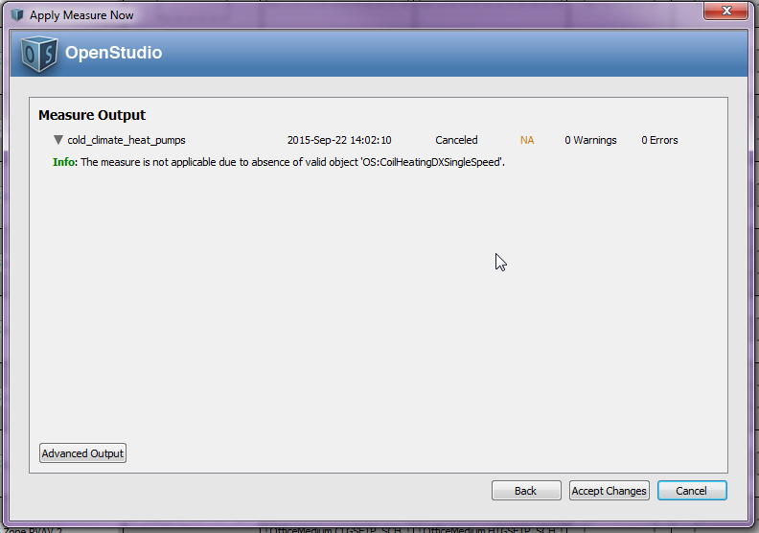

1. Large Office

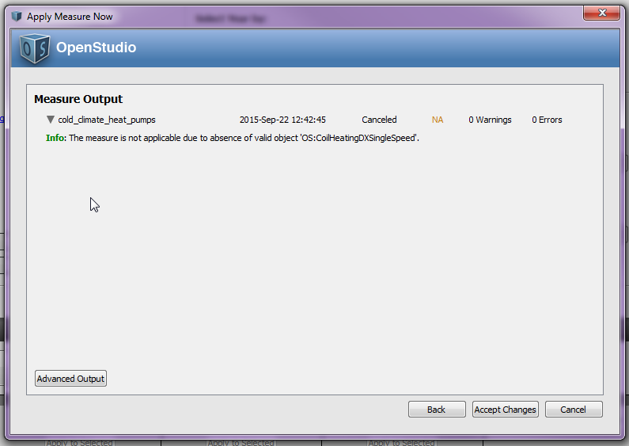

1. Primary School

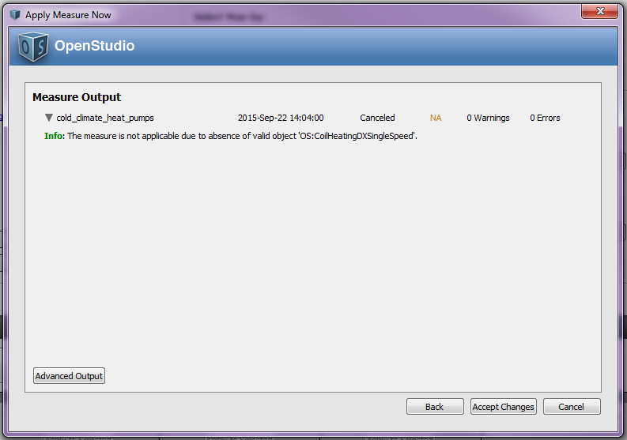

1. Stand-Alone Retail
2. Strip Mall
3. Supermarket
4. Quick Service Restaurant
5. Full Service Restaurant
6. Small Hotel

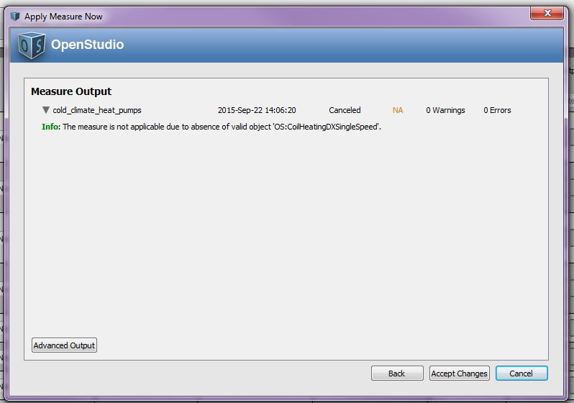

**Test results:**

Run the simulation using prototype .osm files, examine the results, cut and paste some before/after screenshots/evidence that makes you think that the measure is working correctly, including generating messages.

References

1. BeOPT v2.4. – Models and internal documentation for split heat plump performance
2. <http://energy.gov/sites/prod/files/2014/10/f18/emt57_messmer_042314.pdf>
3. Specific Installation Manuals for Bryant Extreme Evolution, Mitsubishi Hyper Heat and others referenced in the NEEP data tables.