## Hot Water Supply Temperature Reset

### Description

This energy efficiency measure (EEM) adds a set point reset to all hot water loops present in the OpenStudio model. The hot water supply temperature reset will be based on outdoor-air temperature (OAT). The specific sequence is that as outdoor-air temperature (OAT) lowers from 60°F (15.6°C) down to 20°F (-6.67°C), the hot water supply temperature set point will increase from 160°F (71.1°C) up to 180°F (82.2°C). This sequence provides a 20°F (11.1°C) change in the Hot Water Set Point, over a 40°F (22.2°C) temperature change in the OAT. This sequence assumes all boilers serving the hot water plant loops are non-condensing and should not receive return water below 140°F (60.0°C)

### Modeler Description

This EEM applies an OS:SetpointMsanager:OutdoorAirReset controller to the supply outlet node of all PlantLoop objects where OS:Sizing:Plant.LoopType = “Heating”

### Use Case Types

Model Articulation, Retrofit EE, New Construction EE

### Arguments

No arguments

### Initial Condition Message

### "There are {X} eligible heating loops out of {Y} plant loops. Eligible loops name(s): {A, B, C}

### Final Condition Message

Hot Water Supply Temperature Reset was applied to {X} Plant Loops in the model. Plant Loops affected were {PlantLoop name 1}, {PlantLoop name 2}, etc.

### Not Applicable Messages

Hot Water Supply Temperature Reset has been applied to {X} plant loop(s). Plant Loops affected are: {A, B,C}

### Warning Messages

None

### Information Messages

Information about new Setpoint Manager:OA reset

### Error Messages

N/A

### Code Outline

Loop through the model and identify each OS:PlantLoop where LoopType = “heating”

* For each qualified loop:

* + Remove any existing setpoint manager objects from the supply outlet node
  + Add and configure an OS:SetpointManagerOutdoorAirReset object to the supply outlet node as follows:
  + Name
  + SetpointatOutdoorHighTemperature = 71.1
  + SetpointatOutdoorLowTemperature = 82.2
  + outdoorHighTemperature = 15.6
  + outdoorLowTemperature = -6.67
* Add comments to the code describing the sources of the hot water reset schedule – the source document for the original PNNL retuning models.

<http://www.pnl.gov/buildingretuning/documents/pnnl_sa_89222.pdf>

### Tests

**This measure applies to:**

1. Secondary School

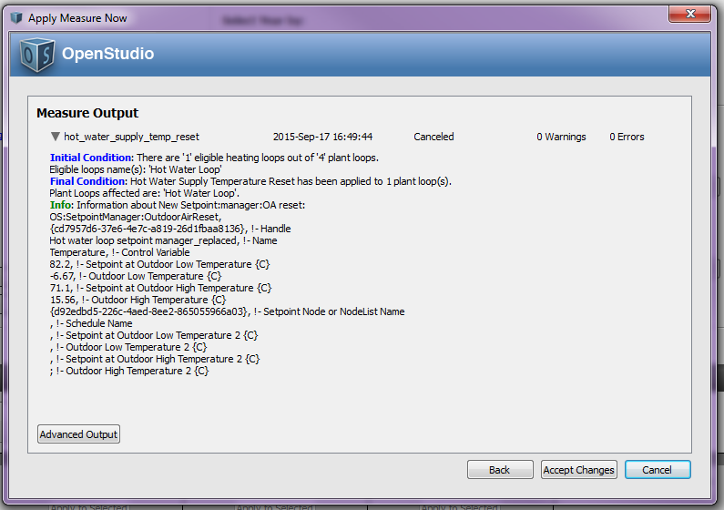

1. Primary School

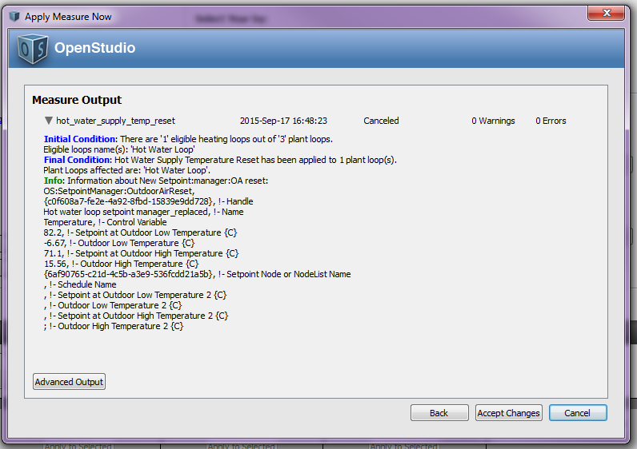

1. Outpatient Healthcare
2. Large Office

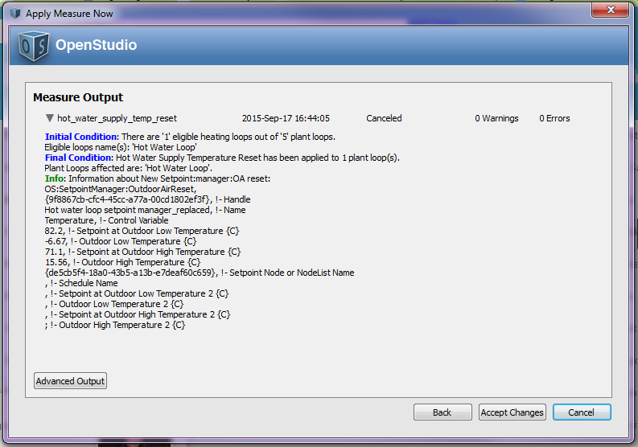

1. Large Hotel

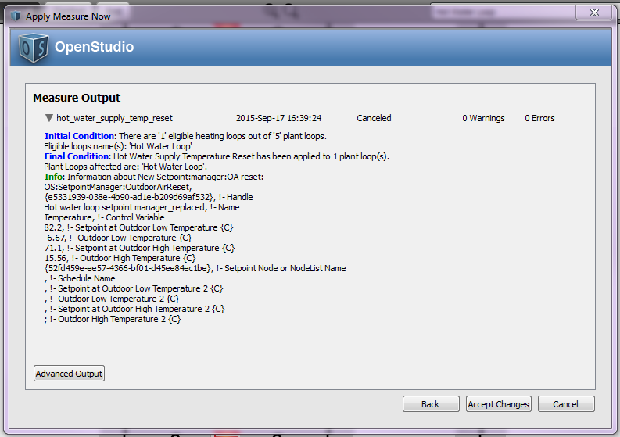

1. Hospital

**This measure does not apply to:**

1. Warehouse
2. Midrise Apartment
3. Small Office

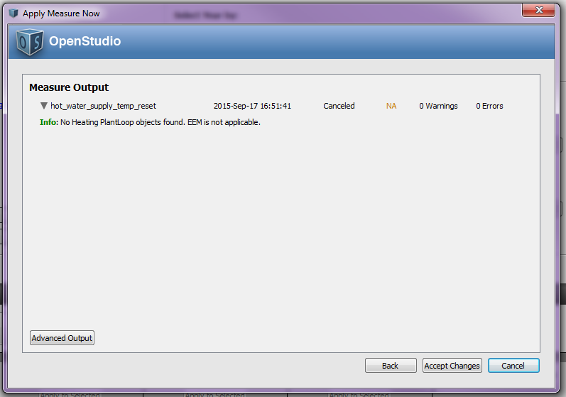

1. Medium Office

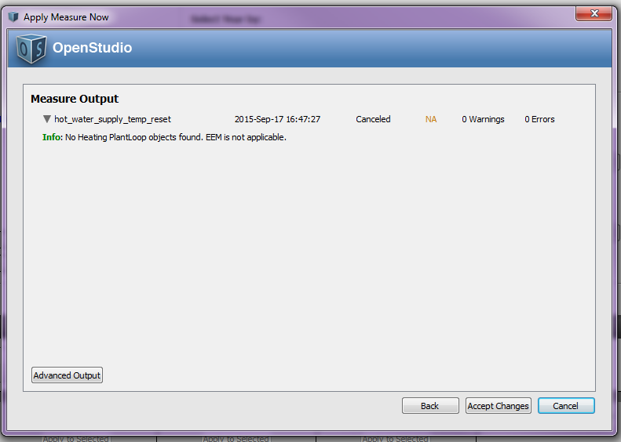

1. Stand-Alone Retail
2. Strip Mall
3. Supermarket
4. Quick Service Restaurant
5. Full Service Restaurant
6. Small Hotel

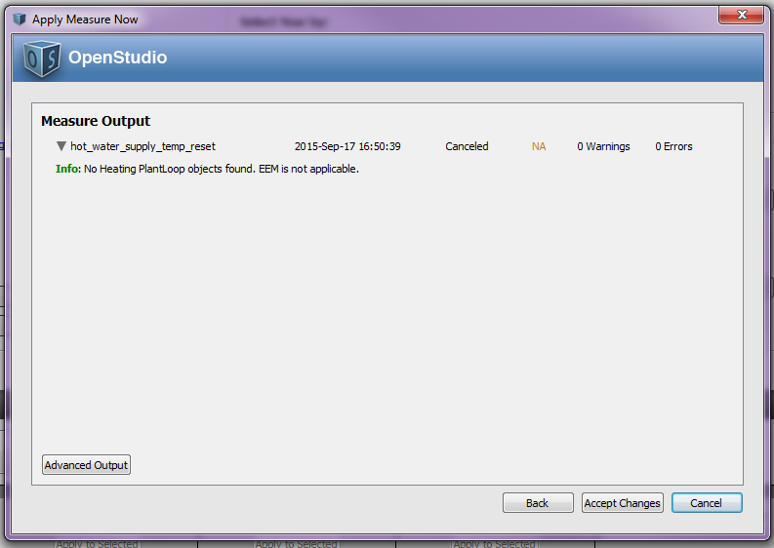

**Test results:**

Run the simulation using prototype .osm files, examine the results, cut and paste some before/after screenshots/evidence that makes you think that the measure is working correctly, including generating messages.