## Reduce Economizer Damper Leakage

### Description

This energy efficiency measure (EEM) changes the minimum outdoor air flow requirement of all Controller:OutdoorAir objects present in a model to represent a value equal to a continuous 10% of outdoor air flow damper leakage condition . For cases where the outdoor air controller is not configured for airside economizer operation, the measure triggers an NA message. For cases of controllers configured for airside economizer operation, the measure calculates and assigns a minimum outdoor airflow rate value equal to 10% of the calculated system ***maximum*** outdoor air flow rate. For the economizer case, outdoor air damper leakage is set to occur for all hours of the simulation.

### Modeler Description

This measure loops through all ‘Controller:OutdoorAir’ objects present on all air loops in the model. If the Controller Economizer Control Type is set to ‘No Economizer’, the measure will show ‘not applicable’ message. If the Controller Economizer Control Type is not set to ‘No Economizer’, the attribute of ‘IsMaximumOutdoorAirFlowRateAutosized’ will be examined. If it is ‘true’, sizing run will be initiated & value of ‘MaximumOutdoorAirflowRate’ will be retrieved. If it is ‘false’, the value of ‘MaximumOutdoorAirflowRate’ will be retrieved. In any case, the value of ‘MaximumOutdoorAirflowRate’ will be multiplied by 0.10 & assigned to the ‘MinimumOutdoorAirflowRate’ attribute. A schedule maintaining this minimum value for all hours of the year is created and assigned to attribute ‘Minimum Outside Air Schedule’.

### Use Case Types

New Construction, Retrofit, Model Articulation

### Arguments

No arguments

### Initial Condition Message

The initial model contained '{X}' airloops with '{Y}' Outdoor Air Controller objects. The measure is applicable for '{Z}' objects with some kind of economizer as control type.

### Final Condition Message

### A continuous outdoor air damper leakage condition representing poor damper/actuator control has been applied to '{X}' Outdoor Air Controllers. There are '{Y}' objects with control type = 'no economizer'.

### Not Applicable Messages

* If No AirLoops write N/A message
* If there are Airloops but no outdoor air controllers then write N/A message
* If there are airloops with OA controllers & all of them have economizer type = “no economizer”, write non applicable message.

### Warning Messages

### None

### Information Messages

Write info message whenever attributes of an outdoor air controller are altered. The message should include the name, object type, previous and new attribute value(s).

### Error Messages

N/A

### Code Outline

1. Loop through all AirLoops (only one outdoor air controller allowed per airloop)
   1. For each AirLoopHVAC OutdoorAir System
   2. Get OS:ControllerOutdoorAir
   3. Get setting for EconomizerControlType for each OS:ControllerOutdoorAir object
      1. If EconomizerControlType = ‘NoEconomizer’
         * 1. Write NA message
      2. If EconomizerControlType <> ‘NoEconomizer’
         1. Get value for “IsMaximumOutdoorAirFlowRateAutosized”
            1. If value = true

Launch sizing run

Retrieve autosized value: MaximumOutdoorAirflowRate

* + - * 1. If value = false

Retrieve value: MaximumOutdoorAirflowRate

* + - * 1. Set value of MinimumOutdoorAirflowRate = 0.10 * MaximumOutdoorAirflowRate
        2. Write info message
  1. Create schedule having value of 1.0 for all hours for assigning to MinimumFractionofOutdoorAir Schedule attribute

1. Write initial conditions message
2. Write final conditions message
3. Write AsNotApplicible message

### Tests

Run this model against applicable prototype buildings and test against each qualified object type. Several prototype buildings contain AirLoops with Outdoor Air Controller objects having both functioning airside economizers and no economizer. In addition, there are several prototype models having OutdoorAirController MinimumOutdoorAirflowRate and MaximumOutdoorAirflowRate attribute values equal to both ‘Autosize’ or 0 values. The measure will be tested against all possible cases.

**This measure applies to All Prototype Models:**

1. **Medium Office**
2. **Large Office**

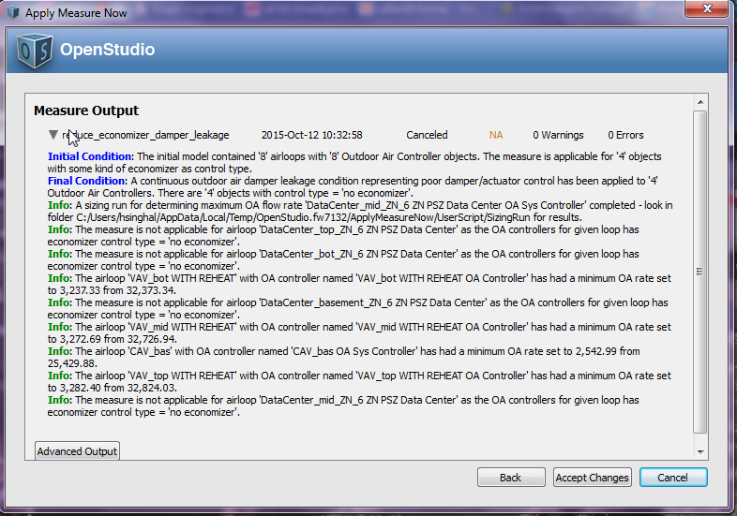

1. **Primary School**

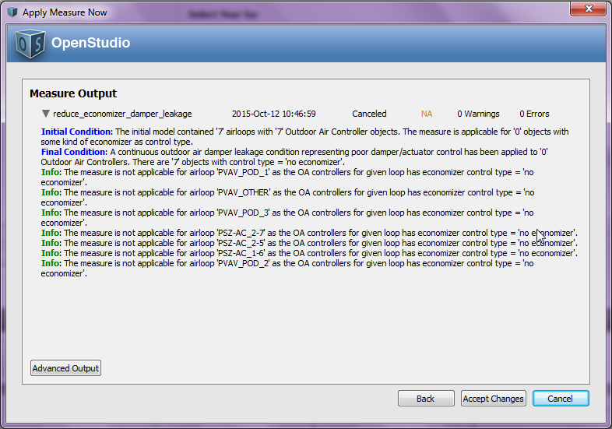

1. **Secondary School**
2. **Outpatient Healthcare**
3. **Large Hotel**

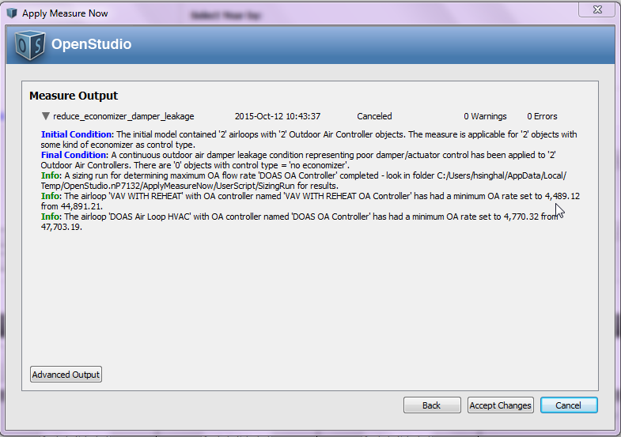

1. **Hospital**
2. **Mid Rise Apartment**
3. **High Rise Apartment**
4. **Small Office**
5. **Full Service Restaurant**
6. **Quick Service Restaurant**
7. **Stand Alone Retail**
8. **Strip Mall**
9. **Warehouse (non-refrigerated)**
10. **Small Hotel**

**Test results:**

The delivered measure will include screen shots of the initial, final and info messages as well as screen shots of the OS Application UI showing the object modifications.