Go to aws.amazon.com, log in, go to Account Activity page. Click Enable Now for cloud watch if you see that option:

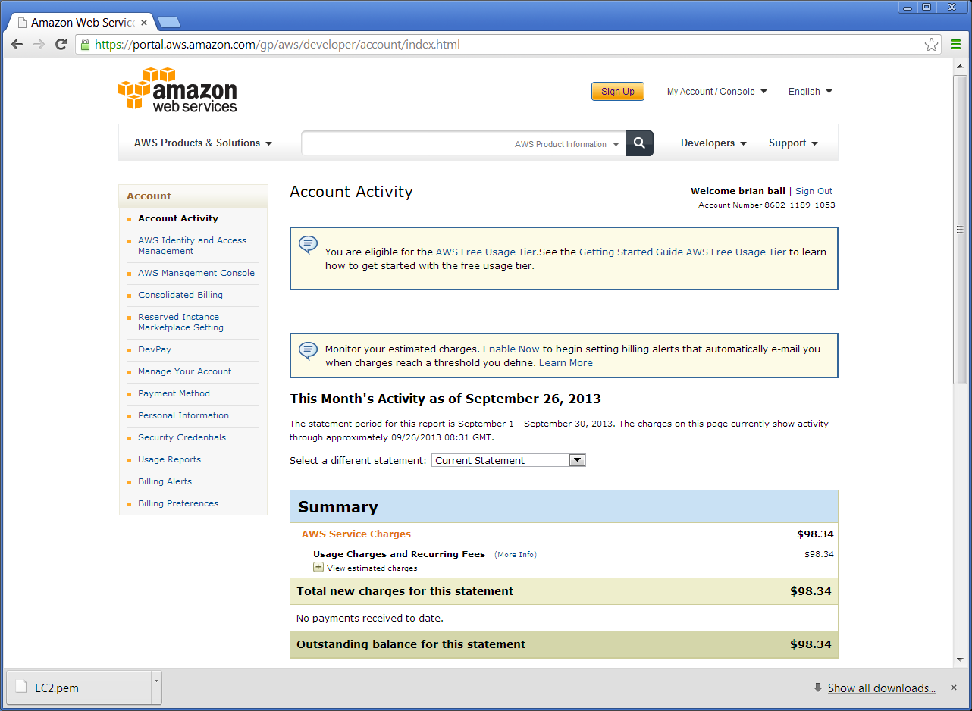

click on AWS Management Console:

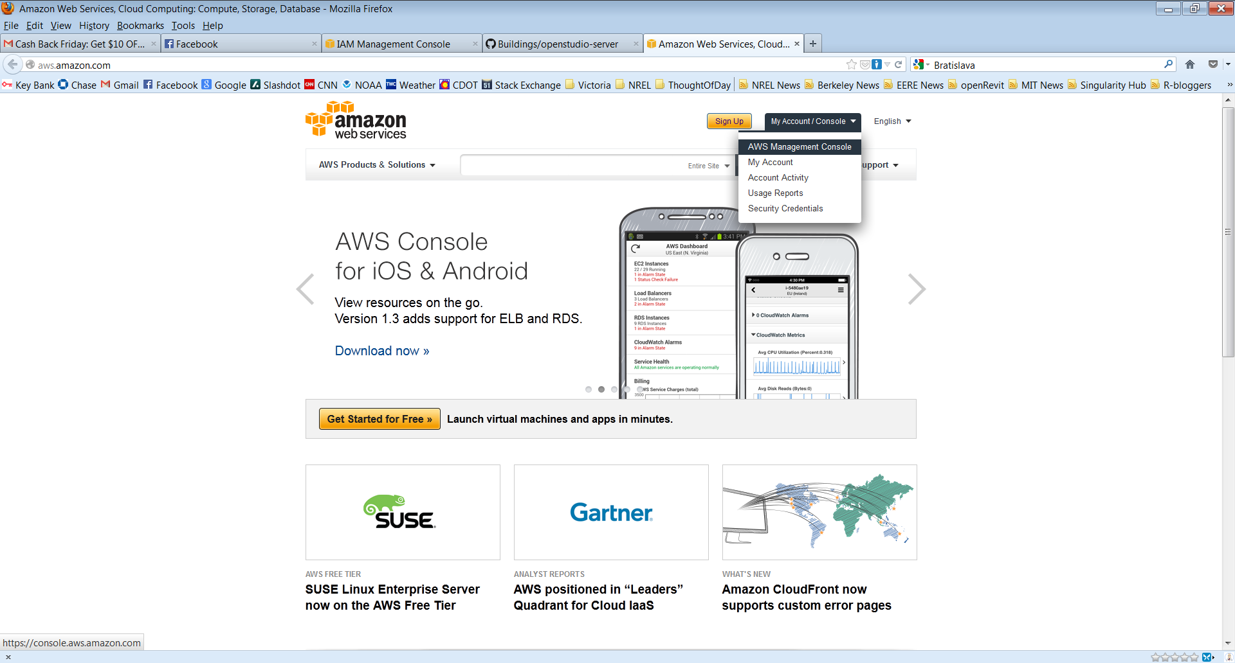

Go to Security Credentials under your account:

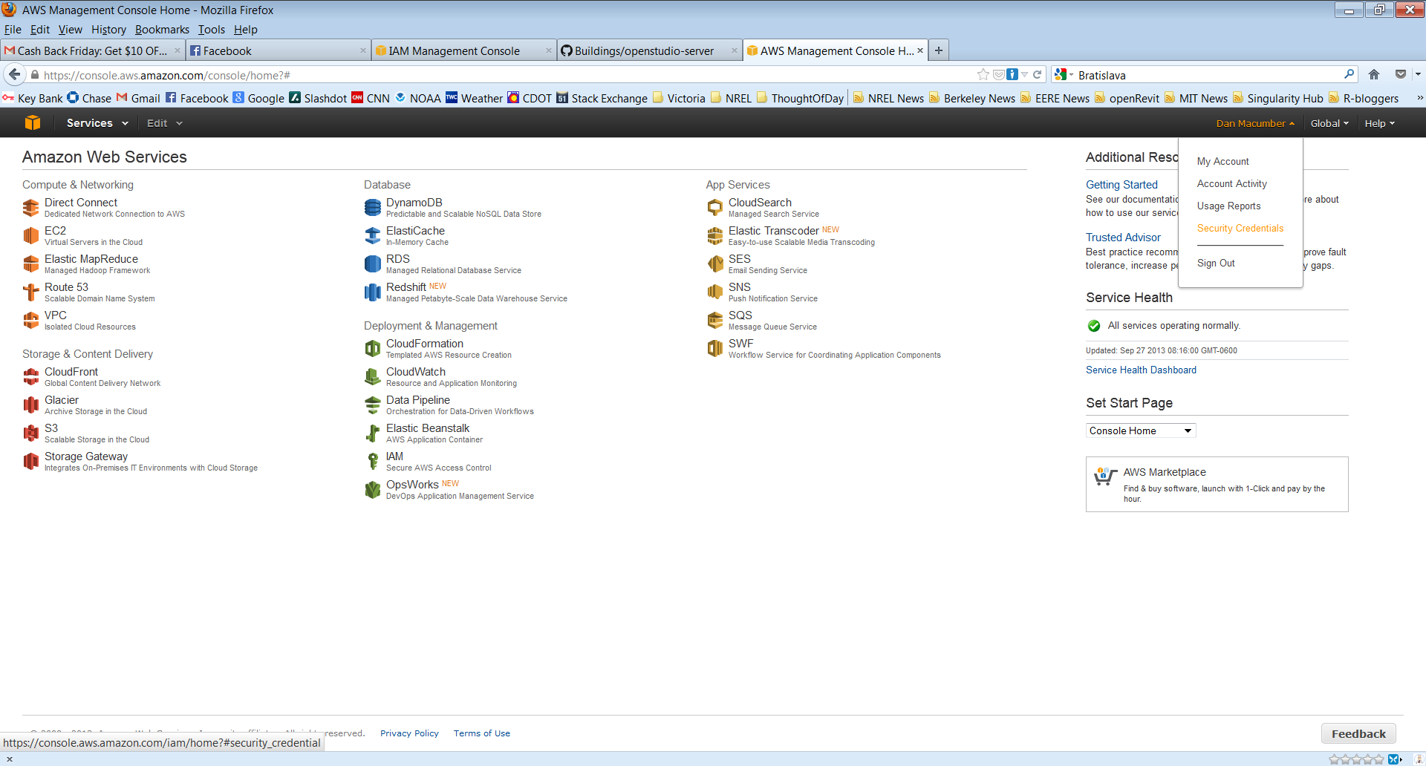

Click on Access Keys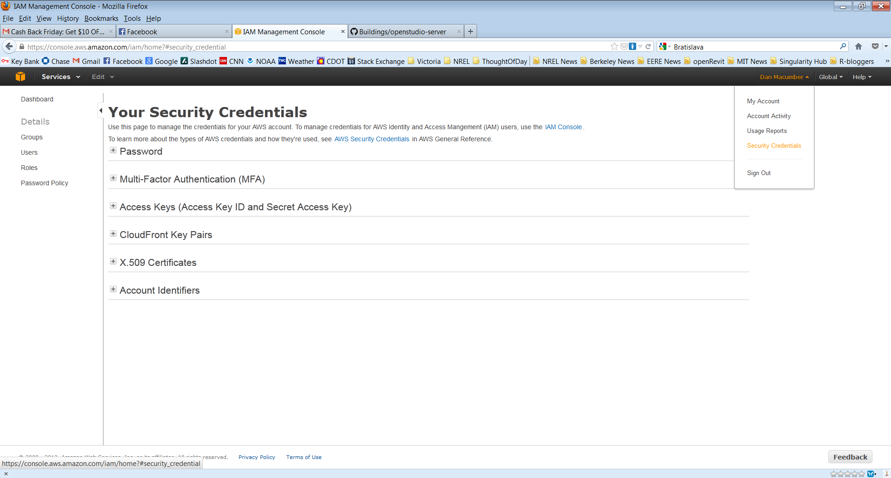

Click Create Access Key, save file:

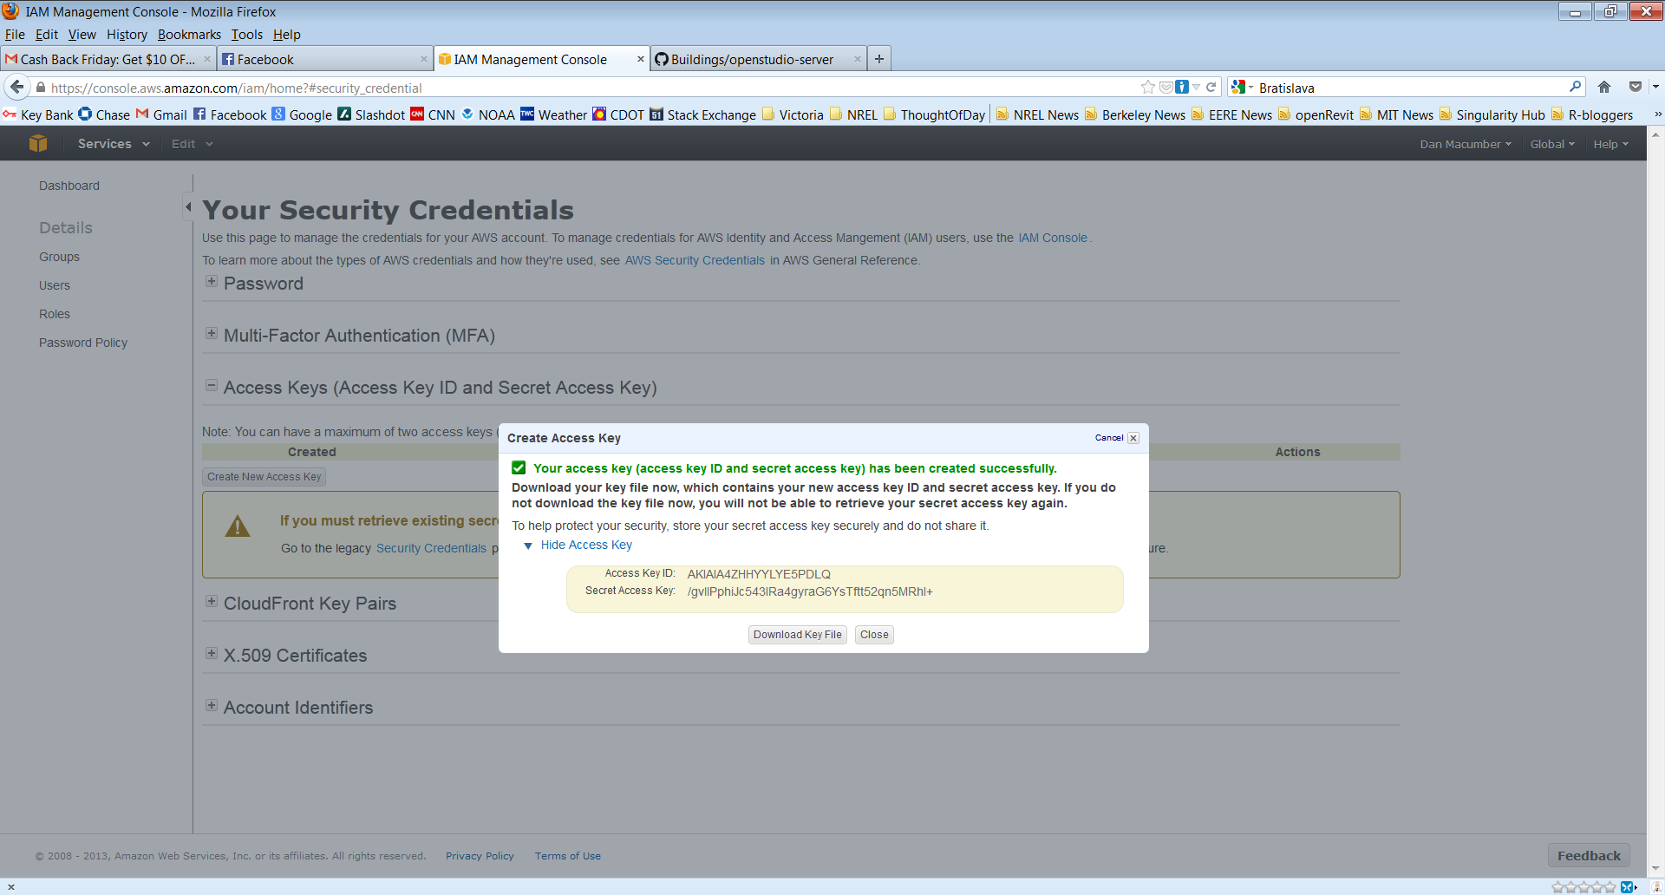

Now you have your access and secret keys: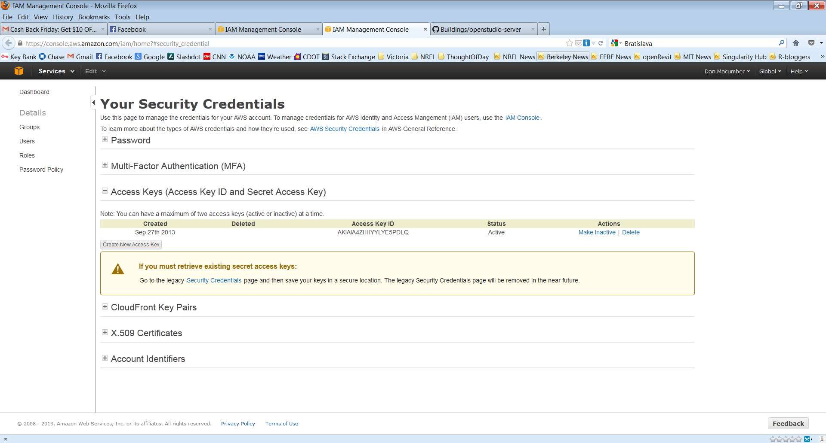

Create an .aws_secrets file in your home directory and include the following:

access_key_id: access_key

secret_access_key: secret_access_key

access_key is the value after AWSAccessKeyId in your download

secret_access_key is the value after AWSSecretKey in your download

Make sure to change your region to US N. Virginia in order to see the instances you have launched.  
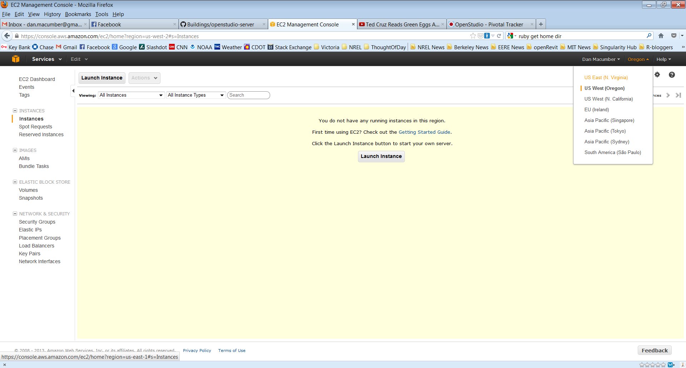

If you experience problems with running the simulations you should delete your security groups in case you have an old one that was not configured correctly:

