Go to aws.amazon.com, log in, go to Account Activity page. Click Enable Now for cloud watch if you see that option:

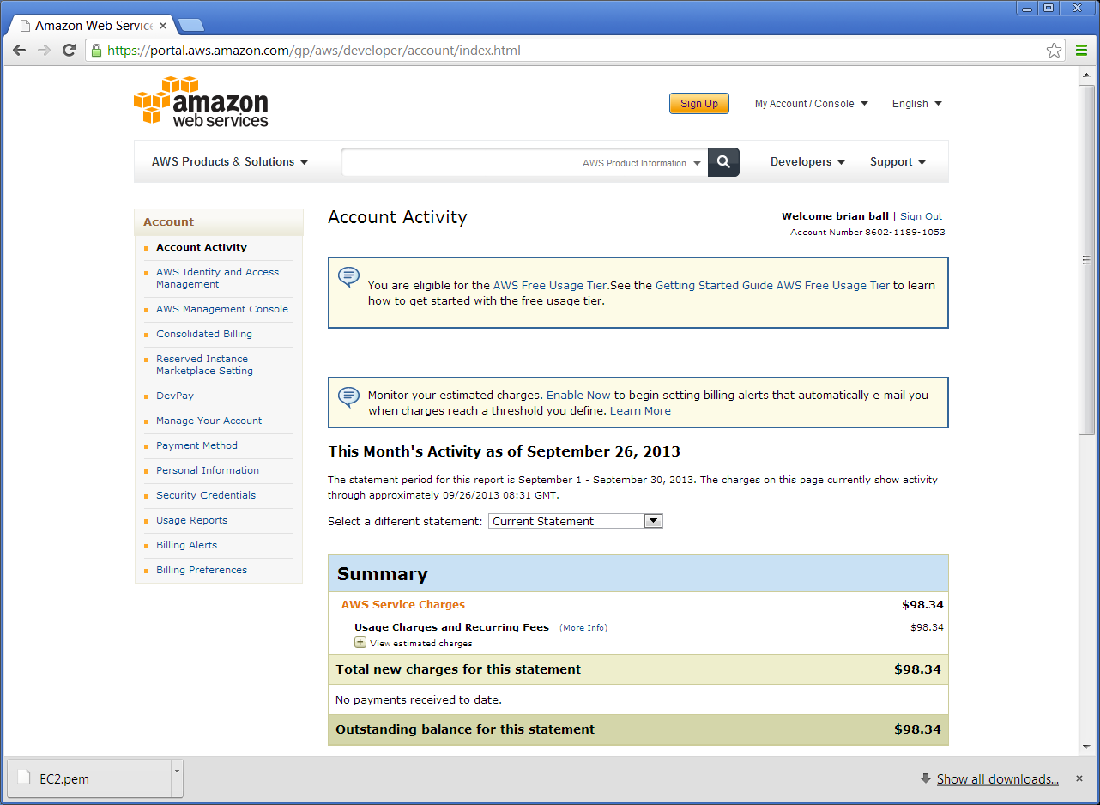

click on AWS Management Console:

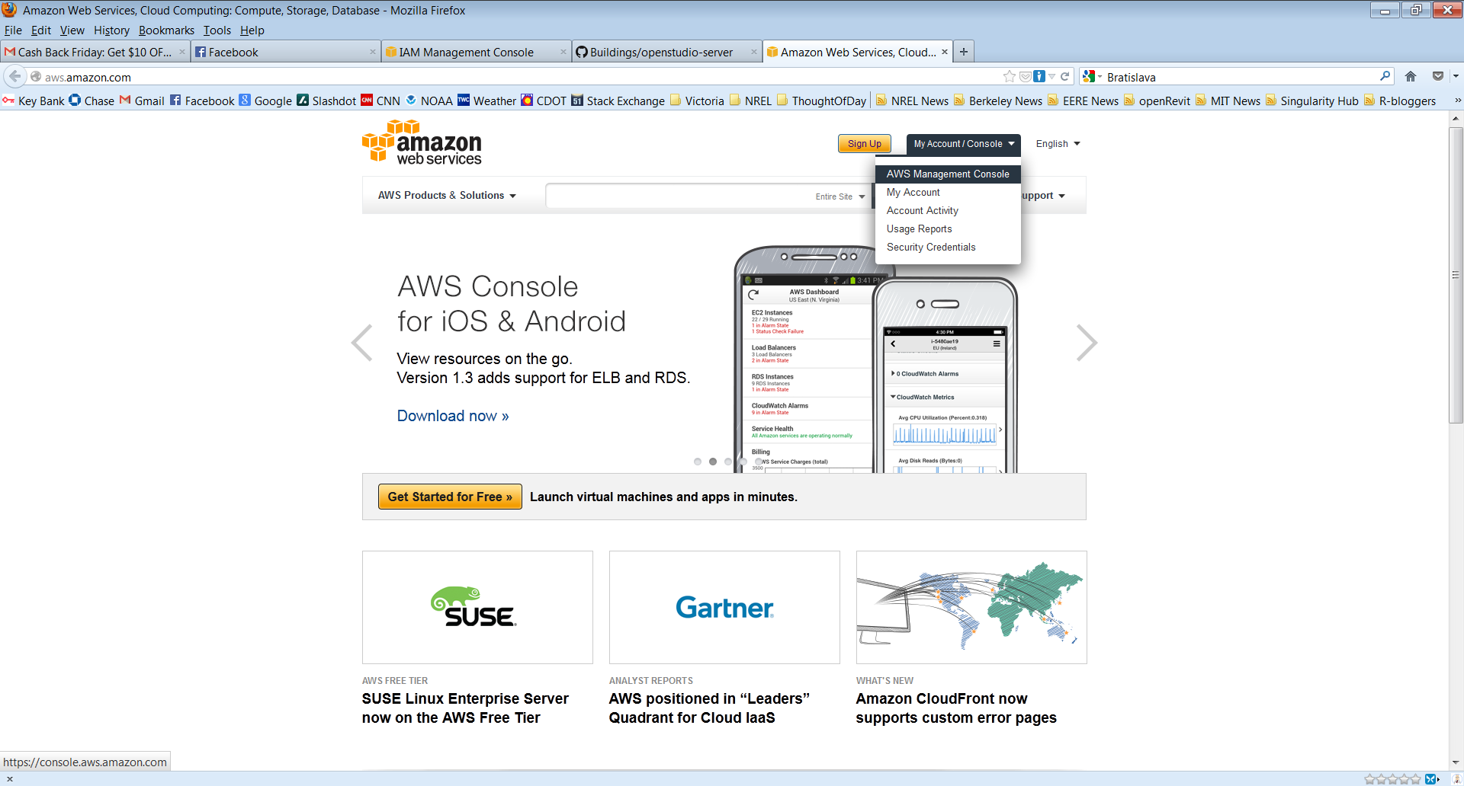

Go to Security Credentials under your account:

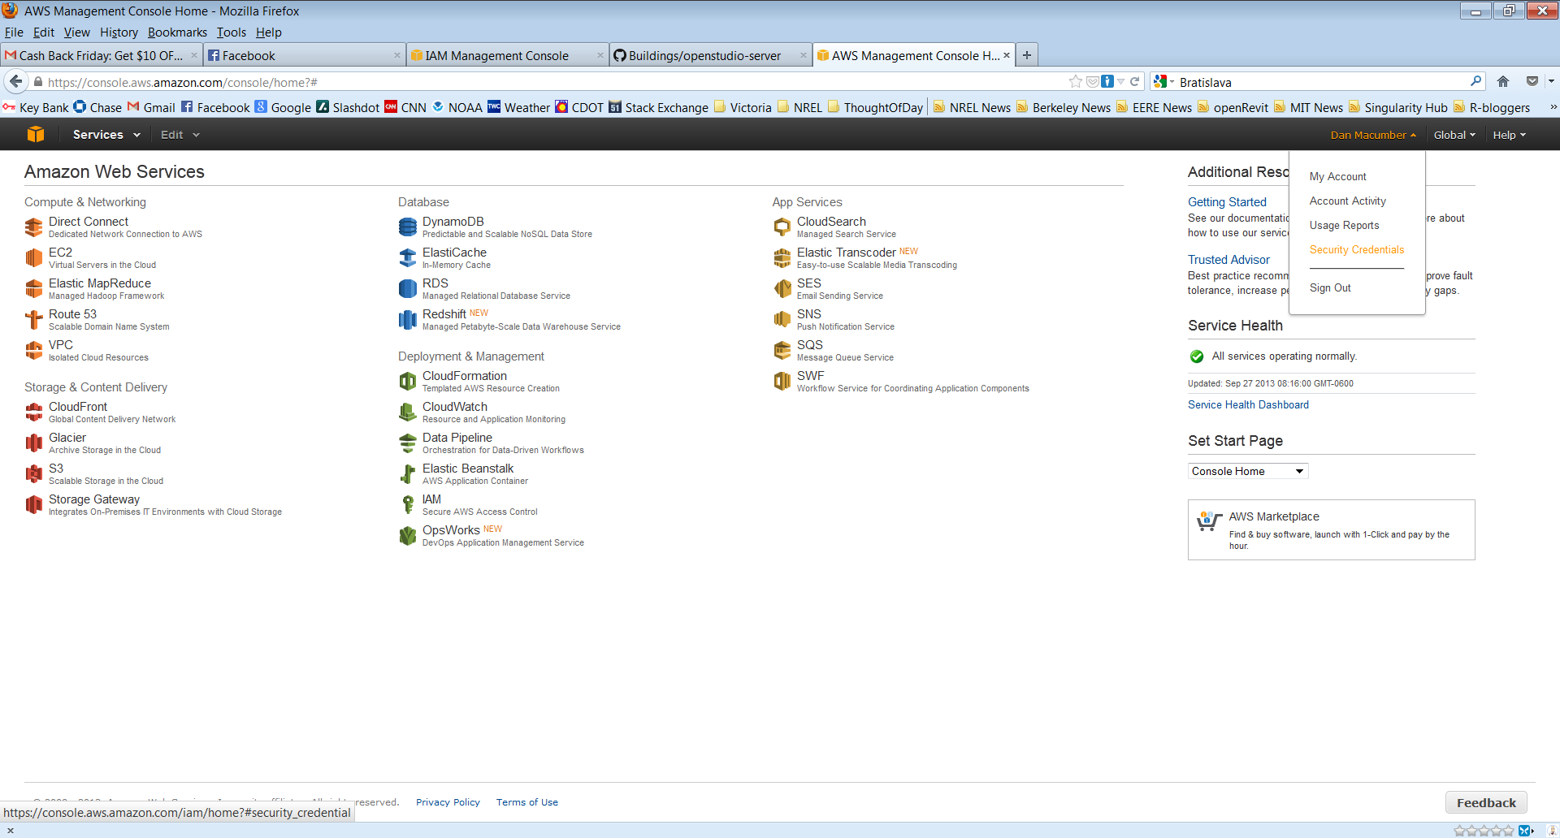

Click on Access Keys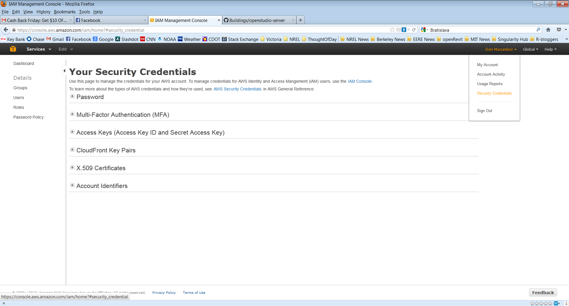

Click Create Access Key, save file:

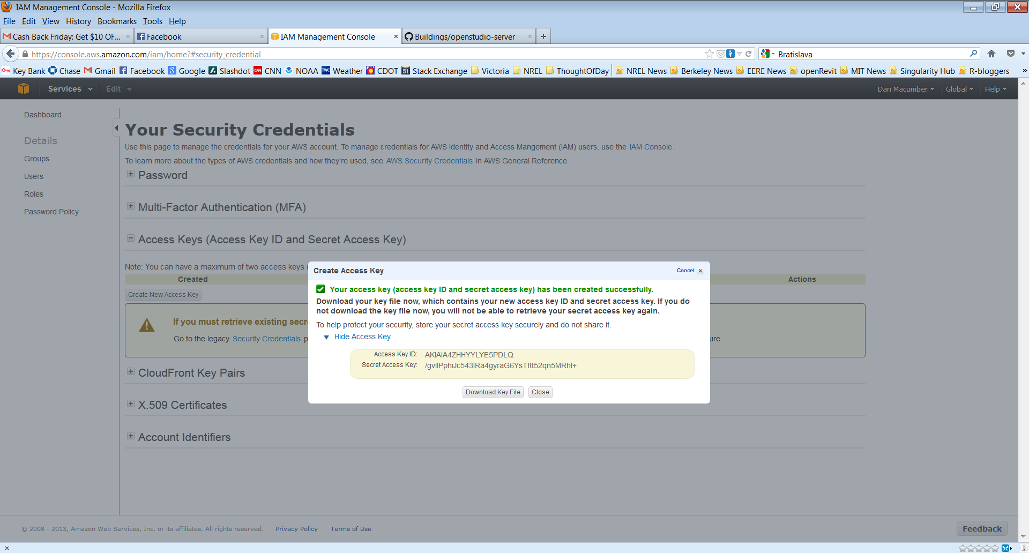

Now you have your access and secret keys: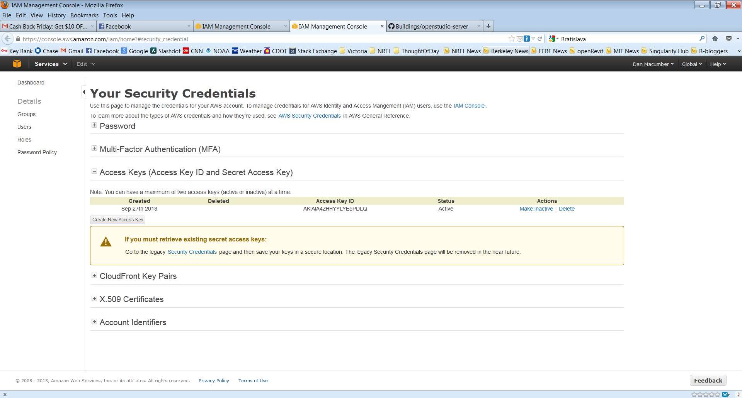

Create an .aws_secrets file in your home directory and include the following:

access_key_id: access_key

secret_access_key: secret_access_key

access_key is the value after AWSAccessKeyId in your download

secret_access_key is the value after AWSSecretKey in your download

Make sure to change your region to US N. Virginia in order to see the instances you have launched.  
