Installation Instructions for Using Radiance with OpenStudio 0.9.x

Updated: 10/18/2012

This installation workflow has been tested on Windows 7 and OS X (10.6-10.8) to work for the Radiance functionality of OpenStudio. Please note, the installation order **is** important.

### Install Ruby 1.8.7

For Windows systems, the easiest way to get this version is to download the RubyInstaller for Windows, here: <http://rubyforge.org/frs/download.php/76277/rubyinstaller-1.8.7-p370.exe> Mac OS and Linux users will likely already have Ruby installed, but if not, Ruby installers for these platforms are also available at: http://www.ruby-lang.org/en/downloads/

### Install OpenStudio (and EnergyPlus)

Download the latest [OpenStudio package](http://openstudio.nrel.gov/downloads). You will also be instructed at this step to install the correct version of EnergyPlus; follow the OpenStudio installation instructions for detail on how to do that.

### Install Radiance

[Download the latest Radiance installer package and install to the default location](https://openstudio.nrel.gov/getting-started-developer/getting-started-radiance)

### Install Perl

Radiance requires Perl for full functionality. For Windows systems, [ActivePerl](http://www.activestate.com/activeperl) is recommended, but [Strawberry Perl](http://strawberryperl.com) has been tested and works on some Windows systems. Mac OS and Linux users will likely already have Perl installed, but if not, Perl installation methods for these platforms are also available at: <http://www.perl.org/get.html>

# Installation Notes for Radiance

## Windows XP

Ideally you should be logged in with Administrator rights; in this case, the installer will install Radiance to C:\Program Files\Radiance [version]\. If you do not have Admin rights (not recommended), the installer will install Radiance to the "My Documents" directory in your user directory.

## OS X

The MacOS install .dmg will copy the Radiance manpages (documentation) to /usr/local/radiance/man for you; simply add that directory to your MANPATH environment variable, and you will have command line access to the latest Radiance documentation as well.

## All Users – Setting your environment variables

Regardless of which installation option you choose, you need to add the Radiance bin directory to your search path, add the RAYPATH environment variable to your system, and set it to the lib directory.

On Windows, simply right-click on the “My Computer” icon, click on the “Advanced” tab, then click the “Environment Variables” button. There you will see your current path. Click “edit” to add “C:\[your path to]\radiance\bin” to the path (assuming you chose the default install location), then click “new” to add the RAYPATH environment variable, and set that to “C:\Program Files\[your path to]\radiance\lib”. The following graphic shows the Radiance environment variables being added to a Windows system.

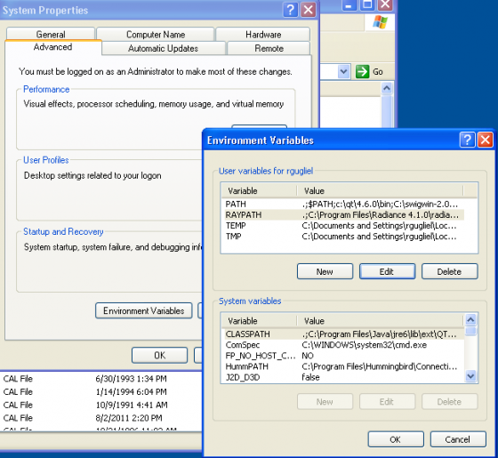

On MacOS and Linux, add these lines to your .profile or .bashrc (assuming you are using the Bash shell) file:

*PATH=.:/usr/local/radiance/bin:$PATH*

*RAYPATH=.:/usr/local/radiance/lib:$RAYPATH*

*Export PATH RAYPATH*