Advances in CSP Simulation Technology in the System Advisor Model
Aron P. Dobos,¹ Ty W. Neises,² and Michael J. Wagner³
¹ Engineer, MSEE, Strategic Energy Analysis Center, National Renewable Energy Laboratory, 15031 Denver West Parkway, Golden, CO, 80401. 303.384.7422
² Engineer, MSME, Thermal Systems Group, National Renewable Energy Laboratory
³ Engineer, MSME, Thermal Systems Group, National Renewable Energy Laboratory
Corresponding Author: aron.dobos@nrel.gov
The System Advisor Model (SAM) is modeling software developed by the National Renewable Energy Laboratory (NREL) that for renewable generators that combines annual timeseries power production models with financial analysis to estimate the levelized cost of electricity (LCOE) and other metrics. The tool enables detailed simulation of concentrating solar thermal power plants including: parabolic troughs, molten salt power towers, direct steam power towers, and direct steam linear Fresnel. These systems models for CSP plants are based primarily on first-principles analysis thermodynamic and heat and mass transfer models of plant components, and consequently require robust numerical solution techniques to solve the interdependent equations describing the system.
To date, the SAM tool has utilized the general purpose commercial TRNSYS transient systems modeling software package for CSP simulation. To achieve: (1) significantly higher model performance, (2) easy parallelization of concurrent simulations to take advantage of modern multi-core processor desktop computers, and (3) to allow straightforward modification of CSP component models without requiring TRNSYS, the SAM CSP team has undertaken to reformulate the CSP models into a new in-house designed transient simulation framework written in C++. The new simulation engine, TCS, is cross-platform (Win32/x64, Linux, OSX), reentrant and thread-safe, and depends only on the standard C++ library. This paper seeks to demonstrate the accuracy, high performance, and utility of the new TCS-based CSP systems models for large scale CSP plant analysis.
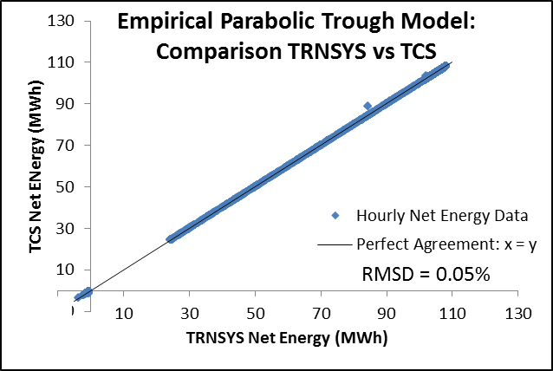
Preliminary results show excellent matching with the accepted TRNSYS-based models. As shown in Figure 1, the hourly net energy for the empirical parabolic trough model as calculated by TRNSYS and TCS matches with a root-mean-square deviation (RMSD) of 0.05%, but . However, the TCS simulation engine runs in 0.159 seconds, while the TRNSYS simulation takes 2.556 seconds. For the physical parabolic trough model based on first-principles, the TCS model runs in 10.8 seconds, compared with 15.4 seconds in TRNSYS, yielding a 30% improvement. These results are preliminary, and we expect additional simulation performance improvements as the numerical techniques are improved in the custom TCS engine. Significant improvements in CSP model simulation performance enable larger scale plant configuration analysis, as well as grid-integration studies that require many thousands of simulations.
Figure 1. Empirical trough model comparison

