**What is Trac?**

Trac is a web-based project management tool that allows you to do things like report software bugs, track user enhancement requests, track business development, and broadly plan for specific milestones. By reporting this information in one place, a coherent sense of the project roadmap and progress can be determined. It makes it very clear what progress has been made and which issues remain. As an example, here is a list of the active tickets in the SAMnt trac.

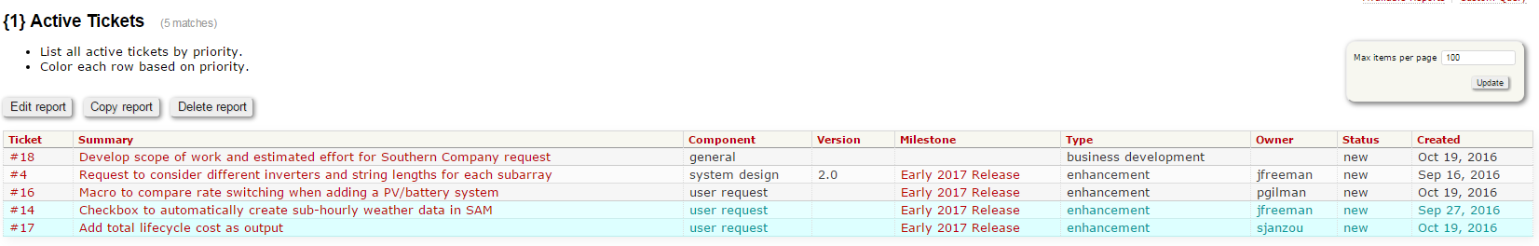

**Where is Trac?**

There are Trac’s for each of the 4 core SAM repositories:

SAMnt:

<https://efmsvn2.nrel.gov/SAMnt/trac/>

ssc:

<https://efmsvn2.nrel.gov/ssc/trac>

wex:

<https://efmsvn2.nrel.gov/wex/trac>

lk:

<https://efmsvn2.nrel.gov/lk/trac>

**How should I use Trac?**

You should enter enhancement requests, bugs, and business development opportunities. As a default, the SAMnt trac should be used for high-level project planning activities (business development for example). Otherwise, you should use the appropriate trac. For instance, a bug in lk should be listed in the lk trac. All of these activities are entered in a standard ticket, seen below. Please fill out as much information on the form as possible, giving a summary and description of the activity, whether it is a defect, enhancement, or business development opportunity. You can prioritize the activity, and assign a component that the ticket belongs in. If you know who should take responsibility for resolving the task, please fill that out as well.

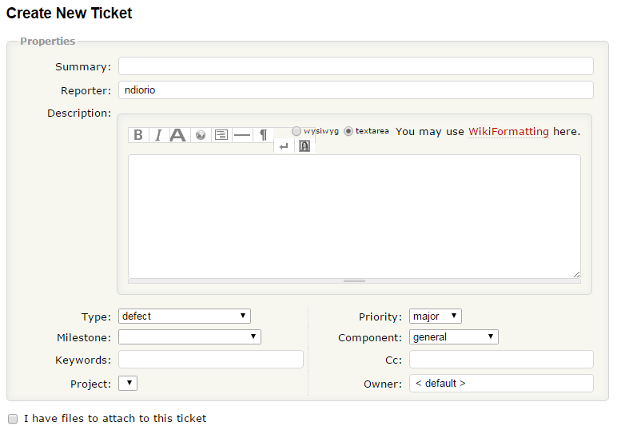

**Limitations**

There are a few minor issues I am trying to resolve.

* You cannot copy and paste text into the body of a ticket and successfully create the ticket. Please type the body for the time being.
* You cannot view tickets across all 4 svn’s in one place. Working to resolve.
* You cannot close tickets or associate svn commits to tickets (to my knowledge). This is an advanced, but powerful feature that allows you to directly link something you commit in the SVN to a Trac ticket.

**What I need from you**

* Can you login to the Trac versions that are relevant to you?
* Please gather a list of current defects and enhancements that you know about. Login to the appropriate Trac and enter them. As the status of enhancements and bugs change, or if you get more information, update the ticket with a comment.
* As you enter tickets, and come across limitations, please let me know. For instance, you may wish to add additional options to the:
  + Type
  + Milestone
  + Component
* What’s missing? Are there other things you want to Trac? I can also envision using this as a place to store user feedback for instance.

**Where we go from here:**

* The Trac will serve as an ongoing agenda item. I.e, what bugs are the Trac and what progress has been made? What is the plan of attack to resolve the issues?
* The Trac will serve as a project planning tool when targeting features for a specific release
* The Trac will serve as evidence to our sponsors that we have an active and well organized product that utilizes modern software engineering methodologies.