**Date: February 12, 2015**

**Company: Sunverge**

**Participants: Nick, Paul, Jon Fortune (Sunverge), Stina Brock (Sunverge)**

Paul and I spoke with Jon Fortune and Stina Brock from SunVerge to discuss their model needs and get ideas on some use cases.  They provided a wealth of information, though they believe their setup is quite different from others and would require considerable customization to model directly with SAM.  Specifically, their feedback:

* They use hybrid inverters, such that the battery is dc attached.  Power from the battery and the panel then are inverted.
* They are interested in load profiling analytics to ballpark load impact estimates.
* Need higher resolution than 1 hour, perhaps 15 minutes
* They are interested in tools that can reflect quality of performance, such as cycle life, the depth of discharge, accurately reflecting degradation & when the battery needs to be replaced.
* From an economic perspective, they are interested in defining how the system operates in order to obtain specific tax credits.
* LCOE for a battery – they expressed interest in this metric
* Battery responsiveness to charge/discharge (ramp rate).

Finally, they were interested in following up with a detailed (2 hour) meeting to walk us through their system.  But, Paul and I determined it may be best not to do this for now, as it may not be relevant to what we need to accomplish.

**Date: March 24, 2015**

**Company: tenK**

**Participants: Paul, Larry Weiss**

Here are some of the features that would be useful to us:

1)      the ability to add energy storage to the DC side of the system as shown in the illustration below,

2)      the ability to actively limit output on the AC side to control the storage (much like what SAM has today with DC:AC ratio, but adjustable by hour vs. a fixed value over the year),

3)      an accumulation parameter for how much energy is in the storage at any time, and

4)      parameters to account for efficiency loss in the battery.

We do not need (at least for now as we can model it with the existing SAM program) the ability to model parallel inversion or the charge controllers in the modules.  As an FYI - the system below operates by:  1) with no storage – the inversion units set the bus voltage by controlling how much current they pull from the bus, the modules produce maximum power.  If the inverters saturate, the system voltage rises slightly and the modules then take control and limit the voltage.  2) With storage – the inversion units have a voltage setpoint at the minimum battery voltage, and the battery pins the voltage during operation (the modules will limit power if the voltage rises above a set value).  The inverters will export at a maximum level if allowed during operation, thus by limiting the AC output full control of the system is possible.

The graph below is an example of what we are working to model in SAM, currently using the 8760 output followed by computations in Excel.  The graph is an illustration of the average daily system output over the summer for an array with a DC:AC ratio of 2.5, and no active control over the AC output.  In this case – excess energy flows into the battery (when the AC output is limited) and then flows to the grid in the later hours after the PV power level drops below the output limit.  There is also sub-hour stabilizing effects going on since passing cloud cover fluctuations are also buffered by the battery without the need for a control algorithm.

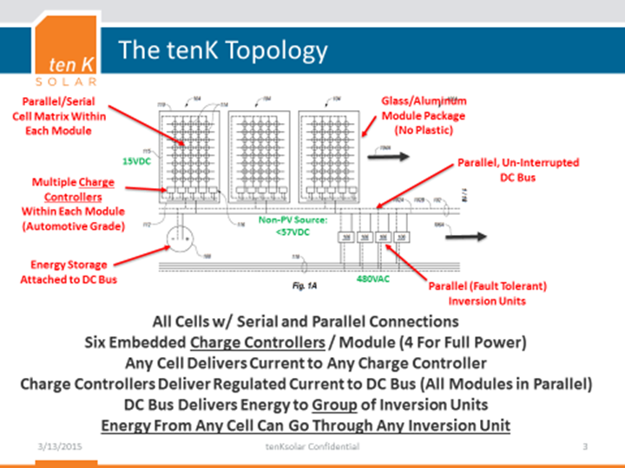

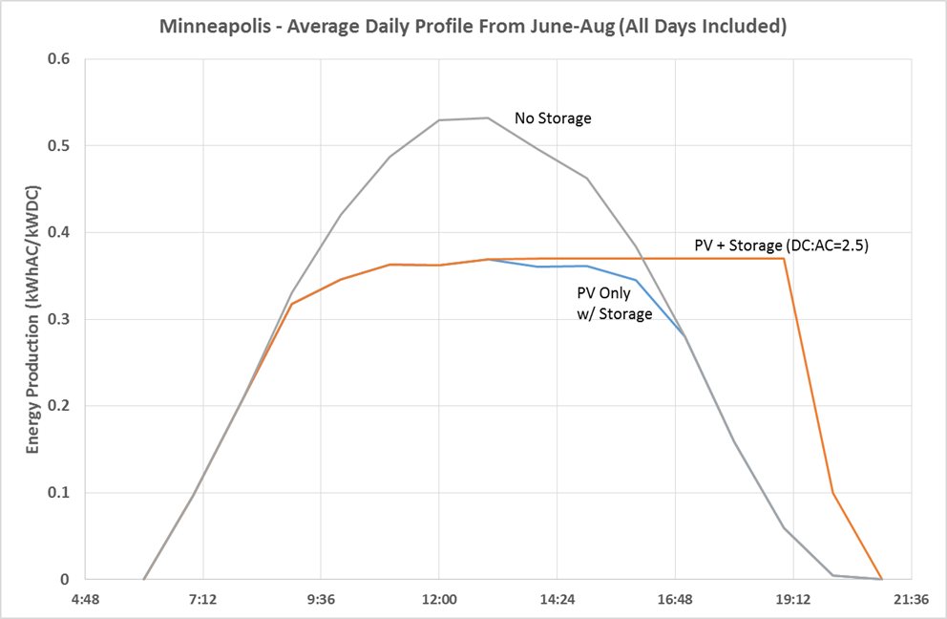

**Date: March 31, 2105**

**Company: Black and Veatch**

**Participants: Paul, Nathan Clark (email)**

1. Data Describing Energy Storage System:
2. System Design:
   * 1. Losses:
     2. Transformer
     3. Charge/Discharge
     4. Degradation Curve (% degradation versus cycles)
   1. Incentives:
      1. % of Capital Cost Limits for all types of incentives
      2. Generic Annual Award Amount Schedule ($/yr)
   2. Different battery chemistries to look up parameters above (i.e. Lithium Ion, Vandium Redox)
3. Optimization Algorithms (optimums change depending on the economic metric of interest):
   1. Daily Cycling leveling peak loads throughout the day. Some incentives require daily cycling anyways to qualify see SGIP from SDG&E.
   2. Monthly cycling leveling peak loads throughout the month.
   3. Energy Arbitrage.
   4. Peak not to exceed.
   5. Generally the capacity of storage systems are economically optimal about their power rating rather than their energy rating.
4. Results:
   1. Time series graphs showing at least:
      1. Energy charge/discharge (kWh)
      2. State of Charge (%)
      3. Building Load (kWh)
      4. Building Load Net of Solar (kWh)
      5. Building Load Net of Solar and Energy Storage (kWh)
   2. Statistics:
      1. Sum of Annual Cycles on Energy Storage
   3. Cashflow:
      1. Annual Energy Value of Battery Storage (Total Demand Savings and Energy Arbitrage?)
   4. Summary:
      1. Energy Capacity (kWh)
      2. Power Capacity (kW)

**Date: March 26, 2015**

**Company: Strategen Consulting**

**Participants: Nick, Paul, Strategen: Amanda Coggins, Chris Edgette, Shana Patadia**

* They believe some of the most important benefits of storage are those which are not always effectively captured in generic demand charge reduction dispatch scenarios.  For instance, a two-hour capacity battery at some load is more valuable over a six-hour high demand charge period by shaving peaks, not fully discharging in the first two hours.
* Other benefits of storage, which include frequency regulation and reducing ramping are worth considering.
* Storage has the benefit of no start-up cost or minimum run requirements, as opposed to power-generation facilities.
* The company has done work for the California Energy Storage Alliance and is interested in good free public tools advising people in renewable deployment.
* They believe a dispatch model which doesn’t capture scenarios beyond simplistic demand charge reductions may do more bad than good, as it may suggest that storage is not as high a value as it truly is.
* *Warning that model will be misleading if it doesn't show value of storage for peak shaving (requires knowledge of subhourly behavior of PV system and load along with demand charge utility rate data).*
* They've worked with DOE/Sandia on public models for storage optimization.
* A company called Integral Analytics has smart engineers who work on storage optimization and would be good for us to work with.
* Utilities (in California?) have an interest in storage applications for distribution ancillary services (frequency control, peak demand management). PV System owners may use storage to minimize demand charges during peak periods, and then sell other services to the utility during other periods.
* They are willing to work with us informally to provide input and review software versions, but are also interested in more formal collaboration.

**Email feedback summary, April 1, 2015**

|  |  |  |  |
| --- | --- | --- | --- |
| Name | Organization | Email | Comment |
| Lane Garrett | ULG Energy Solutions (Arizona) | lane.ulg@gmail.com | Yes. Will use. Need battery chemistry and technology. Cycle life vs depth of cycle. Self discharge rates. Internal resistance. Operatime temperature range. If a battery management system is used, details on design and reliability. Temperature effects and compensation needed. Expected lifetime to 80% and 50% capacity. Approximate cost per kWh of capacity. Maximum recomended DOD. |
| Roger Shane | Cellennium (Thailand) Co. Ltd. | rogerinbangkok@gmail.com | Vanadium redox flow battery manufacturer. Would like to participate in SAM model development. |
| Lisa Laugner | Go Electric Inc | Lisa@goelectricinc.com | Include economic benefits of PV battery system tied to grid including demand response income. Utility demand charge reductions from peak shaving. Lower energy costs from energy shifting. Lower power factor fees/fines from power factor correction. |
| Nathan Clark | Black and Veatch | ClarkND@bv.com | Working on compiling a list of typical data inputs that we use to describe an energy storage system to model as well as results we would like to see. Will send by end of week. |
| Austin Arensberg | Samsung Electronics (Korea) | a.arensberg@samsung.com | Is there any way you can share a draft version of the model before you add it to your site? Residential and commercial systems would be great. I am currently developing models for the Japanese market but any structures from other markets are very useful to our work. I can talk by phone if that would be helpful. |
| Jo | ?? (South Africa) | jodean@ewcsa.co.za | The age old question of non grid connected and related tools for calculating load vs supply and demand. |
| Peter Hans Hirschboeck | Houlihan Lokey | PHirschboeck@HL.com | I've been doing very high level analysis with sensitivities on price on $/kWh energy storage capacity. Nothing concrete on cost or module type. Mostly commercial but some residential as well. Nothing utility-scale at the moment. |

**Summary of feedback solicited, November 2014**

People

* Bilal Maarouf, Khatib & Alami (Multinational)
* Mark Siira, ComRent Load Bank Solutions (Canada)
* Omar Ramirez, Sun Capital Solar
* Sanjay Srivastava, VP DD Group (India)

Comments

* Want to model battery storage with Li-on technology
* Model storage with SGIP rebate and clarification of the qualification of the rebate
* I am working on a general model for energy storage based on grid location...have enhanced the location descriptions from those put in Sandia’s ES Select.
* ....our system simulation will include the operation during day (grid+PV generation) and during the night (PV storage usage).
* ... if I’m generating with my peak capacity yet more power is needed, will I be able to take from the grid simultaneously? If so, how will the overall generation/consumption of my PV system look like throughout the year?
* Users might want to realize the differences in O&M costs due to different selections of battery types. In my opinion, the model should also differentiate between storing the batteries outdoors or indoor. Also between air conditioned cooled, fan cooled or naturally cooled.
* I also suggest implementing scheduling of battery operation. For instance, I want to store energy for 2 hours during the day (while let’s say consuming from the grid) and then consume energy from my batteries in my following sun hours. The reason to such settings might because I might have an electricity market in the country where electric tariff changes during the day, and thus consume energy from my PV battery when tariff is the highest.
* Additionally, I think the PV storage should have a “thresholding” setting; whereby I allow my batteries to supply energy until 25% mAh only, for example. This is a setting that ensures safe operation of my batteries to not drop below a safe capacity margin.
* Finally, I believe the new model should include “suggested sizing” wizard; whereby a user can select a battery capacity based on different suggested operations/system assembly. This sizing wizard should differentiate between residential, commercial, and utility battery sizing. As there could be different safety/operation standards between the three.
* ... have batteries as part of the forecasting model both for electricity and financials.
* The new upcoming battery storage model must have battery back calculation for number of hours & days and the system must support most types of batteries & voltages