# **Working with WaterTAP3 using Jupyter and Conda**

1. **Install Anaconda**

Follow the instructions here: <https://docs.anaconda.com/anaconda/install/>

If successful, Python, pip and Jupyter Notebooks are automatically installed

1. **Open Anaconda Prompt, use cd to navigate to your directory (type “cd” then folder name)**

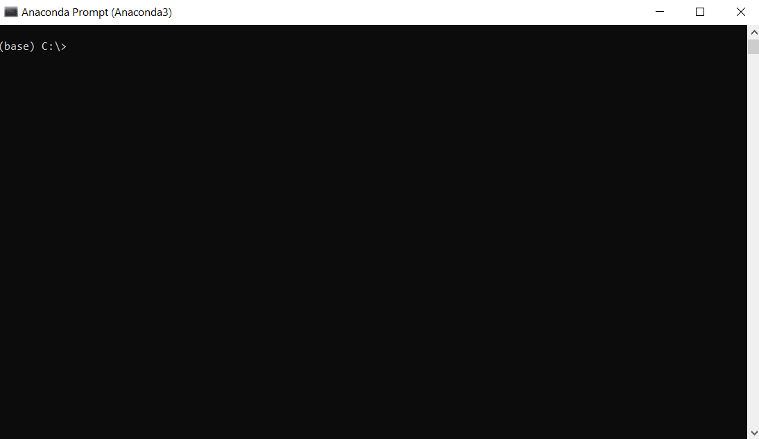

Base is the default environment that we are working on

1. **Clone watertap3 repository to local machine using Git**

To install Git

$ pip install git

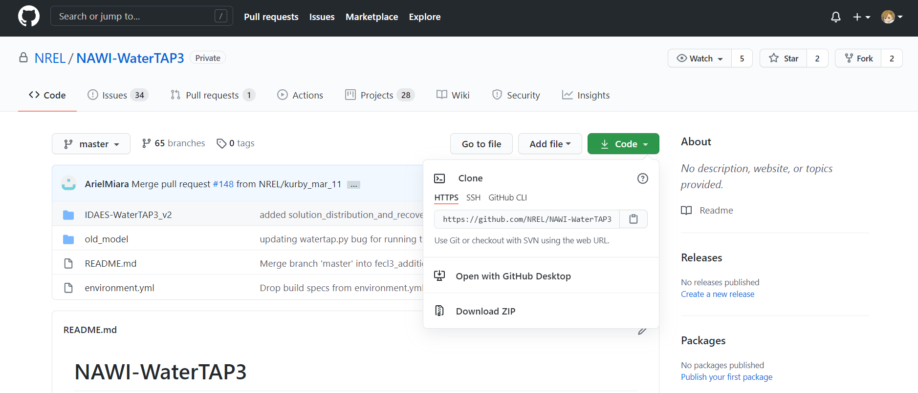

Then clone this remote repository to local machine using Git

$ git clone https://github.com/NREL/NAWI-WaterTAP3.git

If successful, there will be a folder called NAWI-WaterTAP3 in your directory

1. **Create an WaterTAP3 environment from the given file environment.yml**

$ conda env create --file environment.yml

If successful, there will be a new environment called watertap3 when you type

$ conda env list

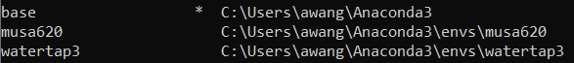

Environments must first be activated before packages are available to use

$ conda activate watertap3

If the development team update the environment.yml in the future (do not do this step)

$ conda env update --file environment.yml

To delete this environment (do not do this step)

$ conda remove --name watertap3 --all

1. **Open Jupyter Notebook dashboard**

$ jupyter notebook

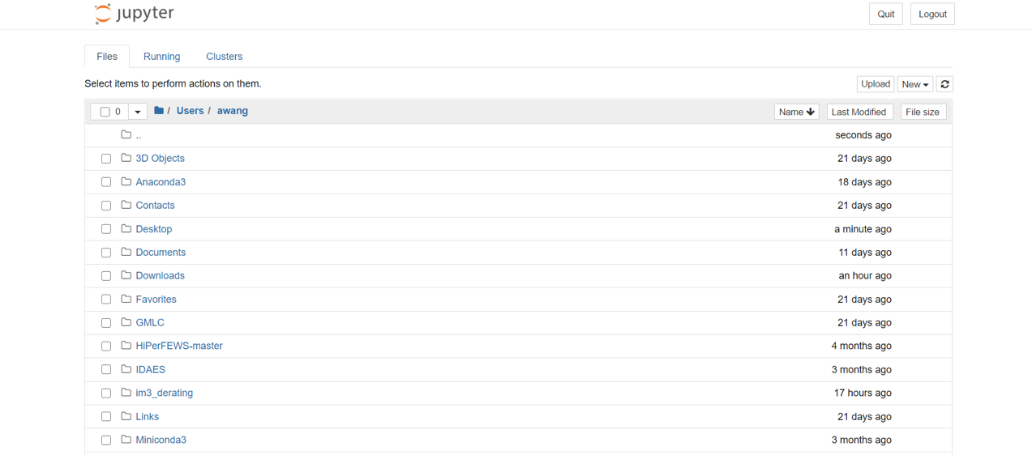

1. **Open the desired .ipynb notebook and execute cells**

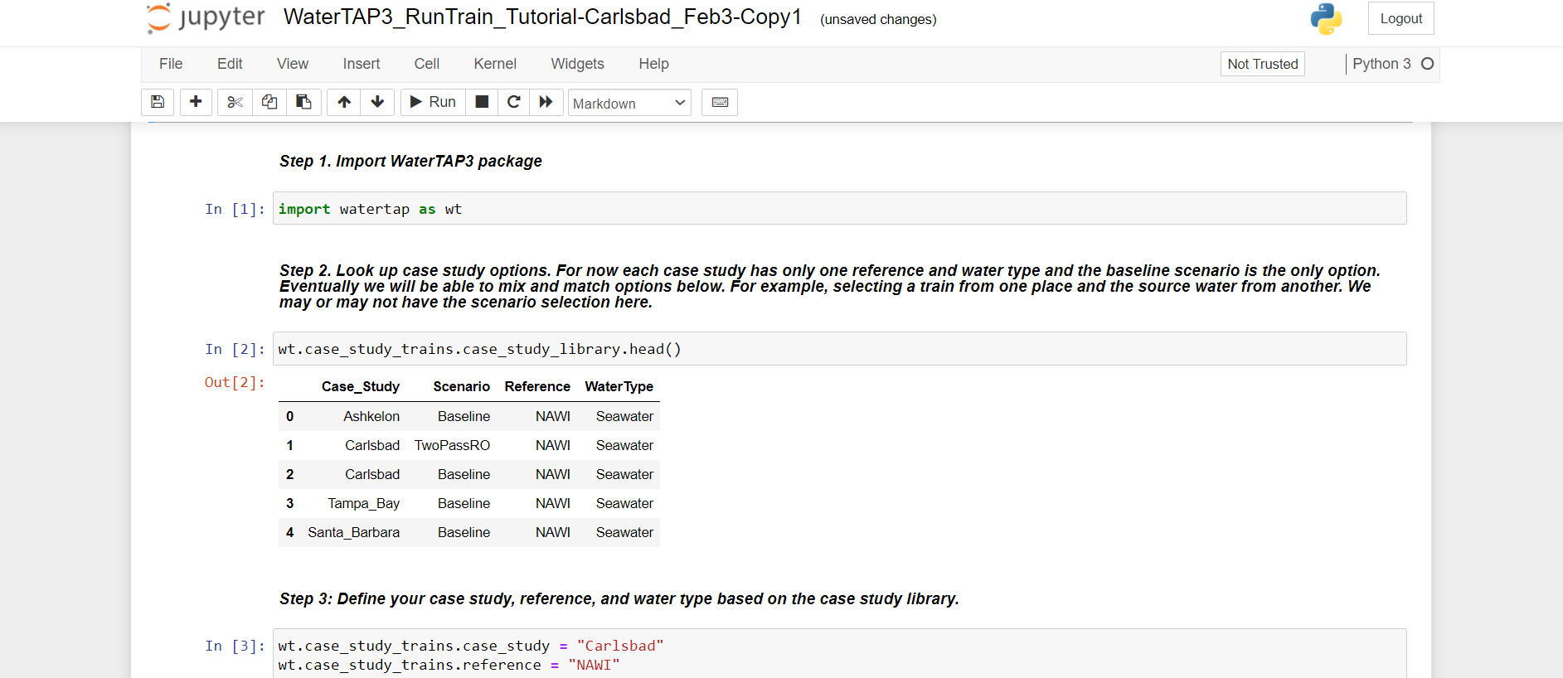

**Useful Links**

1. Anaconda: <https://docs.anaconda.com/anaconda/>
2. Jupyter Notebook: <https://jupyter-notebook.readthedocs.io/en/stable/>
3. Git: <https://education.github.com/git-cheat-sheet-education.pdf>
4. Conda Issues: <https://musa-550-fall-2020.github.io/guides/conda-issues>