**Technical Summary:**

**Development of dWind Customer Locations and Allowable Turbine Height Ranges**

Michael Gleason – GIS Scientist

National Renewable Energy Laboratory

5/1/15

**Introduction**

The dWind Model evaluates the economic value of distributed wind systems at potential customer locations within each county of the contiguous United States. Customer locations in the model are represented using a fine-resolution, national geospatial grid, derived by the dWind team through a first-of-kind analysis. This grid indicates which grid cells are likely to be used by each of the three customer sectors (residential, commercial, and industrial). Each square grid cell is 200 m by 200 m in size, which is a sufficiently high degree of spatial resolution to attribute each location with local characteristics critical to evaluating the local economics of distributed wind.

One of most important characteristics attributed to each customer location is a set of constraints defining the allowable wind system size and turbine height that can be constructed at the site. These constraints are determined in the model using a combination of three local factors: parcel size, degree of existing development, and nearby tree canopy density and height. These local factors have been set for each customer location in the model through a GIS analysis of fine-resolution, national geospatial datasets; however, the specific assumptions relating these factors to ranges of allowable turbine heights are flexible inputs that can be adjusted by users of the dWind model.

This document provides a summary of the analysis methods used to derive the customer location grids for each sector, as well as the turbine height factors for each customer location.

**Customer Locations**

Figure 1 provides an overview of the analysis process used to identify customer locations for each of the three customer sectors. Customer locations for the residential sector were developed primarily using an analysis of the LandScan™ USA geospatial grids, which provide a fine-resolution estimate of daytime and nighttime population (ORNL 2011). These population grids were overlaid and combined to determine the ratio of nighttime to daytime population. Under the assumption that residential areas tend to be more heavily populated in the evening and night (when most people are home) than during the day (when many people are at work or school), grid cells with a nighttime to daytime ratio exceeding a value of one were classified as residential. To refine the resulting grid, a second analysis was conducted to remove grid cells coinciding with known locations of non-residential facilities with high nighttime populations, including prisons, hotels, motels, college campuses, and industrial complexes (HSIP Gold 2012). For the commercial and industrial sectors, the customer location grids were derived using a dataset of known business facility locations. These locations were separated into commercial and industrial groups based on two digit codes from the North American Industry Classification System (NAICS), then each point location was expanded by a 90 m radius, and the resulting areas were overlaid on the grid to identify grid cells occupied by facilities of each sector. Based on a qualitative evaluation against select city and county zoning maps, the customer locations were determined to be of sufficient fidelity for use in the dWind model. Figure 2 illustrates an example of the qualitative validation performed on the customer locations; specifically, it shows dWind residential customer locations overlaid on areas zoned for residential use by the City of Boulder, Colorado.

**Figure 1.** Graphical workflow illustrating the analysis used to develop customer locations for the dWind model.

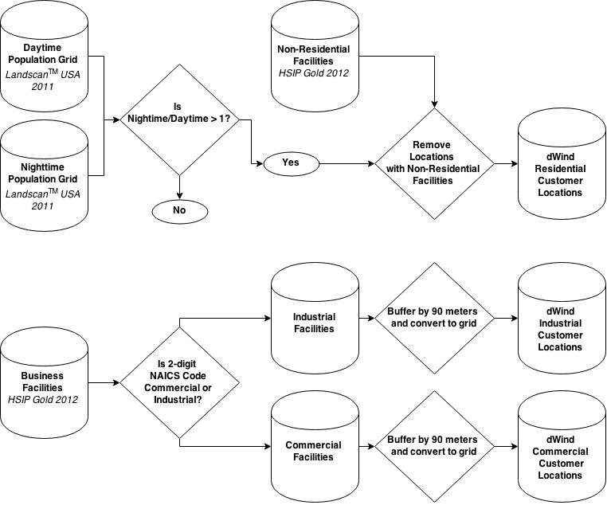

**Figure 2.** A comparison of the derived dWind residential customer locations to land that is legally zoned for residential use in the City of Boulder, CO.

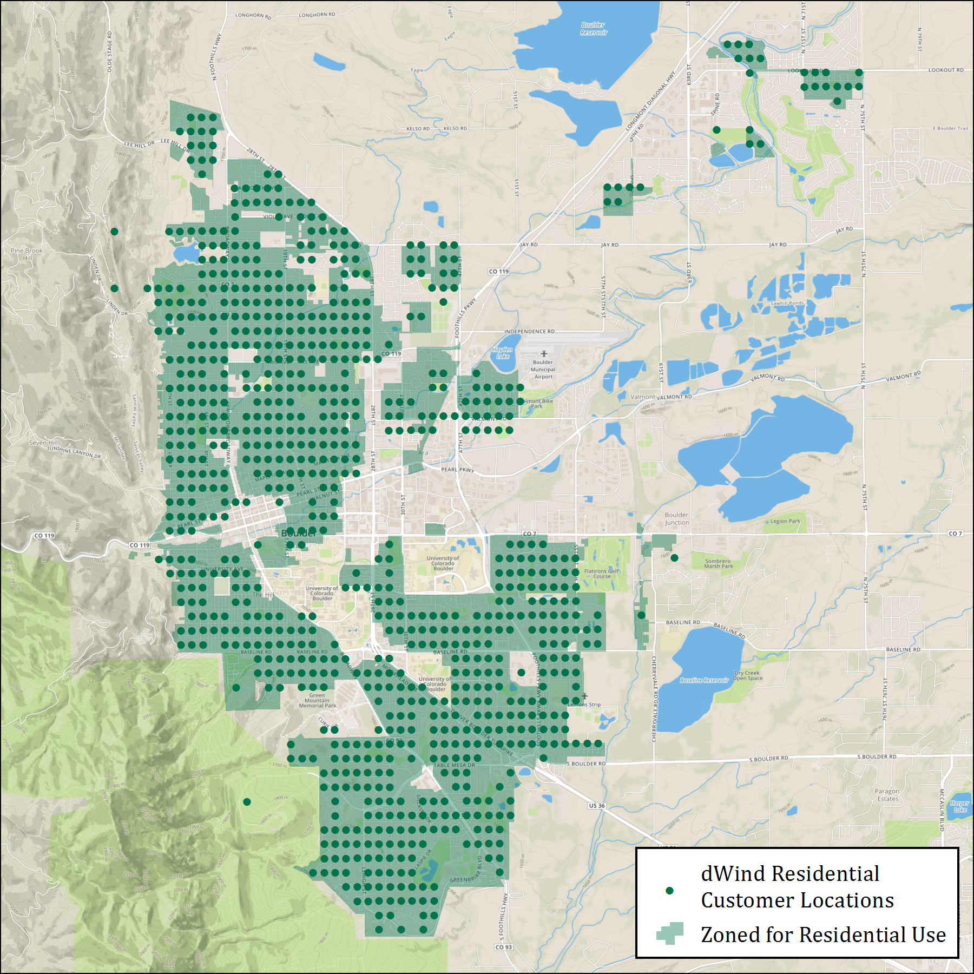

**Turbine Height Criteria**

For each customer location, the dWind model determines the range of feasible turbine heights that can be constructed. This turbine height range is based on three local factors: the average residential parcel size, the amount of existing highly developed land, and the amount and height of existing tree canopy. Together, these three factors are used to provide a nationwide approximation of the legal (i.e., zoning, safety) and operational constraints affecting distributed wind development. Figure 3 provides an overview of the processes used to analyze each factor and how they are combined to determine the range of allowable turbine heights at each site; each process is also described in detail in the text that follows.

**Figure 3.** Graphical workflow illustrating the analysis used to develop and combine each of the factors that affects the range of developed turbine hub heights at each customer location.

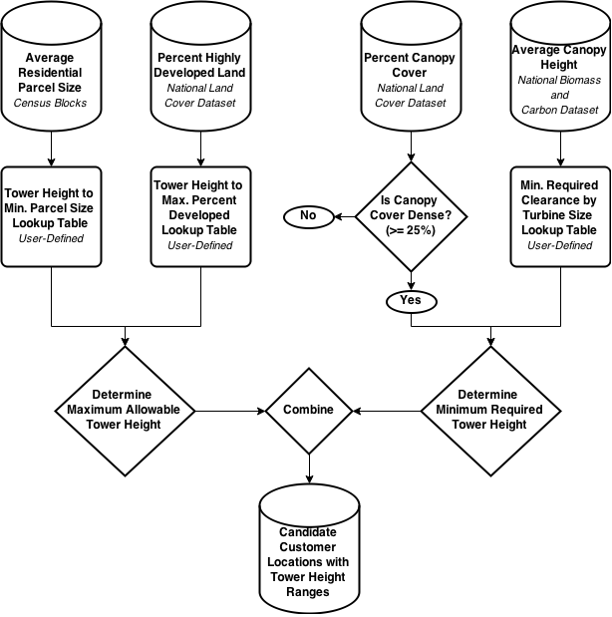

The average residential parcel size was selected as an important constraint because, during discussions between NREL and representatives from DWEA, parcel size was highlighted as an important first order indicator for the feasibility of installing different height turbines. Nationwide parcel datasets are not freely available; therefore, as an alternative, the dWind model uses estimates of acres per housing unitderived from the Census 2010 at the block-level. Blocks are the smallest available geographic region for Census data. Commonly, they correspond to city blocks – small areas bounded by streets on all sides; however, in rural areas, they tend to be slightly larger and may be bounded by other physical, manmade, or cultural features (e.g., railroads, streams, etc.) (U.S. Bureau of the Census 1994). Due to their fine spatial resolution, blocks allow for capturing sufficient spatial heterogeneity to differentiate patterns in parcel size between customer locations. In the dWind model, the maximum allowable turbine height allowed at each customer location is constrained by the average residential parcel size for the intersecting block, and a user-defined table that defines minimum required parcel size for each of the turbine hub heights evaluated in the model (see Table 1). The current default values shown in Table 1 are based on preliminary feedback from DWEA representatives.

**Table 1.** User input table defining minimum parcel size required for each turbine hub height, populated with current default values.

|  |  |
| --- | --- |
| **Turbine Hub Height (m)** | **Minimum Parcel Size (acres)** |
| **20 m** | 0.50 |
| **30 m** | 1.00 |
| **40 m** | 2.00 |
| **50 m** | 3.00 |
| **80 m** | 4.00 |

Because the Census block data only account for residential development, a secondary dataset was used to assign an overall degree of all developed land to each customer location. This data was derived from the fine-resolution (30 m by 30 m) National Land Cover Dataset 2011 (NLCD) (Jin et al. 2013), which includes a “High Intensity” land class. This land class is defined by MRLC (2014) as follows:

“Highly developed areas where people reside or work in high numbers. Examples include apartment complexes, row houses and commercial/industrial. Impervious surfaces account for 80% to 100% of the total cover.”

Given the intensity of development associated with this land class, the dWind model assumes that portions of customer sites that it occupies cannot be developed for wind. The percent of each 200 m by 200 m customer location covered by this land class was derived from the finer resolution NLCD grid. To translate the percent of highly developed land at each site to a turbine height constraint, the dWind model allows the user to define the maximum percentage of heavily developed land at a customer site for each of the turbine hub heights evaluated in the model (see Table 2). The current default values shown in Table 2 were derived by NREL analysts based on the assumption that a turbine of hub height HH requires a minimum area of undeveloped land equal to (2*HH)2 , and that the non-highly developed land within each customer location is optimally configured in a contiguous square area.

**Table 2.** User input table defining the maximum allowable percent of heavily developed land at each customer site for each turbine hub height, populated with current default values.

|  |  |
| --- | --- |
| **Turbine Hub Height (m)** | **Maximum % Heavily Developed Land** |
| **20 m** | 96% |
| **30 m** | 91% |
| **40 m** | 84% |
| **50 m** | 75% |
| **80 m** | 26% |

The third factor that contributes to the range of allowable turbine heights in the dWind model is the density and height of the tree canopy around each customer location. The density of the canopy cover was determined using a fine-resolution (30 m by 30 m) grid of percent canopy that is included as a component of the NLCD (2011) (Jin et al. 2013). Customer locations with an average canopy cover less than 25 percent are treated in the model as “low density canopy”, and are not assigned any additional turbine height requirements. This threshold was selected by NREL analysts, and can be adjusted in the dWind database, if necessary. Locations with canopy coverage above this threshold are further evaluated in the model by determining the average canopy height, which was derived from the fine-resolution (30 m by 30 m) National Biomass and Carbon Dataset (Kellndorfer et al. 2012). At locations with high canopy density, the canopy height is combined with a user-defined minimum required clearance above tree cover for each turbine size (e.g., 20 m clearance for a 10 kw turbine) (see Table 3) to constrain the range of allowable turbines. The current default values for minimum required canopy clearances shown in Table 3 were derived by NREL analysts based on a static clearance of 15 m for all turbines, plus a scalar factor of 1.1 times the approximate turbine radius.

**Table 3.** User input table defining the canopy clearance required for each turbine size (i.e., rated capacity), populated with current default values.

|  |  |  |
| --- | --- | --- |
| **Turbine Size (kW)** | **Approx. Rotor Radius (m)** | **Required Clearance (m)** |
| **2.5 kW** | **2.2** | 17.40 |
| **5 kW** | **3.1** | 18.40 |
| **10 kW** | **4.4** | 19.80 |
| **20 kW** | **6.2** | 21.80 |
| **50 kW** | **9.8** | 25.70 |
| **100 kW** | **13.8** | 30.20 |
| **250 kW** | **21.9** | 39.00 |
| **500 kW** | **30.9** | 49.00 |
| **750 kW** | **37.8** | 56.60 |
| **1000 kW** | **43.7** | 63.10 |
| **1500 kW** | **53.5** | 73.9 |

**References Cited**

Homeland Security Infrastructure Program (HSIP) (2012). “HSIP Gold 2012 Infrastructure ArcGIS 9.3 Filebase Geodatabases”.

Jin, S., Yang, L., Danielson, P., Homer, C., Fry, J., and Xian, G (2013). “A comprehensive change detection method for updating the National Land Cover Database to circa 2011”. *Remote Sensing of Environment*, 132: 159 – 175.

Kellndorfer, J., Walker, W., LaPoint, E., Bishop, J., Cormier, T., Fiske, G., Hoppus, M., Kirsch, K., and Westfall, J. (2012). “NACP Aboveground Biomass and Carbon Baseline Data (NBCD 2000), U.S.A., 2000”. Available on-line at http://daac.ornl.gov from ORNL DAAC, Oak Ridge, Tennessee, U.S.A.

Multi-Resolution Land Characteristics Consortium (MRLC) (2014). “National Land Cover Database 2011 Product Legend”. Accessed May 1, 2015: http://www.mrlc.gov/nlcd11_leg.php.

Oak Ridge National Laboratory (ORNL) (2011). “Landscan USA™ Raster Datasets (2011‑Prerelease)”.

U.S. Bureau of the Census (1994). *Geographic Areas Reference Manual*. U.S. Dept. of Commerce, Economics and Statistics Administration, Bureau of the Census. Accessed May 1, 2015: https://www.census.gov/geo/reference/garm.html.