**Technical Summary:**

**Retail Electric Rate Data in the dWind Model**

Michael Gleason – GIS Scientist

National Renewable Energy Laboratory

5/27/15

**Introduction**

To estimate the value of distributed wind systems to prospective customers, the dWind model calculates the electricity bills with and without a distributed wind system for each customer type in the model. These costs of electricity are derived from location-specific retail electric rates. Users of the dWind model are able to select from three types of retail rate structures to model: real-world tariffs based on the Utility Rate Database (OpenEI 2015), annual averages by state ($/kWh) from EIA 861 forms (EIA 2015a), and user-defined flat rates structures. This document details the data sources for each of these rate structures, as well as the method by which they are assigned to customer types in the model.

**Data Sources**

*URDB Rate Tariffs*

By default, rate structures in dWind are based on data from the Utility Rate Database (URDB) (OpenEI 2015b). The URDB is a free source for actual rate data for utilities across the US. URDB data collection is funded by the Department of Energy and performed by Illinois State University (ISU) (OpenEI 2015a). Rate data stored in the URDB provide very detailed information about various tariff parameters, including seasonal and time-of-use rates, rate tiers, demand charges, and other energy charges. The URDB contains a large number of rates, with geographic coverage of most of the US (Figure 1). It therefore provides a uniquely valuable source of freely available rate data for most the US; however, adapting it for use in the dWind model posed a number of challenges.

The largest challenge with adapting the URDB data for use in dWind was allowing for automated assignment of rates to customers types in the model. As shown in Figure 1, most utility territories include several rate tariffs. As a result, the dWind model needed a logical basis for selecting a single rate for each unique customer type in those locations. To facilitate this automated rate selection process, the dWind model uses a subset of rates from the URDB curated by NREL for this purpose. The remainder of this section details the data curation process performed by NREL to integrate URDB data into the dWind model.

In utilities with multiple rate structures, actual real-world customers are limited to certain rates based on the customer’s sector (residential, commercial, industrial, etc.) and electric usage requirements (voltage, demand levels, etc.). Given these same parameters in machine-readable form, the dWind model could also limit the rates available to simulated customers based on their various characteristics. Unfortunately, although the URDB does include parameters corresponding to many of these rules, the actual values are not defined for the majority of rates in the database. To overcome this missing information , we curated two different collections of rates from the URDB: (1) a selection of rates that were manually reviewed by NREL to determine the rate type (i.e., time-of-use, seasonal, tiered, etc.) and the range of applicable demand levels (minimum and maximum demand in kW); and (2) a selection of rates that are the only available option in their utility territory and sector.

**Figure 1.** Map showing geographic coverage of all rates in the URDB . Source: OpenEI 2014.

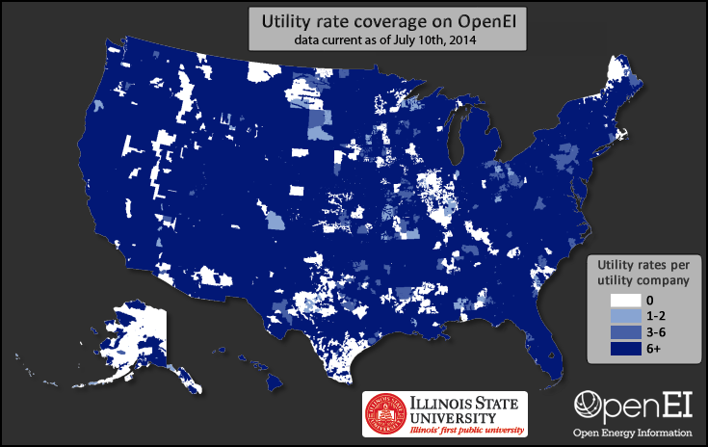

The first set of curated rates includes approximately 1,130 tariffs reviewed by NREL staff during mid-2014. These rates were selected for review because they correspond to the most populous utility companies in each state of the US; in total, they cover 242 utility companies serving approximately 75 percent of residential and commercial customers and load in the US. The second set of rates includes approximately 1240 additional tariffs covering an additional 1,050 utility territories. Each rate in this second set is the only available rate in its utility territory and sector; therefore, they tend to be associated municipal and cooperative utilities with small populations of customers. Combined, we extracted a total of 2,370 rates from the URDB for use in the dWind model. The full set of extracted rates is associated with utility territories serving approximately 80 percent of residential and commercial customers and load in the US. Figure 2 shows the geographic coverage of the two combined subsets of rates extracted from the URDB for use in the dWind model. For geographic regions lacking rate coverage, we developed a ranked backfilling methodology, as described in the next section.

**Figure 2.** Map showing geographic coverage of rates extracted from URDB for use in the dWind model.

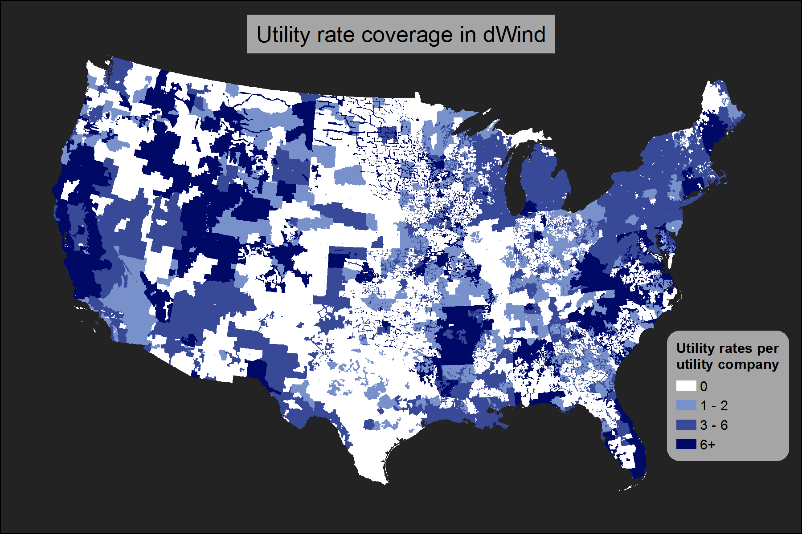

There are two important caveats to note about URDB rates used in dWind. First, due to the limitations of project schedule, staff availability, and funding, the URDB rates used in the dWind model are currently limited to residential and commercial sector rates. Industrial rates do exist in the URDB, and may be added to dWind at a later time as a model enhancement. In place of industrial rates, the current version of the model uses commercial rates to evaluate electric bills for industrial customers. The second caveat to note is that the data extracted from the URDB for the dWind model represent a snapshot of real world rate structures, as of the time they were downloaded (December 2014). Future model enhancements may include updates to the URDB rates used in the model.

*Annual Average Flat Rates*

To allow for comparison, the dWind model allows users to calculate bill savings based on the average cost of electricity ($/kWh) by state. While average rates do represent overall energy expenditures for customers, by definition they do not incorporate important nuances in distributed energy resource value proposition such as offsetting energy charges at higher tiers or reductions in demand charges. These flat rates are derived from average retail price data by sector and utility territory provided by the US Energy Information Administration (EIA) (EIA 2015b). The dWind model uses data for 2012, which represented the most recently available data at the time of model development. We mapped the rates to counties using the utility territory to county lookup table included in the EIA 861 for 2012 (EIA 2015c). For counties with multiple utility territories, we calculated a simple average rate from the overlapping utility territory rates. The resulting dataset provides annual average flat retail rates for each county in the US for 2012.

*User-Defined Flat Rates*

As a final option, users of the dWind model may also choose to provide user-defined flat retail rates. Users can specify a unique rate for each state and sector. Default values in the input table for user-defined rates are based on the state annual average flat rates from 2012, as provided by the EIA (EIA 2015a).

**Selecting a Rate for Each Customer Type**

Each customer type that is evaluated in the dWind model is assigned a single retail rate. When the model is run using either annual average or user-defined flat rates, rates are tied to regions (counties or states, respectively); therefore, one and only one rate is available for each customer location. In the case of URDB rates, the process of selecting an appropriate rate is more complex.

The first step in selecting a complex rate structure for each customer type in the model is to determine the most applicable rates for each customer location. First, the pool of potential rates for each customer is filtered to match the customer’s sector and state. As noted previously, because industrial rates were not extracted from URDB, industrial customers are matched to commercial rates.

The resulting subset of rates is then ranked from most applicable to least applicable for each customer location. In this ranking, priority is assigned in tiers. In the first tier, all rates associated with a utility territory within 50 miles of the customer location and matching the utility type (municipal, cooperative, investor-owned, or other) of the customer are ranked in order of distance from the customer location. For customers located in utility territories with rate coverage (as shown Figure 2), these criteria automatically result in prioritizing the rates from the customer’s own utility territory; meanwhile, for customer locations without rate coverage, these criteria limit the influence of location-based drivers for differences in rates, such as differing climate and utility company structure. The remaining set of rates (i.e., rates that do not meet the two criteria) comprise the second tier of rates, and are ranked purely using their proximity to the customer location. The two tiers of rate rankings are then consolidated, in order, into a single seamless set of rankings of potential rates for each customer location.

The rate rankings often include ties between rates from the same utility territory; breaking of ties is dealt with dynamically within the dWind model. During each model run, a stochastic process is used to generate a set of customer types by sampling from customer locations and annual electric loads. Each customer type is also assigned a normalized annual electric load profile. Using this profile and the annual electric load of the customer, the dWind model determines the maximum demand required by the customer over the course of a typical year. This maximum demand hour is compared to the demand ranges associated with each of the curated URDB complex rate structures to filter out inapplicable rates. The remaining rate with the highest rank is then selected as the most applicable. If there is a tie amongst the most highly ranked rates, a weighted random sample is then performed to determine the single rate to use for the customer. This random sampling process is performed independently for each customer with a tie in its most highly ranked rates; therefore, customers from the same region with the same tied rates may each end up with a different selected rate. The weights for random sampling are based on user-defined inputs that give the prevalence of different rate types by sector (Table 1). Default values for these weights are very rough estimates based on the judgment of NREL staff, and do not have a strong empirical basis.

**Table 1.** User input table for defining the relative prevalence of different rate structures, by sector.

|  |  |  |
| --- | --- | --- |
|  | Residential | Commercial / Industrial |
| Flat | 0.2 | 0.05 |
| Demand | 0 | 0.2 |
| Seasonal | 0.2 | 0.05 |
| Tiered | 0.2 | 0.05 |
| Time of Use | 0.15 | 0.1 |
| Demand Tiered | 0 | 0.3 |
| Tiered Seasonal | 0.2 | 0.05 |
| Demand Time of Use | 0 | 0.15 |
| Other | 0.05 | 0.05 |
| SUM | 1 | 1 |

This random sampling approach for breaking ties is consistent with other techniques used in the dWind model. In the absence of better data or knowledge, we are uncertain which rate to use for certain customers. Therefore, rather than make a potentially incorrect or biased choice, the model allows users to use random sampling to investigate the effects of this uncertainty on model outputs. Nevertheless, this is a potential area for future model enhancement: given sufficient funding, a manual or semi-automated process could be performed to develop a more empirically-founded ranking of rate prevalence or applicability within each utility area.

This complicated process overcomes gaps in both data coverage and attributes to

incorporate real-world, complex rate structures into the dWind model. Due to the importance of rate structures as a first-order driver of the economics of distributed generation, this is a unique and highly valuable capability of the dWind model.

**References Cited**

OpenEI (2014). “Utility rate coverage on OpenEI”. Accessed May 27, 2015: http://prod-http-80-800498448.us-east-1.elb.amazonaws.com/w/images/f/fd/OpenEI_Utility_Rate_Coverage.png.

OpenEI (2015). “Get Utility Rates”. Accessed May 27, 2015: http://en.openei.org/services/doc/rest/util_rates.

OpenEI (2015). “U.S. Utility Rate Database”. Accessed May 27, 2015: http://en.openei.org/wiki/Utility_Rate_Database.

U.S Energy Information Adminstration (EIA) (2015). “Detailed State Data: Average Price by State by Provider (EIA-861)”. Accessed January 2, 2015: http://www.eia.gov/electricity/data/state/avgprice_annual.xls.

U.S Energy Information Adminstration (EIA) (2015). “Electric Sales, Revenue, and Average Price: Tables T6, T7, and T8 (2012)”. Accessed January 2, 2015: http://www.eia.gov/electricity/sales_revenue_price/.

U.S Energy Information Adminstration (EIA) (2015). “Electric Power Sales, Revenue, and Energy Efficiency Form EIA-861 Detailed Data Files: service_territory_2012.xls.” Accessed January 2, 2015: http://www.eia.gov/electricity/data/eia861/zip/f8612012.zip.