**Introduction**

**Data Source**

Complex utility rate tariff structures in dWind/dSolar are modeled using rate data from the Utility Rate Database (URDB). Rate structures in the URDB provide very detailed information about various tariff parameters, including seasonal and time-of-use rates, rate tiers, demand charges, and energy charges. The URDB contains a large number of rates with geographic coverage of most of the US (see Figure 1).

Figure 1. Add caption. Source: <http://prod-http-80-800498448.us-east-1.elb.amazonaws.com/w/images/f/fd/OpenEI_Utility_Rate_Coverage.png>

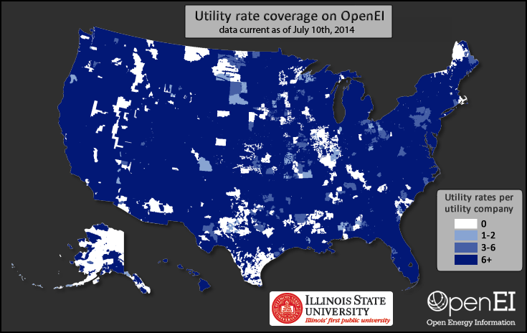

As shown in Figure 1, most utility territories include several rate tariffs available to customers. To help identify the type of customer to which each rate applies, the URDB identifies the sector associated with each rate (i.e., residential, commercial, or industrial); however, even within a single sector of each utility territory, multiple rates are common.

This multiplicity of utility rates for a given location poses a challenge for using URDB rates in the dWind model because, within the model, a single rate must be assigned to each customer type. Because the customer types in each dWind model run are generated stochastically, it is not feasible to predetermine the rate that should be assigned to each customer. Therefore, where multiple rates are available in a customer’s utility area and sector, the model must dynamically and automatically select the most applicable rate.

The URDB includes a series of parameters that may be used to determine the rate applicability, such as minimum and maximum demand (kW), energy (kWh), voltage, and characteristics for phase wiring; however, these attributes are not populated for the majority of rates in the database. Commonly, it takes review of the URDB text description of the rate, or even the source description of the rate tariff by the utility company, to accurately determine the applicability of the rate.

To solve the challenge of automating the selection of rates for each customer type in a model run, the dWind model uses only a subset of rate data from the URDB. This subset of rates includes two separate groups of rates: 1) a selection of rates that were manually reviewed by NREL to determine the rate type (i.e., time-of-use, seasonal, tiered, etc.) and the range of applicable demand levels (minimum and maximum demand in kW); and 2) a selection of rates that are the only available option in their utility territory and sector.

The first set of rates includes approximately 1130 tariffs that were manually reviewed by NREL between June and August 2014. For each of these rates, NREL staff reviewed the source rate sheet from the utility company and determined the rate type (e.g., seasonal, time of use, tiered, etc.), as well as the minimum and maximum demand level (kW) allowed for the rate. These rates were selected for review because they correspond to the most populous utility companies in each state of the US. In total, these rates cover 242 utility companies which serve approximately 75 percent of residential and commercial customers and load in the US. Together, the rate type and range of applicable demand levels provide a basis for automating the selection of an applicable rate for customers in the dWind model corresponding to these utility areas.

The second set of rates includes approximately 1240 additional tariffs. Each rate in this set is the only available rate in their utility territory and sector which drastically simplifies the issue of selecting an applicable rate for each customer type. Because it is possible that other rates exist in reality, but simply were not added to the URDB, we extracted the range of demand levels for these rates where that information was provided. These rates cover an additional 1050 utility territories; however, in contrast to the manually reviewed data, these tend to be municipal utilities with small populations of customers.

In total, we extracted approximately 2370 rates from the URDB for use in the dWind model. Together, these rates approximately 80 percent of residential and commercial customers and load in the US. Figure 2 shows the geographic coverage of the two combined subsets of rates extracted from the URDB for use in the dWind model. For geographic regions lacking rate coverage, we developed a backfilling methodology, as described in the next section.

It is notable that the URDB rates extracted for use in the dWind model represent only residential and commercial sector rates. Although the URDB includes industrial rates, these have not been included in the model at this time because the manual review effort that yielded the first set of rates used in the model was actually performed for a different NREL project. That project was focused on determining breakeven prices for solar photovoltaics (Davidson et al., forthcoming) for the commercial and residential sectors, and due to the labor-intensive effort of reviewing source tariff sheets, focused only on rates for those sectors. In compiling the second set of singular rates, we decided to continue to limit our collection to residential and commercial rates for consistency. Because industrial rates are not included in the dWind model, we use commercial rates to assess the economics of distributed wind for industrial customers. In the future, it would be possible to incorporate industrial rates from the URDB into the dWind model, contingent on sufficient funding to perform the labor intensive review needed to determine their applicability to different demand levels.

It is also important to note that the utility rates extracted from the URDB for use in the dWind model represent a snapshot of real world rate structures, as of the time they were downloaded (December 2014). Currently, we have no short-term plans to update the rates used within the model due to the time consuming nature of reviewing new rate structures and the computational complexity of integrating them into the model; however, future updates to the rates used in the model are possible given sufficient time and funding.

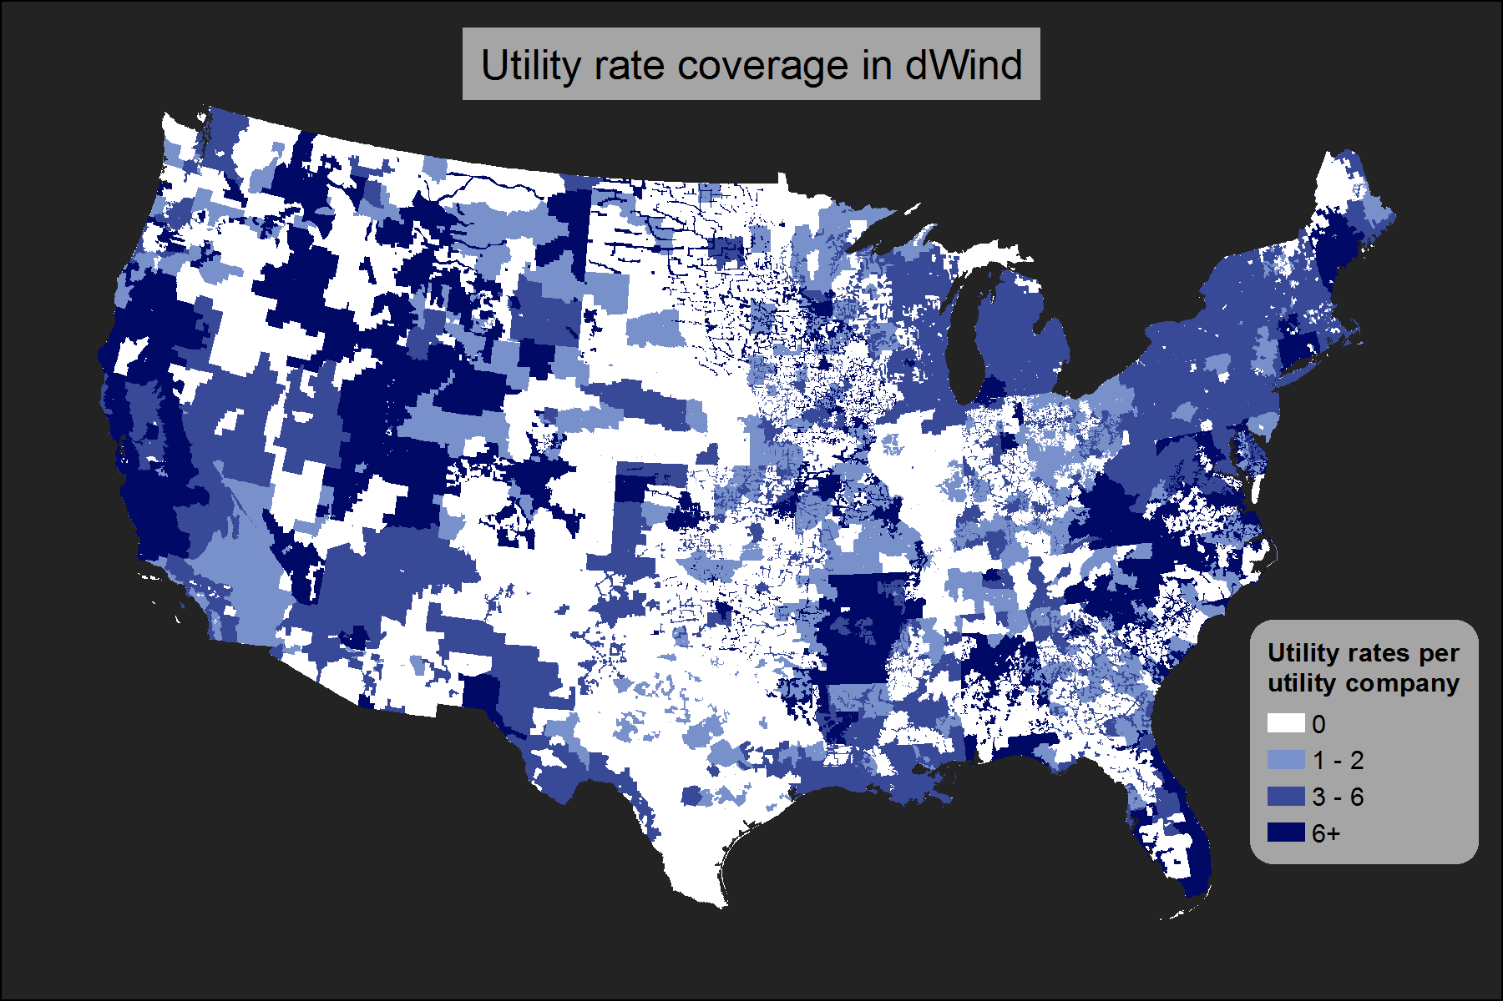

**Backfilling and Selecting Rates for Customer Types**

* Determining the set of potential rates for each customer location
  + Believe it is limited to rates within the same state, then prioritized according to:
    - Consider only rates within the same sector (for ind use com rates) and state
      * Why state? Legal factors affecting rates are generally state level
    - Priority is given to rates within 50 miles and the same utility type (muni, coop, etc.), based on proximity
      * why? Because for nearby utility territories, location based drivers for differences in rates (e.g., climate zone) are less likely, so it seems like the bigger driver of costs would be the utility type
    - If no matches under those constraints, priority is based on proximity
      * farther distances, you may starting getting into different climate zones and therefore different rates, so pure proximity seems more important
  + For customer locations in utilities with rates, those rates will be selected
* Determining the applicable rate from the set of potential rates:
  + Need to look at code for this but I believe it is determined first by demand min and max (where we have them), and secondly by user defined priorities for different rate types and a stochastic sampling method…

**Alternative Rates**

* EIA Annual average rates