2/11 /2014 PSC - Repsol - 26/07/2011

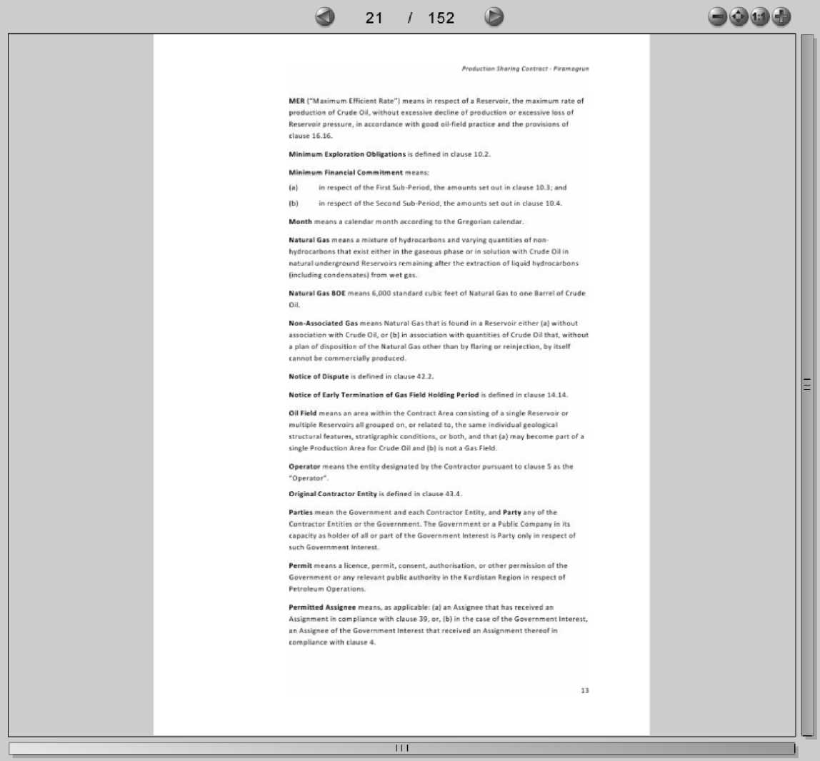

© 2014 Kurdistan Regional Government, KRG

<http://www.krg> .org/p/p.aspx?l=12&r=296&h= 1 &s=030000&p= 18

2/2