Navy - PRT Warm Up

Reference: **PRT_WARM_UP**

1. 10 military four-count Pec Fly w/ Overhead Raise

Pec Fly with Overhead Raise: With elbows bent to 90 degrees, raise your elbows to shoulder level and move them back so they are in alignment with your body (arms should look like a field goal post). This is your starting position. Bring your elbows together as if you were performing a pec fly. Once your elbows/fist are touching (midline body), gently lift both arms up and over your head. Reverse this exercise to get back to starting position. (Purpose: This exercise is used to warm-up the chest muscle and increase the range of motion of the arms while doing overhead motion. Explain how most weightlifters have tight chest and triceps motion and this is also a good exercise to perform in the weight room. It will also prepare the chest and arms for the push-ups.)

1. 10 military four-count Chest Press / Shoulder Press

Chest Press / Shoulder Press: Simulate you are performing a push-up in the air in front of your body. Once you get back to the starting position, then proceed into an overhead should press. Make sure you use a narrow hand-stance and keep elbows tucked in during the shoulder press to ensure you are engaging the triceps (back arm) muscle.

1. 10 military four-count Basic Squat – Picture 1.1

Stand with feet slight wider than shoulder width apart. Squat down to a comfortable depth (this will vary from member to member) Do not go below thighs parallel to the deck (i.e., a 90 degree bend in the knees) Return to starting position. To make this exercise more difficult, perform a 3 count down and a one count up. The 3rd countdown will also be slower and will allow the members to focus on good technique (knees remains above the ankle and all movement will be performed at the hips/buttock lowering down).

Picture 1.1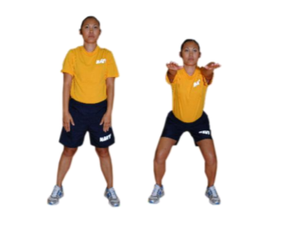

1. 10 military four-count Calf Raise

Place feet shoulder width apart and then stand on your toes.

1. 10 military four-count Knee Blocks to the right – Picture 1.2

With both arms raised above your head, contract your abs and lower both arms to your right knee to perform a knee block. Perform a certain number of repetitions. Repeat on left side Perform alternating knee block by alternating from right to left side after one repetition.

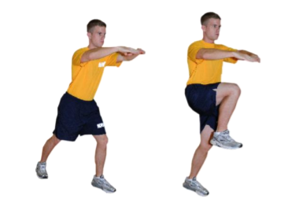

Picture 1.2

1. 10 military four-count Knee Blocks to the left

Same as Knee Blocks to the right but to the left.

1. 10 military four-count 3 Side-Step Touch the Deck – Picture 1.3

In the defensive position, take 3 side steps to the right and touch the deck. Make sure to maintain a partial squat and remain low. Return to defensive position and take 3 side steps to the left and touch the deck. This completes one repetition.

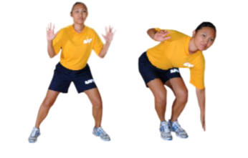

Picture 1.3

8. 30 seconds of Quick Feet followed by 30 seconds of High Knees – Picture 1.4

Start In the defensive position (feet slightly wider than shoulder width and hands at waist level). Perform a quick shuffle of feet until call for high knees (run in place). Gradually increase the height of the knees and exercise tempo. To increase difficulty, count down from 10 in high knees position.

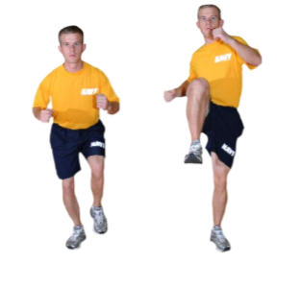

Picture 1.4