They will ask you a lot of question on SERVICE AND PODS

1. Container is going to do everything
2. Management of container , kubernate is do
3. If you don’t mention any replicaset , by default it will take 1
4. Deployment which is nothing but template which tells which image which replicaset which version is running
5. Expose the out side world , you put service , memonent you put the service , it becomes IP followed by port number

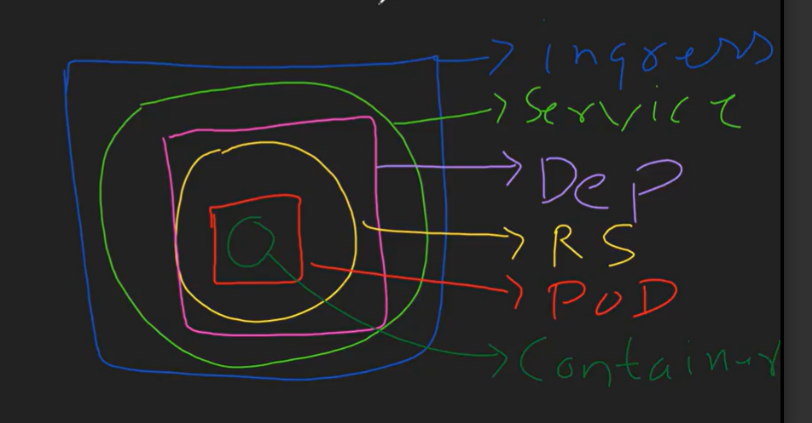

Always it works master-slave architecture

Most ask question in interview:

What is the size of your cluster? How big your cluster was

In test env : I had 1 master node , 2 worker node

UIT /PROD : 3 master node and 8 worker nodes , 8 worker node can also be auto scale to 20

So in my PROD Env bare minimum 2 Master node will be run , actual capacity 3 range b/w 2-3 and worker node range from 5 to 20 auto scale as per incoming request

What type of service you are using :

Loadbalancer

Whey ?

Because your are using cloud provide

Do you think nodePort better ?

Yes , it is better , it is cheaper but the problem is it has a limited range port

And the moment you existors , it will become default

What else problem do you see service ?

Service is always expose the services but it is ipaddress follow by port number

Ipadress may be problem to remember every one

So you have to use DNS service or INGRESS controller to controller the traffic to do load balancing and also give the human readable name

IS INGRESS working fine for you ?

Yes ingress work fine for me and with ingress I can use path base routing or domain base routing /sub domain base routing

You change different different domain name based on that it is going to diffent services

Or

Different path based on that it is going to different services