<https://drive.google.com/file/d/1x-wsyNdZnbl0eoQz_P8cb25uyORM8Clg/view>

1. LAUNCH GOOGLE CLOUD

Then search kubernates in GOOGLE CLOUD

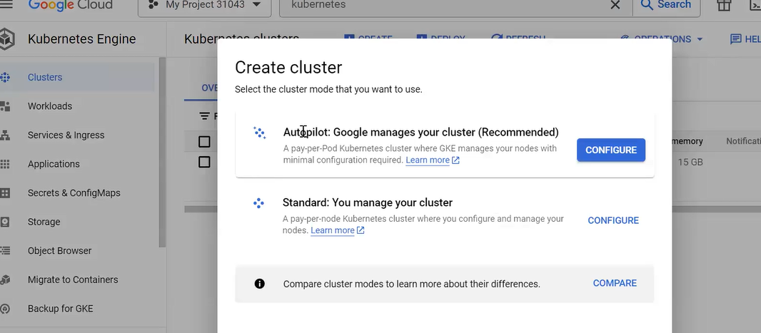

THEN SELECT ONE OF THEM

THEN CREATE THE KUBERNATE CLUSTER

THEN CONNECT CLOUD SHELL

THEN , see worker nodes

#kubectl get nods

#kubectil get nodes –o wide

O –o/p

Wide: get further mode details

To GET THE KUBECTL VERSION

#kubuctl version

POD:

1POD = 1 CONTAINER

IT IS NOT MANDATORY

POD IS SMALEST UNIT OF WORK

DEPLOYMENT:

INSIDE DEPLYMENT –REPLICA SET (PODS)

PODS

CONTAINER

WHO START WORK TWO WAYS

KUBECTL :

-IMPERATIVE

AHOC , NOR RESUABLE , TEST IT

- DECLARATIVE

WRITE IN MANIFEST FILE AND WRITE IN YAML FILE

GO TO DECLARATIVE SCRIPT WHEN YOU WORK ON PRODUCTION

RE USYE AND TRACK FOR DECLARATIVE SCRIPT

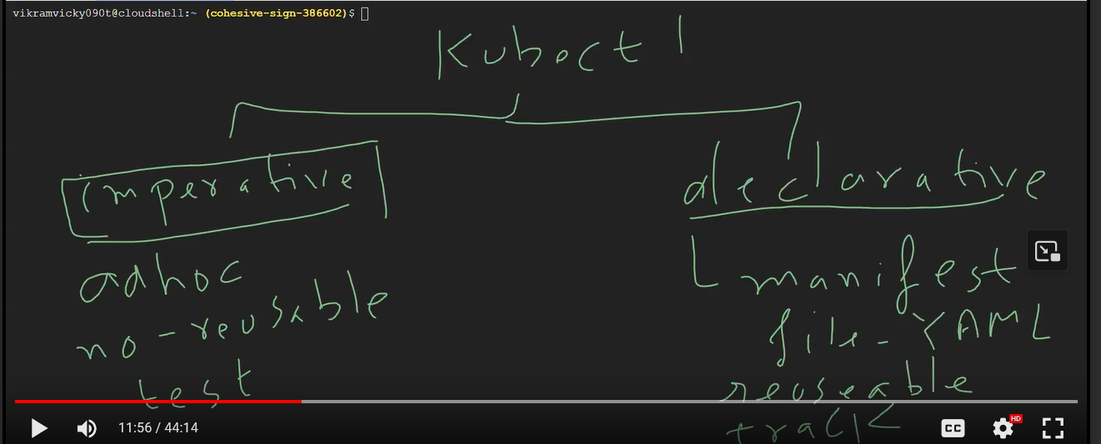

IMPERATIVE ONLY USE FOR ONE TIME EXECUTION

#kubectl get all

#kubectl delete

To WORK ON IMPERATIVE WAY :

#kubectl create deployment hell—node –image =k8s.gcr.io/echoserver:1.4

THEN

#kubectl get

Then

TO GET HOW MANY API-RESORUCES

#kubectl api-resources

#kubectl api-resources |wc –l

To DISPLAY HOW MANY YOU DEPLOYED

#kubectl get deploy

THEN INSIDE MY DEPLOY , YOU WILL GET REPLICASET

#kubectl get replicaset

THEN INSIDE REPLICAS , YOU WILL GET PODS

#kubectl get pods

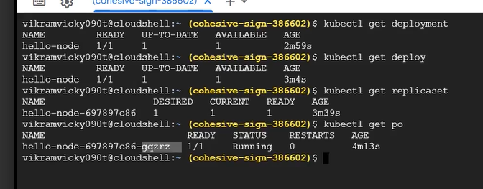

Name of POD : hello-node-697897c86-gqzrz

Deploy name-replicaname-pod name

INSIDE POD , YOU WILL GET CONTAINER

#kubectl describe pod name of pod

I WANT TO SEE ALL

#kubectl get all

TO INCREASE THE NODE AND CONTAINER

#AKUBECTL SCALE DEPLOYMENT HELLO-NODE -- REPLICAS=5

TO SEE POD IS RUNNING ON WHICH NODE

#kubectl get pods –o wide

THEN I WANT TO EXPOSE THOSE PODS OR CLUSTER OUT SIDE GCP

SO WE WILL BE CREATE THE SERVICE TO EXPOSE TO OUT SIDE

#kubecttl get service

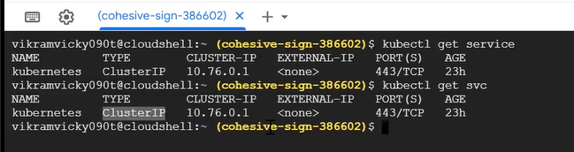

Component of service which will help us to expose outside world

#kubectl expose deployment hello-node -- type-Loadbalancer –port=8080

SERVICES ARE 4 TYPES

* LOADBALANCER
* BY DEFAULT CLUSTERIP
* NODE BOARD

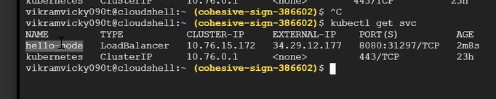

EXTERNAL_ID AND PORT NUMBER TO ACCESS OUT SIDE WORLD

TO DELETE THE SERVICE

#kubectl delete service name of service

NOW CREATE THE DEPLOYMENT AGAIN

#kubectl create deployment test-nginx - - image =nginx:1.18-alpine - - replicas=5

THEN

#KUBECTL get all

Then I WANT TO EXPOSE THIS DEPLOYMENT

#KUBECTL EXPPOSE DEPLOYMENT TEST-NGINX - - TYPE=LoadBalancer - -port=8080

Then

#kubectl get svc