<https://drive.google.com/file/d/1aCaLzoPPH18z-mqajNCtxpJ_Oq24dasY/view>

EKS ---ELASTIC KUBERNATE SERVICE

1. CREATE THE EC2 INSTANCE (AMZON LINUX )

NAME : K8S-MGND

INSTANCE TYPE : FREE TIRE

CREATE NEW KEY PAIR

REST IS SAME

THEN LAUNCH IT

THEN

CONNECT TO PUTTY MACHINE

TO BECAME A ROOT USER

#SUDO SU –

#HOSTNAME K8S-MGNT-NODE

I HAVE FOLLOW THE BELOW DOCUEMTNS

<https://docs.aws.amazon.com/eks/latest/userguide/getting-started-eksctl.html>

1. INSTALL AWSCLI

#AWS –VERSION

INSRALL LATEST AWS CLI

curl "https://awscli.amazonaws.com/awscli-exe-linux-x86_64.zip" -o "awscliv2.zip"

unzip awscliv2.zip

sudo ./aws/install

/usr/local/bin/aws –version

1. INSTALL OR UPDATE KUBECTL

curl -O https://s3.us-west-2.amazonaws.com/amazon-eks/1.26.4/2023-05-11/bin/linux/amd64/kubectl



THEN APPLY EXECUTE PERMISON TO THE BINARY

chmod +x ./kubectl

After you install kubectl, you can verify its version

kubectl version --short –client

1. Setup kubectl

a. Download kubectl version 1.21

b. Grant execution permissions to kubectl executable

c. Move kubectl onto /usr/local/bin

d. Test that your kubectl installation was successful

```sh

curl -o kubectl https://amazon-eks.s3.us-west-2.amazonaws.com/1.21.2/2021-07-05/bin/linux/amd64/kubectl

chmod +x ./kubectl

mv ./kubectl /usr/local/bin

kubectl version --short --client

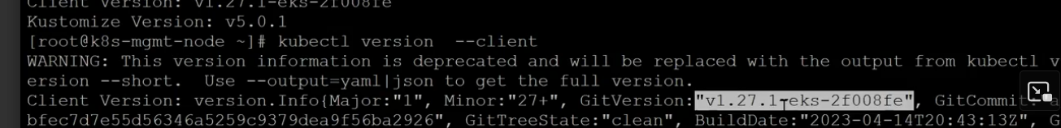

Setup eksctl

a. Download and extract the latest release

b. Move the extracted binary to /usr/local/bin

c. Test that your eksclt installation was successful

```sh

curl --silent --location "https://github.com/weaveworks/eksctl/releases/latest/download/eksctl_$(uname -s)_amd64.tar.gz" | tar xz -C /tmp

sudo mv /tmp/eksctl /usr/local/bin

eksctl version

```

3. Create an IAM Role and attache it to EC2 instance

`Note: create IAM user with programmatic access if your bootstrap system is outside of AWS`

GO TO IAM ----- CLICK ROLE -------CREATE ROLE ---------EC2

IAM user should have access to

IAM

EC2

CloudFormation

Admin

Note: Check eksctl documentaiton for [Minimum IAM policies](https://eksctl.io/usage/minimum-iam-policies/)

THEN CREATE ROLE

THEN ATTACHED THIS ROLE TO EC2 INSTANCE

SELECT EC2-------CLICK “ACTION” -----------SECUROTY-----------MODIFY IAM ROLE ------ATTAHCE ROLE HERE

THEN CREATE THE EKS CLUSTER

```sh

eksctl create cluster --name cluster-name \

--region region-name \

--node-type instance-type \

--nodes-min 2 \

--nodes-max 2 \

--zones <AZ-1>,<AZ-2>

-- runtime-env CRI-O

- - vpc vpcpname

-- subnet

example:

eksctl create cluster --name demo-cluster --region us-east-1 --node-type t2.medium

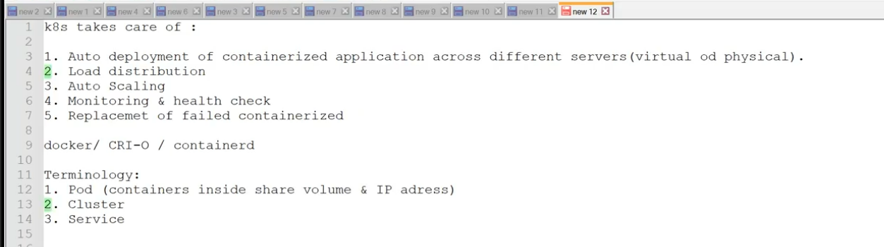

Then execute this



WHEN EVERY YOU RUN THE ABOVE COMMAND , 2 WORKER NDES WILL BE CREATED BY DEFAULT

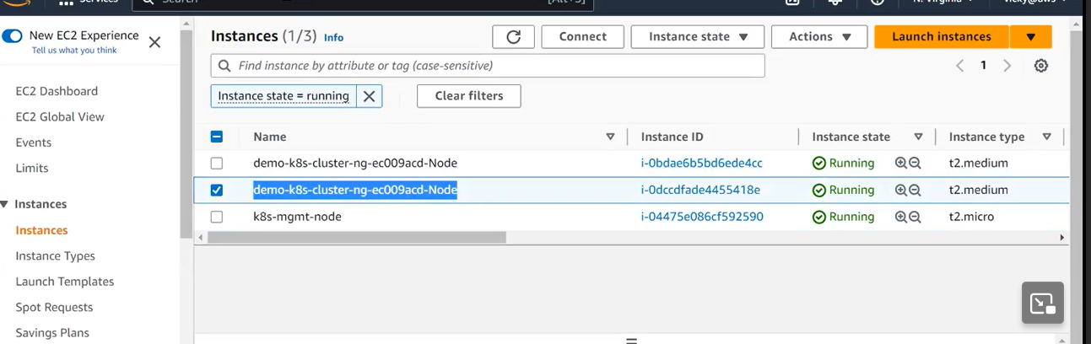

Then GO TO AWS TO CHECK CLOUD FORMATION

THEN GO TO CHECK THE”EKS”

INNER SOFTWARE IS KUBERNATE

YOU CAN CREATE THE “EKS “ MANAULLY IN AMAZON

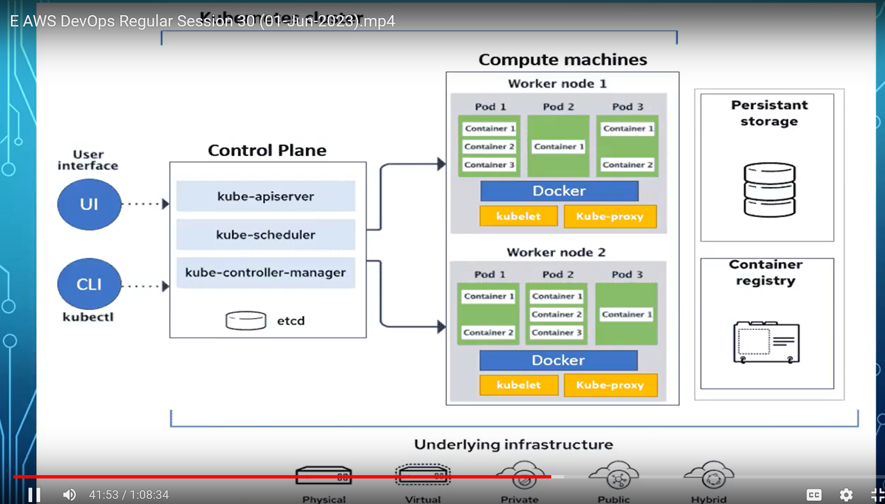

To SHOW ME HOW MANY WORKER NODES AVAIABLE with DETAILS

#kubectl get nodes –o wide

#kubectl create deployment demo-nginx - -image=nginx - -replicas=2 - -port=80

Replicas: how many pods you want

To display all pods

#kubectl get pods

#kubectl describe pod nameof the pod

To delete the cluster

#kubectl delete cluster cluster-name –region us-east-1