<https://drive.google.com/file/d/1hL3yQl-sfqq7yTLhwWjY2OXSoHlphhrR/view>

INSTALL MINIKUBE ON AWS UBUNTU, 22.04 LTS

WHAT IS MINIKUBES?

MINIKUBES IS SMALL SET UP WHERE WEILL GET EVEYTHING AT ONE PLACE

ONE SGINE MICHANE WE WILL GET EVERYTHING

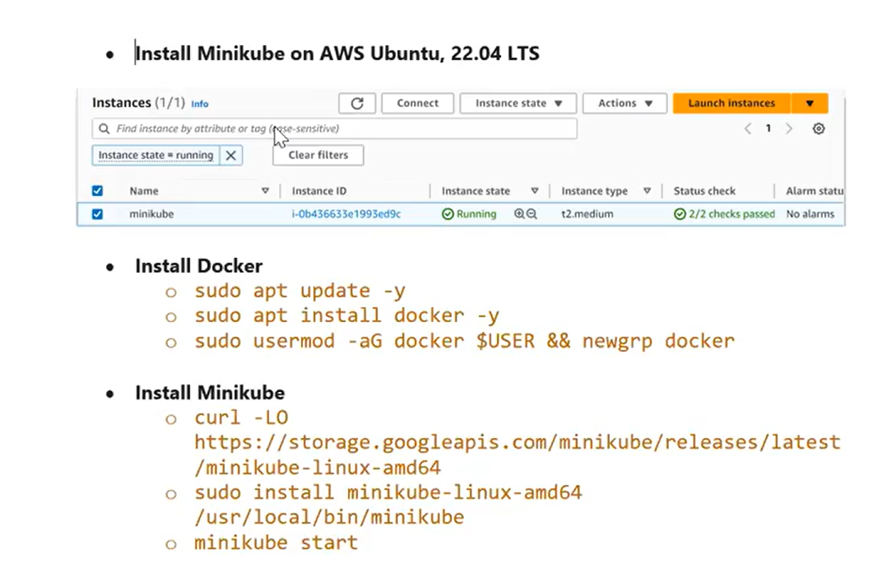

LAUNC EC2 INSTANCE :

NAME : MINIKUBE CLUSTER

TYPE : UBENTU

INSTANCE TYPE: T2.MEDIUM

CONFIGURE STORAGE :16 GB

THEN LAUNC THE INSTANCE

CONNECT TO PUTTY FOR UBENTU

USERNAME OF UBENTU : Ubuntu

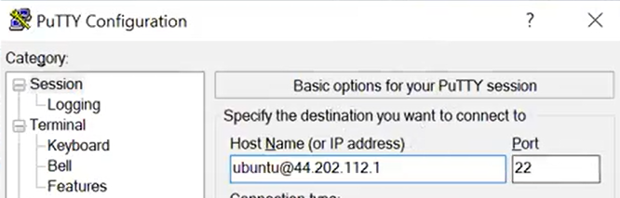

Ubuntu repository : apt-get

WORKING ON NORMA UBUNTU USER NOT UPGRATE TO ROOT USER

#SUOD APT-GET UPDATE

INSTALL DOCKER

#sudo apt-get install docker.io

TO CHECK DEOCKER

# docker –version

To CHECK CURRENT USER GROUP

# id

Then

TO START THE DOCKER

#sudo service docker start

#suod systemctl enable docker

Then

ADD THE CURRENT USER TO DOCKER GROPU

#sudo usermod -aG docker $USER && newgrp docker

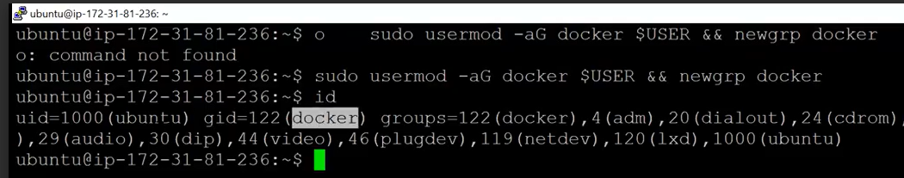

Then install minikubes

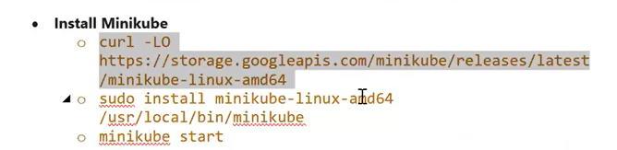

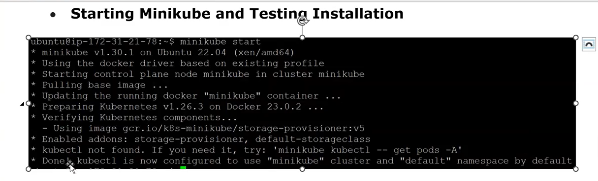

Then

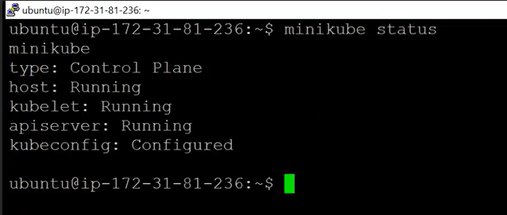

Then

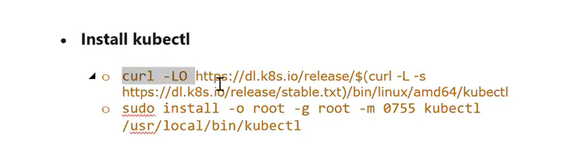

Then

#kubectl get nodes

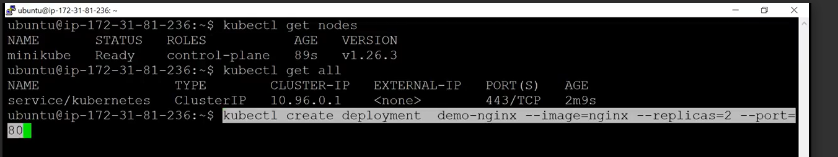

Then could I run deployment in in MINIKUBES

#kubectl create deployment demo-nginx - -image=nginx –replicas=2 - -port:80

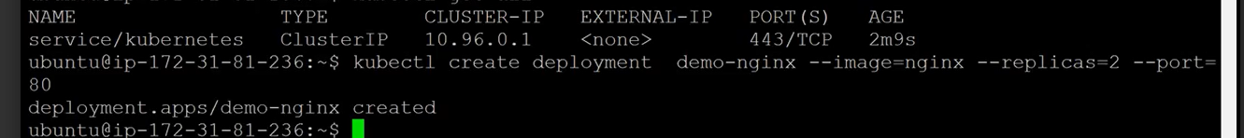

THEN

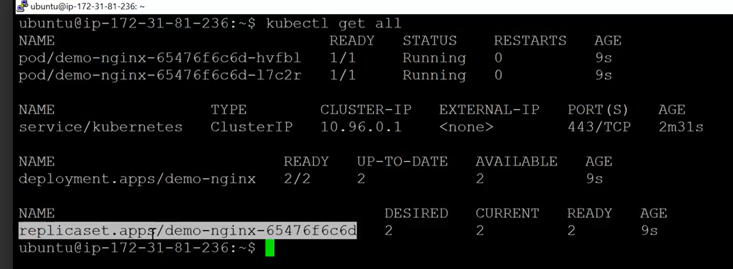

THEN YOU CAN USE GOOGLE CLOUD FOR PRATICE OF KUBERNATE

Create the cluster in google cloud

Two option:

Autopilot : this option will take care of work load

Standard cluster