<https://drive.google.com/file/d/1VHZWuR4SCZHqTY0OWgUYpFdlx5_h7j3w/view>

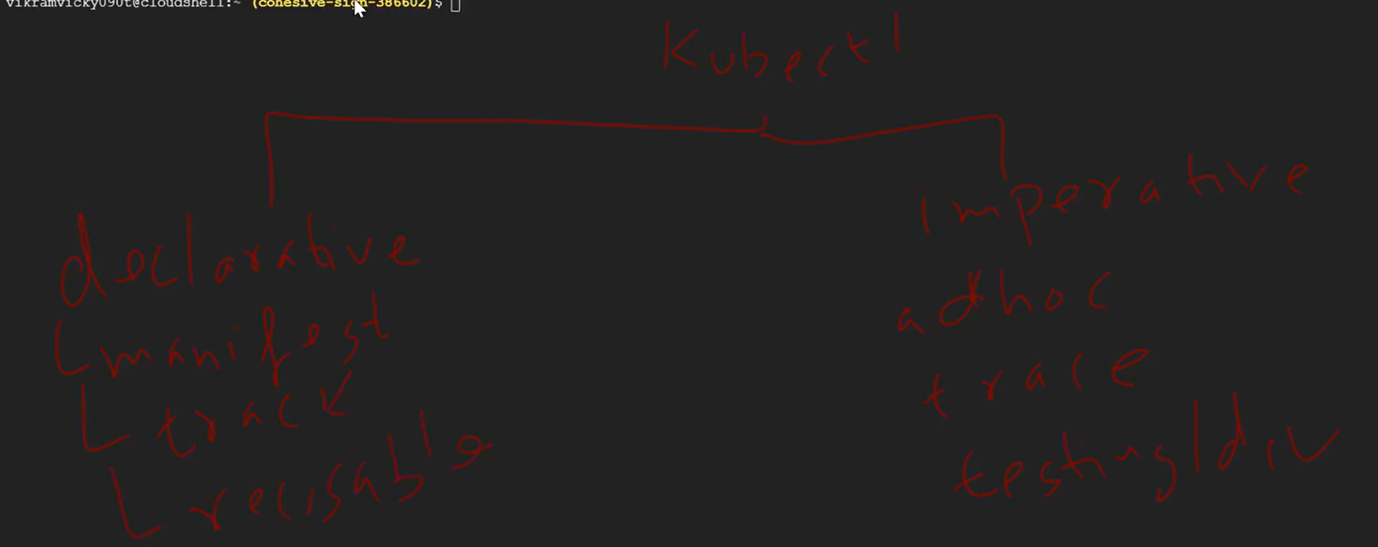

Most of them use declarative way

Go to declarative way to write manifest file or yaml file

apiVersion: apps/v1 --always getting from kubernate end

how do I get this

#kubectl api-resoruces

Kind: Deployment

Metadata:

Name:

Lables:

App:

Labels and app associated your component together

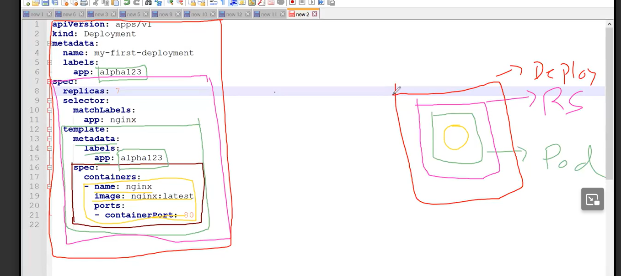

Then take yaml file and run it in cloud

Then execute the yaml file

#kubectl create –f filename

If you are running file 2nd time , user “APPLY”

#kubectl apply –f filename

-apply ---- update or create

