<https://drive.google.com/file/d/1fCCKXKEMn7C3HNvaBpidHSVKxALB4WiF/view>

TODAY WE ARE GOING TO TALK ABOUT “POD”

**LIVENSS PROBE:**

A liveness probe monitors the availability of an application while it is running

If a liveness probe falls, kubernate will restart your “POD”

This could be useful to catch deadlocks and infinite loops or just a stuck application

**READINESS PROBE:**

**STARTUP PROBE:**

Start-up probes are used to determine if a container has started up successfully

Only one time it gets executed and it makes sure your container started properly

Once started the container and after that the readiness takes control and till the container a live, this readiness take care of the work

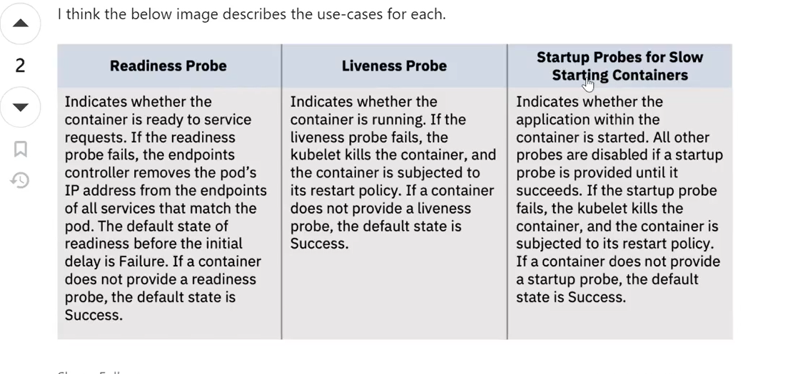

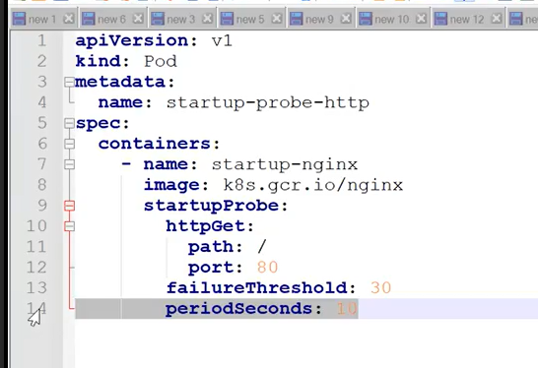

Then go to cloudshell and execute the above script

Name : startup-hc.yaml

Then execute this script

#kubecte create /apply –f startup-hc.yaml

Then pod has created

Then go inside pod

#kubectl describe padname

Then go and check that ready to take traffic

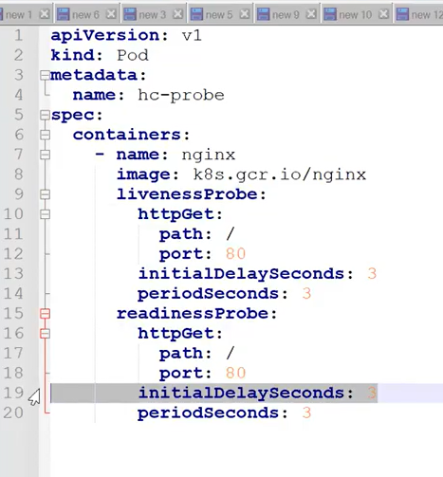

1. initialDelaySeconds: start up probe told has container started but you are not go immediately to check ,it will wait for 3 seconds after that it will check whether the container is ready to the traffic or not

Suppose to get the response “YES”

1. periodSeconds : after another 3 seconds again go and check

3 time consecutively it get the response yes as ready to take traffic

Then only this “livenssProbe” is take control

Then go and run above yaml file in clouds SHeel

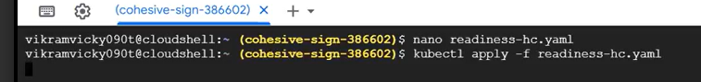



Then

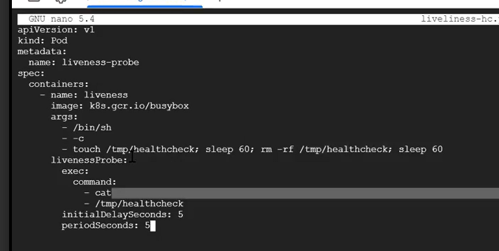

ANOTHER WAY TO WRITE THE LIVENESS AND THIS IS STANDARD WAY

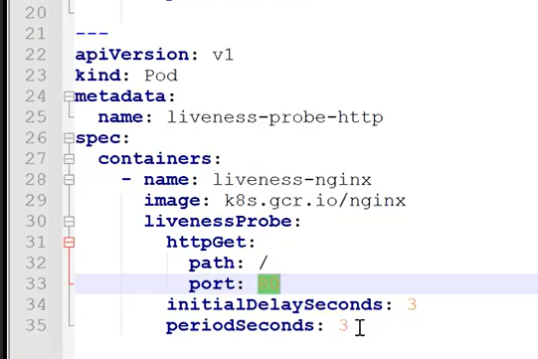

When you runs container , you don’t want to allocate extra resource on that container

When containers start it will request 64MB of memory from your systems and At least 250mb of CPU

Now it is mandatory that much amount of content should be there your system then it will start

Limits: can’t request more than limits, this is called resource limitation

This particular pod never go this limits

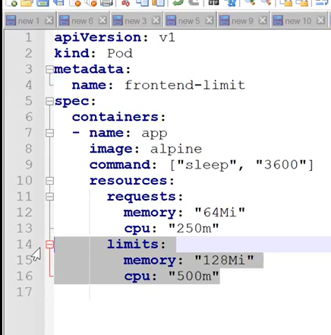

Requests:

Memory=”64Mi”

Cpu: “250m”

While staring the container we request this amount of memory and cpu

Interview Question :

1 master and 5 worker node

I want to create the pod and move the pod to worker 3 , is it possible

Ans: Yes , it is possible using node affinity

And not affinity - id not want to run this node

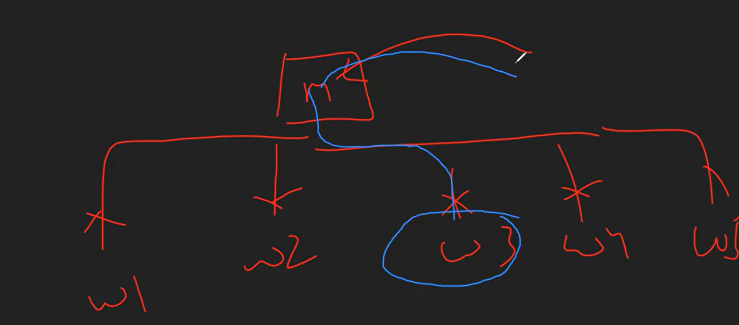

You will get the interview question form this sessions

What is liveness probe

Question : my container is running last 3 month now total data which is 3 gb I never want 3 gb what should I do

ANS: while creating container you should have given limit , now you can change the definition and add