<https://drive.google.com/file/d/1bC5OZgWF4jq9C4Oo0Zx1mdV4EU8klMFK/view?pli=1>

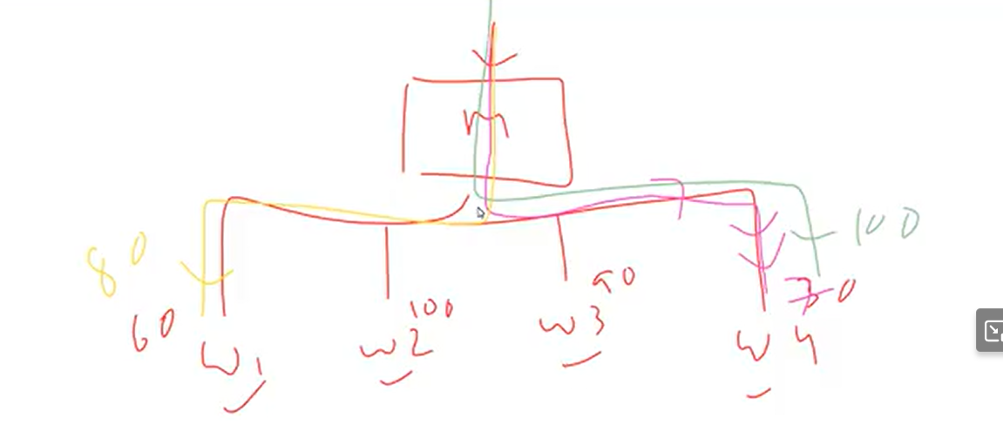

1 MASTER NODE

3 WORKER NODE

EXTERNAL REQUEST IS COMING TO MASTER THEN IT WILL CHECK THAT WHICH WORKER NODE IS FREE

MY LOADBALANCER IS SEE WHICH WORKER NODE IS OCCUPY LEAST AND THEN IT WILL ROUTE THE TRAFFIC TO THAT PARTICULER WORKER NODE

THIS IS NORMAL TYPE OF DEPLOYMENT

**DEAMON SET :**

DEAMONSET SAYS THAT WHEN YOU CREATE THE DAMONSET , YOU DON’T NEED SPECIFY THE REPLICASET

NUMBER OF WORKER NODES ARE 5 , EACH NODES WILL MANDATORY HAVE 1 DEAMONSET

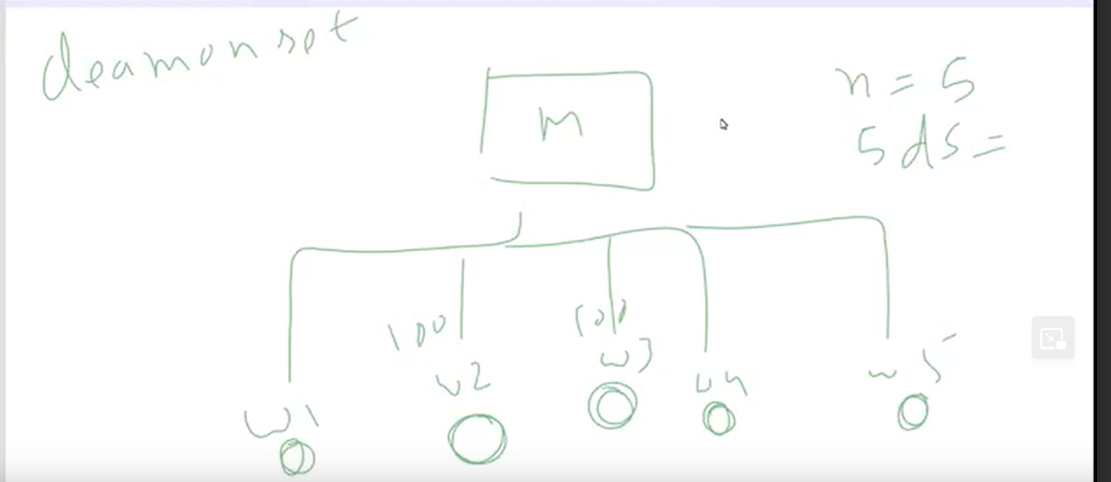

EACH WORKER NODE SHOULD HAVE AT LEAST 1 DAEMON SET

**Daemonset** :

How do you know how many replicas need ?

5 worker nodes – 5 daemon set created automatically

THEN CREATE THE DAEMONSET IN CLOUD THEN RUN IT USING NAME : DAEMONSET.YAML

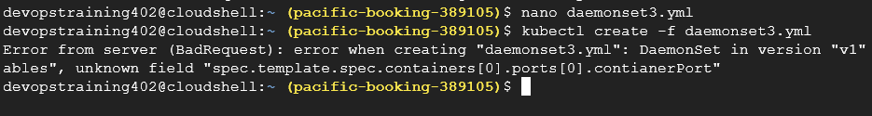

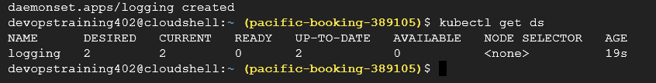

q) DAEMONSET VS DEPLOYMENT

**Purpose of daemonset :**

I want to know what is happing on worker node ,put the daemonset in worker node

Daemonset is special kind of deployment where it make sure atlases on daemonset in one worker node

Main use of daemonset for monitoring purpose

Daemon Set runs a Copy of a Pod on New Node as they added to Cluster automatically. DaemonSet will be helpful in case of Monitoring, Log Collection, Proxy Configuration etc.

Node Affinity is used for Pods Allocation on Worker Nodes.

Not to Schedule Pod on Nodes is achieve via Node Anti-Affinity.

**VOLUMES:**

**PV – persistant valume -** ACTUAL PROVISON BY ADMIN

**PVC - persistent volume claim**

ADMIN PROVISION THE STORAGE FOR YOU , LET’S SAY ADMIN PROVISION 10GB STORAGE FOR YOU

THIS 10GB STORAGE IS AVIABLE FOR ALL DEVELOPERS

WHEN EVER YOU CREATE THE POD , YOU CLIAM THAT STORAGE OR YOU ASK THAT STORAGE

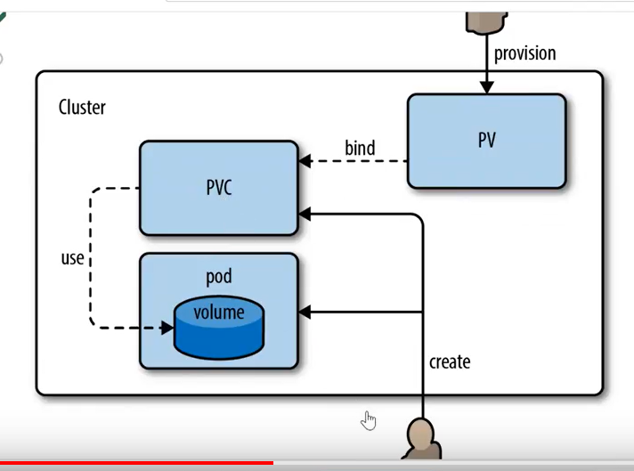

Then CREATE THE YAMEL FILE OFR VOLUMES

THEN

RUN IT

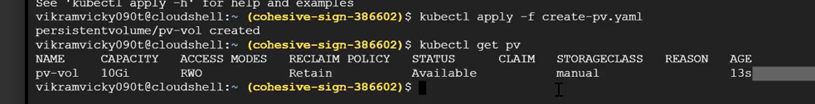

THEN CLAIM THE GB

Pvc.yaml

THEN

USE THE PVC STORAGE USING DEPLYMENY

FILE : reate-redis-deployment.yaml

Getting this error when I run it

