NAME SPACE AND WHY USE NAME SPACE :

IN KUBERNET ACCOUNT, THEY ALLOCATE DEV AND PROD

THERE IS 3 DIFFERENT TEAMS ARE WORKING

TEAM 1 TEAM 2 TEAM 3

TEAM 3 THEY WANT COMPLETE ISOLATION, ANY RESOURCE FROM TEAM 1OR TEAM2 THEY DON’T WANT TO COME AND ENTER INTO TEAM 3 AND DISTRIBUTE THEIR WORK

SO WHAT THEY DO, THEY CREATE SOMETHING CALLED “NAMESPACE”

NAMESPACE WILL HELP YOU TO CREATE THE LOGICLA BOUNDRIES, YOU CAN RESTRUCT THE ACCESS OTHERS BY CREATING YOUR OWN NAMESPACES

#KUBECTL GET NAMESPACE

#kubectl get ns

#kubectl get all

Then

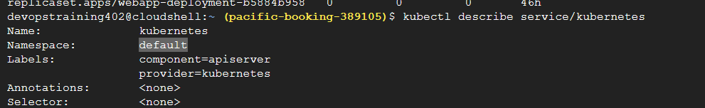

#kubectl get ns

#kubectl get all --namespace default

Create my own namespace

#kubectl create namespace dev

Then

#kubect get ns

THEN

CREATE THE DEPLOYMENT

#kubectl create deployment demo-nginx –image =nginx –replicas=2 –port=80 --namespace dev

Then check it

#kubectl get all --------🡪 but this command pointing to default name space

#kubectl get all –namespace dev

See all things

Then

#kubectl describe podname –namespace dev

RBACK : role based access control

RBACK is method of restricting network access based on the roles of individual users within the enterprise

This is not inbuild feature in kubernate

So you need to setup it

1. Generate private key

#openssl genrsa –out mia.key 2048

1. Generate the CSR

openssl req -new -key mia.key -out mia.csr -subj "/CN=mia/O=acg"

/CN – comman name , you will gice any name

/O –orginazation name

<https://medium.com/@mattgillard/creating-a-kubernetes-rbac-user-in-google-kubernetes-engine-gke-fa930217a052>

#kubectl config view