INGRESS IN K8S :

You will have set of pods which will be exposed via service and then we will have another set of pods which will be exposed via another service ,we will do service exposer the problem is still have ipaddress follow with port name , when you go and give the detail someone , they don’t understand

That’s why you will give human readable name that is provided the ingress controller

And also we try to provide the load balancer when you talk interm of ingress controller

Nginx ingress controller

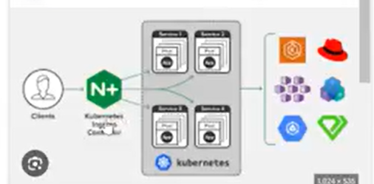

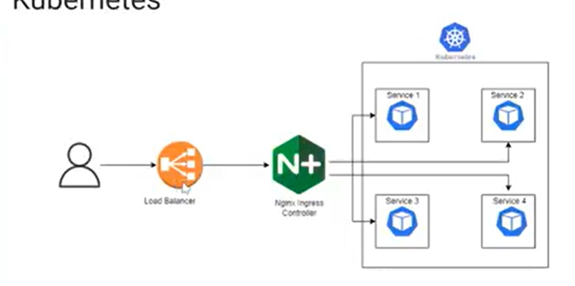

Ingress support path based routing

Nginx ingress controller :

It is also checking ssl and tls certificate which is valid or not, validating everything is here ans distribute the load as per url here

It is act as load balancer

It is act as security enhancer

It is act as reverse proxy

1. DNS Resolver or Server :

You type in browser [www.google.com](http://www.google.com) DNS server is actually convert that google.com into relevant IP address

Login Google cloud

#kubectl delete all –all

I am trying to achieve below set up

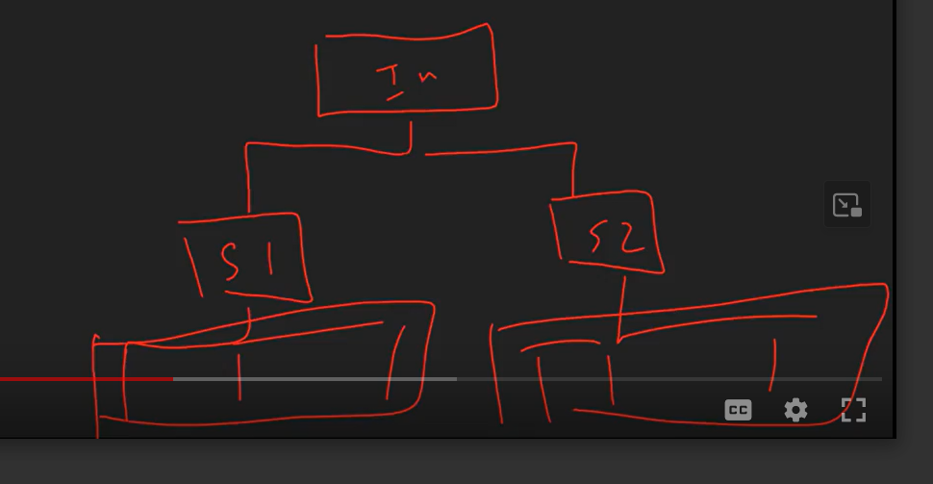

Then

Create 2 yaml file with name :ingress.yaml and ingress1.yaml

Then execute it

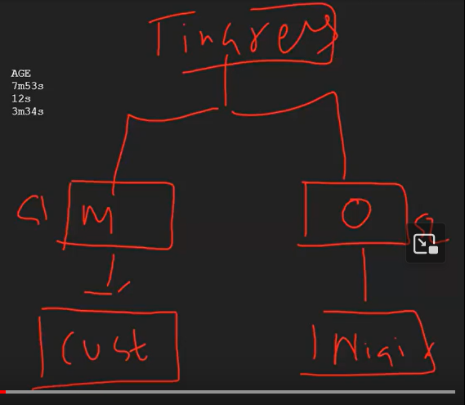

spec:

  rules:

    - host: nginx-official.example.com

    - host: magical-nginx.example.com

Example.com – main domain

Nginx-official is sub domain

This is called sub-domain

Then create the Ingress for yaml and executed

#kubectl get ingress

#kubectl describe ingress nginx-rules

#kubectl get svc

So you don’t have domaine name that’s why I could manage withn the cluster level

#sudo nano /etc/hosts

