External Name : Headless service

What is stateful and stateless application?

When every we work any application, two types

1. Stateful: state preserved , logout ---- 1 year ----place you left =======my-sql ,mongoDB

Online platform where people register for rental cabs ---100-----preserve

Stateful application all about below

When you deployment

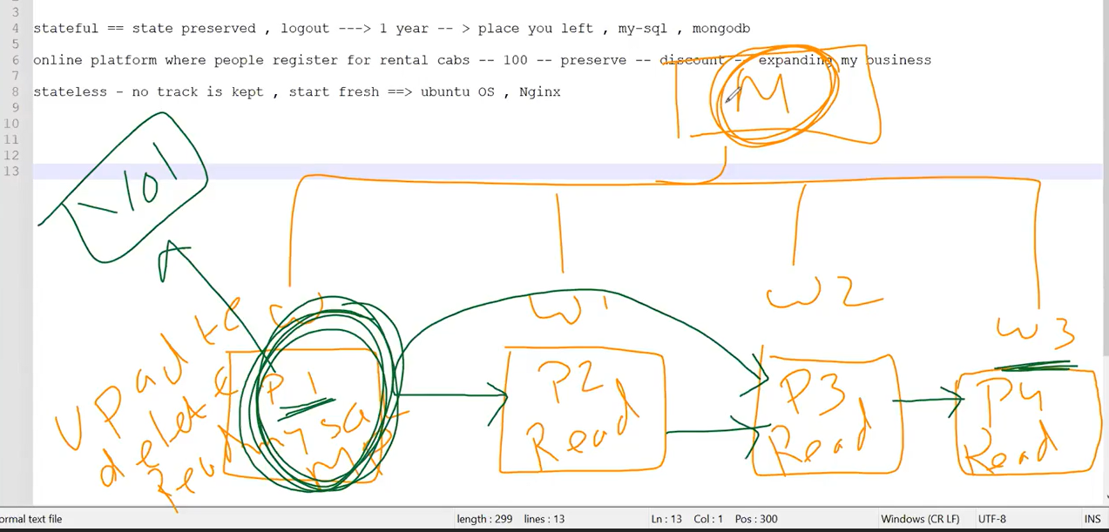

Usually data is not sync in application if one pod will be crashed , to avoid this problems

We will make it one worker nod become master and that master is allow to do the update /delete/read operation then slowly that worker master will inform to other worker node one by one( sequence ) to update the data , to maintain the data consistency we will do this type of setup

I will do above figure flow hence achieve the data consists

Statefull is help us that state preserved for ndoes , if node will be crash ,data will be store at temporary location

If another node will be created then node will point to temporary location and get the data of crashed node

Which pod will be crashed only that pod will be created by stateful

When we use deployment it cannot happen the Sequence execution, development go and do it every place

2. Stateless: no track is kept, start fresh=====🡺 ubentu OS, nginx