<https://drive.google.com/file/d/1mxZROqt4Ni8sCwsltOc5iwcMODVkN79I/view>

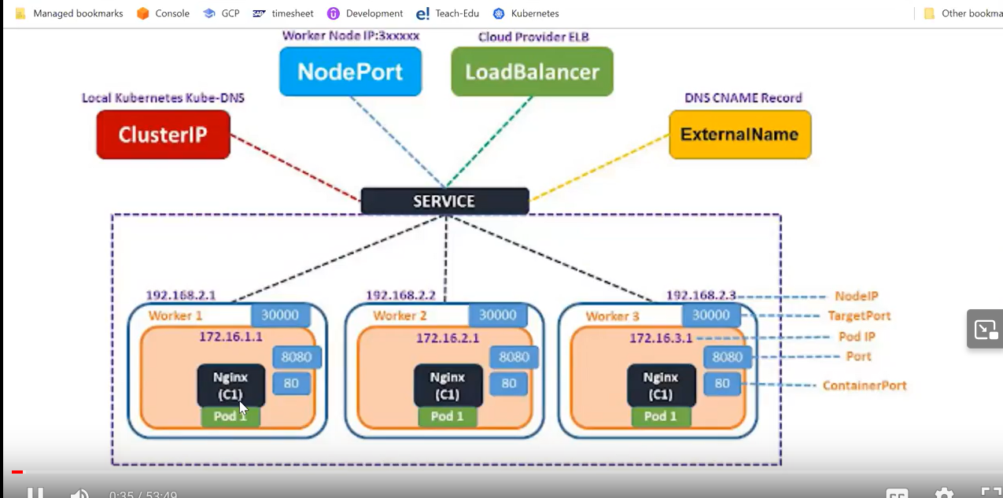

SERVICE DOES TWO THINGS FOR US

1. EXPOSE THE PORT OF CONTAINER TO OUT SIDE WORLED
2. ANY TRAFIC WHICH IS COMING FORM OUT SIDE , IT IS ALSO ACT AS LOAD BALANCER , IT IS DISTRIBUTE THE WORK LOAD ACCORDING TO INCOMING TRAFFIC

EVEY CONTAINER HAS INNER PORT OR CONTAINERPORT , IT IS EXPOSED AS PORT

NODEIP: worker node ip

Target Port: which port number is exposed?

1. ClusterIP : default service , it will take clusterip by default and it will work for internal communication

Let’s say with in the cluster , 3 worker nodes they want to talk to each other , by default they will connect to each other

You cannot expose the service using clusterIP

1. NodePort : can be used but Nodeport has two limitation

There is port range and it is not very good idea to use when you use cloud

Nodeport can be used on-premises or cloud

When you use the cloud not recommended

Nodeport range: 30000- 32767

1. Load Balancer : it will use in cloud
2. ExternalName: DNS CNAME Record , here many problems , security

Benefit of DNS CNAME Record: use to fetch the pod directly whatever there inside the pod , you can directly reach the pod but there can be security issue

Today you are accessing certain name tomorrow the pod will be gone

Port: cluster port

targetPort: we define container port here on which our application running

Nodeport: worker node port on which we can access our application

Whatever service you created it will be across the worker node

Service – NodePort:

