<https://drive.google.com/file/d/1tnZ_Zmue95ZHyCdy6TC9Nckii88jM_pi/view>

I want to see the api resoruces

#kubectl api-resources

Let me say , THERE IS POD AND INSDIE POD TWO COTNAIERS

FIRST CONTAINER MYSQL

SECOND CONTAINER : NODEJS

WHEN EVERY USER LOG IN , HE IS LOGGING TO FRONT END APPLICATAION –NODEJS AND PASS SOME DATA TO SQL THEN GET RESPONSE THEN USER GET THE RESPONSE

INTERNALLY TWO CONTAINERS , CONTAINER 1 AND CONTANER 2 ARE SAME NETWORK AND THEY ARE COMMINCATE EACH OTHER AND THEY PASS DATA EACH OTHER

THEY CLASSFIED TWO TYPES WHEN THEY PASS DATA EACH OTHER

1. CONFIDENTIAL DATA LIKE USERNAME AND PASSWORD WHICH IS CONFIDINETAL
2. GENERIC DATA LIKE PORT NUMBER , END POINT

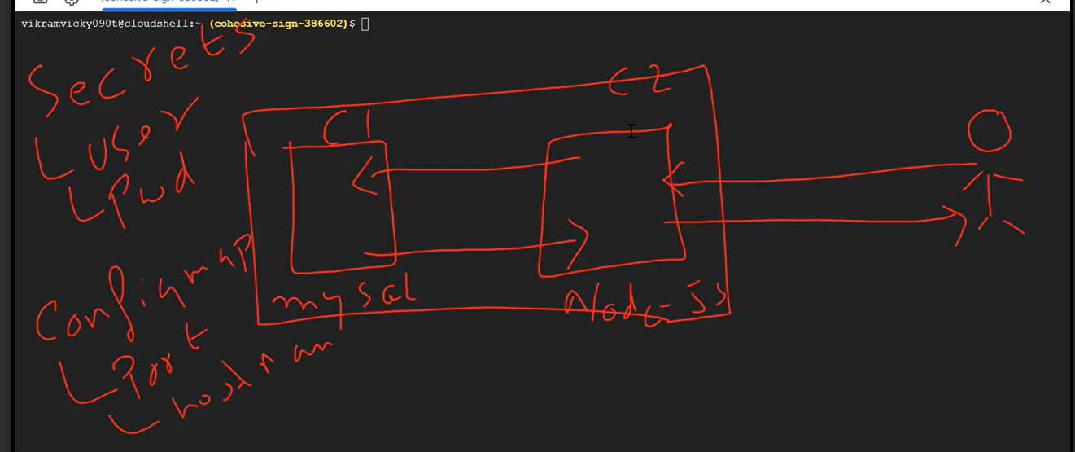

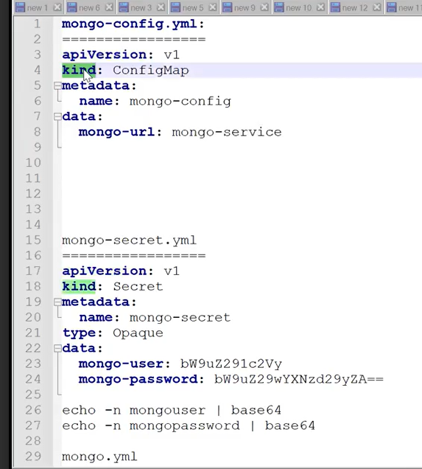

Mango-user and password , you need to do the encryption

Echo –n mongouser | base 64

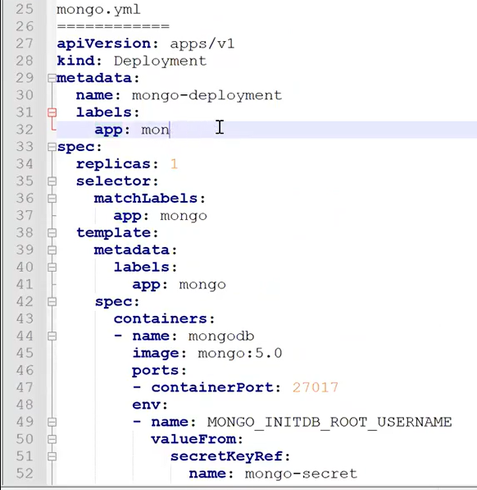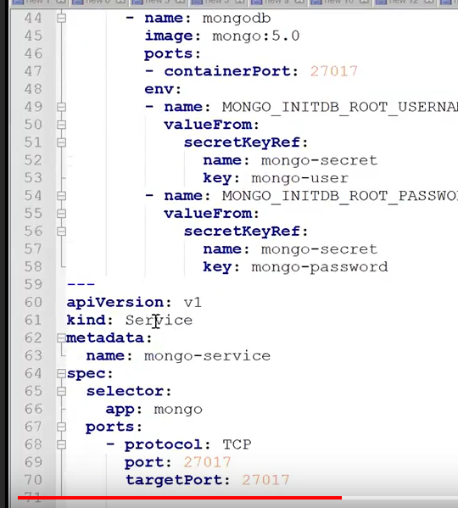

IF YOU DON’T SPECIFY SERVICE TYPE , DEFAULT SERVICE “CLUSTERIP” WOULD BE PICKED UP

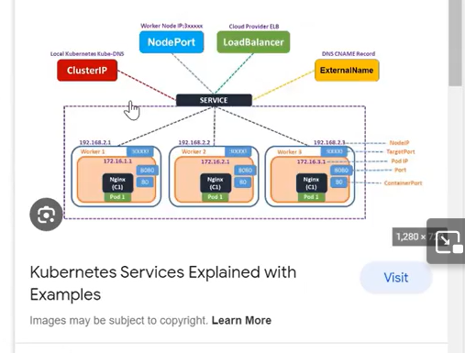

CONFIGMAPS(cm) :

SECRETS☹