<https://drive.google.com/file/d/1J1JesaJx7UsIV-ylcimvyFGS_4_upqAl/view>

ANOTHER WAY TO INSTALL KUBERNATE CLUSTER :

KOPS KUBERNATE INSTALATION

KUBBERNATE ON AWS USING KOPS :

1. LAUNCH LINUX EC2 INSTANCE IN AWS (KUBERNATE CLIENT)
2. CREATE AND ATTACHE IAM ROLE TOEC2 INSTANCE .KOPS NEED PERMISONS TO ACESS

CREATE IMA ROLE -------ROLES ----CREATE ROLE----------EC2 –NEXT-------PERMISION POLICIES ADMINSTRATORACCESS

THEN CLICK NEXT

THEN ROLE

THEN CLICK CREATE ROLE

THEN GO TO EC2 INSTANCE –ACTIONS-------SECURITY---------MODIFYIAM

THEN GOT TO ROUTE53 (dns) -----HOSTED ZONES

DOMIANE NAME : K8S.IN

PRIVATE HOSTED ZONE :

REGION:

VPC ID :

THEN CLICK CREATE

THEN GO TO S3

CREATE A BUCKET --------BUKCET NAME: kops-demo.k8s.in

AWS REGION : SELECT CORRECT REGION

THEN LAUNCH EC2 INSTACE ON PUTTY

#SUDO SU –

#HOSTNAME

#SUDO SU –

THEN

CONFIGURE ENVERIONMENT VARIABLE

OPEN .bashrc file

Vi ~/.bashrc

ADD FOLLOWING CONTENT INTO .BASHRC, YOU CAN CHOSE ANY ARBITARY NAME FOR CLUSTER AND MAKE SURE BUCKET NAME MATCHES THE ONE YOU CREATED INPREVIOUS STEP

Export KOPS_CLUSTER_NAME=k8s.in

Export KOPS_STATE_STORE=s3://kops-demo.k8s.in

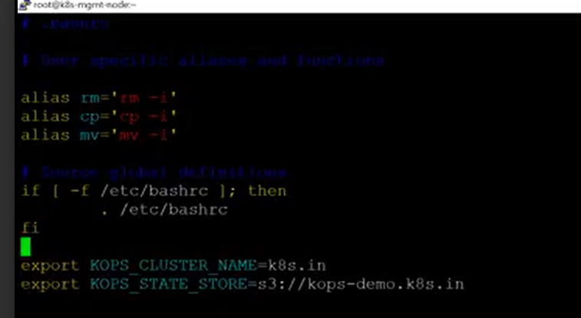

Then running command to reflect variable added to .bashrc

To RESTART THE APPLICATION

#soruce ~/.bashrc

1. DOWNLOAD THE KOPS AND INSTAL IT
2. curl -LO https://github.com/kubernetes/kops/releases/download/**$(**curl -s https://api.github.com/repos/kubernetes/kops/releases/latest | grep tag_name | cut -d '"' -f 4**)**/kops-linux-amd64

TO GIVE THE EXECUTION PERMISON

CHMOD +X KOPS-LINUX-AMD64

TO MOVE LOCAL BIN

SUDO MV KOPS-LINUX-AMD64 /USER/LOCAL/BIN/KOPS

TO CHECK THE KOPS VERSION

#KOPS VERSION

THEN INSTALL THE KUBECTL

curl -LO https://storage.googleapis.com/kubernetes-release/release/$(curl -s https://storage.googleapis.com/kubernetes-release/release/stable.txt)/bin/linux/amd64/kubectl

chmod +x ./kubectl

sudo mv ./kubectl /usr/local/bin/kubectl

kubectl version