A REAL-TIME / FIELD-BASED RESEARCH PROJECT REPORT ON
MIND MANCER
in the partial fulfillment of the requirements for the award of the degree of
BACHELOR OF TECHNOLOGY
in
COMPUTER SCIENCE AND ENGINEERING (DATA SCIENCE)

Submitted by
B RAM GANESH 23B81A6730
N ROHITH REDDY 23B81A6734
D DHANUSH 23B81A6711

Under the guidance of
Mrs.M.Nikita
Assistant Professor, CSE (DS)

DEPARTMENT OF COMPUTER SCIENCE AND ENGINEERING (DATA SCIENCE)
CVR COLLEGE OF ENGINEERING
(An Autonomous institution, NAAC Accredited and Affiliated to JNTUH, Hyderabad)
Vastunagar, Mangalpalli (V), Ibrahimpatnam (M),
Rangareddy (D), Telangana- 501 510

APRIL 2025

CVR COLLEGE OF ENGINEERING
(An Autonomous institution, NAAC Accredited and Affiliated to JNTUH, Hyderabad)
Vastunagar, Mangalpalli (V), Ibrahimpatnam (M),
Rangareddy (D), Telangana- 501 510

COMPUTER SCIENCE AND ENGINEERING (DATA SCIENCE)
CERTIFICATE
This is to certify that the Real-Time / Field-Based Research Project report entitled “Mind Mancer” bonafide record of work carried out by B RAM GANESH (23B81A6730), N ROHITH REDDY (23B81A6734) and D DHANUSH (23B81A6711) submitted to Dr.Afreen Fatima Mohammed, Assistant Professor for the requirement of the award of Bachelor of Technology in Department of Computer Science and Engineering (Data Science) to the CVR College of Engineering, affiliated to Jawaharlal Nehru Technological University, Hyderabad during the year 2024-2025.

Project Guide Project Coordinators
Mrs.M.Nikita Dr. Shaik Janbhasha
Assistant Professor Associate Professor
Department of CSE (DS) Department of CSE (DS)

Head of the Department
Dr. S.V. Suryanarayana
Professor, HoD of CSE (DS)


CVR COLLEGE OF ENGINEERING

(An Autonomous institution, NAAC Accredited and Affiliated to JNTUH, Hyderabad)
Vastunagar, Mangalpalli (V), Ibrahimpatnam (M)
Rangareddy (D), Telangana- 501 510

DECLARATION
We hereby declare that the Real-Time / Field-Based Research Project report entitled “MIND MANCER” is an original work done and submitted to Computer Science & Information Technology Department, CVR College of Engineering, affiliated to Jawaharlal Nehru Technological University Hyderabad in partial fulfilment for the requirement of the award of Bachelor of Technology in Computer Science and Information Technology and it is a record of bonafide project work carried out by us under the guidance of Dr.Afreen Fatima Mohammed , Assistant Professor, Department of CSE (Data Science).
We further declare that the work reported in this project has not been submitted, either in part or in full, for the award of any other degree in this Institute or any other Institute or University.
Signature of the Student
B RAM GANESH

Signature of the Student
N ROHITH REDDY

Signature of the Student
D DHANUSH
Date:
Place: Hyderabad

ACKNOWLEDGEMENT

We are thankful for and fortunate enough to get constant encouragement, support, and guidance from all the Teaching staff of CSE (Data Science) Department that helped us in successfully completing this Real-Time / Field-Based Research Project.
We are extremely thankful to our internal guide Dr.Afreen Fatima Mohammed Department of CSE (Data Science) for providing support and guidance, which made us to complete the Project on time.
We thank Dr.Shaik Janbhasha, Dr.Afreen Fatima Mohammed, Project Review Committee members for their valuable guidance and support which helped us to complete Real-Time / Field-Based Research Project Work successfully.
We thank Professor, Head of the Department CSE (Data Science), Dr. S. V. Suryanarayana, for giving us all the support and guidance, which made us to complete the Real-Time / Field-Based Research Project duly.
We thank our Vice-Principal Prof. L. C. Siva Reddy for providing excellent computing facilities and a disciplined atmosphere for doing our work.
We wish a deep sense of gratitude and heartfelt thanks to our Principal Dr. Ramamohan Reddy and the Management for providing excellent lab facilities and tools.

TABLE OF CONTENTS
Chapter No. |  | Contents | Page No.
 |  | List of Tables | i
 |  | List of Figures | ii
 |  | List of Symbols | iii
 |  | Abbreviations | iv
 |  | Abstract | 1
1 |  | Introduction | 2-6
 | 1.1 | Motivation | 2
 | 1.2 | Problem Statement | 4
 | 1.3 | Project Objectives | 5
 | 1.4 | Project Report Organization | 6
2 |  | Literature Survey | 7-9
 | 2.1 | Existing work | 7
 | 2.2 | Limitations of Existing work | 9
3 |  | Software & Hardware specifications | 10-14
 | 3.1 | Software requirements | 10
 | 3.2 | Hardware requirements | 13
4 |  | Proposed System Design | 15-24
 | 4.1 | Proposed method | 15
 | 4.2 | Class Diagram | 17
 | 4.3 | Use case Diagram | 18
 | 4.4 | Activity Diagram | 19
 | 4.5 | Sequence Diagram | 20
 | 4.6 | System Architecture | 21
 | 4.7 | Technology Description | 22
5 |  | Implementation & Testing | 23-27
 | 5.1 | Front page Screenshot | 23
 | 5.2 | Testing | 24
 | 5.3 | Backend Implementation | 26
6 |  | Conclusion & Future Scope | 28
 |  | References: | 32

LIST OF TABLES

Table No. | Title | Page No.
3.1 | Software Requirements for Frontend and Backend | 10
3.2 | Web Server Development Tools Used | 11
4.7 | Technology Description | 22
6 | Expandable Technologies for Future Scope | 31

LIST OF FIGURES

Figure No. | Title | Page No.
4.1 | Class Diagram | 17
4.2 | Use Case Diagram | 18
4.3 | Activity Diagram | 19
4.4 | Sequence Diagram | 20
4.5 | System Architecture | 22

SYMBOLS
Symbol | Description
AJAX | Asynchronous JavaScript and XML, used for sending/receiving data from the server without reloading the page.
GET | HTTP method used to request data from the server.
POST | HTTP method used to send data to the server.
{username} | Path variable in REST API representing the user's username.
{question} | Path variable in REST API representing the question being asked to the user.
MongoDB | NoSQL database used to store game data such as questions, user responses, and game history.
Mongoose | Object Data Modeling (ODM) library used for MongoDB to interact with the database.
Node.js | JavaScript runtime used for executing backend code.
Express.js | Web framework for building the REST API to handle client requests and interactions with the database.
CORS | Cross-Origin Resource Sharing middleware used in Express.js to handle cross-origin requests.
React.js | JavaScript library used to build the frontend user interface.
Bootstrap | Frontend framework used for responsive layout and UI components.
Fetch API | Browser API used to make asynchronous HTTP requests from the frontend to the backend.
MongoDB Compass | GUI tool used for managing MongoDB databases and interacting with data during development.
id | Primary key in MongoDB collection to uniquely identify songs, questions, and user data.
title | Field in the database that stores the song title.
artist | Field in the database that stores the song's artist name.
mood | Label or tag associated with a song, determining its mood (e.g., happy, sad, angry).
YouTube iframe | HTML element used to embed YouTube videos for playing songs within the app.

ABBREVIATIONS
- AJAX – Asynchronous JavaScript and XML
- API – Application Programming Interface
- CORS – Cross-Origin Resource Sharing
- DB – Database
- UI – User Interface
- HTTP – HyperText Transfer Protocol
- CRUD – Create, Read, Update, Delete
- JSON – JavaScript Object Notation
- JS – JavaScript
- HTML – HyperText Markup Language
- CSS – Cascading Style Sheets
- REST – Representational State Transfer
- DBMS – Database Management System
- ODM – Object Data Modeling
- MVC – Model-View-Controller
- MERN – MongoDB, Express.js, React.js, Node.js
- URL – Uniform Resource Locator
- TCP/IP – Transmission Control Protocol/Internet Protocol
- SSH – Secure Shell
- IDE – Integrated Development Environment
- DOM – Document Object Model

ABSTRACT

Mind Mancer is an interactive guessing game built to predict the character, object, or concept a user is thinking of by asking a series of strategically crafted questions. The system relies on a decision-tree model to dynamically narrow down the possibilities based on user input, presenting a more intuitive and personalized experience compared to traditional guessing games. By analyzing user responses such as “Yes,” “No,” or “Maybe,” the game continuously refines its questions, ultimately arriving at the most likely guess.
The unique aspect of Mind Mancer is its ability to learn and evolve over time. When the system fails to make an accurate guess, it prompts the user to contribute new information, which then updates its knowledge base. This process ensures the system grows smarter with every interaction, improving its guessing accuracy and broadening the range of concepts it can handle. This feature distinguishes Mind Mancer from static guessing games, as it adapts its questioning strategies and knowledge base based on the user’s feedback.
The application is structured to offer an engaging user experience, combining intelligent reasoning with a seamless interface. The backend processes data efficiently, ensuring that the system can handle new information while maintaining quick response times and smooth gameplay. The interface is designed to be simple and intuitive, encouraging users to engage with the system without any complexity. Overall, Mind Mancer showcases how well-designed systems can simulate cognitive functions like deduction and reasoning, creating an entertaining yet educational experience for users.
The project highlights key concepts such as decision trees, knowledge representation, and adaptive intelligence, demonstrating how a system can intelligently evolve through user interactions while maintaining a focus on user experience.

CHAPTER 1
INTRODUCTION
Mind Mancer is an interactive and intelligent guessing game where the system attempts to identify the character, object, or concept a user is thinking of through a series of smart, guided questions. It creates a unique experience by simulating a thought process, using carefully structured questioning to progressively narrow down the possibilities based on the user's responses.
At its core, Mind Mancer relies on a decision-tree model that maps questions to potential answers and outcomes. The game starts with a predefined set of knowledge but is designed to adapt and evolve through continued interaction. When the system fails to predict accurately, it asks users to contribute the correct answer along with distinguishing questions. This self-expanding mechanism allows Mind Mancer to learn and grow smarter over time.
The development of Mind Mancer emphasizes several key areas of artificial intelligence, including knowledge representation, decision-making, and adaptive learning. It demonstrates how a simple yet effective questioning strategy, when combined with user feedback, can create an engaging and continuously improving system.
The user interface is designed to be simple and intuitive, encouraging users to interact easily without needing technical knowledge. Meanwhile, the backend is optimized for quick decision-making, ensuring smooth gameplay without lag or confusion.
Mind Mancer aims not just to entertain but also to demonstrate fundamental AI principles in action. It serves as a foundational project that highlights the power of user-driven learning and dynamic database management in building intelligent systems. Future improvements may include enhanced learning algorithms, optimized question strategies, and broader category support, opening the door to even more challenging and enjoyable user experiences.

  - MOTIVATION:

The increasing presence of artificial intelligence in our daily lives has led to the growing desire to demonstrate its potential in engaging, interactive ways that both entertain and educate. Mind Mancer is motivated by the desire to create an immersive experience that showcases AI’s ability to simulate cognitive functions such as deduction, reasoning, and decision-making. The game is designed to not only entertain but also to give users a glimpse into how intelligent systems can grow smarter over time through adaptive feedback.
One of the core motivations behind the development of Mind Mancer is the idea of a self-evolving system. Unlike traditional guessing games that are limited to a fixed set of questions and answers, Mind Mancer expands its knowledge base by allowing users to contribute new information when the system makes an incorrect guess. This helps the game to not only evolve but also enhance its ability to make future predictions more accurate and efficient.
Additionally, Mind Mancer aims to make the experience of interacting with intelligent systems more accessible and enjoyable. Many users may find traditional AI concepts to be abstract or overly technical. By wrapping these ideas in the format of a fun and engaging game, Mind Mancer makes complex ideas such as logical deduction, knowledge expansion, and decision optimization more approachable and relatable. The game presents an opportunity for users to experience how AI can simulate reasoning and learn from experience in real-time, all within the context of a playful environment.
Ultimately, Mind Mancer seeks to inspire curiosity about artificial intelligence and intelligent systems by offering a hands-on, engaging experience. It demonstrates that AI is not limited to highly technical applications but can also be used to create entertaining and thought-provoking experiences. Furthermore, the project has the potential to evolve, offering the possibility of future updates and enhancements that expand its capabilities and user base.

  - PROBLEM STATEMENT:
Traditional guessing games are often based on static datasets and question sequences, which leads to a repetitive user experience and limited ability to adapt to new information. These systems tend to follow predetermined paths that make the gameplay predictable and lack the ability to grow smarter with each user interaction. This results in decreased engagement, as the novelty of the game wears off over time, and the system’s guessing accuracy remains constrained by its initial dataset.
Another key limitation of most guessing games is their inability to learn from user input. When the system fails to guess correctly, it cannot adjust its internal knowledge or questioning patterns to improve future gameplay. Without continuous expansion and updates, such games remain limited and fail to provide an evolving experience for users.
Mind Mancer addresses these challenges by creating an adaptive and dynamic system that:
- Uses a flexible questioning engine to ask relevant questions that narrow down the possibilities based on user input
- Expands its knowledge base by accepting new information provided by users when an incorrect guess is made
- Adapts its decision-making approach, optimizing its guessing accuracy and ensuring that future gameplay becomes more accurate
- Provides an engaging user interface that is simple, intuitive, and easy to navigate
- Scales effectively to accommodate an expanding database of potential objects, characters, and concepts
By focusing on adaptability, knowledge expansion, and dynamic interaction, Mind Mancer aims to offer an enhanced gaming experience where the system grows smarter with each user interaction, ultimately providing a more engaging and unpredictable experience.

  - Project Objectives

The primary goal of Mind Mancer is to create an intelligent, adaptive guessing game that simulates the reasoning process by asking a series of dynamic and contextually relevant questions to determine what the user is thinking. Through a flexible decision-making system and the ability to expand its knowledge base, the project aims to provide a smarter and more engaging experience that evolves over time.
Key objectives of the project include:
- Design a Dynamic Questioning Engine
Develop a system that can intelligently select and sequence questions, progressively eliminating unlikely options while engaging the user in an interactive decision-making process.
- Create an Adaptive Knowledge Base
Build a system capable of expanding its knowledge base as users introduce new objects, characters, and concepts, ensuring the system becomes increasingly accurate and effective with each game session.
- Optimize Decision-Making Processes
Implement efficient algorithms that allow the system to quickly analyze responses and update its questioning strategy, minimizing the number of questions asked while maximizing accuracy.
- Develop an Intuitive User Interface
Ensure that the frontend is simple and user-friendly, enabling players to easily interact with the game without any steep learning curve.
- Ensure Scalability and Performance
Design the system to handle a growing number of potential entries and user interactions, ensuring that performance does not degrade as the knowledge base expands.
- Demonstrate Key Concepts of Intelligent System Design
Showcase how a well-structured, adaptive system can create engaging user experiences by continuously learning and optimizing based on user input and interaction.
By achieving these objectives, Mind Mancer will offer an engaging and adaptive gameplay experience that evolves over time, enhancing its accuracy and providing an innovative example of how intelligent systems can evolve with user input.

    - Project Report Organization

This project report is organized to provide a comprehensive, structured, and logical walkthrough of the Mind Mancer development process, from conceptualization to implementation and evaluation. Each chapter builds progressively, offering a clear narrative and technical depth to understand the motivations, design choices, and outcomes of the project. The report is divided into the following chapters:
• Chapter 1 – Introduction
This chapter provides a detailed introduction to the Mind Mancer project, explaining the background, motivation, and problem statement. It defines the project’s objectives and outlines the scope, setting the stage for the technical discussions in the following chapters.
• Chapter 2 – Literature Review
This chapter examines existing literature and research related to intelligent guessing systems, decision trees, and adaptive systems. It reviews the state of the art, identifies key challenges in current systems, and discusses how Mind Mancer addresses these limitations by introducing a dynamic and self-updating system.
• Chapter 3 – System Design
This chapter provides a detailed description of the system’s architecture, explaining the interaction between different components such as the frontend, backend, and knowledge base. It discusses the decision-making engine, the structure of the knowledge base, and the overall design considerations that guided the development of Mind Mancer.
• Chapter 4 – Implementation
This chapter explains the implementation of Mind Mancer, detailing how each component of the system was developed and integrated. It covers the design of the dynamic questioning engine, the development of the knowledge base, and the creation of the user interface. Additionally, it discusses the backend processes that ensure efficient decision-making and data storage.
• Chapter 5 – Results and Evaluation
This chapter presents the results of testing and evaluating the system, showcasing the effectiveness of the system in terms of guessing accuracy, response time, and user engagement. It includes data and analysis of system performance under various conditions, offering insights into how well the system meets the project objectives.
• Chapter 6 – Conclusion and Future Scope
The final chapter summarizes the achievements of the project, reflecting on how well the objectives were met and discussing the challenges encountered during development. It also outlines potential future improvements, including the expansion of the knowledge base, optimization of the question flow, and further refinement of the user experience.

CHAPTER 2
Literature Survey

Existing works:
The development of Mind Mancer draws from multiple fields including interactive decision-making games, adaptive systems, and knowledge representation. Below is a summary of relevant works in these areas and how Mind Mancer differentiates itself.

1. Interactive Guessing Games
Traditional interactive guessing games rely on predefined sets of questions that lead to a fixed path of inquiry. While these games can be entertaining, they often lack the ability to evolve or adapt based on player interaction. Mind Mancer improves upon this by expanding the knowledge base through user input. When the system fails to make an accurate guess, it asks the user to provide new information, which is then added to the system’s dataset, allowing for more accurate guesses in future sessions.

2. Decision Trees in Games
Decision trees are commonly used to guide behavior in games, helping systems determine actions based on prior conditions or user choices. However, many systems use static decision trees that do not evolve with the user. In contrast, Mind Mancer employs a decision-making structure that adapts to the user’s responses over time, refining its questioning strategy and improving its ability to make more precise guesses.

3. Knowledge Representation Systems
Knowledge representation in various systems often relies on predefined databases and rules. These systems simulate expert-level decision-making by using a static set of rules. Mind Mancer takes this approach further by enabling a system that grows and adapts. The game’s knowledge base is updated in real time, incorporating new data provided by the user, which enhances the accuracy of future guesses.

4. Interactive Questioning Systems
Interactive systems such as chatbots and virtual assistants ask preset questions and adjust based on the user's responses. However, these systems are often limited by predefined logic and lack the flexibility to evolve based on continuous interaction. Mind Mancer creates a dynamic experience by asking questions that evolve as it learns more from the user’s responses, maintaining engagement and personalization throughout the game.

5. Adaptive Strategies in Games
Adaptive strategies in gaming systems allow for a more personalized and challenging experience. While many games rely on static rules and strategies, Mind Mancer applies adaptive decision-making to optimize each user interaction, ensuring that questions are increasingly tailored to the individual’s input, providing a more engaging experience.

Conclusion
Existing systems in interactive games and adaptive technologies offer solid foundations, but Mind Mancer distinguishes itself by incorporating dynamic question flow and expanding its knowledge base based on direct user interaction. This approach enhances user engagement, personalization, and the overall gaming experience.

Limitations of Existing works:
Despite the contributions of existing systems in interactive games and decision-making, several limitations remain that Mind Mancer aims to overcome:

1. Static Knowledge Base
Most systems rely on a static knowledge base, which does not evolve with user input. This limits adaptability and makes the experience repetitive. Mind Mancer addresses this by dynamically expanding its knowledge base with each user interaction, ensuring continuous improvement.

2. Limited Personalization
Existing games often offer minimal personalization, relying on general datasets. Mind Mancer enhances personalization by adapting its questions based on individual user responses, offering a more tailored experience.

3. Repetitive Questioning
Many systems feature repetitive question sets, leading to user disengagement. Mind Mancer combats this by evolving the questions based on previous answers, keeping the gameplay fresh and engaging.

4. Lack of System Evolution
Current systems often don’t improve or adapt over time. Mind Mancer continuously evolves by incorporating new information provided by the user, refining its guessing abilities and providing more accurate outcomes.

5. Fixed Questioning Paths
Existing systems follow linear, predictable paths of questioning. Mind Mancer offers a more dynamic structure, where the questioning path adapts and evolves based on the user’s responses.

6. Limited Interactivity
Traditional games may lack deep interactivity and user-driven evolution. Mind Mancer enhances engagement by ensuring every session is unique and increasingly complex based on user input.

Conclusion
The limitations of existing works—static knowledge bases, limited personalization, repetitive questioning, and lack of evolution—are addressed by Mind Mancer, creating a more adaptive, personalized, and engaging experience.

.
CHAPTER 3
Software & Hardware specifications
Software Requirements:
Component | Software/Tool | Purpose
Frontend | HTML5 | Structure and layout of the web pages
Frontend | CSS3 | Styling and responsive design
Frontend | JavaScript (ES6) | Client-side scripting and dynamic functionality
Frontend | Bootstrap (Optional) | UI framework for responsive design and ready-made components
Frontend | Google Fonts (Montserrat) | Font styling and typography enhancement
Frontend | http-server (Node.js static server) | Local server to serve static frontend files
Frontend | Fetch API | Sending asynchronous HTTP requests to backend
Backend | Node.js | Server-side JavaScript runtime environment
Backend | Express.js | Web framework for building REST APIs
Backend | CORS Middleware | Handling Cross-Origin Resource Sharing for frontend-backend communication
Backend | body-parser (express.json()) | Middleware for parsing incoming JSON requests
Backend | Mongoose | ODM (Object Data Modeling) library for interacting with MongoDB
Database | MongoDB | NoSQL database for storing game data, user interactions, and knowledge base
Database Tool | MongoDB Compass | GUI for managing MongoDB data visually

Hardware Requirements:
For the Mind Mancer project, the hardware requirements are based on the needs for running the backend server, database, and frontend in a local or cloud environment. Below are the recommended hardware specifications for optimal performance:
Tool | Purpose
http-server | A lightweight Node.js static server used for serving frontend files during local development.
Express.js | Web framework for Node.js, used to build RESTful APIs and manage backend server operations.
MongoDB Compass | Graphical user interface (GUI) tool for visualizing and managing the MongoDB database easily.
Visual Studio Code (VS Code) | Code editor used for writing, debugging, and managing project code for both frontend and backend.
npm (Node Package Manager) | Tool for installing project dependencies like Express, Mongoose, and other backend libraries.
Git | Version control system used to track code changes and collaborate during development.
Browser DevTools (Chrome DevTools / Firefox DevTools) | Built-in browser tools used for debugging frontend issues like network requests, JavaScript errors, and layout problems.

1. Server Requirements (for Local or Cloud Hosting)
- Processor:
  - Minimum: Intel Core i3 or equivalent
  - Recommended: Intel Core i5 or higher
  - The processor should support multi-threading, as the backend will handle multiple simultaneous user interactions.
- RAM:
  - Minimum: 4 GB
  - Recommended: 8 GB or higher
  - Sufficient RAM is necessary for running Node.js server and handling multiple concurrent connections to the database.
- Storage:
  - Minimum: 10 GB of free disk space
  - Recommended: 50 GB or more (depending on the size of the database and the number of objects/characters stored)
  - The storage is used to hold the application files, logs, and database files.
- Network:
  - Minimum: 1 Mbps download/upload speed
  - Recommended: 5 Mbps or higher for smoother interaction with the server, especially if the game is hosted online and serving multiple users.
- Operating System:
  - Windows 10/11, macOS (latest version), or Linux (Ubuntu/Debian preferred)
  - The system should be capable of running Node.js and MongoDB without issues.

2. Development Machine Requirements
- Processor:
  - Minimum: Intel Core i3 or equivalent
  - Recommended: Intel Core i5 or higher
  - A good processor ensures smooth development when running multiple tools like code editors, browsers, and backend servers.
- RAM:
  - Minimum: 4 GB
  - Recommended: 8 GB or higher
  - Sufficient RAM ensures a smoother experience while coding and testing the game in different environments.
- Storage:
  - Minimum: 20 GB free space for the project and associated tools (including IDE, local database, etc.)
  - Recommended: 50 GB or more to accommodate the codebase and other development tools.
- Network:
  - A stable internet connection for downloading dependencies, collaborating (if necessary), and testing the game over the network.
- Operating System:
  - Windows, macOS, or Linux (Ubuntu or Debian)
  - A developer-friendly operating system that supports Node.js, MongoDB, and other necessary development tools.

3. Database Storage (MongoDB)
- Storage Space:
  - Minimum: 2 GB (for development)
  - Recommended: 10 GB or more (for production with a large number of users or stored objects)
- Backup and Redundancy:
  - If hosting the game for production use, ensure the server or cloud environment includes redundancy (e.g., cloud database backups or replication) to prevent data loss.

4. User Device Requirements
For players interacting with the game, the hardware requirements are minimal, as the game is web-based and runs in a browser.
- Processor: Any modern processor should suffice.
- RAM: Minimum 2 GB for smooth performance.
- Storage: The game is lightweight and does not require significant local storage.
- Network: A stable internet connection with 1 Mbps or higher speed is required for loading and interacting with the game.

5. Optional: Cloud Deployment (for Production)
If you deploy the game to the cloud (using platforms like Heroku, AWS, Vercel, or Render), the hardware specifications will be determined by the cloud provider's infrastructure. Generally, cloud services offer scalable environments, so hardware requirements can be adjusted based on traffic and usage.
- Processor: Cloud instances typically range from 2 vCPUs for small projects to more for heavy usage.
- RAM: Start with 2 GB or 4 GB, scaling as needed.
- Storage: Initially 10 GB of storage, scaling based on the database size and user interactions.
These hardware specifications ensure smooth operation during both development and production phases, offering scalability and optimal performance for a web-based interactive game.

CHAPTER 4
Proposed System Design
This section provides an overview of the system design for Mind Mancer, an interactive guessing game that adapts based on user responses. The system is structured using Node.js, Express.js, MongoDB, and basic HTML/CSS/JavaScript for both frontend and backend. This design ensures scalability, flexibility, and responsiveness in handling user interactions while maintaining simplicity in its core logic.

4.1 Proposed Method
The Mind Mancer game follows an interactive flow where users are presented with questions to help the system guess the object or character the user has in mind. The process is driven by user responses and dynamically adapts the questioning path based on previous answers.
- User Input:
  - The user starts by entering a character or object in mind. They are then prompted with a series of questions to narrow down the possibilities.
  - These questions are displayed on the frontend in real-time, and the user answers them interactively (e.g., yes/no or descriptive responses).
- Question Handling (Backend - Express.js):
  - The backend is built using Express.js, which handles user responses, processes the decision-making logic, and communicates with the MongoDB database to refine the game flow.
  - The backend uses decision tree logic to generate adaptive questions based on user answers. If a question doesn't narrow the possibilities enough, the backend adjusts and asks more specific questions.
- Dynamic Question Generation:
  - The game adapts its questioning sequence based on previous responses. A decision tree is used to decide the next question, leading to a more personalized and effective guessing process.
  - The game gradually learns about the objects and characters based on user feedback and updates the knowledge base stored in the MongoDB database.
- Database Management (MongoDB & Mongoose):
  - The knowledge base and user interaction data are stored in MongoDB, a NoSQL database. This structure provides flexibility in managing evolving data such as character attributes, responses, and game history.
  - Mongoose, an ODM (Object Data Modeling) tool, is used to interact with the MongoDB database, allowing for efficient querying and data updates.
- Frontend Interaction (HTML, CSS, JavaScript):
  - The frontend is created using HTML5, CSS3, and JavaScript. The UI is responsive, ensuring the game can be accessed from different devices.
  - The Fetch API is used to handle AJAX calls, sending user input to the backend and retrieving updated game states and questions without reloading the page.
- Game Flow:
  - The game starts by asking a set of general questions. As users provide more answers, the game narrows down the possibilities, moving towards more specific questions.
  - Once enough data is gathered, the system attempts to guess the object or character the user has in mind. If the guess is incorrect, the system requests more data and refines its knowledge.
- Admin Functionality (Optional):
  - Admin users have the ability to add new objects or characters to the game via an admin interface. This allows the knowledge base to expand and improve over time.
- Security and Accessibility:
  - The game does not require user authentication or login, making it easily accessible.
  - CORS is enabled to handle cross-origin requests between the frontend and backend, ensuring smooth interaction during development and deployment.

Class Diagram
- Purpose:- The purpose of the Mind Mancer class diagram is to define the structure and interactions between the key components of the game. It provides a clear understanding of how different classes work together to enable the decision-making process, handle user inputs, store character data, and manage the overall game flow.

- Description:- The class diagram for Mind Mancer outlines the key components and their interactions. The GameEngine class is the core of the game, responsible for managing the game logic, handling the decision tree, and making guesses based on user input. It interacts with the QuestionNode class, which represents each node in the decision tree, storing either a question or a character. The Character class holds the details of potential characters that the system can guess. Finally, the UserInterface class manages communication with the player, displaying questions, collecting answers, and showing the final guess or prompting the addition of new characters.

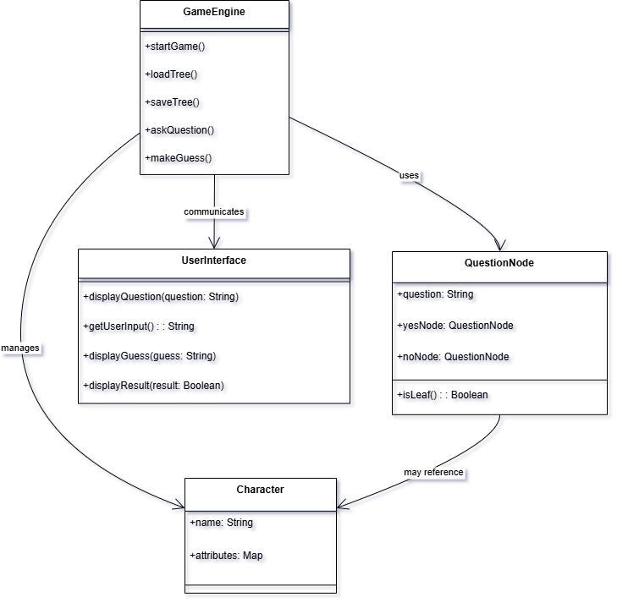

Use Case Diagram

Purpose:- The purpose of the Mind Mancer use case diagram is to depict the interactions between the system and external actors (the user and the system). It shows the different actions and processes that users can perform during the game, such as starting the game, answering questions, receiving guesses, adding characters, and viewing history.

Description:- The Mind Mancer use case diagram consists of two primary actors: the User and the System. The User can interact with the system by starting the game, answering questions, receiving guesses, adding new characters, and viewing the history of previous games. The System is responsible for asking questions, making guesses, and updating the knowledge base. The diagram shows the flow of these actions and identifies the relationships between the actors and their respective use cases.

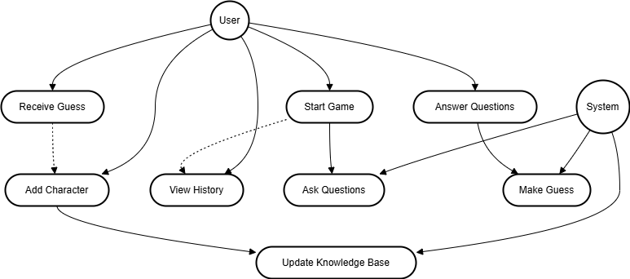

Activity Diagram

Purpose:- The purpose of the Mind Mancer activity diagram is to illustrate the flow of control and decision-making within the game. It shows the various steps involved in the game process, including asking questions, receiving answers, making a guess, and handling the outcome.

Description:- The Mind Mancer activity diagram outlines the sequence of activities that occur during gameplay. The game starts by asking the user a series of questions, with each answer leading to a new question or a guess. If the system's guess is correct, the game ends with a congratulatory message. If the guess is incorrect, the user is prompted to add a new character to the system’s knowledge base. The diagram shows the flow from the start of the game to either ending or learning new characters, including decision points for correct or incorrect guesses.

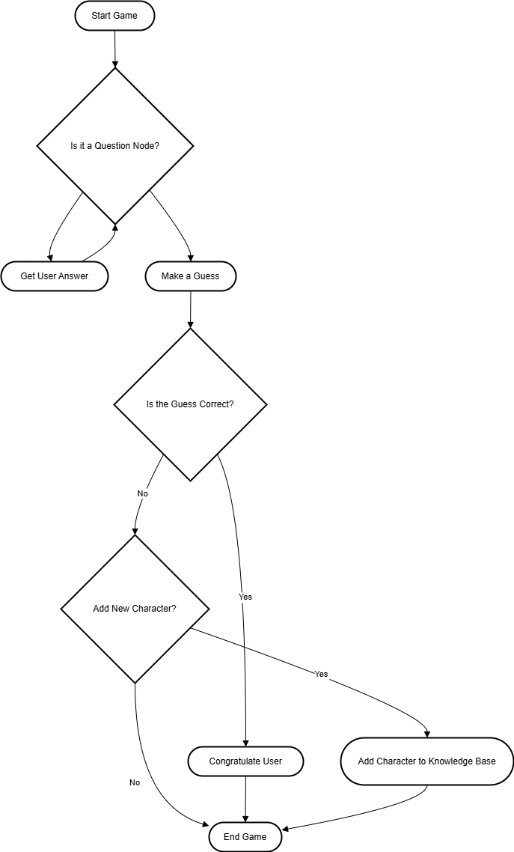

Sequence Diagram

Purpose:- The purpose of the Mind Mancer sequence diagram is to illustrate the interaction between different system components over time. It shows the sequence of messages exchanged between the user, user interface, game engine, and decision tree.

Description:- The Mind Mancer sequence diagram details the interactions between the User, User Interface, Game Engine, and Question Node during the game. The user interacts with the interface, which communicates with the game engine to retrieve and display questions. Based on the user’s responses, the game engine traverses the decision tree and makes a guess. If the guess is correct, the system congratulates the user; otherwise, the system prompts the user to add a new character to the knowledge base.

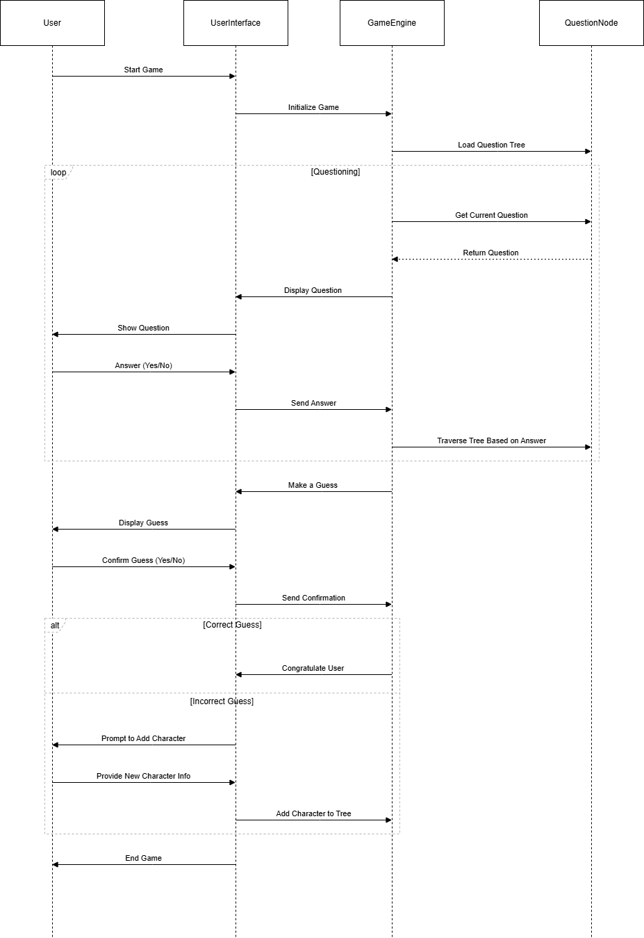

4.6 System Architecture

Component | Description
Frontend | HTML/CSS/JavaScript for User Interface (UI)
Backend | Python Flask server for handling application logic
Database | SQLAlchemy ORM to store and manage character data
AI Engine | Decision Tree algorithm for making predictions
Hosting | Cloud deployment on platforms like Heroku or Render

1. Frontend (Client Side)
- Core Technologies: Built using HTML5, CSS3, and JavaScript (Vanilla/ES6), the frontend handles the display of the game interface and user interactions.
- UI Libraries: Bootstrap and Google Fonts (Montserrat) help with layout and styling.
- Communication: The frontend communicates with the backend through AJAX requests made using the Fetch API to send and receive game data.

2. Backend (Server Side)
- Platform: The backend is built with Node.js, enabling server-side JavaScript execution.
- Web Framework: Express.js handles HTTP requests and serves the RESTful API.
- Middleware: CORS ensures safe cross-origin requests, while body-parser processes incoming JSON data.
- Database Interaction: The backend interacts with MongoDB using Mongoose to query and manage game data.

3. Database Layer
- MongoDB: The database stores game-related data like questions, responses, and user progress. It’s flexible and scalable, making it ideal for a dynamic game like Mind Mancer.
- MongoDB Compass: A GUI tool for database management during development.

4. Data Flow
- User Input: The user interacts with the game via the frontend, and the input is sent to the backend.
- Backend Processing: The backend processes the input, queries the database, and determines the next game step.
- Database Interaction: MongoDB stores and retrieves game data as needed.
- Frontend Update: The frontend updates with new game data and displays it to the user.
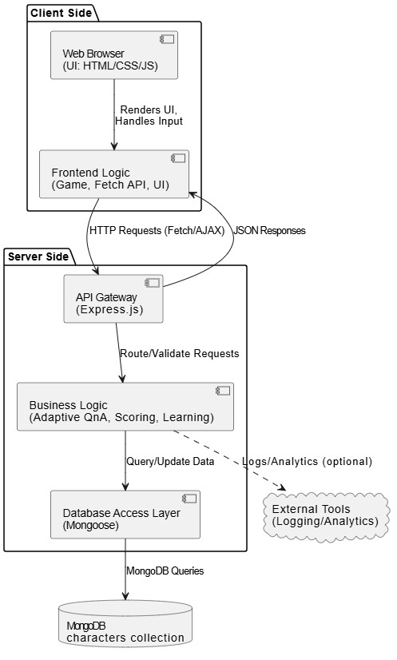

4.7 Technology Description

Technology | Role in the Project
HTML5 | Structuring the web pages and building the basic layout of the frontend.
CSS3 | Styling the web pages and ensuring responsive, attractive design.
JavaScript (ES6) | Implementing dynamic frontend behavior and backend server logic.
Bootstrap (Optional) | Accelerating frontend UI development with responsive components.
Node.js | Running the server-side backend logic using JavaScript.
Express.js | Creating RESTful APIs and managing HTTP requests and responses.
MongoDB | Storing game data such as questions, user responses, and game sessions.
Mongoose | Simplifying MongoDB database interactions using an object modeling approach.
Fetch API | Handling asynchronous communication between frontend and backend.
http-server | Serving static frontend files during local development.
Visual Studio Code | Main IDE used for development of frontend and backend code.
Git | Version control system for tracking and managing code changes.
MongoDB Compass | GUI tool for managing and visualizing MongoDB database content.

CHAPTER 5
IMPLEMENTATION & TESTING

5.1 Implementation & Testing

Splash Screen

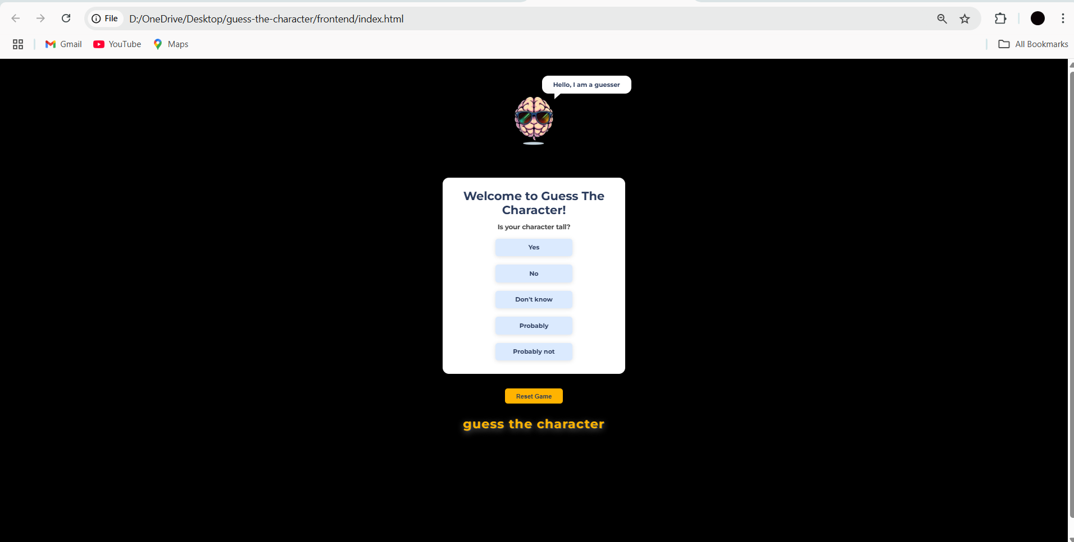

5.2 Testing

User need to select the options under the questions




Output


If the character guessed is incorrect we teach it

then adds succesfully to the data base.

5.3 Implementation Backend
1. Start MongoDB
Open a terminal and run:

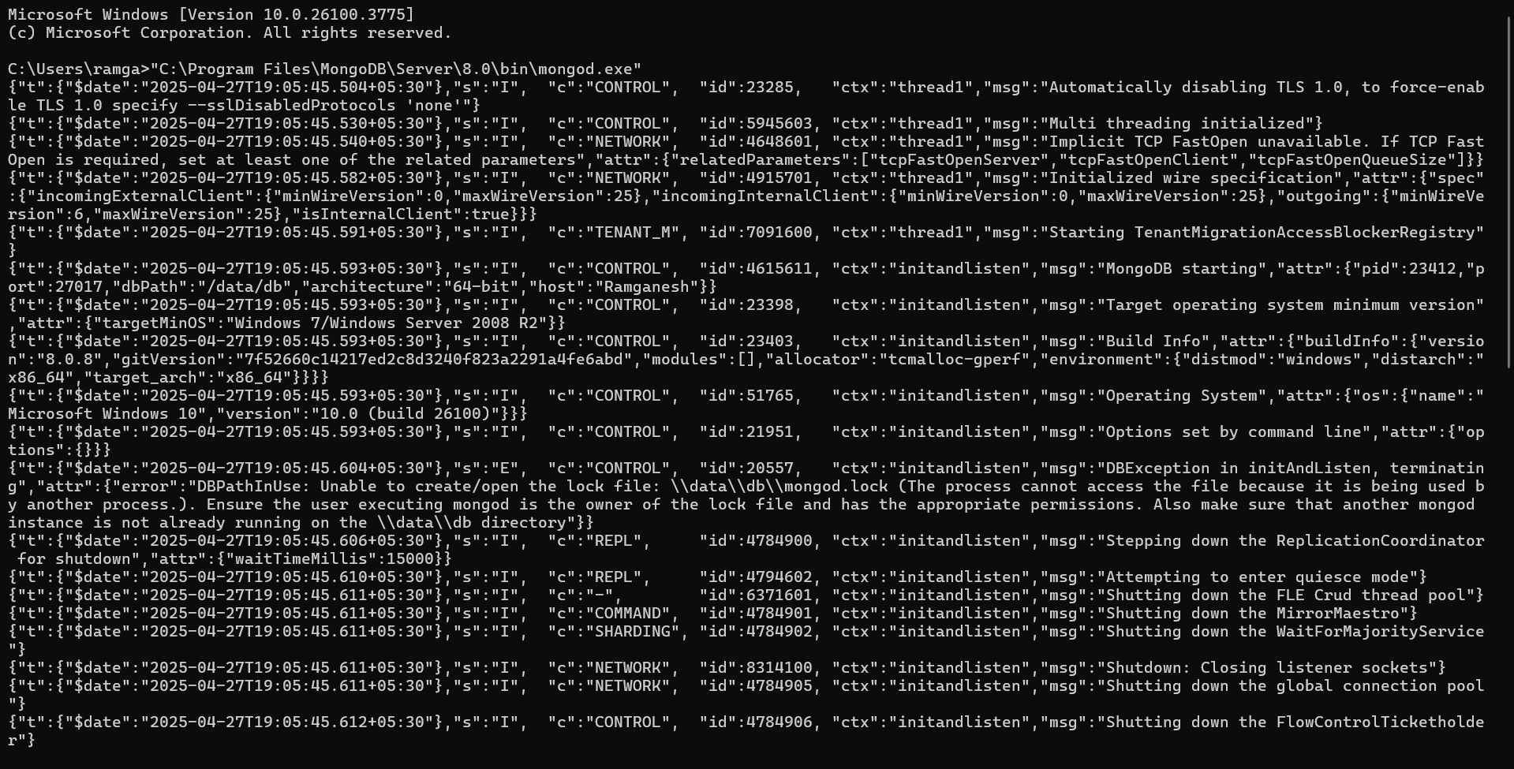
Leave this window open. If you see errors, create the data directory with mkdir C:\data\db and try again

2. Install Backend Dependencies
Open a new terminal, navigate to your backend folder, and run:
cd D:\OneDrive\Desktop\mind-mancer\backend
npm install

3. Start the Backend Server
In the same terminal:
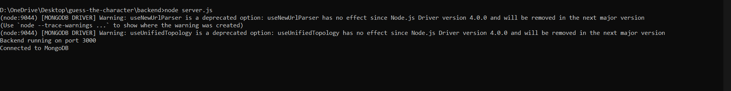
You should see:
Connected to MongoDB
Backend running on port 3000
4. Test Backend Endpoints
Open your browser and navigate to:
- http://localhost:3000/characters
- http://localhost:3000/properties
You should see JSON data. If not, check your backend terminal for errors.
5. Serve the Frontend
Open a new terminal, navigate to your frontend folder, and run:
cd D:\OneDrive\Desktop\guess-the-character\frontend
npx http-server -p 8080

If we want to update data to be updated in database we can directly update
In the browser when we guess the character
or else

In MongoDB compass we can update
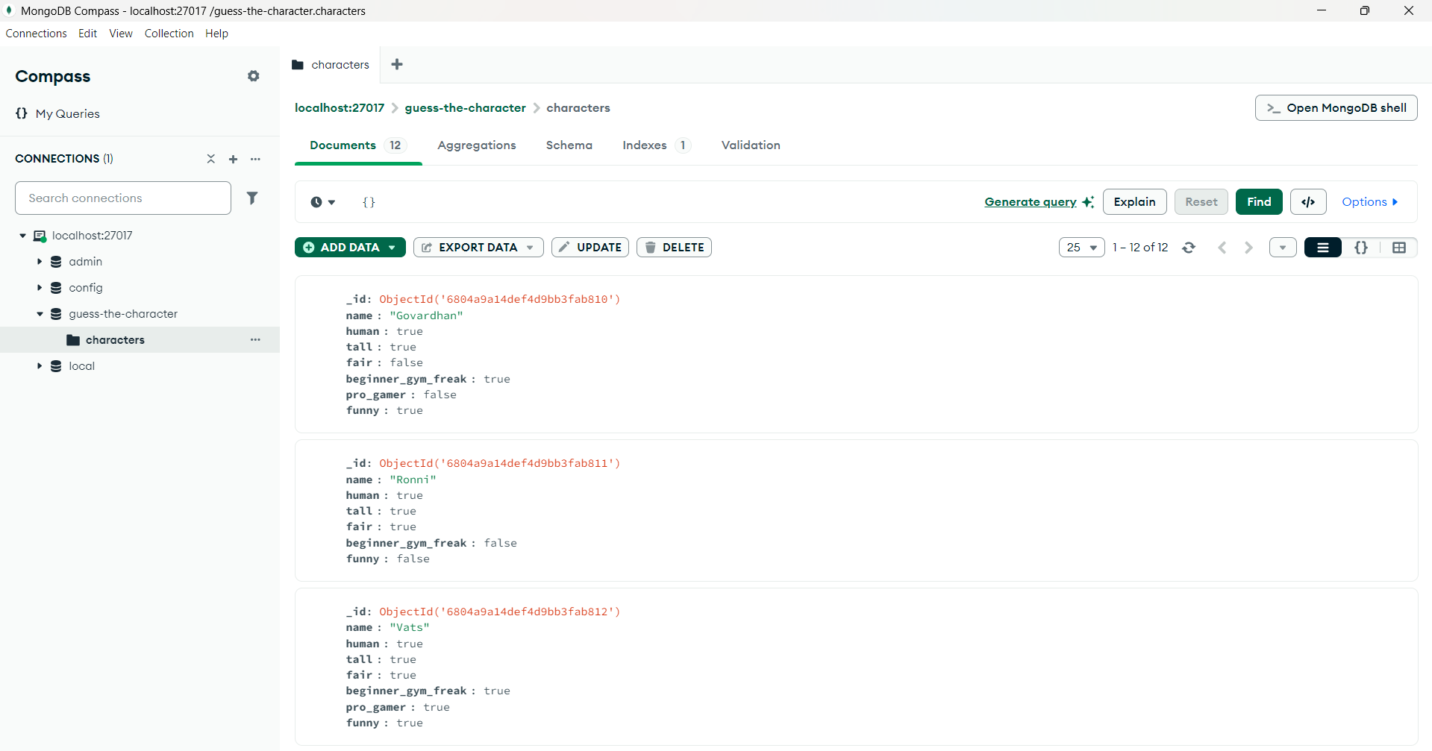
Conclusion & Future Scope

Conclusion:
The Mind Mancer project successfully demonstrates the potential of building an interactive web application using JavaScript, Node.js, Express.js, and MongoDB. Through a simple yet engaging user interface, the game is able to simulate the process of guessing a character or object that a user has in mind based on a series of adaptive questions. This project showcases how decision tree-based logic can be applied in real-time interactions to create a dynamic and evolving experience for users.
The application is designed to be both scalable and user-friendly, ensuring that it can handle multiple concurrent users while maintaining an intuitive interface. The game adapts to user responses, refining its questions to make more accurate guesses over time, providing a fun and personalized experience. The system architecture, built on a robust stack, allows for easy maintenance and future enhancements.
Overall, the Mind Mancer project provides a solid foundation for further developments in interactive gaming experiences. Its design emphasizes flexibility, scalability, and ease of use, with a focus on real-time decision-making and a dynamic question flow based on user feedback. It serves as a strong prototype for building more sophisticated interactive systems in the future.

Future Scope:

While Mind Mancer has been successfully implemented, there are several areas for future improvements and extensions to enhance the overall user experience and functionality:
- Advanced User Interaction:
  - Incorporating more sophisticated question types (e.g., multiple-choice, descriptive) could improve the game's adaptability and make it more engaging.
  - Voice recognition could be added to allow users to interact with the game using voice commands, improving accessibility.
- Expanding Knowledge Base:
  - Currently, the game is limited to a predefined set of objects or characters. Expanding the knowledge base to include a wider variety of objects, professions, or historical figures could make the game more interesting.
  - Implementing a user-generated content feature, where users can suggest new objects or categories, would keep the game dynamic and evolving.
- AI and Machine Learning Integration:
  - Although the current system uses decision tree logic, incorporating more advanced algorithms such as AI-based classification or adaptive learning techniques could improve the accuracy and speed of guessing.
  - Machine learning could be employed to analyze user interaction patterns and optimize the question sequence based on previous users' answers.
- Cloud Deployment and Scalability:
  - Hosting the application on a cloud platform like AWS, Heroku, or Vercel could allow the game to scale effortlessly, supporting many concurrent users. Implementing load balancing and auto-scaling would ensure consistent performance under high traffic.
  - Migrating the database to a cloud-hosted MongoDB Atlas would provide enhanced data management features, including automated backups and security.
- Mobile App Version:
  - Developing a mobile version of the game would increase accessibility and engagement by allowing users to play on smartphones and tablets.
  - Incorporating responsive design elements for a better mobile experience or creating a native mobile app using frameworks like React Native could help reach a larger audience.
- Multilingual Support:
  - To reach a global audience, the game could be adapted to support multiple languages, allowing users from different regions to enjoy the experience in their native language.
- User Authentication and Profiles:
  - Adding user authentication would allow for a more personalized experience, with saved progress, user statistics, and preferences. Users could also track their past games and see how their answers evolve over time.
Technology | Purpose for Future Enhancement
React.js / Vue.js | To enhance frontend scalability and maintainability with component-based UI.
Docker | For containerizing the application, enabling easier deployment and environment consistency.
MongoDB Atlas | To use a cloud-managed MongoDB database for better scalability, backups, and security.
Heroku / Vercel / Render | For cloud deployment of the application, ensuring high availability and easier scaling.
Machine Learning Models | To improve the guessing strategy and adaptive decision-making in the game logic.
WebSocket / Socket.io | To enable real-time interactions, such as multiplayer guessing sessions.
Mobile App Development (React Native) | To build mobile versions of the game for Android and iOS platforms.
Multilingual Support | To reach a broader audience by supporting multiple languages in the game.

REFERENCES

Books:
- "Node.js Design Patterns" by Mario Casciaro
  - This book offers a deep dive into designing scalable and maintainable systems using Node.js. It is helpful for understanding server-side architecture and backend best practices.
- "MongoDB: The Definitive Guide" by Kristina Chodorow
  - A must-read for understanding MongoDB, this book offers insight into document-based databases, data modeling, and performance tuning.
- "CSS Secrets: Better Solutions to Everyday Web Design Problems" by Lea Verou
  - This book focuses on advanced CSS techniques, which can help in creating polished and responsive user interfaces for web-based applications like Mind Mancer.

Research Papers:
- "A Survey of Question-Answering Systems" by Anthony R. H. and S. A. F.
  - This paper explores various question-answering systems, which is relevant for understanding the logic and design of interactive question-based games like Mind Mancer.
- "The Use of Interactive Games in Cognitive Learning Systems" by D. B. H.
  - This paper examines how interactive games can be used to engage users in cognitive learning, providing insights into how Mind Mancer's interaction logic might be improved for educational or cognitive purposes.

Websites and Blogs:
- Node.js Official Documentation
URL: https://nodejs.org/en/docs/
  - The official Node.js documentation is an invaluable resource for understanding the runtime environment and its usage in backend development.
- MongoDB Official Documentation
URL: https://docs.mongodb.com/
  - MongoDB’s official documentation provides detailed information on setting up, querying, and optimizing MongoDB databases.
- MDN Web Docs (JavaScript, HTML, CSS)
URL: https://developer.mozilla.org/en-US/
  - The Mozilla Developer Network (MDN) offers comprehensive documentation on JavaScript, HTML5, and CSS3, which are essential for building the frontend and backend of the application.
- Express.js Official Website
URL: https://expressjs.com/
  - Express.js is the web framework used for the backend of Mind Mancer. The official website provides a wealth of information on its usage, routing, and middleware.
- Stack Overflow
URL: https://stackoverflow.com/
  - Stack Overflow is an essential resource for troubleshooting issues and finding solutions to common challenges in web development and game design.

Tools and Libraries:
- Bootstrap Documentation
URL: https://getbootstrap.com/docs/
  - Bootstrap can be used to speed up the development of the frontend by providing pre-made components for layout and design.
- Mongoose Documentation
URL: https://mongoosejs.com/docs/
  - Mongoose is a MongoDB object modeling tool for Node.js, and the documentation helps in designing the database schema and handling data interactions.

Online Articles and Tutorials:
- "How to Build a Question-Answer Game with Node.js" by Dev.to
URL: https://dev.to/
  - A step-by-step tutorial on creating a question-answer game using Node.js, which may serve as a foundation for building the question interaction system in Mind Mancer.
- "Building a REST API with Express.js" by DigitalOcean
URL: https://www.digitalocean.com/community/tutorials/
  - This tutorial helps with setting up a RESTful API using Express.js, which is essential for the backend of your game.

