BIOLOGY PROJECT



Made by

Cells

Table of Contents

I. The Idea Of The Project 3

II. Team Members 3

III. Stages Of Work 4

IV. Project Decription 5

V. Block Diagram 6

VI. Functions 6

1. The Idea Of The Project

Program for 8th and 9th grade students studying biology. It is in the form of a game that will benefit students to learn essential things related to the study material in an easy and accessible and interesting way.

1. Team Members

|  |  |  |
| --- | --- | --- |
| Name | Role | Class |
| Nikoleta Ruseva | Scrum Trainer | 10A |
| Filipa Popova | Back-End Developer | 10B |
| Kaloyan Georgiev | Back-End Developer | 10V |
| Stelian Nikolov | Front-End Developer | 10G |

1. Stages Of Work

|  |  |
| --- | --- |
| № | Stages |
| **1** | Assembling the team  We gathered and distributed the roles, so each person can work on the field that is most competent with. We started thinking about an idea fot the project |
| **2** | The process of creating  Every week we met and discussed how we were progressing with the project. Each member fulfilled their duties and if we fell behind with our project we helped each other. |
| **3** | Finishing the project  After we finished with the project and the documentation, we fixed some bugs and made the overall user experience a bit more pleasant. |
| **4** | Presenting the product  After weeks of hard working and sleepless nights we finished the project and now it is ready to be presented. |

1. Project Decription

|  |  |
| --- | --- |
| № | Description |
| **1** | Description  Program for 8th and 9th grade students studying biology. It is in the form of a game that will benefit students to learn essential things related to the study material in an easy and accessible and interesting way. |
| **2** | How to access the project  You can access our website by pasting this link into your browser: https://github.com/NRRuseva21/Cells |
| **3** | Team work  The main communication platform is Microsoft Teams. During the project we stayed in touch with each others. |
| **4** | The technologies that are used  The technologies used are Visual Studio, GitHub - collaborative work, Microsoft Teams - communication, PowerPoint - presentation, Word - documentation, Excel – the QA tests. |

1. Block Diagram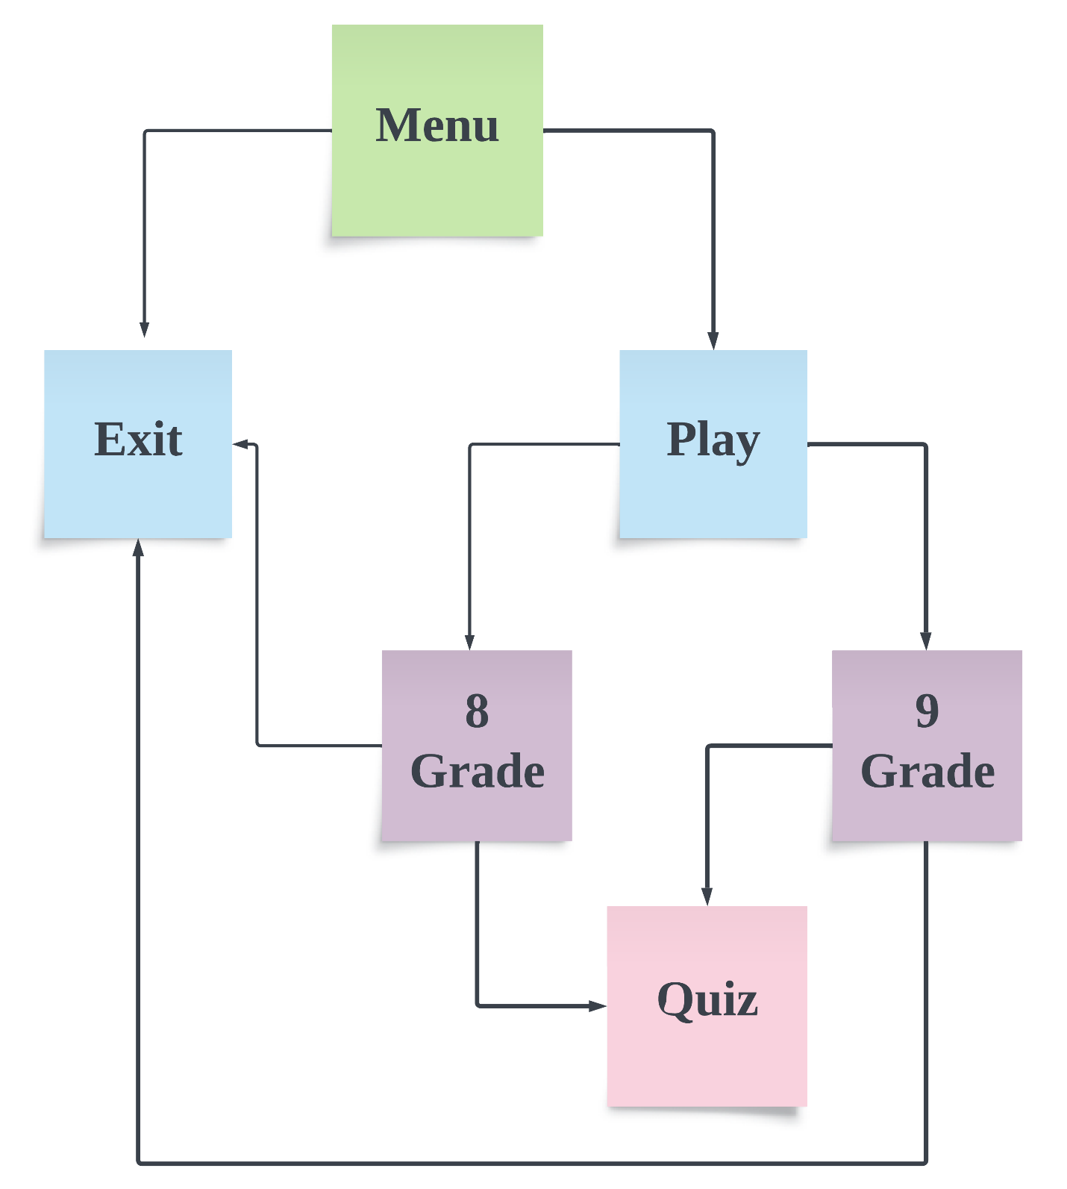
2. Functions

|  |  |  |  |
| --- | --- | --- | --- |
| Type | Name | Description | |
| void | mainMenu() | | Menu main function. Create game menu. Calls all menu functions |
| void | theTopics() | | Creates two topics which the user should choose. |
| void | correct91() | | Function for correct answer 9 grade |
| void | correct92() | | Function for correct answer 9 grade |
| void | correct93() | | Function for correct answer 9 gradev |
| void | correct94() | | Function for correct answer 9 grade |
| void | correct95() | | Function for correct answer 9 grade |
| void | question91() | | Function for the question 9 grade |
| void | question92() | | Function for the question 9 grade |
| void | question93() | | Function for the question 9 grade |
| void | question94() | | Function for the question 9 grade |
| void | question95() | | Function for the question 9 grade |
| void | result9() | | Function which counts how many correct answers you got and at the end of the quiz you see your result, 9 grade |
| void | wrong91() | | Function for wrong answer 9 grade |
| void | wrong92() | | Function for wrong answer 9 grade |
| void | wrong93() | | Function for wrong answer 9 grade |
| void | wrong94() | | Function for wrong answer 9 grade |
| void | wrong95() | | Function for wrong answer 9 grade |
| void | correct81() | | Function for correct answer 8 grade |
| void | correct82() | | Function for correct answer 8 grade |
| void | correct83() | | Function for correct answer 8 grade |
| void | correct84() | | Function for correct answer 8 grade |
| void | correct85() | | Function for correct answer 8 grade |
| void | question81() | | Function for the question 8 grade |
| void | question82() | | Function for the question 8 grade |
| void | question83() | | Function for the question 8 grade |
| void | question84() | | Function for the question 8 grade |
| void | question85() | | Function for the question 8 grade |
| void | result8() | | Function which counts how many correct answers you got and at the end of the quiz you see your result, 8 grade |
| void | wrong81() | | Function for wrong answer 8 grade |
| void | wrong82() | | Function for wrong answer 8 grade |
| void | wrong83() | | Function for wrong answer 8 grade |
| void | wrong84() | | Function for wrong answer 8 grade |
| void | wrong85() | | Function for wrong answer 8 grade |