**CELLS TEST PLAN**

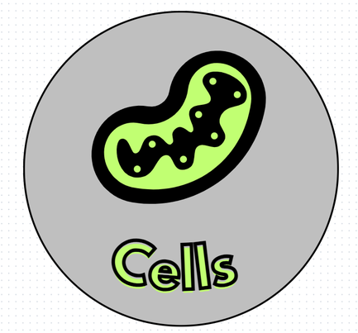

made by

Cells

**Contents**

1. Introduction 3

2. Entry and Exit requirements 3

3. Project goals 4

4. Tasks 4

5. Testing 5

6. Testing process 5

# **Introduction**

Program for 8th and 9th grade students studying biology. It is in the form of a game that will benefit students to learn essential things related to the study material in an easy and accessible and interesting way.

# **Entry and Exit requirements**

Exit

* Most of the tests are successful.
* There are no errors preventing the program from working.

Entry

* Access to the game is provided.
* The first tests begin.

# Project goals

We aimed to organize ourselves well as a team and create a working program that people could use as a form of entertainment that also helps improving their thinking.

# Tasks

The tasks that must be done to ensure our success are:

* To test the most important elements.
* Create multiple test cases.
* To prepare test and bug documentation.

# Testing

Manual testing

* Menu options.
* Checking that error messages are displayed.
* Checking that the correct values are accepted by the code.
* Function testing.

# Testing process

Test results

* Excel table
* Test plan

Resources

* Excel for test management.
* Word for Test Plan
* GitHub for reporting issues.