# Module 4 - Assignment 2

## Random Forests

### Nicole Westrick

names(drug) = c("ID", "Age", "Gender", "Education", "Country", "Ethnicity",  
"Nscore", "Escore", "Oscore", "Ascore", "Cscore", "Impulsive",  
"SS", "Alcohol", "Amphet", "Amyl", "Benzos", "Caff", "Cannabis",  
"Choc", "Coke", "Crack", "Ecstasy", "Heroin", "Ketamine", "Legalh",  
"LSD", "Meth", "Mushrooms", "Nicotine", "Semer", "VSA")

drug[drug == "CL0"] = "No"  
drug[drug == "CL1"] = "No"  
drug[drug == "CL2"] = "Yes"  
drug[drug == "CL3"] = "Yes"  
drug[drug == "CL4"] = "Yes"  
drug[drug == "CL5"] = "Yes"  
drug[drug == "CL6"] = "Yes"

drug_clean = drug %>% mutate_at(vars(Age:Ethnicity), funs(as_factor)) %>%  
mutate(Age = factor(Age, labels = c("18_24", "25_34", "35_44",  
"45_54", "55_64", "65_"))) %>%  
mutate(Gender = factor(Gender, labels = c("Male", "Female"))) %>%  
mutate(Education = factor(Education, labels =  
c("Under16", "At16", "At17", "At18", "SomeCollege",  
"ProfessionalCert", "Bachelors", "Masters", "Doctorate"))) %>%  
mutate(Country = factor(Country,  
labels = c("USA", "NewZealand", "Other", "Australia",  
"Ireland","Canada","UK"))) %>%  
mutate(Ethnicity = factor(Ethnicity,  
labels = c("Black", "Asian", "White", "White/Black", "Other",  
"White/Asian", "Black/Asian"))) %>%  
mutate_at(vars(Alcohol:VSA), funs(as_factor)) %>%  
select(-ID)

## Warning: `funs()` is deprecated as of dplyr 0.8.0.  
## Please use a list of either functions or lambdas:   
##   
## # Simple named list:   
## list(mean = mean, median = median)  
##   
## # Auto named with `tibble::lst()`:   
## tibble::lst(mean, median)  
##   
## # Using lambdas  
## list(~ mean(., trim = .2), ~ median(., na.rm = TRUE))  
## This warning is displayed once every 8 hours.  
## Call `lifecycle::last_warnings()` to see where this warning was generated.

drug_clean = drug_clean %>% select(!(Alcohol:Mushrooms)) %>% select(!(Semer:VSA))  
names(drug_clean)

## [1] "Age" "Gender" "Education" "Country" "Ethnicity" "Nscore"   
## [7] "Escore" "Oscore" "Ascore" "Cscore" "Impulsive" "SS"   
## [13] "Nicotine"

**Task 1:**

summary(drug_clean)

## Age Gender Education Country   
## 18_24:643 Male :943 SomeCollege :506 USA : 557   
## 25_34:481 Female:942 Bachelors :480 NewZealand: 5   
## 35_44:356 Masters :283 Other : 118   
## 45_54:294 ProfessionalCert:270 Australia : 54   
## 55_64: 93 At18 :100 Ireland : 20   
## 65_ : 18 At16 : 99 Canada : 87   
## (Other) :147 UK :1044   
## Ethnicity Nscore Escore Oscore   
## Black : 33 Min. :-3.464360 Min. :-3.273930 Min. :-3.273930   
## Asian : 26 1st Qu.:-0.678250 1st Qu.:-0.695090 1st Qu.:-0.717270   
## White :1720 Median : 0.042570 Median : 0.003320 Median :-0.019280   
## White/Black: 20 Mean : 0.000047 Mean :-0.000163 Mean :-0.000534   
## Other : 63 3rd Qu.: 0.629670 3rd Qu.: 0.637790 3rd Qu.: 0.723300   
## White/Asian: 20 Max. : 3.273930 Max. : 3.273930 Max. : 2.901610   
## Black/Asian: 3   
## Ascore Cscore Impulsive   
## Min. :-3.464360 Min. :-3.464360 Min. :-2.555240   
## 1st Qu.:-0.606330 1st Qu.:-0.652530 1st Qu.:-0.711260   
## Median :-0.017290 Median :-0.006650 Median :-0.217120   
## Mean :-0.000245 Mean :-0.000386 Mean : 0.007216   
## 3rd Qu.: 0.760960 3rd Qu.: 0.584890 3rd Qu.: 0.529750   
## Max. : 3.464360 Max. : 3.464360 Max. : 2.901610   
##   
## SS Nicotine   
## Min. :-2.078480 Yes:1264   
## 1st Qu.:-0.525930 No : 621   
## Median : 0.079870   
## Mean :-0.003292   
## 3rd Qu.: 0.765400   
## Max. : 1.921730   
##

There is not any missing data.

**Task 2:**

set.seed(1234)   
drug_split = initial_split(drug_clean, prop = 0.7, strata = Nicotine)   
train = training(drug_split)  
test = testing(drug_split)

**Task 3:**

p1 = ggplot(train, aes(x = Age, fill = Nicotine)) + geom_bar(position = "fill") + theme(axis.text.x = element_text(angle = 90))   
p2 = ggplot(train, aes(x = Gender, fill = Nicotine)) + geom_bar(position = "fill")  
p3 = ggplot(train, aes(x = Education, fill = Nicotine)) + geom_bar(position = "fill") + theme(axis.text.x = element_text(angle = 90))  
p4 = ggplot(train, aes(x = Country, fill = Nicotine)) + geom_bar(position = "fill") + theme(axis.text.x = element_text(angle = 90))  
grid.arrange(p1,p2,p3,p4)

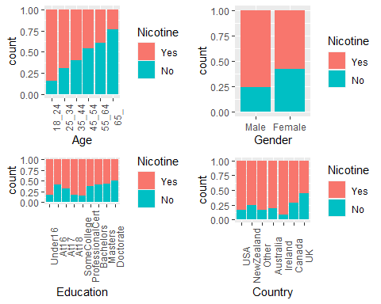

p5 = ggplot(train, aes(x = Ethnicity, fill = Nicotine)) + geom_bar(position = "fill") + theme(axis.text.x = element_text(angle = 90))  
p6 = ggplot(train, aes(x = Nicotine, y = Nscore)) + geom_boxplot()  
p7 = ggplot(train, aes(x = Nicotine, y = Escore)) + geom_boxplot()  
p8 = ggplot(train, aes(x = Nicotine, y = Oscore)) + geom_boxplot()  
grid.arrange(p5,p6,p7,p8)

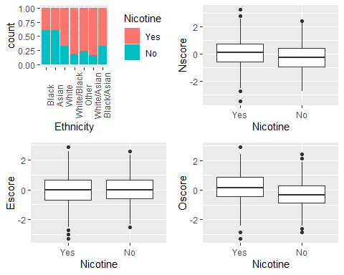

p9 = ggplot(train, aes(x = Nicotine, y = Ascore)) + geom_boxplot()  
p10 = ggplot(train, aes(x = Nicotine, y = Cscore)) + geom_boxplot()  
p11 = ggplot(train, aes(x = Nicotine, y = Impulsive)) + geom_boxplot()  
p12 = ggplot(train, aes(x = Nicotine, y = SS)) + geom_boxplot()  
grid.arrange(p9,p10,p11,p12)

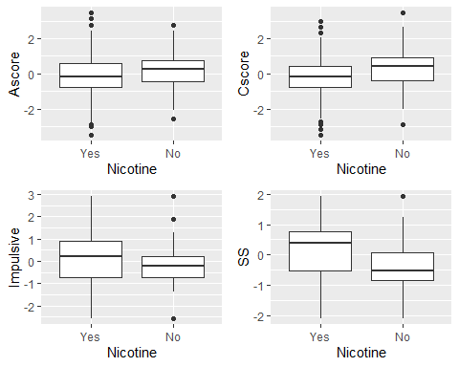

For age, it appears that Nicotine consumption is decreases as age increases. The age group with the highest Nicotine consumption is 18 to 24.

For gender, it appears that males have higher Nicotine consumption, compared to females.

For education, the highest Nicotine consumption is for those who left school before 16, at 18, and those that had some college but no certificate or degree.

For country, the country with the highest Nicotine consumption is Ireland. The country with the least Nicotine consumption is the UK.

For ethnicity, white/asian and white/black have the highest Nicotine consumption, and black and asian have the lowest.

There is no significant difference in Nscore, for neuroticism, between those who consume Nicotine and those who do not.

There is no significant difference in Escore, for extraversion, between those who consume Nicotine and those who do not.

There is no significant difference in Oscore, for openness to experience, between those who consume Nicotine and those who do not.

There is no significant difference in Ascore, for agreeableness, between those who consume Nicotine and those who do not.

There is no significant difference in Cscore, for conscientiousness, between those who consume Nicotine and those who do not.

It appears that those who consume Nicotine score slightly higher on impulsiveness scales than those who do not consume Nicotine.

It appears that those who consume Nicotine score higher, on average, on sensation seeing than those who do not consume Nicotine.

**Task 4:**

set.seed(123)  
rf_folds = vfold_cv(train, v = 5)

train_recipe = recipe(Nicotine ~., train) %>%  
 step_dummy(all_nominal(), -all_outcomes())  
  
rf_model = rand_forest(mtry = tune(), min_n = tune(), trees = 100) %>%   
 set_engine("ranger", importance = "permutation") %>%   
 set_mode("classification")  
  
train_wflow =   
 workflow() %>%   
 add_model(rf_model) %>%   
 add_recipe(train_recipe)  
  
rf_grid = grid_regular(  
 mtry(range = c(2, 8)),   
 min_n(range = c(5, 20)),   
 levels = 10  
)  
  
set.seed(123)  
rf_res_tuned = tune_grid(  
 train_wflow,  
 resamples = rf_folds,  
 grid = rf_grid   
)

##   
## Attaching package: 'rlang'

## The following objects are masked from 'package:purrr':  
##   
## %@%, as_function, flatten, flatten_chr, flatten_dbl, flatten_int,  
## flatten_lgl, flatten_raw, invoke, list_along, modify, prepend,  
## splice

##   
## Attaching package: 'vctrs'

## The following object is masked from 'package:dplyr':  
##   
## data_frame

## The following object is masked from 'package:tibble':  
##   
## data_frame

rf_res_tuned %>%  
 collect_metrics() %>%  
 filter(.metric == "accuracy") %>%  
 select(mean, min_n, mtry) %>%  
 pivot_longer(min_n:mtry,  
 values_to = "value",  
 names_to = "parameter"  
 ) %>%  
 ggplot(aes(value, mean, color = parameter)) +  
 geom_point(show.legend = FALSE) +  
 facet_wrap(~parameter, scales = "free_x") +  
 labs(x = NULL, y = "Accuracy")

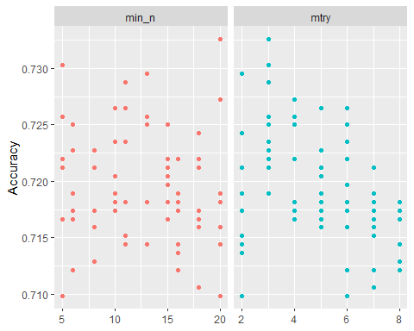

rf_res_tuned %>%  
 collect_metrics() %>%  
 filter(.metric == "accuracy") %>%  
 mutate(min_n = factor(min_n)) %>%  
 ggplot(aes(mtry, mean, color = min_n)) +  
 geom_line(alpha = 0.5, size = 1.5) +  
 geom_point() +  
 labs(y = "Accuracy")

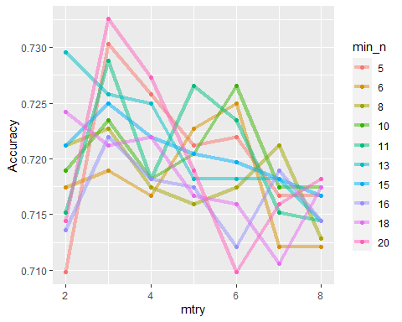

**Task 5:**

best_rf = select_best(rf_res_tuned, "accuracy")  
  
final_rf = finalize_workflow(  
 train_wflow,  
 best_rf  
)  
  
final_rf

## == Workflow ====================================================================  
## Preprocessor: Recipe  
## Model: rand_forest()  
##   
## -- Preprocessor ----------------------------------------------------------------  
## 1 Recipe Step  
##   
## * step_dummy()  
##   
## -- Model -----------------------------------------------------------------------  
## Random Forest Model Specification (classification)  
##   
## Main Arguments:  
## mtry = 3  
## trees = 100  
## min_n = 20  
##   
## Engine-Specific Arguments:  
## importance = permutation  
##   
## Computational engine: ranger

final_rf_fit = fit(final_rf, train)

final_rf_fit %>% pull_workflow_fit() %>% vip(geom = "point")

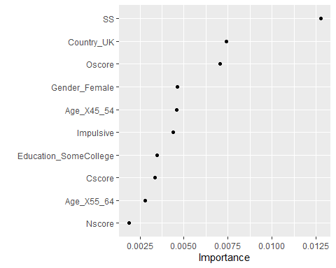

It appears that SS (sensation seeing), Country (UK), and Oscore (openness to experience) are the most important variables in this model.

**Task 6:**

trainpredrf = predict(final_rf_fit, train)  
head(trainpredrf)

## # A tibble: 6 x 1  
## .pred_class  
## <fct>   
## 1 Yes   
## 2 Yes   
## 3 Yes   
## 4 No   
## 5 Yes   
## 6 Yes

confusionMatrix(trainpredrf$.pred_class, train$Nicotine,   
 positive = "Yes")

## Confusion Matrix and Statistics  
##   
## Reference  
## Prediction Yes No  
## Yes 850 171  
## No 35 264  
##   
## Accuracy : 0.8439   
## 95% CI : (0.8232, 0.8631)  
## No Information Rate : 0.6705   
## P-Value [Acc > NIR] : < 2.2e-16   
##   
## Kappa : 0.6163   
##   
## Mcnemar's Test P-Value : < 2.2e-16   
##   
## Sensitivity : 0.9605   
## Specificity : 0.6069   
## Pos Pred Value : 0.8325   
## Neg Pred Value : 0.8829   
## Prevalence : 0.6705   
## Detection Rate : 0.6439   
## Detection Prevalence : 0.7735   
## Balanced Accuracy : 0.7837   
##   
## 'Positive' Class : Yes   
##

This model is 84% accurate on the training set, which is very good.

testpredrf = predict(final_rf_fit, test)  
head(testpredrf)

## # A tibble: 6 x 1  
## .pred_class  
## <fct>   
## 1 Yes   
## 2 No   
## 3 No   
## 4 Yes   
## 5 No   
## 6 Yes

confusionMatrix(testpredrf$.pred_class, test$Nicotine,   
 positive = "Yes")

## Confusion Matrix and Statistics  
##   
## Reference  
## Prediction Yes No  
## Yes 337 121  
## No 42 65  
##   
## Accuracy : 0.7115   
## 95% CI : (0.6722, 0.7486)  
## No Information Rate : 0.6708   
## P-Value [Acc > NIR] : 0.02111   
##   
## Kappa : 0.2676   
##   
## Mcnemar's Test P-Value : 9.999e-10   
##   
## Sensitivity : 0.8892   
## Specificity : 0.3495   
## Pos Pred Value : 0.7358   
## Neg Pred Value : 0.6075   
## Prevalence : 0.6708   
## Detection Rate : 0.5965   
## Detection Prevalence : 0.8106   
## Balanced Accuracy : 0.6193   
##   
## 'Positive' Class : Yes   
##

This model is 71% accurate on the testing set, which is good.

**Task 7:**

This model could be used in the real world for education and healthcare. Being able to accurately predict groups at higher risks of nicotine dependency, can help professionals target these groups for special education. I would recommend this model for real world use, however, I would warn that no test or model is perfect. Individual assessment is key in most situations.