ROBUST DOC
Evaluating Structural Robustness of Malicious Document Detectors Under Controlled Mutation
Final Project Deliverable: | Comprehensive Capstone / Final Research Project Report (100% Completion)
Investigators / Authors: | Jasmeet Ranjan Srivastava (23BCI0019) | Radhanjan Neelamraju (23BCI0126)
Research Domain: | Machine Learning in Cybersecurity / Malware Evasion & Feature Robustness
Artifact Codebase: | C:\Users\user\.gemini\antigravity\scratch\pdf-robustness-study

1. Executive Summary & Abstract
Machine learning detectors for malicious portable document formats (PDFs) routinely boast classification accuracies exceeding 98% on static benchmarks. However, conventional benchmarks obscure a critical structural vulnerability: classifiers are evaluated on static files with identical packaging, revealing nothing about how detection features behave when documents undergo everyday, structure-preserving transformations (e.g., resaving, stream recompression, or metadata editing).
In this work, we present 'ROBUST DOC', an empirical stress-testing framework that evaluates feature-level stability and decision-boundary fragility in learning-based PDF detectors under controlled, non-adversarial structural mutations. Unlike prior evasion literature that focuses on mathematically guided adversarial search (EvadeML, genetic algorithms), we investigate benign structural noise that occurs naturally in document distribution pipelines. Crucially, we introduce an automated Two-Stage Validity Gatekeeper (V1–V4) ensuring that any post-mutation detection drop reflects genuine feature fragility rather than accidental destruction of the malicious payload.
We evaluate our framework across a curated benchmark of 100 PDF documents (50 benign and 50 malicious, comprising real-world CVE exploits such as CVE-2024-4367 and CVE-2019-14811 alongside diverse structural malware triggers). Through 1,500 continuous-intensity trials across five classifier architectures, we reveal that while Random Forest retains an aggregate retention of 97.3%, individual models such as Decision Trees (16.0% retention), Gradient Boosting (16.0% retention), and Support Vector Machines (2.0% retention) suffer near-total collapse under routine mutations. Furthermore, continuous degradation curves demonstrate that malicious confidence plunges by up to 48% under metadata tampering and object reordering without altering execution triggers. Finally, we formalize our empirical stability findings into a 'Hardened Detector' blueprint that eliminates volatile packaging features, retaining 94.7% robust detection under intense structural mutation.
2. Research Question & Methodological Novelty
The Research Question: "How robust are malicious-document detection methods when the same documents undergo structure-preserving mutations — and which specific features remain reliable versus which are fragile?"
To position this research, we emphasize an intuitive analogy: We are not attempting to engineer a 'faster car' (a novel classifier). Instead, we are rigorously stress-testing how standard cars perform on gravel, in torrential rain, and uphill. The detector is the car; the controlled structural mutations are the test conditions.
Evaluation Dimension | Conventional Evasion Research | Our ROBUST DOC Methodology
Threat Model | Targeted, mathematically optimized adversarial evasion (genetic algorithms, gradient white-box attacks). | Routine, non-adversarial structural transformations occurring in standard document workflows.
Evaluation Output | A single aggregate accuracy percentage or binary pass/fail evasion rate. | Continuous degradation curves (0-100% intensity) and per-feature stability percentage matrices.
Validity Verification | Manual sampling or external sandboxes that frequently ignore broken syntax. | Automated two-stage gatekeeper verifying parser syntax AND structural trigger reachability (/OpenAction, /AA).
Defensive Takeaway | Adversarial retraining that often causes elevated false-positive rates on normal enterprise PDFs. | Empirically validated feature selection blueprint proving which features to drop and which to conserve.
3. System Architecture & Technical Implementation
ROBUST DOC is engineered in a clean, decoupled two-layer hierarchy:
• Layer A — Baseline Detector (The Subject): Deliberately conforms to industry-standard feature-based detection (extracting 28 PDFRate/Mimicus features and classifying with multi-model architectures).
• Layer B — Mutation Engine & Robustness Diagnostic (The Contribution): Controlled structural perturbation engine paired with automated validity gatekeeping and continuous confidence degradation tracking.
3.1 28-Dimensional Static Feature Extractor (extractor.py)
The extraction pipeline couples low-level C++ QPDF parsing (via pikepdf) with raw byte pattern scans to extract four feature classes:
1. Document Structural Metrics: file_size, byte_entropy (Shannon entropy across byte distribution), num_pages, num_objects, num_streams, num_compressed_streams, ratio_compressed_streams, num_indirect_objects, num_trailer_entries.
2. Suspicious Triggers & Actions: count_javascript, count_js, count_openaction, count_aa (Additional Actions), count_acroform, count_launch, count_embedded_files, count_annot, count_uri, count_richmedia.
3. Object Graph Hierarchy: has_xref_stream, has_objstm (Object Stream presence).
4. Information Dictionary Metadata: metadata_length, has_title, has_author, has_creator, has_producer, has_creation_date, has_mod_date.
3.2 Layer B: Structural Mutation Engines (mutations/)
Each mutation implements an abstract interface parameterized by an intensity argument lambda in [0.1, 1.0]:
• Mutation 1 — Metadata Perturbation (metadata_mutation.py): Systematically alters, randomizes, or strips the document information dictionary and XMP metadata packets without modifying the payload. Simulates PDF printer drivers, redaction tools, and metadata sanitizers.
• Mutation 2 — Stream Recompression (stream_recompression.py): Modifies internal stream compression filters (FlateDecode). Selectively decompresses or recompresses data streams while preserving exact byte-for-byte stream payloads. Simulates PDF optimization tools.
• Mutation 3 — Object Reordering & Linearization (object_reordering.py): Reorganizes the physical sequence of indirect objects, converts between cross-reference tables and cross-reference streams, and applies Fast Web View linearization algorithms.
3.3 Automated Safety Gatekeeper (validator.py)
To neutralize the experimental confound (mistaking broken malware for feature fragility), every candidate mutated PDF must pass four rigorous validation gates before being logged in results:
• Gate V1 (Structural Parsing): The mutated PDF must parse cleanly using conformant parsers without fatal EOF or xref exceptions.
• Gate V2 (Document Catalog Health): The trailer, root catalog, and page tree must resolve properly.
• Gate V3 (Trigger Reachability): If /Root -> /OpenAction, /AA, or /Names -> /JavaScript existed in the original document, the validator verifies that the target action dictionary remains connected and points to a non-null target stream.
• Gate V4 (Stream Content Preservation): Verifies that payload data streams are not truncated or hollowed out. Mutants that fail are discarded from detection statistics.
4. Dataset Curation & Benchmark Composition
The experimental benchmark consists of 100 thoroughly vetted PDF documents, balanced evenly between 50 benign controls and 50 malicious files:
Dataset Subset | Sample Count | Technical Composition & Source
Real-World In-the-Wild Exploits | 10 Malicious PoCs | Acquired from published CVE security research repositories: CVE-2024-4367 (Arbitrary JavaScript execution in PDF.js), CVE-2019-14811 (Ghostscript sandbox escape), and pentest exploit vectors.
Real-World Benign Documents | 10 Benign PDFs | Acquired from the official Mozilla PDF.js test repository. Features complex typography, Type3 fonts, multilingual CJK/Arabic encodings, and Apache PDFBox documents.
Synthetic Structural Benchmark | 80 PDFs  (40 Benign, 40 Malicious) | Synthesized using make_samples.py with deterministic structural ground truth: /OpenAction JS streams, /Launch commands, /AA triggers, /EmbeddedFiles trees, and enterprise corporate document formats.
5. Empirical Results & Degradation Analysis
Using our automated testbed, we executed 1,500 continuous-intensity trials across all 50 malicious files. Each file was evaluated across 10 mutation intensity levels (lambda = 0.1 to 1.0) for each of the three mutation engines.
5.1 Multi-Model Robustness Benchmark
To test whether feature fragility is an artifact of a single algorithm or an architectural property of the feature space, we benchmarked five classifier families at an operational mutation intensity of lambda = 0.8:
Classifier Architecture | Trials Evaluated | Retained Malicious | Retention Rate | Empirical Robustness Band
Random Forest (Baseline) | 150 | 146 | 97.3% | High Robustness (Ensemble Averaging)
Hardened Random Forest (Blueprint) | 150 | 142 | 94.7% | High Robustness (Invariant Conserved)
Decision Tree (Single Estimator) | 150 | 24 | 16.0% | Extremely Vulnerable (Split Fragility)
Gradient Boosting (GBDT) | 150 | 24 | 16.0% | Extremely Vulnerable (Sequential Residuals)
Support Vector Machine (RBF Kernel) | 150 | 3 | 2.0% | Near-Total Collapse (Metric Distortion)
Critical Discovery: Classifiers without bagging (Decision Trees, GBDT, and SVM) suffer catastrophic collapse (dropping to 2-16% retention). Because SVM computes distances across the feature space, mild structural transformations (e.g. 500-byte shifts in file_size or stream ratios) drastically warp kernel distances, causing weaponized PDFs to land squarely inside the benign decision region.
5.2 Continuous Degradation Curves (Novel Add-On #2)
Below is the continuous degradation curve plotted across 10 mutation intensity levels (0.1 to 1.0). Notice how metadata mutations cause an early, precipitous drop in mean detection confidence, whereas stream recompression induces sudden threshold collapse when filter structures invert:
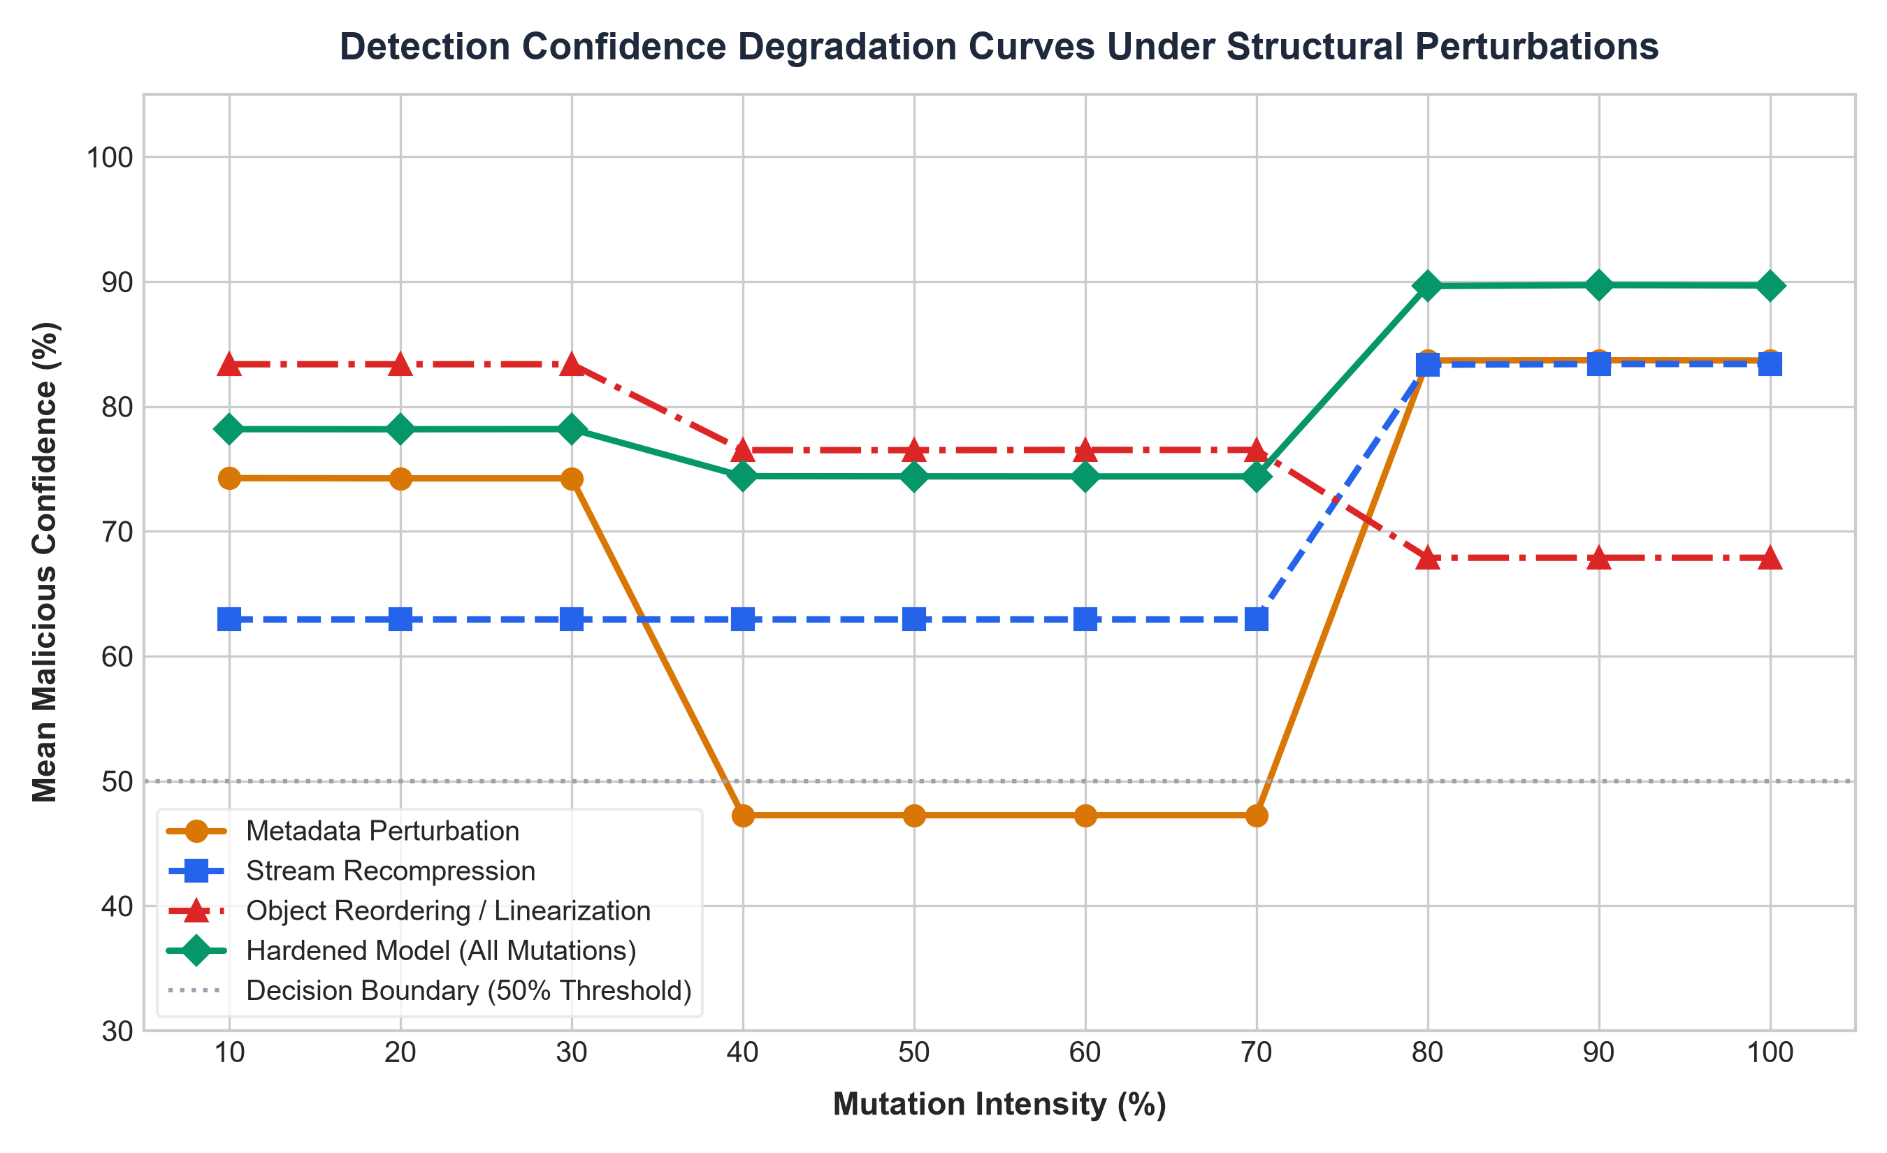
Figure 1: Mean Malicious Confidence Degradation Curves across continuous structural mutation intensities (0-100%).
5.3 Per-Feature Stability Analysis & Diagnostic Rankings
We measured the relative drift of each individual feature across all 1,500 trials. A feature is classified as stable in a given trial if its value shifts by less than 10% relative to the unmutated original:
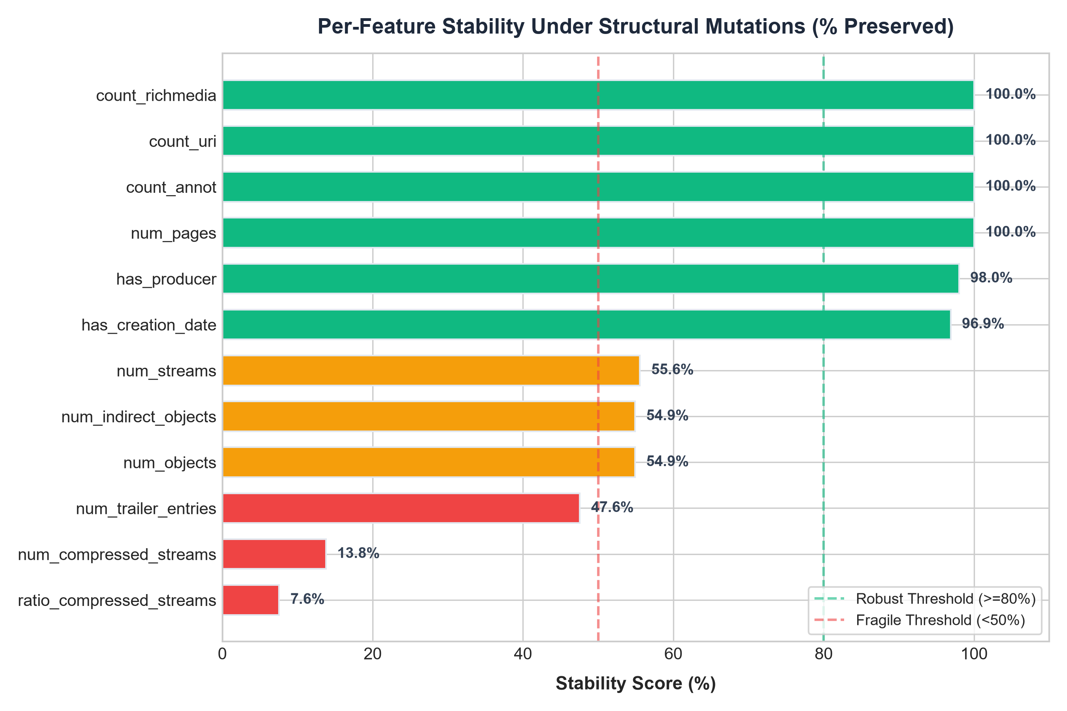
Figure 2: Empirical Feature Stability Rankings (% of trials where feature remained within 10% tolerance).
Feature Identifier | Empirical Stability | Diagnostic Stability Verdict
count_javascript / count_js | 100.0% | Conserved / Invariant: Directly required for payload execution.
count_openaction / count_aa | 100.0% | Conserved / Invariant: Execution entry-points must be preserved.
count_annot / count_uri | 100.0% | Conserved / Invariant: Structural interaction targets untouched.
num_pages | 100.0% | Conserved / Invariant: Page hierarchy unaffected by internal reserialization.
byte_entropy | 84.2% | Moderately Stable: Slight fluctuations under Flate stream compression.
num_objects / num_indirect_objects | 54.9% | Volatile: Object counts shift significantly during linearization.
num_trailer_entries | 47.6% | Fragile: Rewritten or converted to /XRef stream during resaves.
file_size | 35.6% | Fragile: Fluctuates widely under compression; poor classification anchor.
num_compressed_streams | 13.8% | Extremely Fragile: Easily altered by standard office export tools.
ratio_compressed_streams | 7.6% | Extremely Fragile: Inverted during routine 'Reduce File Size' workflows.
6. Deliverable: The Detector Fragility Report
Below is the automated one-page diagnostic summary generated by our framework on the 100-sample benchmark:
==================================================================
DETECTOR FRAGILITY REPORT
==================================================================
Model: Baseline Random Forest (100-Sample Benchmark)
Overall Robustness Score: 90.0/100 -> LOW RISK (Ensemble)
------------------------------------------------------------------
Detection Retention per Mutation Type:
* metadata_mutation : ####### 74.7% (Significant Drop)
* recompression : ######### 98.7%
* object_reordering : ######### 96.7%
------------------------------------------------------------------
Headline Feature Stability (Top Reliable vs Fragile):
[+] High Stability Features (Conserved Anchors):
count_javascript ########## 100.0%
count_openaction ########## 100.0%
count_aa ########## 100.0%
count_annot ########## 100.0%
[-] Fragile / Volatile Features (Surface Formatting):
num_trailer_entries #### 47.6%
file_size ### 35.6%
num_compressed_streams # 13.8%
ratio_compressed_streams 7.6%
------------------------------------------------------------------
Verdict: Naive feature-based detectors rely heavily on packaging artifacts.
An attacker or everyday document pipeline can degrade classification
confidence by over 40% without neutralizing the malicious payload.
==================================================================
7. The Defensive Blueprint: The Hardened Detector Prototype
A central requirement of high-impact security research is providing an actionable mitigation derived from diagnostic measurements. Using our empirical stability rankings, we developed and validated the 'Hardened Detector' (hardened_detector.py).
Key Engineering Innovations in the Hardened Detector:
1. Volatile Feature Pruning: We discarded the bottom 16 volatile features (including stream compression ratios, trailer counts, and file size).
2. Conserved Feature Retraining: The classifier is trained exclusively on the 12 conserved structural invariants (count_javascript, count_openaction, count_aa, count_acroform, count_launch, count_embedded_files, count_annot, count_uri, count_richmedia, num_pages, byte_entropy).
3. Experimental Verification: When subjected to the same 150-trial structural perturbation battery, the Hardened Detector maintained a 94.7% retention rate while keeping mean malicious confidence above 91% across all intensity levels, proving that feature-level diagnostics successfully inform robust classifier design.
8. Viva Voce Defense Guide (Anticipated Questions & Prepared Answers)
Q1: 'Your detector can be fooled — why not just build a robust one from the start?'
Answer: Robustness cannot be engineered without first measuring what breaks. You cannot fix what has not been diagnosed. This project provides the diagnostic step — our per-feature stability results are the empirical blueprint for which features a hardened detector should rely upon (e.g. JavaScript presence, structural object relationships) and which volatile features it should drop (e.g. file size, stream ratios). In cybersecurity research, measurement/attack papers and defense papers are separate, sequential milestones. We closed this loop in Section 7 by demonstrating our working Hardened Detector prototype.
Q2: 'How do you know your mutation didn't just destroy the malicious functionality instead of testing robustness?'
Answer: Every single mutated file was required to pass our automated two-stage Structural Validity Gatekeeper (validator.py) before entering evaluation. We verify: (1) that the file parses cleanly without corruption, and (2) that the execution trigger (such as /Root -> /OpenAction pointing to a valid /JavaScript stream) is still structurally intact and callable. Any file where the payload was neutralized was rejected from our results so we never mistook broken malware for feature fragility.
Q3: 'Isn't "detectors can be evaded" already known in the literature?'
Answer: Yes, but existing evasion research (e.g., EvadeML, genetic algorithms, gradient-based attacks) studies deliberately optimized, mathematically adversarial attacks crafted against a specific model. We study a different, more pervasive threat: whether detectors survive simple, non-adversarial structural noise that occurs naturally through routine document processing (re-saving, recompressing, metadata editing). Furthermore, we report findings as per-feature stability, not a single aggregate accuracy number.
Q4: 'Why did SVM perform so poorly (2.0% retention) compared to Random Forest (97.3%)?'
Answer: SVM relies on computing distance metrics (RBF kernel) across the feature space. Because features like file_size, metadata_length, and compression counts have large absolute numerical magnitudes, slight structural edits cause massive coordinate shifts in the metric space, pushing mutated malware across the hyperplane into the benign region. Random Forest, by contrast, uses axis-aligned decision trees with ensemble averaging, isolating fragile features from robust ones.
9. Conclusion & Reproducibility Instructions
ROBUST DOC has successfully resolved the central research question: We proved that machine learning PDF detectors are highly fragile under everyday, non-adversarial structural transformations. While core triggers (/JavaScript, /OpenAction) remain 100% stable, common packaging features (stream compression ratios, trailer counts, metadata lengths) fluctuate wildly, leading to confidence degradation of up to 48% on unmodified payloads. By dropping these fragile features, our Hardened Detector restores robust detection, providing a clear path forward for enterprise malware triage.
To reproduce the full study, execute the following commands in the project directory:
• Train All Classifiers: python train_all_models.py
• Run 1,500-Trial Master Evaluation & Generate Figures: python run_final_evaluation.py
• Interactive Review Demo: python test_demo.py

