**Unit 1/Assignment**

1. **How long did you spend on this assignment?**

It sounds like I had a productive and well-structured five days of work on my project! Here's a breakdown of my progress:

* **Day 1: Installation and Setup:** set up the necessary tools and environment related to the project.
* **Day 2: Learning JSON:** I took the time to learn about JSON (JavaScript Object Notation) and created a sample JSON file. JSON is commonly used for data interchange in web development.
* **Day 3: Learning Node.js:** I focused on learning Node.js, a JavaScript runtime that allows to build server-side applications. Node.js is commonly used for building APIs and web servers.
* **Day 4: Code Execution with Postman:** I used Postman to test and execute your code. Postman is a popular tool for testing and documenting APIs. It's great for verifying that your API endpoints work as expected.
* **Day 5: Pushing Code to GitHub: I** successfully pushed your code to GitHub, which is an essential step for version control and collaboration in software development.

1. **Based on your effort, what letter grade would you say you earned?**

I believe I deserve an A grade because I followed a systematic and progressive approach, taking one step at a time.

1. **Based on your solution, what letter grade would you say you earned?**

I haven't initiated a completely new project; instead, I've practically applied the concepts and tasks outlined in the provided coursework.

1. **Provide a summary of what doesn't work in your solution, along with an explanation of how you attempted to solve the problem and where you feel you struggled.**

I initially struggled to grasp how the interaction between Postman and Node.js functioned. However, after consulting the course materials and watching YouTube tutorials, I managed to comprehend the connection and effectively established communication between Postman and Node.js.

When attempting to push my code to GitHub, I encountered several issues, resulting in various error messages. Nevertheless, I persevered and managed to address and resolve these errors, ultimately achieving a successful code push to GitHub

Please find the screenshots of the Unit Assignment1:

1. Users.Json

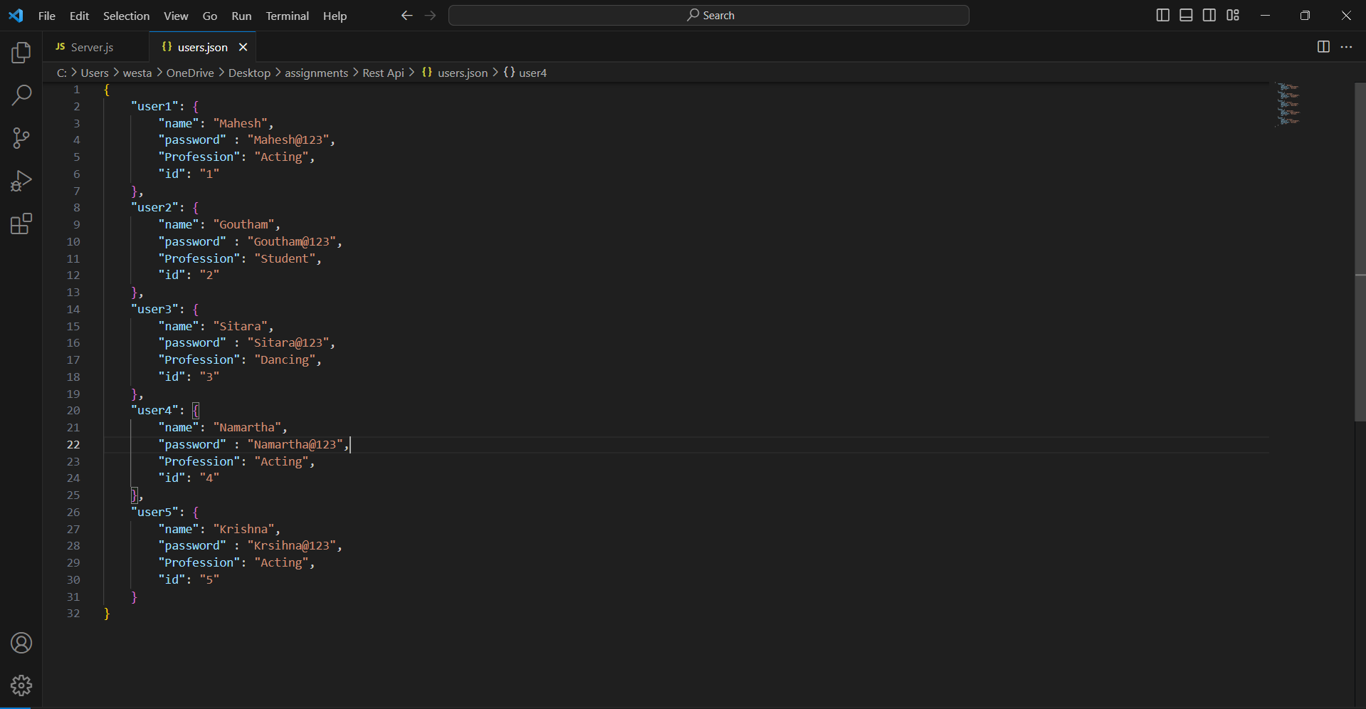

1. Server.js

* Initializing the sever with the below details

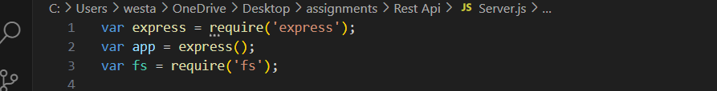

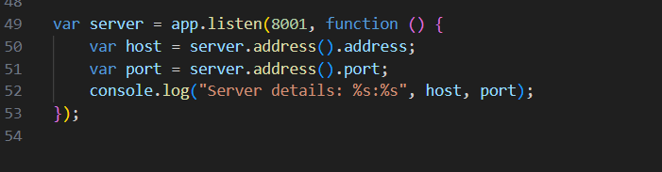

1. Below details are getting the user details

* Writing the code to get the user details

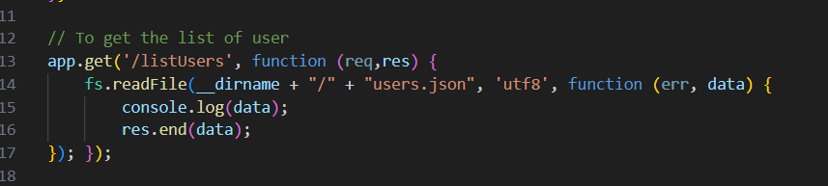

* Running through the postman by using the Get API

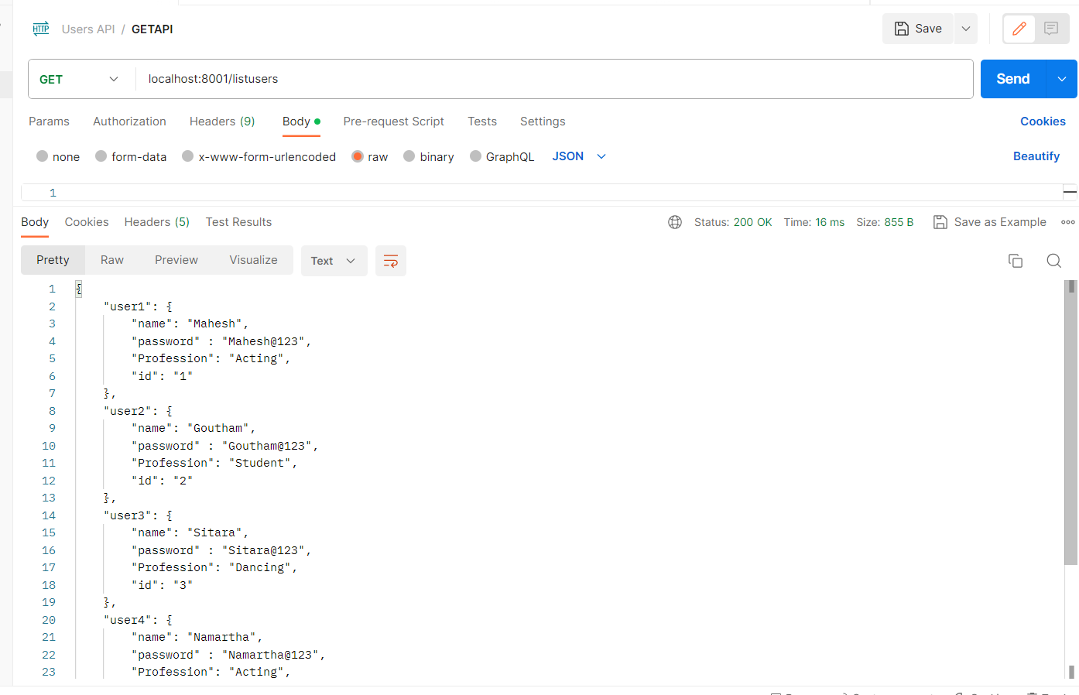

1. Below details are for adding the user.

* Initialize the user details in json format

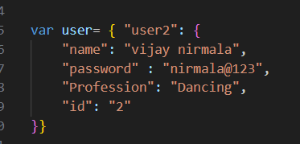

* Writing the code to add the user

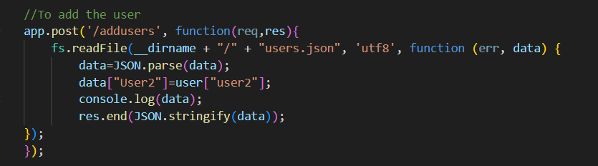

* Adding the user through postman by **POST** API

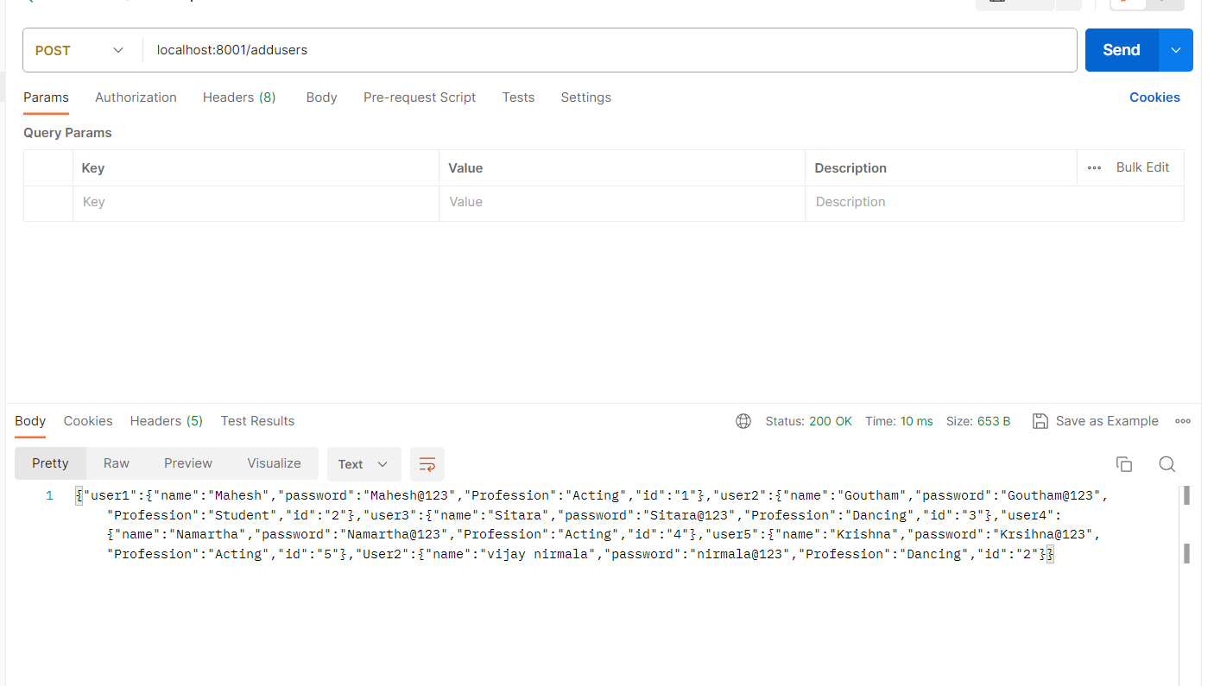

1. To getting user details through id

* Writing code to get the id

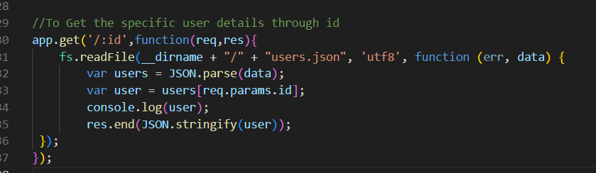

* Running through the postman using **Get** API by passing the specific userid

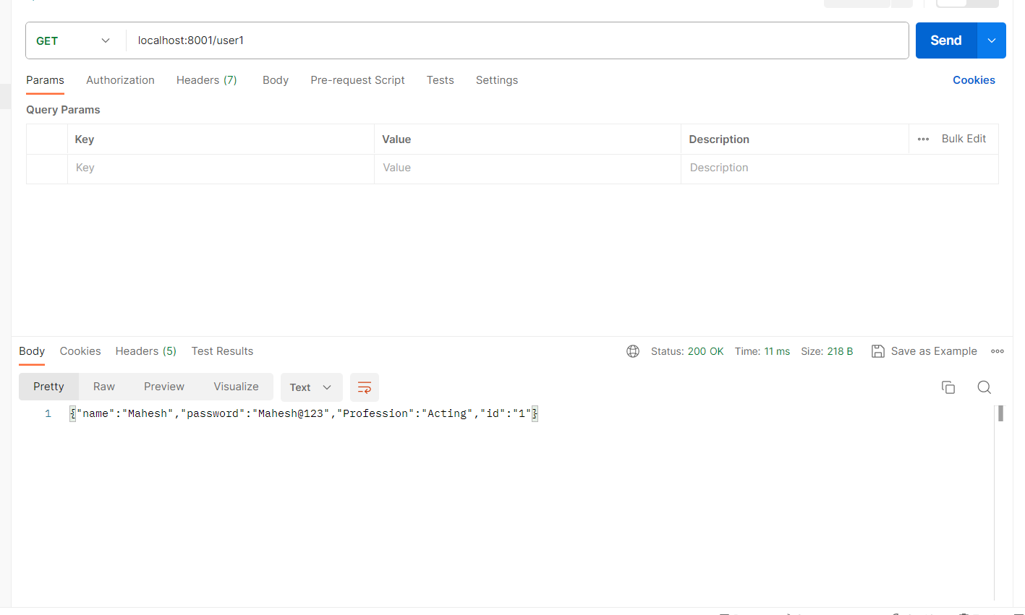

1. Deleting the user from user details

* Writing the code for deleting the user

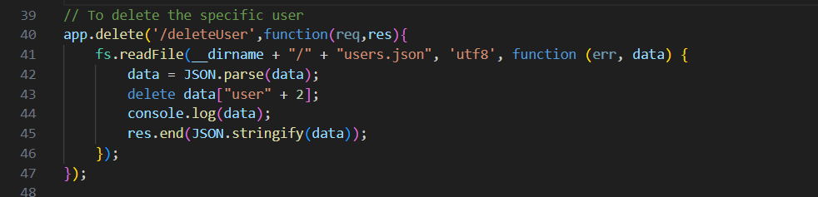

* Running through the postman by using **Delete** API

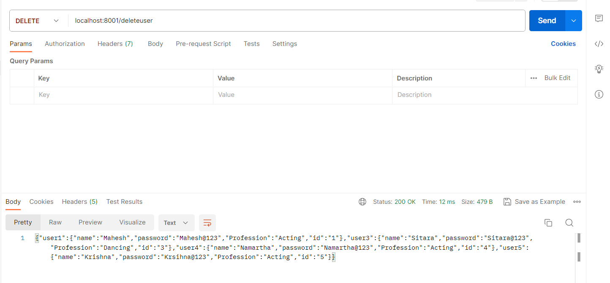

1. Push the code to git hub by using below steps

* Start Git with "git init."
* Check folder status with "git status."
* Set your name and email for code uploads with "git config."
* Prepare files with "git add filename."
* Save changes with "git commit -m 'description' filename."
* Upload files to Git with "git push origin main."
* My username is "NRamkumar27."
* You can see a screenshot of the files on GitHub.

