Outlier Screening

Emily Linebarger

2/17/2021

Run first regression, of just cases-per-capita to overall score.

##   
## Call:  
## lm(formula = cfratio ~ overall, data = dt)  
##   
## Residuals:  
## Min 1Q Median 3Q Max   
## -3.7871 -1.6501 -0.7537 0.5766 27.3988   
##   
## Coefficients:  
## Estimate Std. Error t value Pr(>|t|)   
## (Intercept) 0.52444 0.73506 0.713 0.476482   
## overall 0.05654 0.01676 3.374 0.000908 ***  
## ---  
## Signif. codes: 0 '***' 0.001 '**' 0.01 '*' 0.05 '.' 0.1 ' ' 1  
##   
## Residual standard error: 3.186 on 179 degrees of freedom  
## (11 observations deleted due to missingness)  
## Multiple R-squared: 0.05979, Adjusted R-squared: 0.05454   
## F-statistic: 11.38 on 1 and 179 DF, p-value: 0.0009083

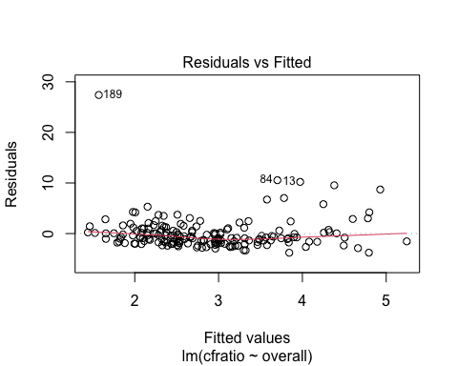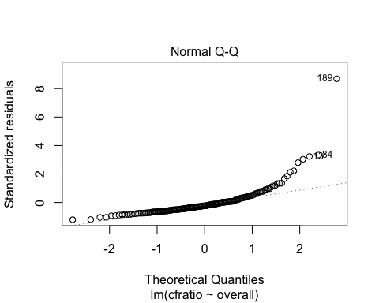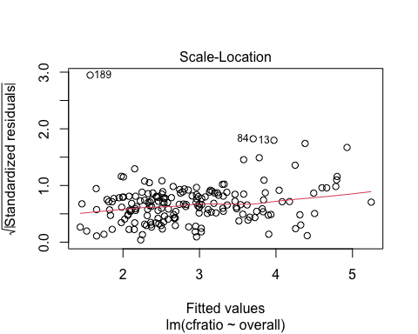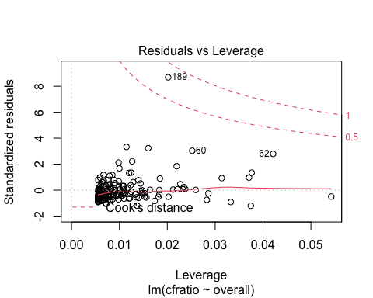

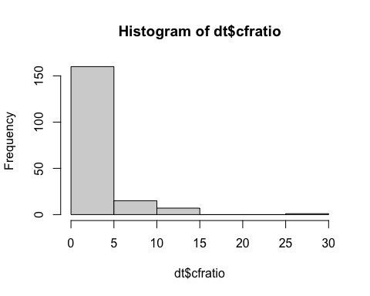

There seems to be constant variance in plots 1 and 3. However, we have an issue with non-normality in our qq-plot. Examining this further with a histogram, we can see two issues: a large cluster of zeros, and a few high outliers with a case fatality ratio higher than 25.

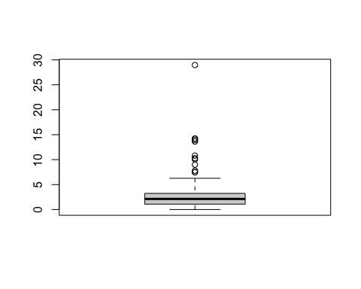

## Min. 1st Qu. Median Mean 3rd Qu. Max. NA's   
## 0.000 1.080 2.121 2.849 3.237 28.969 9

## Review upper values

The upper whisker extends 1.5 times past the interquartile range, to 6.6975. The values that lie beyond that are:

|  |  |  |  |  |  |
| --- | --- | --- | --- | --- | --- |
| country_code | Cases | Deaths | casepc | deathpc | cfratio |
| TCD | 1085 | 81 | 0.0680384 | 0.0050794 | 7.465438 |
| SWE | 76516 | 5730 | 7.4392445 | 0.5570975 | 7.488630 |
| CAN | 114398 | 8919 | 3.0433691 | 0.2372752 | 7.796465 |
| NLD | 69224 | 6227 | 3.9938037 | 0.3592600 | 8.995435 |
| ESP | 282641 | 28441 | 6.0038302 | 0.6041407 | 10.062588 |
| HUN | 5961 | 614 | 0.6101362 | 0.0628458 | 10.300285 |
| MEX | 568621 | 61450 | 4.4571322 | 0.4816754 | 10.806847 |
| GBR | 302261 | 41220 | 4.5225360 | 0.6167482 | 13.637221 |
| FRA | 216684 | 30169 | 3.2312014 | 0.4498815 | 13.923040 |
| BEL | 69402 | 9845 | 6.0433357 | 0.8572756 | 14.185470 |
| ITA | 246488 | 35123 | 4.0878714 | 0.5824961 | 14.249375 |
| YEM | 2047 | 593 | 0.0701943 | 0.0203347 | 28.969223 |

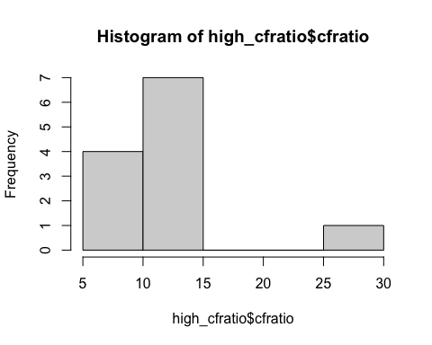

Although these do represent high fatality ratios, many of them represent reasonable values. For example, the second-highest, Italy, had one of the worst early waves in the pandemic and this fatality ratio is very likely six months after they started recording cases/deaths.

The only value that I would treat like an outlier here is Yemen, which has a case-fatality ratio of 28.9. It looks highly likely that Yemen has undercounted cases in these reported numbers, because over 1 in 4 people have died after catching COVID-19 in their reported numbers (593 out of 2047). Because of this, we will drop this data point from our analysis.

## Review zeros/very low values

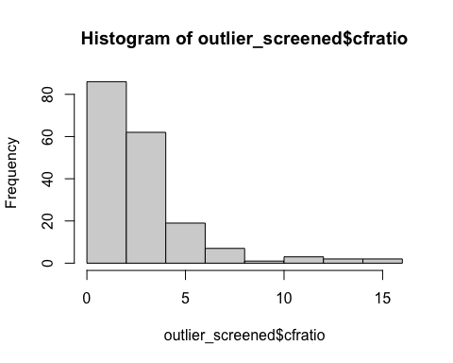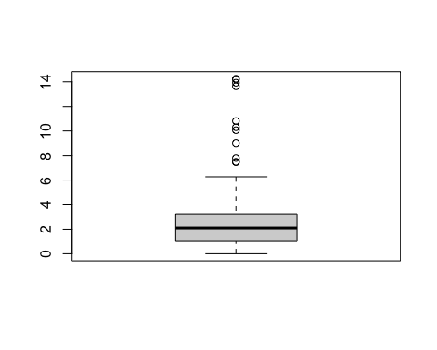 There are also a large cluster of countries with values clustered at zero (N=14), which would signify zero deaths. Review these to make sure these values are believable.

|  |  |  |  |  |  |  |  |
| --- | --- | --- | --- | --- | --- | --- | --- |
| country_code | Cases | Deaths | deathpc | casepc | pop_2019 | clean_date | cfratio |
| BTN | 227 | 0 | 0 | 0.2974740 | 763092 | 2020-09-01 | 0 |
| DMA | 24 | 0 | 0 | 0.3342246 | 71808 | 2020-09-17 | 0 |
| ERI | 364 | 0 | NA | NA | NA | 2020-09-16 | 0 |
| GRD | 24 | 0 | 0 | 0.2142800 | 112003 | 2020-09-17 | 0 |
| KHM | 202 | 0 | 0 | 0.0122524 | 16486542 | 2020-07-24 | 0 |
| KNA | 17 | 0 | 0 | 0.3217625 | 52834 | 2020-09-20 | 0 |
| LAO | 23 | 0 | 0 | 0.0032081 | 7169455 | 2020-09-19 | 0 |
| LCA | 27 | 0 | 0 | 0.1477105 | 182790 | 2020-09-09 | 0 |
| MNG | 310 | 0 | 0 | 0.0961191 | 3225167 | 2020-09-05 | 0 |
| SYC | 137 | 0 | 0 | 1.4033291 | 97625 | 2020-09-09 | 0 |
| TLS | 27 | 0 | 0 | 0.0208797 | 1293119 | 2020-09-17 | 0 |
| VAT | 12 | 0 | NA | NA | NA | 2020-09-01 | 0 |
| VCT | 62 | 0 | 0 | 0.5606344 | 110589 | 2020-09-09 | 0 |
| VNM | 384 | 0 | 0 | 0.0039808 | 96462106 | 2020-07-20 | 0 |

There are a few NA values here where population was not available. We will remove these from our analysis. However, for the rest of the values, they all have very low reported case numbers and may have truly recorded zero deaths. Without more substantial evidence to signify a reporting failure, we will leave these zeros in for now.

# Finally, run initial analysis again and see if non-normality problem persists.

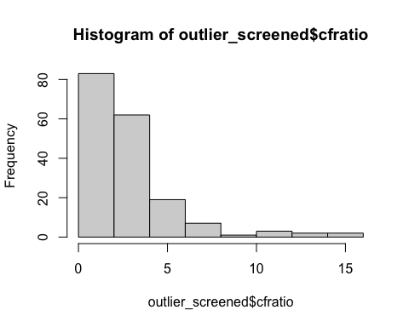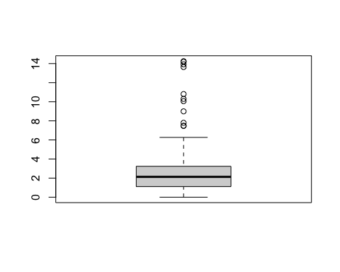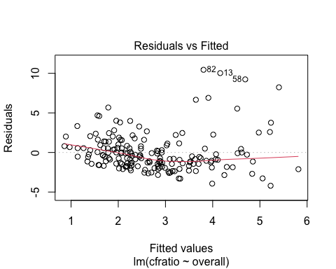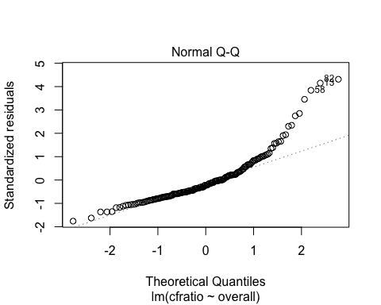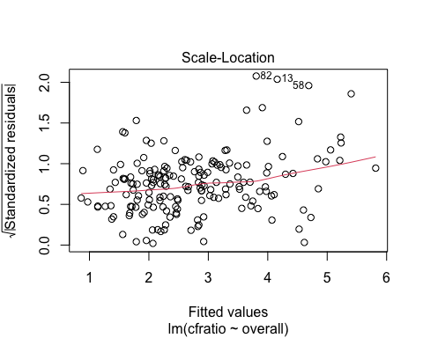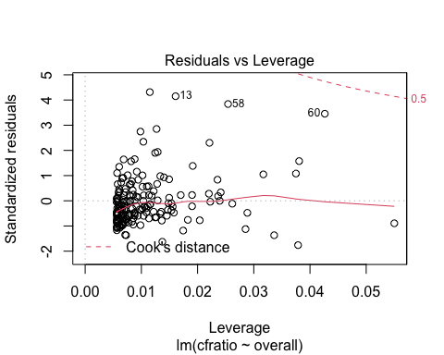

After this cleaning, we do see some evidence of non-constant variance, and our non-normality problem persists. We will need to turn to data transformations to address these issues.

The outlier screening process has taken our total sample size from N=192 to N=179.