

**MyTV System Guide**

Team Best Group (Team 7)

Fall 2019

CS 451R

University of Missouri – Kansas City

Document Control

|  |  |  |  |
| --- | --- | --- | --- |
| **Version** | **Date** | **Name** | **Description** |
| 1.0 | 11/25/19 | Nathan | Initial Draft |
| 1.1 | 12/1/19 | Nathan | Added Admin Features |

Contents

Introduction 4

Initial Setup 4

Admin Controls 5

Shows and Services 6

Helpdesk 7

Managing Users and Roles 7

System Maintenance 8

System components 8

System Security 8

Database 8

# Introduction

The MyTV service allows for users to easily find out information about live streaming tv services that operate over the internet. The MyTV service is a web-based application that facilitates users creating accounts, searching shows, comparing prices, and more.

The MyTV Service is created using ASP.Net Core framework with a local SQLite database.

# Initial Setup

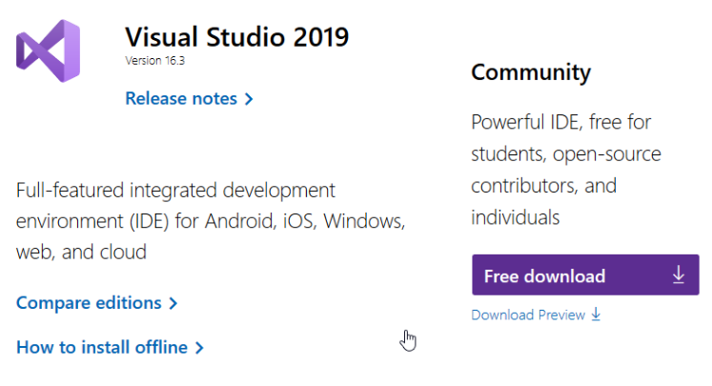Initial setup will require the use of Visual Studio 2019 or similar, as well as downloading the code repository. To download Visual Studio navigate to <https://visualstudio.microsoft.com/downloads/> and download the Community edition:

After installing Visual Studio 2019, select the “Clone or check out code” option:

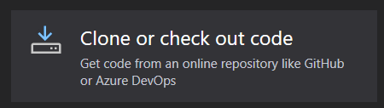

When given the option to add a url, add <https://github.com/umkc-cs-451-2019-fall/semester-group-assignment-team-best-group> and select a local folder for the repo.

Alternatively, if you want to open and run the code in another way rather than in Visual Studio navigate to <https://github.com/umkc-cs-451-2019-fall/semester-group-assignment-team-best-group> and download the code with this button:



# Admin Controls

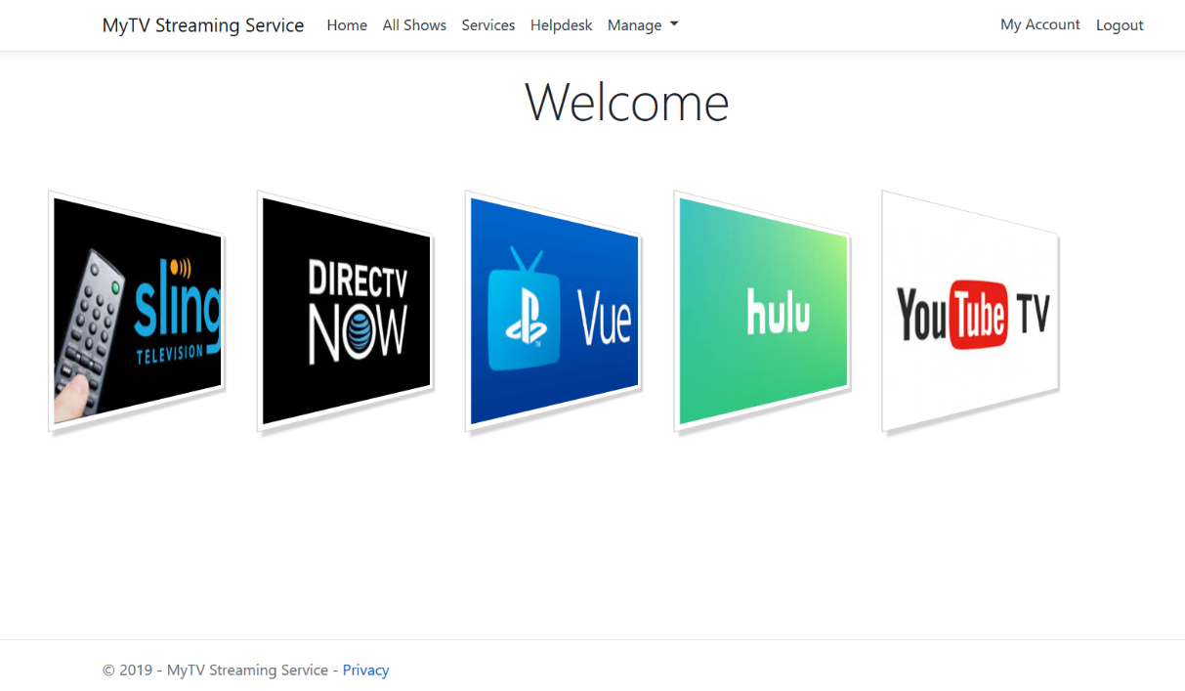Logging in with an admin account allows for detailed control of information such as shows, services, users, roles, and Helpdesk messages.

## Shows and Services

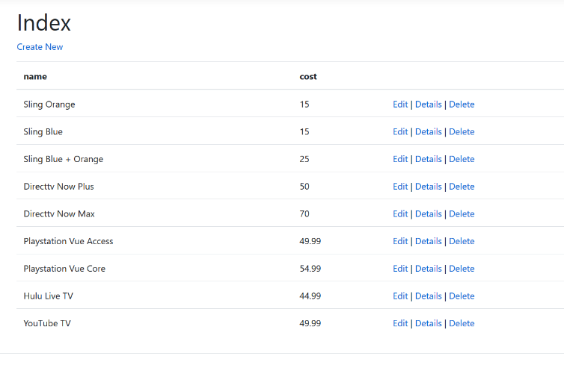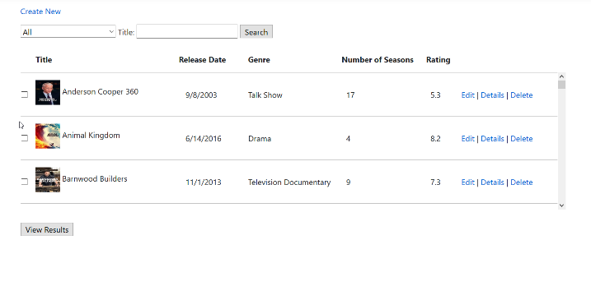Selecting “All Shows” and “Services will let you view, edit, add, and delete items in the database.

## Helpdesk

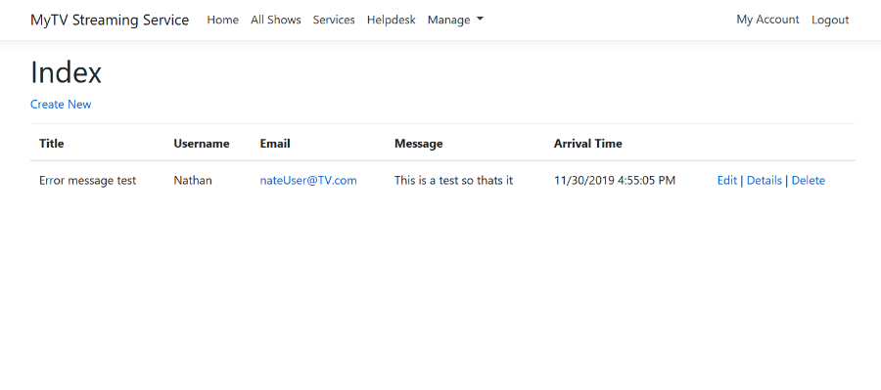Selecting “Helpdesk” will show the list of messages sent from users reporting any issues or questions.

## Managing Users and Roles

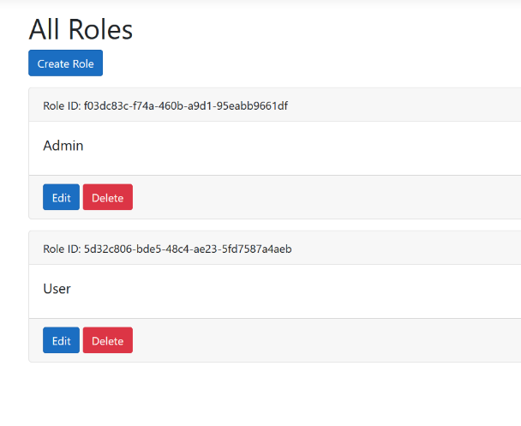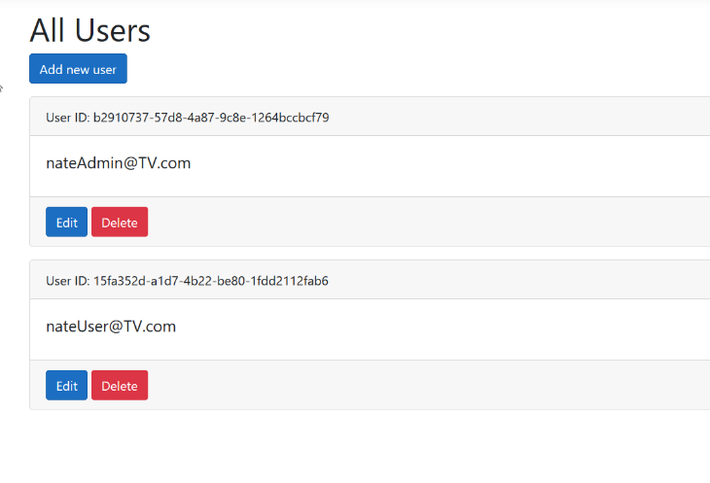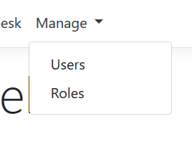Admins have the ability to view, add, edit, and delete current users as well as roles.

# System Maintenance

## System components

The major Controllers for the MyTV Service comprise of:

1. **Account**

This allows for managing users. This facilitates registering, logging in, and logging out. The account management uses the Identity framework as a part of ASP.Net.

1. **Admin Helpdesk**

The helpdesk is a system that allows for creation and storage of messages sent from users to admins.

1. **Administration**

The administration controller allows for creating and managing roles such as Admin and User.

1. **Recommendations**

The recommendations controller provides a list of Services that carry the selected Shows.

1. **Services**

The services controller manages the list of available live tv streaming services.

1. **Shows**

The shows controller manages the list of all available tv shows.

1. **Show/Service**

This is responsible for joining the Show and Services tables and producing the results for when a Show is selected by the user.

## System Security

The system utilizes the built-in Identity framework that is made available by ASP.Net. This brings features such password criteria, 2FA security, Account confirmation and password recovery, user authentication and role-based authorization. This allow for quick implementation of authorization rules and is easier to maintain that a custom security solution.

## Database

As the name implies, The SQLite database is lightweight and simple to use, but robust enough for the needs of the software. The SQLite database is created by the migration tool in Entity Framework Core (EF Core) a data access technology framework. The EF Migrations look at the current state of the .Net models and creates the database from there. This allows for a simpler mapping between objects and the database.