

**MyTV User Guide**

Fall 2019

CS 451R

University of Missouri – Kansas City

Contents

Introduction 3

Getting Started 3

Creating an Account 4

Searching for Shows 5

Viewing Show Details 5

Reporting an Issue 6

Selecting Shows and Services 7

Managing Your Account 8

# Introduction

Welcome to MyTV, your source of information for all major live TV streaming services. MyTV makes it easy to search show, see which services carries them, and lets you compare costs. As you become familiar with MyTV, you will quickly be able to find all your favorite shows for the best value. Previously, comparing shows and pricing across services was time consuming and confusing, but MyTV has made it an easy and streamlined process.

# Getting Started

The first page you will see is the home page, showing several popular streaming services such as Hulu, Youtube TV, and SlingTV.

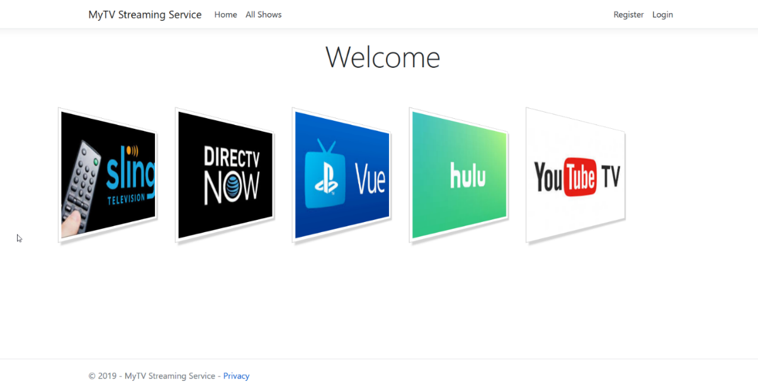

# Creating an Account

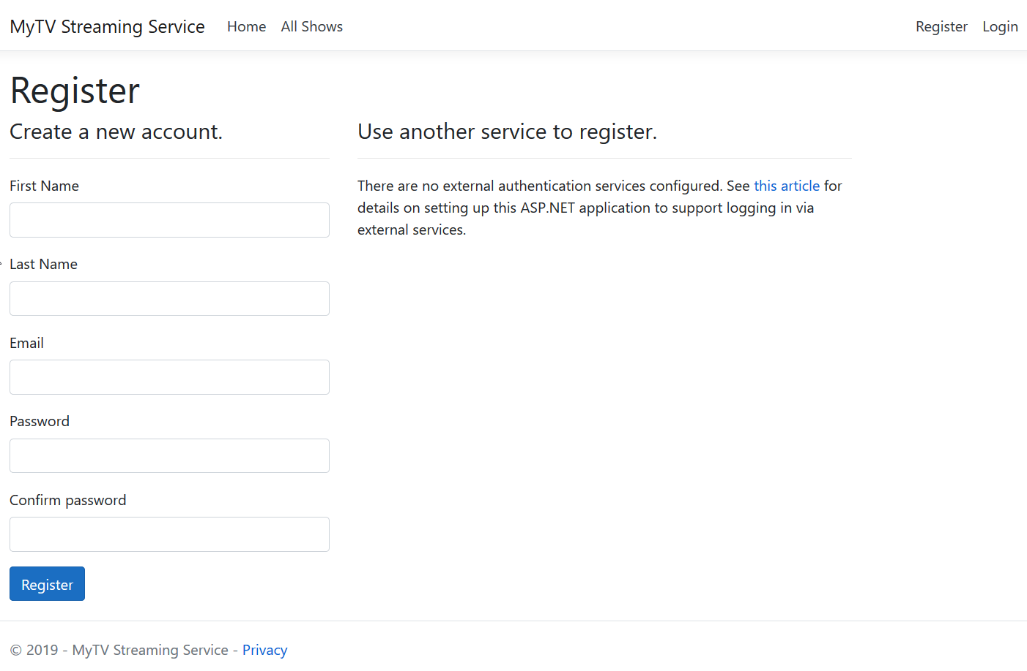Although an account isn’t required to look at a list of shows and services, an account is recommended in order to save searches and using additional features. To create an account, first navigate to the “Register” page by hitting the button in the top-right corner.

Fill out the required fields which include your name, email address, and password. Once your account is created, you will be logged in and be able to save searches and favorite shows.

# Searching for Shows

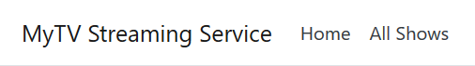To pick your favorite shows and see what services carry them, start by selecting the “All shows” button.

## Viewing Show Details

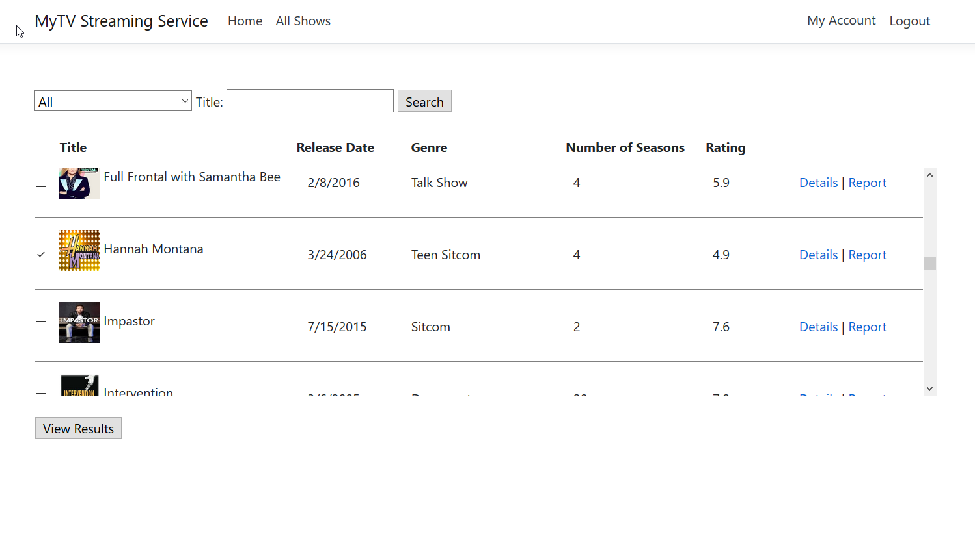On the “All Shows” page you will be able to browse the entire list of shows across multiple streaming services.

To look at more information regarding a specific show, select the “Details” button.

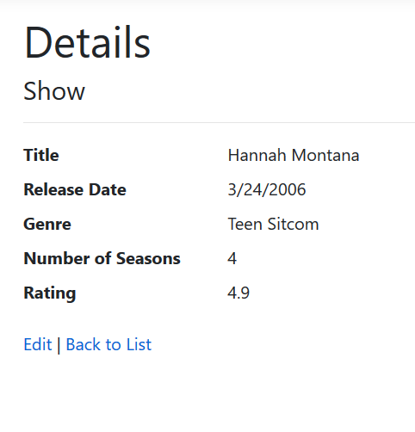You’ll be able to see details such as number of seasons, release date, and genre.

## Reporting an Issue

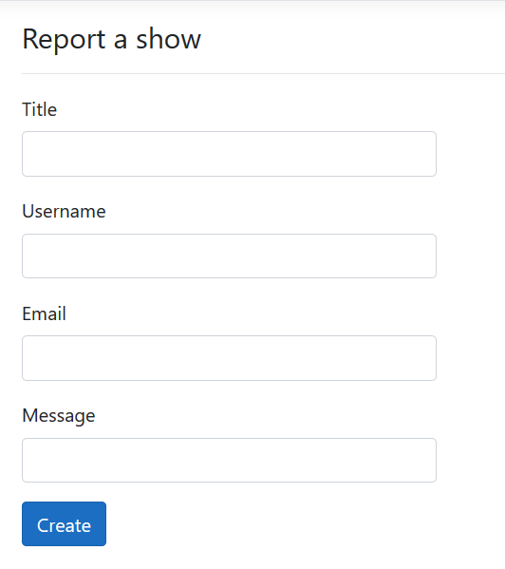If you find any issues with a show such as incorrect or missing information, select “Report” to send the Helpdesk a message.

## Selecting Shows and Services

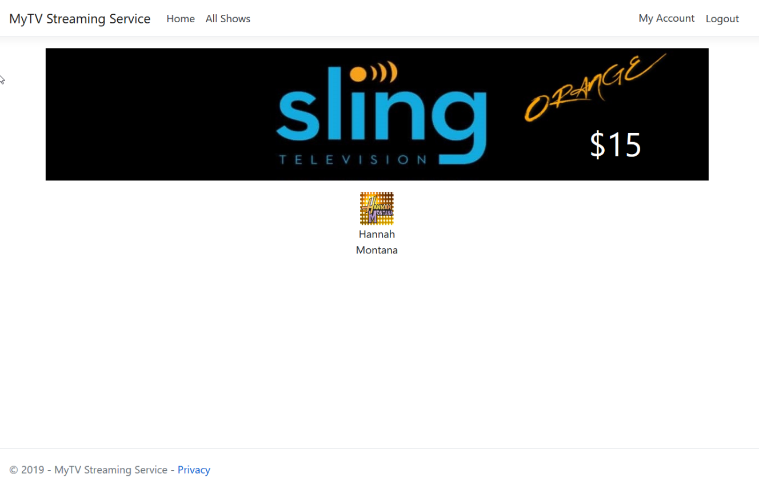You can either search for a show in the Title search bar, or select one of more shows from the list of available titles. Select the “View Results” button to see the results.

# Managing Your Account

To view details of your account, select “My Account”.

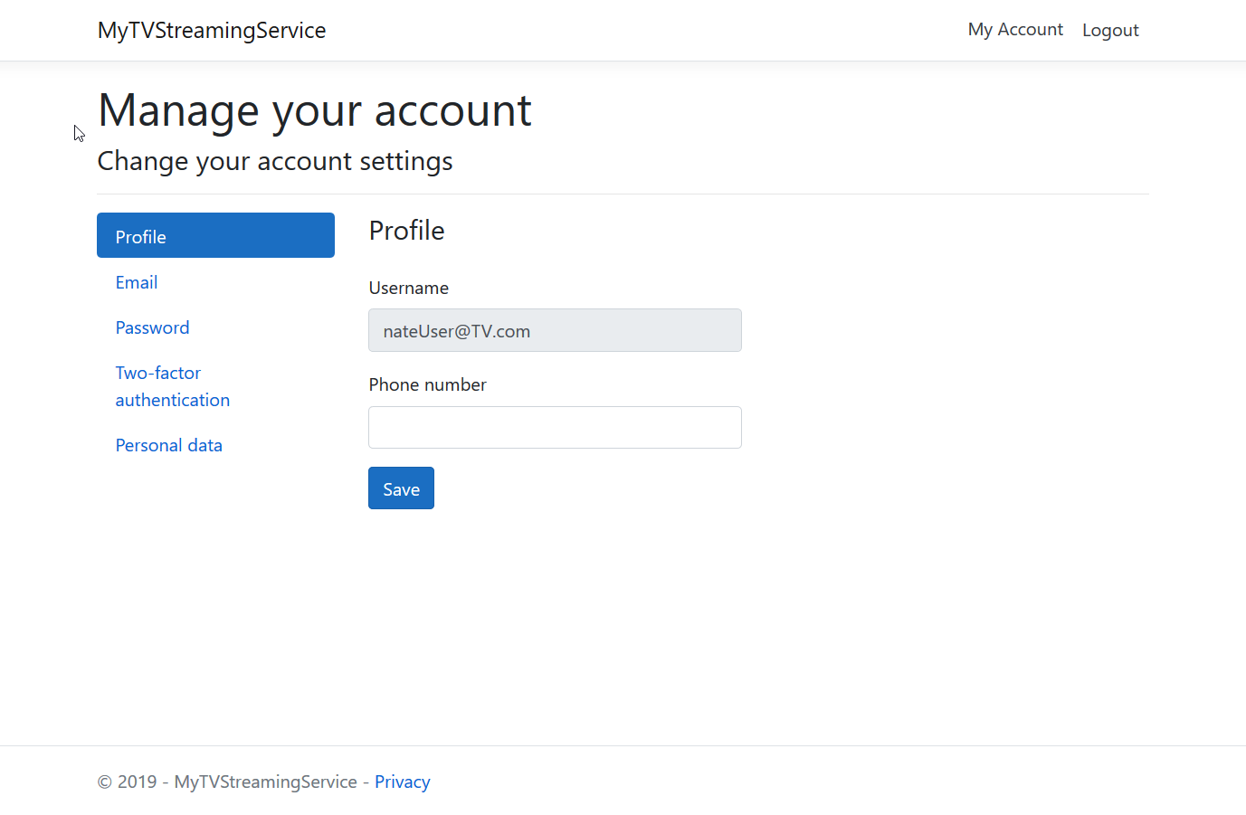Here you will have the ability to manage your account and update details such as your email address and password.