Architecture/Design Document
For
MyTVStreamingService

10.29.2019
V 1.0

Prepared by:
Eric Chadwick
MyTVStreaming Service
Architecture/Design Document

Table of Contents
1 Change History 3
2 Introduction 4
3 Design Goals 4
4 System Behavior 4
5 Logical View 4
5.1 High-Level Design 5
5.2 Mid-Level Design 5
5.3 Detailed Class Design 6
6 Physical View 6

Change History
Version: V 1.0
Date: 10.19.2019
Description of Change: Initial Publication

Introduction
This document describes the architecture and design for MyTVStreamingService. The system is intended to assist users in navigating the increasingly complex ecosystem of streaming services by providing them with recommendations of what services they should subscribe to have access to all their favorite shows at the lowest cost.

The purpose of this document is to describe the architecture and design of MyTVStreamingService in a way that addresses the interests and concerns of all major stakeholders. For this application the major stakeholders are:

- Users – Want an architecture which will provide the desired functionality while minimizing cognitive load and interaction time.
- Developers – Want an architecture that will minimize complexity and development effort but will still warrant a high grade.
- Instructor – The only stakeholder who actually matters; the Instructor wants an architecture which is easy to grade but still sufficiently complex as to demonstrate developers’ understanding of the topic.

Design Goals
The design priorities for MyTVStreamingService are:
- The design should be easy to implement.
- The design should be complex/complete enough to warrant a high grade
- The design should minimize load on the cognitive and time resources of an external user.
- The design should minimize load on cognitive and time resources of an admin user.

System Behavior
This section provides brief, high-level description of the interactions between the system and various types of users

- External Users – Will input a list of shows that they want to be able to watch. The system will respond with a list of 0 or more services which cumulatively provide those shows.
- Administrative Users – Will be able to input new shows and services and associate shows with services which provide them. The system will then use the new information when servicing subsequent external user interactions.

Logical View
This section describes the main functional components of the system and their interactions with one another.

High-Level Design

The application uses an MVC (model-view-controller) architecture. The overall layout of the MVC architecture is as follows:

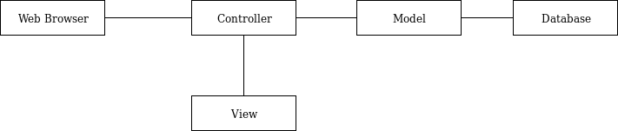
- Web browser – This is the user’s gateway into the application. All interaction with the application will be done in a web browser.
- Controller – The controller receives the request from the web browser. It requests data from the model, performs any business logic and renders a view back to the browser. It can be viewed as the main “driver” of an interaction.
- Model – Receives a request for data from the controller, gets the data from the database and returns it to the controller.
- Database – Stores the application data which is used to service user requests.
- View – The view is rendered in the web browser by the controller and is populated with data returned by the model. This is what the user actually sees in their web browser window.

Mid-Level Design
This section shows the relationships between the main modules in the application.

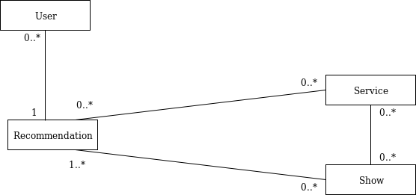
- User – the user of the application
- Service – A streaming service such as Netflix or Hulu
- Show – A television show
- Recommendation – A list of shows and a list of services that between them, carry all of the listed shows.

Detailed Class Design
This section describes most important data attributes of the main classes in the application.

- User
  - Name
  - Username
  - Password
  - 0 or more recommendations belonging to user
- Show
  - Name
  - Rating
  - Number of episodes
  - 0 or more services which carry this show
- Service
  - Name
  - Price
  - 0 or more shows which are carried by this service
- Recommendation
  - 1 or more shows
  - 0 or more services which, between them, provide all of the shows

Physical View
TBD. This information will be included in a separate deployment plan document.

