Beginning in January and continuing through September, the Global Template project is conducted sequentially as well as in parallel with continuous “hand-offs”, reviews and subsequent “hand-offs”.

Evidence of both the sequential and parallel activities is visible in the Global Template high-level timeline below. Clearly, within the Global Template Definition, the GT Detailed Spec and Build will begin before the process definitions are complete. Similarly, the Regional Template Definition and identification of regional variants will begin during the Global Template New & Common definition. This must be carefully managed to minimize unnecessary variants and realize the program objectives.

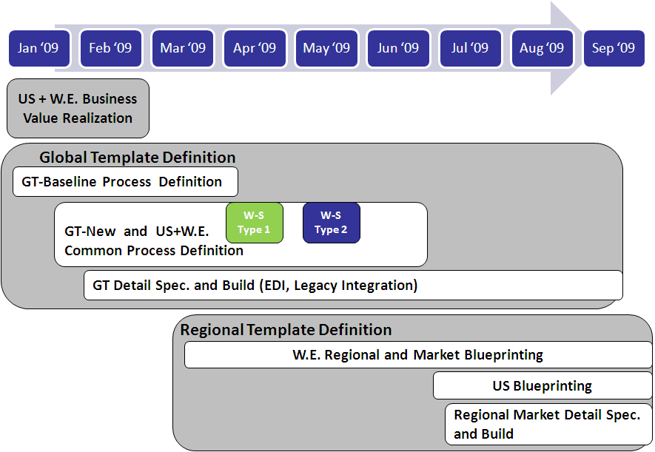

There must be seamless collaboration between the Global Template team and the WE team to ensure that information is shared and milestones are met. Failure to do so will slow the Global Template build and the WE project, delaying program completion and jeopardizing business value.

The dependencies and “hand-offs” between the Global and Regional Template Definitions are portrayed below and will be detailed in the following pages.

**For future reference, activities will be denoted by letters (A, B, C) and deliverables will be denoted by numbers (1, 2, 3).** A table below captures all of the activities and deliverables.



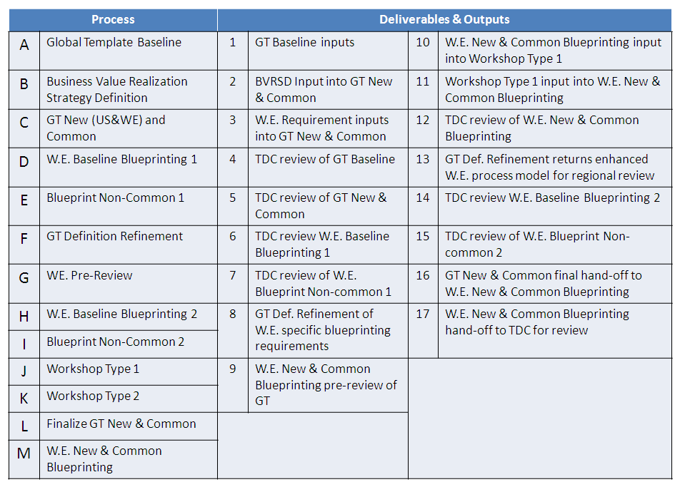

## A. GT Baseline

The first critical element of the Global Template definition, the Global Template Baseline definition focuses on documenting P&G current SAP implementations in various markets and various instances. **This activity is denoted by the letter “A” in the high-level hand-off diagram above.**

The GT-team will leverage as inputs the CPG Repository Structure and CBA (Common Best Approach or CPG best practice), the Existing P&G Process Model ,Jumpstart training material and Key User, and the 10 SOPs (Standard Operating Procedures from P&G markets that have already implemented S2C in SAP). The baseline best practices are considered (Industry CBA as well as SAP best practices) and worked into the Global Template Baseline Definition.

The GT-Baseline will consider the current basic functionalities as is enabled in these 10 markets select the best functionality between the 10 markets and develop the MEGA documentation. P&G selected the 10 markets very careful based on objectives, requirements, and approach for CSO Reinvention. In essence, while primarily a documentation of “As-Is”, the GT Baseline represents a Baseline “To-Be” definition (due to it’s consolidated nature) the best and most applicable functionalities from the 10 markets and the CBA’s.

The key intent of the Baseline Definition is to leverage current, common P&G SAP functions and enriching it with CBA and rapidly document a base Global Template that can be use to start Regional Blueprinting in W.E. The GT Baseline’s second intent is to allow the GT-team to create the deliverables with no or minimal regional interaction (due to NA focus on Canada) and the W.E. ramp-up and BVRSD effort in parallel.

However, best practices are actively shared early and frequently between WE and GT and will be incorporated into the GT Baseline during the parallel efforts of GT-Baseline Definition and W.E.-BVRSD.  Once passing GT-Baseline drafting stages for specific deliverables, this will become infeasible.  In the case that W.E.-BVRSD creates an output in the form of specific, actionable design principles that influence and impact the process design of a baseline process that is currently not planned to be revisited in New+Common, the GT-team will re-open these and revise them as part of an additional workstream aligned within the GT New+Common stream and timelines.

Following this review, a kickoff session enabled the GT Team to draw upon their expertise, cluster into focus area groups based on this expertise and review their respective focus area. The Focus Areas include Order Acquisition, LEM, ATP / Shipment Delivery, Invoicing and Billing, Order Pricing, Post Delivery and Accounts Receivables/Credit Management. These Focus Area discussions consider issues with P&G’s existing business, industry best practices, SOPs and the desired “to-be” state and, given their input, they will developed a draft process model.

The Focus area team will conduct iterative reviews of the draft process model with Business Experts and Solution Owners, refining and enhancing their model. After several weeks, the process will be defined and documented in MEGA, undergoing a final review before acceptance. An illustration of the process below details the inputs, the activities and the outputs.

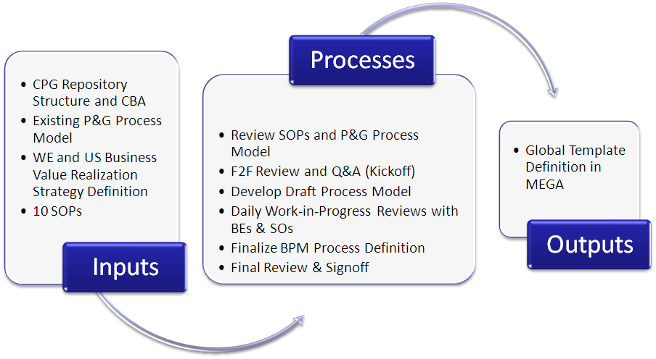

As previously-mentioned, the Focus Areas will develop and finalize their processes in parallel and deliver them with staggered delivery dates, which begin in mid-February and continue to mid-March. **Denoted by the number “1” in the high-level hand-off diagram above, these deliverables will later serve as an input into the Baseline Blueprint. Additionally, these deliverables are denoted by the number “4” as they require the TDC’s review.**

A more detailed schedule of the deliverarbles due dates are below.

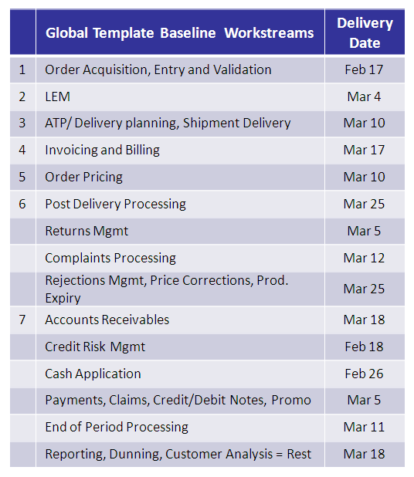



## B. W.E. BVRSD

**The WE Business Value Realization Strategy Definition is another important factor in the Global Template Definition and it is marked by the letter “B” in the high-level hand-off diagram**. Occurring in January and February, the BVRSD leverages SAP best practices and input, the Infosys CPG process repository (including processes, the Infosys CPG expertise/concepts and VRM expertise), the Accenture SWAT work and the WE Senior mgt “win strategy and measures when reviewing the WE business case. These components enable the WE team to refine the value position by incorporating improvement measures into VRM framework and select best practices, resulting in Key Design Principles and Design Decisions. Subsequently, the WE team must lead working sessions to determine strategies for re-engineering & areas for standardization, which ties back to the (larger) CSO Reinvention program’s objectives.

**These efforts will result in three key deliverables: the Value Diagram, process standardization criteria, Business concept definition/ documentation, all of which are denoted by the number “2” in the high-level hand-off diagram.**

1. Value Diagram: Maps all the value and operational levers against level 3 and wherever applicable, level 4 processes in the Infosys repository. The purpose is to make clear linkages between value levers (indicating what is important to shareholders), to operational levers (what needs to be transformed) to change initiatives (specifying how to effect the necessary change) and finally to design principles detailed out by process teams.

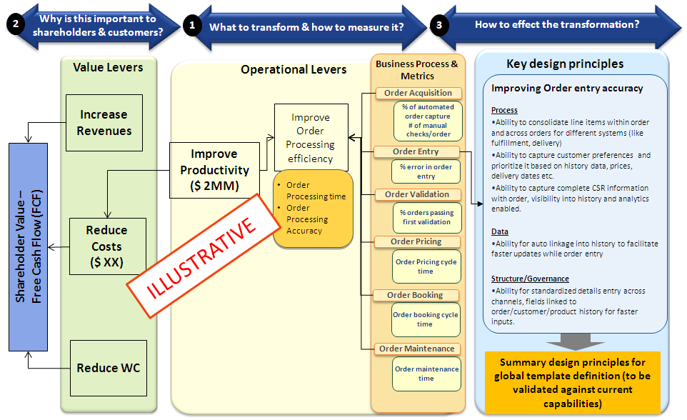

1. For each of the processes in the Infosys repository: provide decisions of standardization and its related level.
2. Definition and documentation: of Business Design Principles with actionable activities to accomplish the Value Proposition.

Please note that the output / deliverables as defined above feed “C”, the NEW and US+WE-Common Global Template Definition. It is described under “C” in more detail. In summary, the value diagram (mapping of value position to metrics and lowest possible processes) will focus the GT work on the processes of highest value for P&G. The Standardization statement by process will provide guidance to the GT-team (and later the W.E. regional blue printing team) on the expectation of standardization or variations of each particular process. Lastly, the Business Design Principals will provide actionable guidance for the GT-team of what concepts, CBA, and rules to apply for a particular process when defining/designing that particular process and its sub-deliverables in NEW and US+WE-Common Global Template.

## D. W.E. Regional Baseline Blueprinting-1

Beginning in March and stretching until mid-April, W.E. will source the GT-Baseline MEGA and the Focus Area Solution Designs (MEGA extracts) and review the Global Template Baseline detailed document functionality. **This Baseline Blueprinting phase is represented by the letter “D”** in the high-level hand-of diagram. The purposes of these reviews are to leverage the regional and pilot row leaders’ knowledge/expertise to debate and review the Global Template, it’s applicability to the W.E. region and pilot markets as well as define refinements and market variants. Ultimately, these group assessments will identify regional variants from the GT-Baseline, which will be documented and submitted for review and approval by the Template Design Council. For variants, these regional/pilot market reviews must detail, capture, and provide detailed documentation in MEGA regarding the following:

1. process flow variation
2. policies, guidelines and/or rule variation
3. data usage variation
4. reports and forms variation (including different reports, need new report or need additional data in report, difference or new form /view for custom-data)
5. Critical Customer Requirements as justification of variants

Examples of this information in MEGA can be found below:

1. Process Flow Variation

Include added process steps, eliminated process steps, variation in process flows and/or variation in process owners from the GT-Baseline process

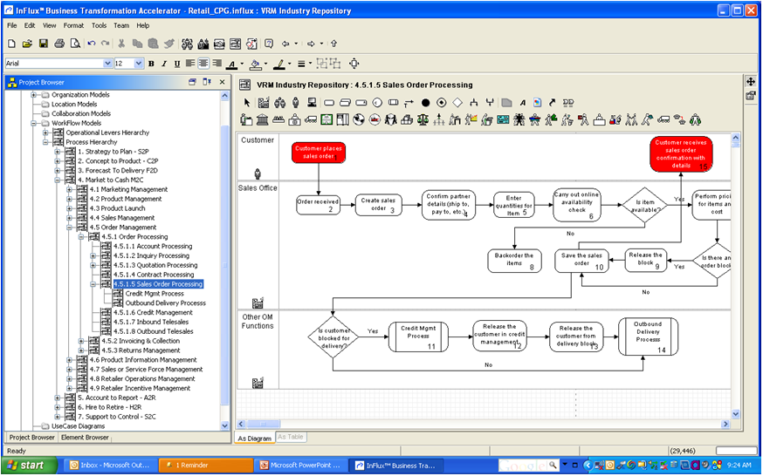

1. Policies, guidelines and rules variation

Capture overview of the constraints (Rules) in the ‘Comments’ of the Text tab. The Data fields and the expression involved in the evaluation of a rule should be included in the ‘Expression Body’. The rule often is an algebraic expression highlighting a condition and calculation, and formalizing of action(s), etc.

For Policies, capture key fields, associated attributes in the Text Tab of the Policies and also attach the policies as external references the Specific constraint (Rule/Policy)

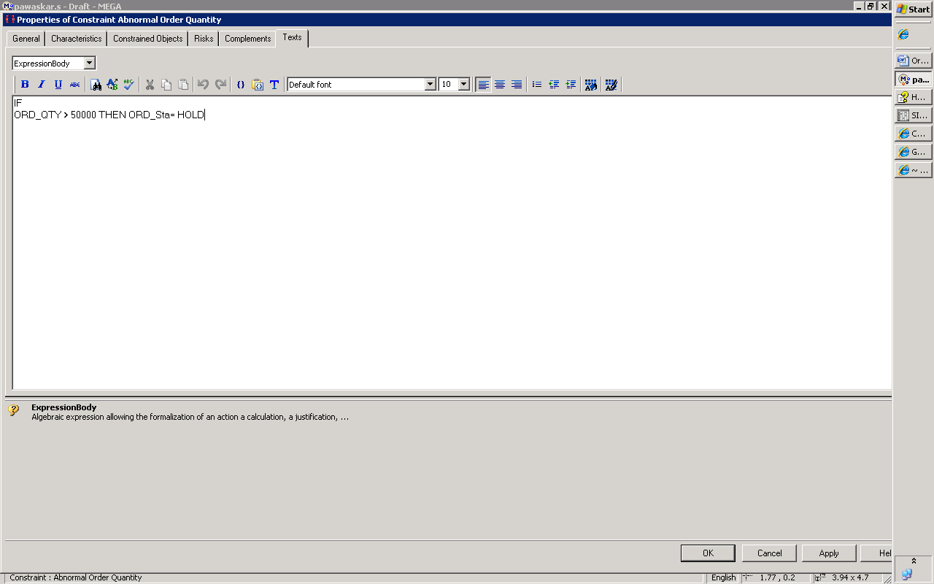

1. Data usage variation

Capture differences in data and differences in data usage

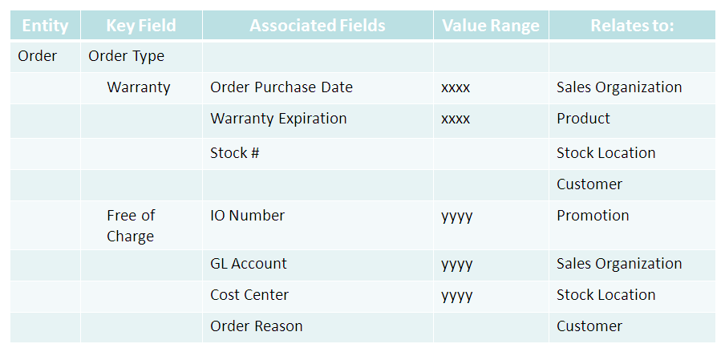

1. Reports and views variation

Add Attributes used in the Reports in the Properties>> Attributes tab of ‘Content’.

Enter Content Type and attach screenshots of the report (if available) as External Resources.

Capture Description on the Report in the Comment Tab. The descriptions that will be captured in the comment still need to be sounded out (i.e .what sub headings do we have—Objective, How Used, Where Used).

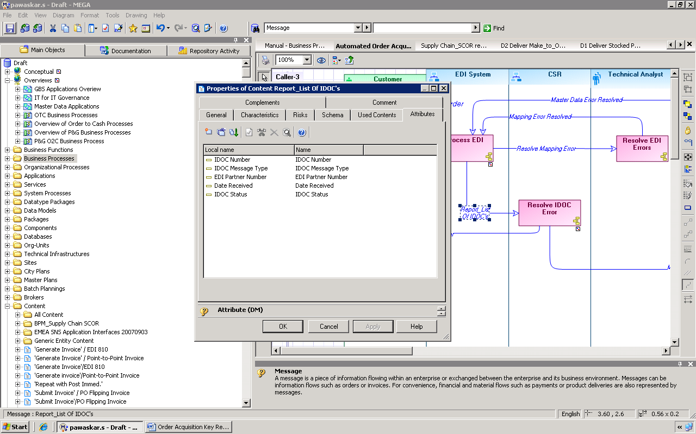

In addition to capturing this variant information, the rational for the variant also needs to be captured.

Summarizing the process variations and completing the detailed documentation requirements in MEGA (as above), the regional row leaders will interact with the Template Design Council and review the region’s variants. **This flow is represented by the number “6” in the diagram above.** In The intent is to provide the Template Design Council compelling justification/rationale for the variants, encouraging the TDC to approve the variants. Given the program’s objectives of simplification and standardization to eliminate redundant costs and business risks, as well to facilitate future growth, it is important that the TDC thoughtfully and effectively weigh the variants’ benefits against the costs. Some of the TDC’s standards in their decision-making process are as follows:

* Is the variant a legal requirement, i.e. a necessity?
* Does the variant provide business Value (NPV, IRR, etc.)?
* Cost of variant based on Total Cost of Ownership calculation
* Are their competitive advantages in allowing the variant(s)?
* Are their external customer impacts associated with the variant(s)?

Additionally, there is a prioritization framework to facilitate the decision when factors may be at odds (i.e. competitive advantage available but high associated customer impact)

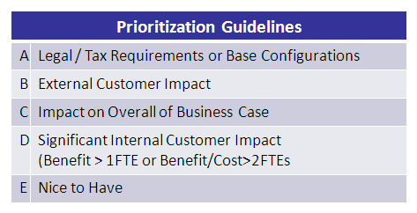



## E. W.E. Regional Non-Common Blueprinting -1

Concurrently, the W.E. team will create the process model document deliverables for non-common processes. These are processes that are only applicable for W.E. or even only one or two markets within W.E. Most processes are common and thus, this represents more of an exception and will only occur for very few W.E. processes. After preparing the documentation the W.E.-team subsequently presents their enhanced model to the regional row leads and pilot markets (DACH, Benelux and France) for their review. Given these markets’ insight, the W.E. team will capture/review the inputs, identify sustainable elements and augment areas in need of further improvement. T**his activity is identified as the “Blueprint Non-Common” and labeled by the letter “E”**. Similar to the Baseline Blueprinting 1, the TDC will review and approve the outcome (**number “7”**).

## F. GT Definition Refinement of W.E. non-common processes

Once the W.E.-only processes have been documented and vetted with the W.E. region and pilot markets and feedback has been captured, that information will be shared with the GT–team for the Global Template Definition Refinement (**the output is number “8” and the activity is letter “F”**). The GT Definition Refinement goals are further process documentation to ensure that the business functions effectively integrate with the other focus area solutions/definitions. Thus, the GT-team will scrutinize the integration of those processes with processes from Baseline as well enhancements from New+Common to ensure operability and contradiction-free processing of the solution. Once integration effectiveness is verified, the GT -team will return the enhanced, revised, updated W.E.-only (non-common) process definition to the W.E. team (**denoted by #13**).

## I. W.E. Regional Non-Common Blueprinting -2

Receiving the GT Team’s inputs, the W.E. team will share their enhanced W.E. only (non-common) definition with all of the W.E. markets. The purpose of this activity (**denoted by the letter “I”)** is to further identify any potential variants. These variants will be documented and shared with the TDC for their approval. **This sharing process is labeled number “15” in the high-level hand-off diagram above.**

## H. W.E. Regional Baseline Blueprinting-2

**As above variants are approved or rejected, the W.E. team will continue their second Baseline Blueprinting session, which is denoted by “H”.** The process and activity and outcome are identical to process “E” and outcome “7”.

## C. New and W.E.+ US - Common GT Definition

**Another major element of the Global Template Definition is the Global Template New & Common, which is represented by the letter “C”.** Launching in early January (with the brainstorming working sessions) and continuing until July, the Global Template New & Common focuses on defining the processes, rules, policies, guidelines, metrics, data, reports, forms, job-roles, etc as identified as New & Common in MEGA.

Note the identification of New & Common processes is based on the RFP/SOW document. These New & Common business areas address the bulk of the requirements, represent the majority of the Reinvention value form the business case and truly propel P&G towards accomplishing the goals of the program. As such, New & Common represent the processes and the SAP-functionality that must be the key focus for all. As such, the input as is provided by the W.E. BVRSD effort is critical and will serve as the guide in developing the GT-Definition. Linkage of value positions and value-metrics to specific processes will focus the GT-teams effort to the right processes. Linkage should occur at an as low as possible process level (level-5 if possible) to allow for specificity of focus but at high-enough process level (level-3) as the value position maybe enabled by multiple processes.

Key Design Principles are specifications of what CBA or business concepts to apply and how to apply them to realize the value - as depicted in the example above (most right side of figure under process “B”). These Key Design Principles are actionable industry best practices that must be applied/implemented to accomplish the value realization. These best practices will be actively shared between the Global Template and W.E. projects and validated by the CPG Domain Experts. As a result, there may (and probably will be) best practices that are identified in the W.E. BVRSD and later considered in the Global Template Baseline. If this active sharing results in recommended modifications to the GT Baseline processes (processes that were not originally planned to be addressed during New + Common), then those processes will be re-opened in parallel or incorporated into the New+Common (on an exception basis).

Another key input and interaction between W.E. and GT for New & Common are the Q&A sessions to be held early in New&Common. These Questions and Answer session are to clarify W.E. requirements and capture those clarifications as early input into the definition. It is important that the W.E. resources whom will provide the answers /clarifications have the history of the past W.E. work ( i.e. the individuals that documented these requirements). **These W.E. requirements are denoted by the number “3”.**

To accomplish the GT-New & Common objectives, it will utilize the GT Baseline Definition, W.E. Requirements, Business Value Realization Strategy Definition, Industry Best Practices and Service Mgrs, SO & BE’s Insight as key inputs. The Global Template New & Common Focus Areas include ATP / Cross-docking, Returns Processing, CC Cockpit / Workflow, FSCM, SLOG Pricing and Free of Charge.

An overview of the Global Template New & Common process below illustrates the inputs, the activities and the outputs.

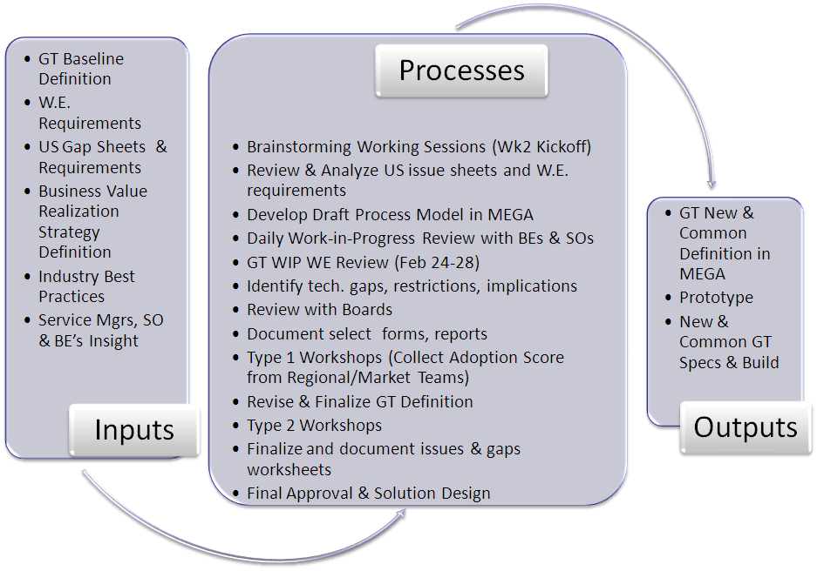

During the Global Template kickoff session, focus area leads and P&G BEs and Solution Owners broke into their respective focus area groups (based on their expertise), reviewed their respective processes and W.E. requirements and built their project plans. In subsequent weeks, the Focus Area Teams will develop draft process models in MEGA and conduct iterative reviews with BEs and SOs, identifying technical gaps, restrictions and implications and enhancing their models. As the GT-New& Common team identifies variants that require the TDC’s insight approval, they will forward them as needed. **This flow is represented by the number “5”.**

In early April, W.E. will conduct a Pre-Review of the Global Template New & Common and while there is no formal agenda, the intent is to discuss the current state and strategize for upcoming months. **This session is denoted by the letter “G” on the high-level hand-off diagram and inflows into that review are denoted by the number “9”.**

**A more structured review process will occur in workshops that are scheduled the end of April, which are represented by the letter “J”.** The purposes of which are to reach consensus on guidelines, criteria, and process, share new process practices and the raw standardized model, consider its fit for regions and markets and identify region/market variants to be included in the “to-be” Global Template. To realize these goals, the focus area teams will capture CCRs, provide feedback for additions, deletions of modifications, enhance the Global Template New & Common Draft and discuss regional variants as well as supporting rationale.

At the completion of the type 1 workshops, the focus area teams will share their results with the W.E. New & Common teams (**denoted by 11**) and focus their efforts on normalizing these variants which to better realize the program’s objectives of greater process simplification and standardization. Given the associated challenges, firm (but fair) analyses and a transparent decision-making process are required; the result will be a revised Global Template Definition.

With the revised Global Template Definition, the Focus Area Teams will meet in a centralized location in late May to present the prototype for collective workshop review **(denoted by letter “K”)**. During these Type 2 workshops, the Focus Area Teams will also identify required changes, refining the Global Template and discussing solution options for key issues. If necessary, the Focus Area Leads with leverage the Template Design Council as needed.

Following the Type 2 Workshops, the Focus Area Teams will finalize the standardized, global processes, document any remaining issues and address them and build a list of market/region variants with supporting rational. With the “to-be” Global Template solution design finalized, the Global Team will validate this template with the Business Experts and Solutions Owners and receive their approval, enabling the Global Template build and unit test. **The finalized version of the GT New & Common is denoted by the letter “L”.**

An illustration of this workshop and normalization process is below.



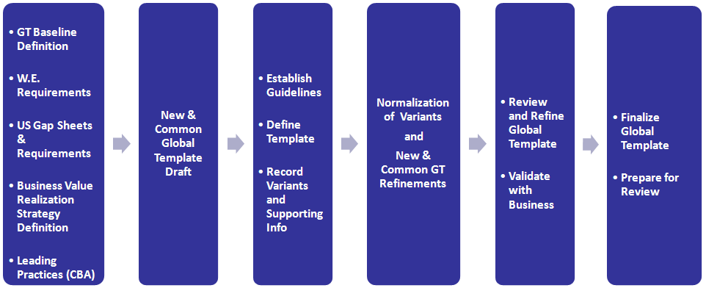

As previously-mentioned, the Focus Areas will develop and finalize their processes in parallel and deliver them with staggered delivery dates, which begin in mid-May and continue to the end of June. A more detailed schedule is below.

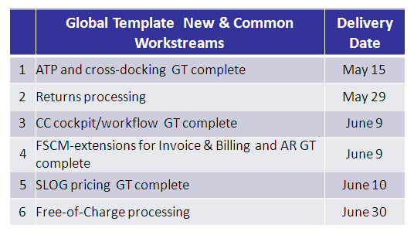



***M. W.E. New & Common Blueprinting***

Receiving the outputs from the Workshop Type 1, the W.E. New & Common team will begin blueprinting their process in early May. Denoted by the letter “M”, the W.E. will share their efforts with the TDC to achieve approval (number 12) by the end of May before continuing the New & Common process model in June (denoted by “N”). Ideally, the TDC will approve their solution design by early August.