**FHG Sub-Domains**

# TestFHG.Fileharmonizer.com

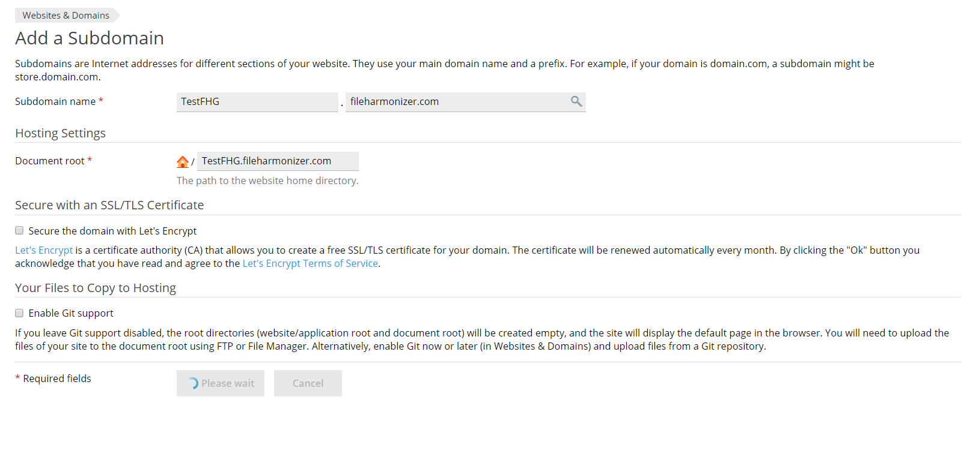

# TestFHGAPI.Fileharmonizer.com

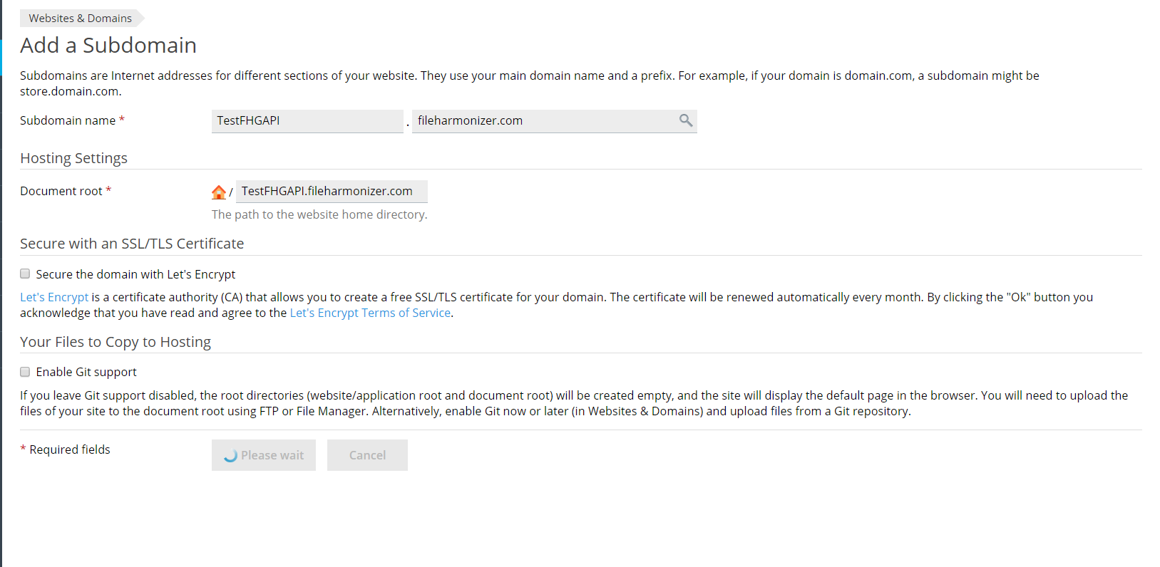

# QualityFHG.Fileharmonizer.com

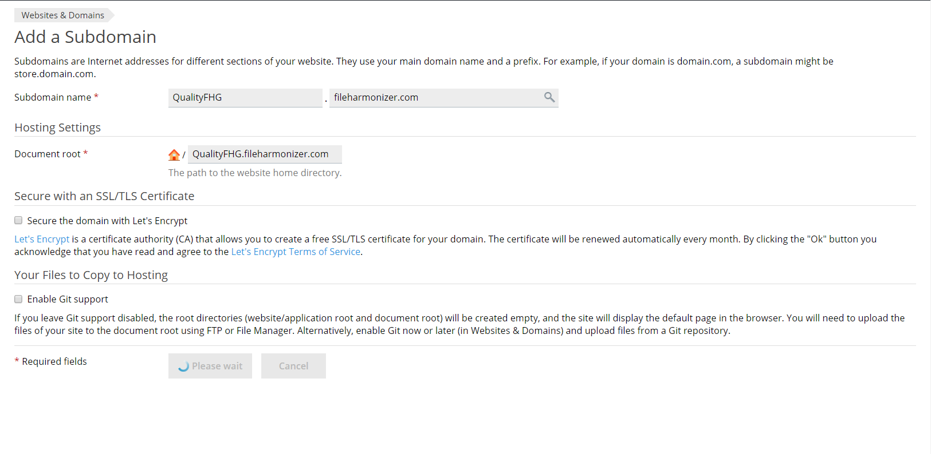

# QualityFHGAPI.Fileharmonizer.com

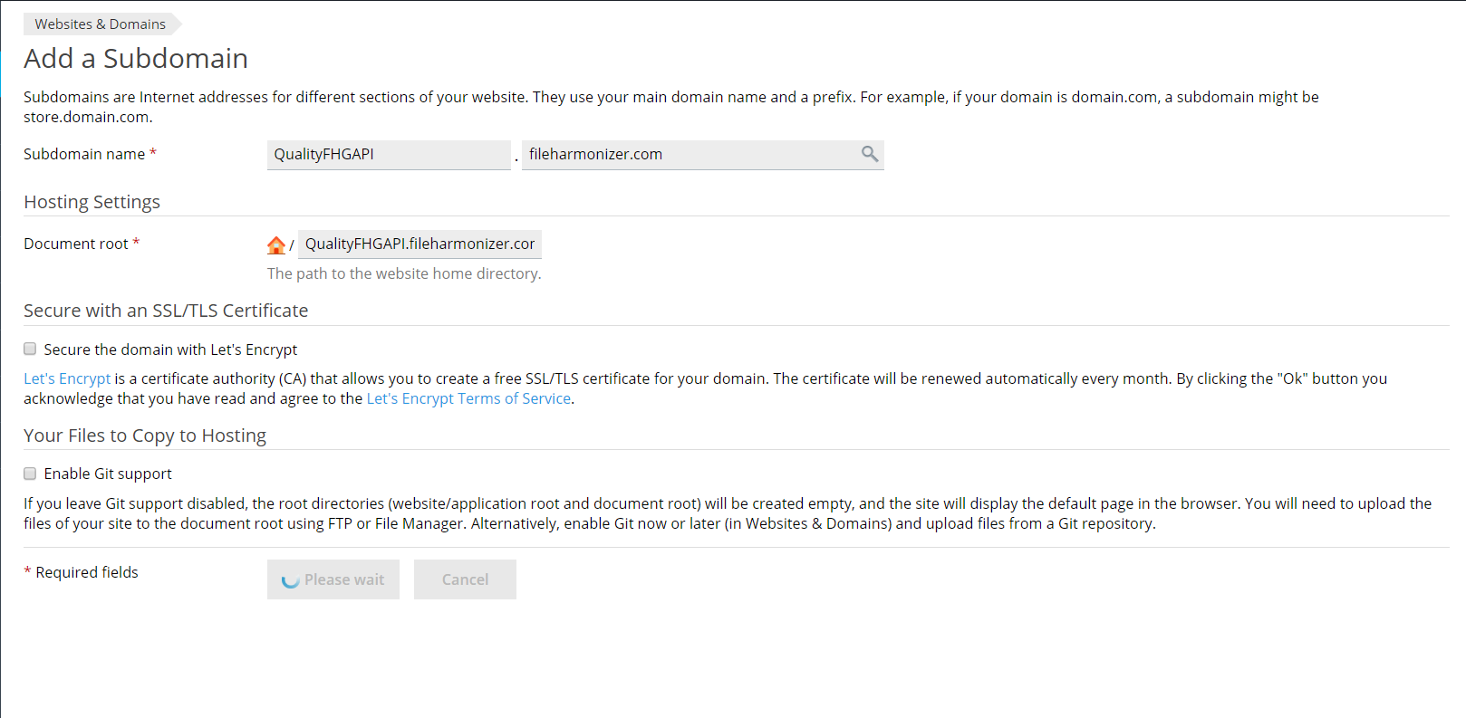

# [www.fileharmonizer.com](http://www.fileharmonizer.com) (Production)

# APIFHG.Fileharmonizer.com (for Production)

