**SMART WHEELCHAIR WITH TRANSLATION & INTERACTION CAPABILITIES FOR PHYSICALLY CHALLENGED/ PARALYZED PERSONS**

EQUIPMENTS:

1. Arduino NANO
2. Arduino LCD display board
3. 5 buttons
4. 1 switch(for mode changing)
5. A chair with 4 wheels, among them 2 is connected with motors
6. DC motors

Working Flowchart:

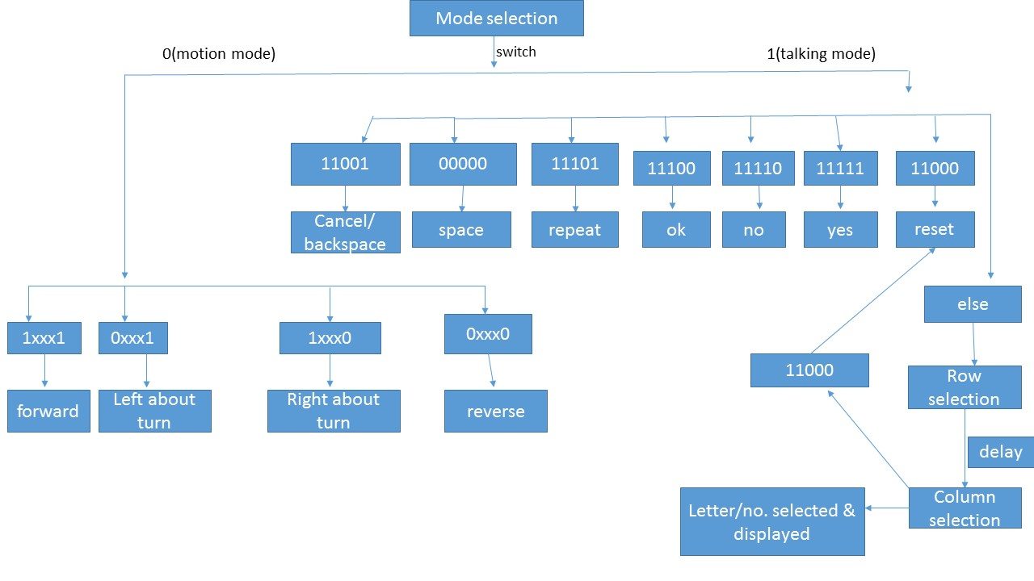

Letter & number selection table:

|  |  |  |  |  |  |  |  |
| --- | --- | --- | --- | --- | --- | --- | --- |
|  | 00001 | 00010 | 00011 | 00100 | 00101 | 00110 | 00111 |
| 00001 | A | B | C | D | E | F | G |
| 00010 | H | I | J | K | L | M | N |
| 00011 | O | P | Q | R | S | T | U |
| 00100 | V | W | X | Y | Z |  |  |
| 00101 | 0 | 1 | 2 | 3 | 4 | 5 | 6 |
| 00110 | 7 | 8 | 9 |  |  |  |  |
| 00111 |  |  |  |  |  |  |  |

Further improvement: 1. No selection mode (simultaneous modes),

2. Speed control motors