Documentation Willify

Name: Niko Sutiono

NIM: 2702215271

Hello everyone, or anyone who see this documentation. In this documentation, I will explain about functionality and purpose from each page of my website.

* Header / Navbar



In this header / navbar consists of logo, home, songs, about us, and login.

* Logo = By clicking this logo, the page will direct you to home page.
* Home = By clicking this button, the page will direct you to home page.
* Songs = By clicking this button, the page will direct you to songs page.
* About Us = By clicking this button, the page will direct you to about us page.
* Login = By clicking this text, the page will direct you to login page.
* Footer



In this footer consists of logo, home, songs, about us, and contact us.

* Logo = The logo doesn’t has any interaction.
* Home = By clicking this button, the page will direct you to home page.
* Songs = By clicking this logo, the page will direct you to songs page.
* About Us = By clicking this logo, the page will direct you to about us page.
* Contact Us = There is no interaction when clicking the logo (Line, Email, Instagram, but the purpose of this is to connect it into Willify’s social media account
* Home Page

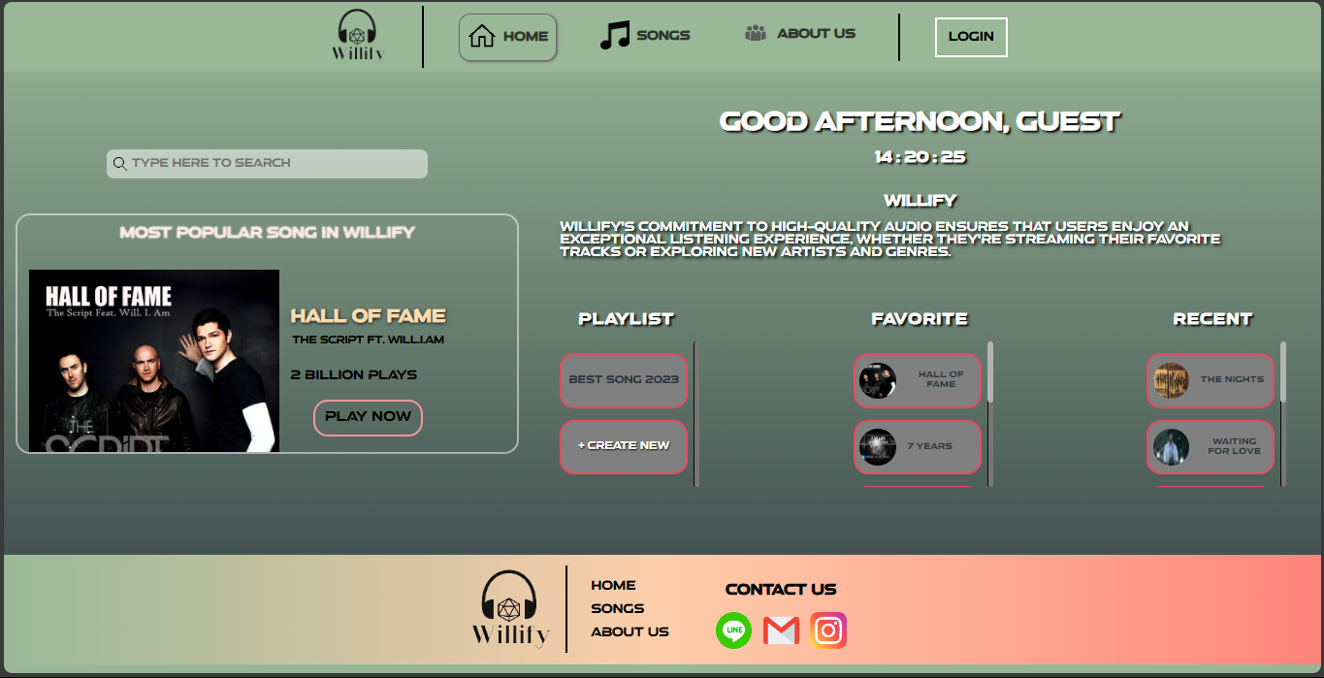

In home page, it consists header / navbar, content, and footer. In content, I display 2 main part, left part and right part.

* Left Part

This part consists of a search bar and the most popular songs. In the most popular songs section, there is a 'Play Now' button. When you click this button, the page will direct you to the song detail page (Hall Of Fame).

* Right Part

This part consists of greetings, a brief description, a playlist, favorites, and recent items. The greetings section includes a greeting and the current time, which updates in real-time. The description section displays a random description each time the page is refreshed. In the playlist section, you can interact by clicking the '+Create New' button. When clicked, the system will prompt the user to input a title. After entering the title, a new playlist will be created. In the playlist and favorites sections, there are some songs that, when clicked, will direct you to their respective song detail pages.

* Songs Page

This page consists of a header, content, and a footer. In the content section, there is a song player and a list of songs. In the song player, you can play songs and you can click forward or backward button to show another song. In the list of songs, there are some available songs provided by Willify, and you can click on them to be directed to the song detail page.

* Song Detail Page

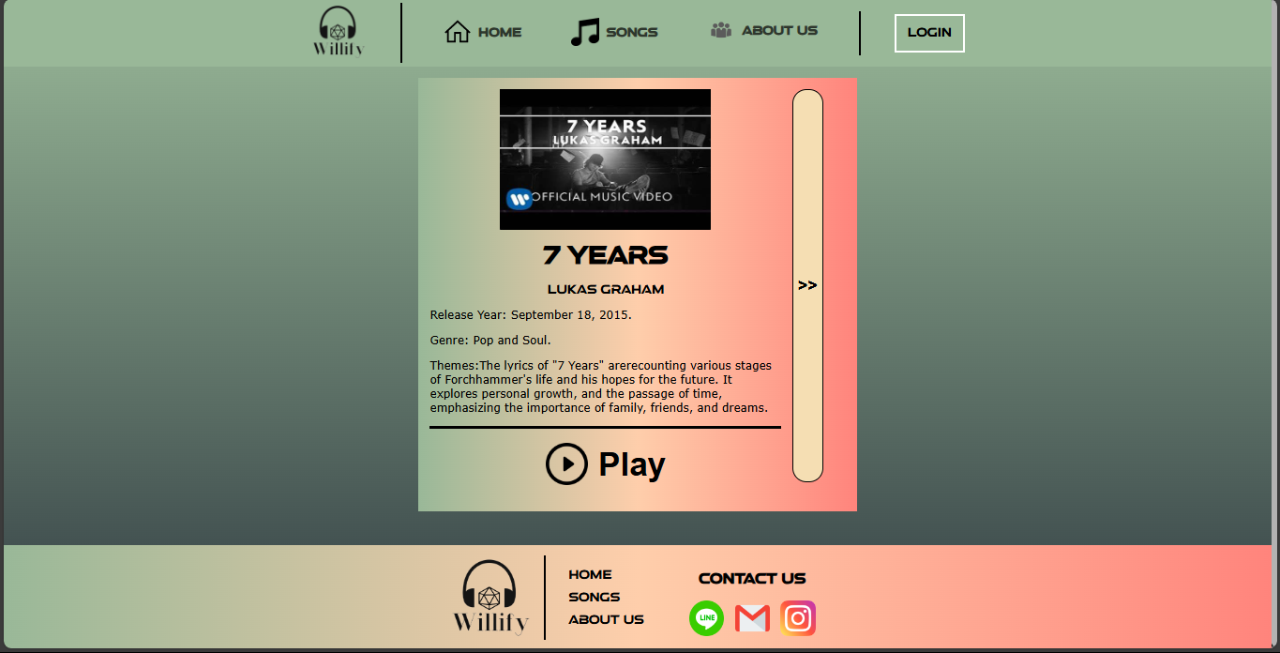

On this page, song information is displayed based on what you clicked before navigating to this page. In the first picture, you can see some information about the song, a play button, and an arrow button. You can play the song by clicking the play button. When you click the arrow button, it will show the song's lyrics (as seen in the second picture).

* About Us Page

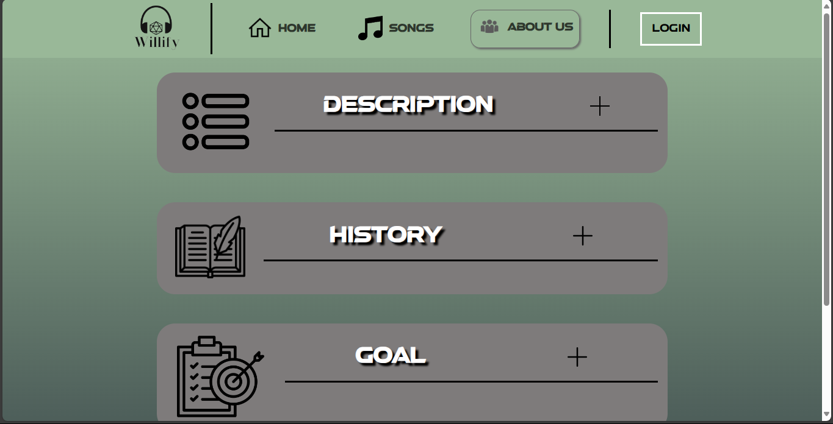

On this page, there is a header, content, and a footer. The content section is divided into three parts, each showing its own explanation. When you click the title or box, the description will be shown (as in the second picture).

* Login Page

On this page, the login section is displayed, consisting of a logo and a form at the bottom. You can go to the sign-up form by clicking the sign-up button.

* Sign Up Page

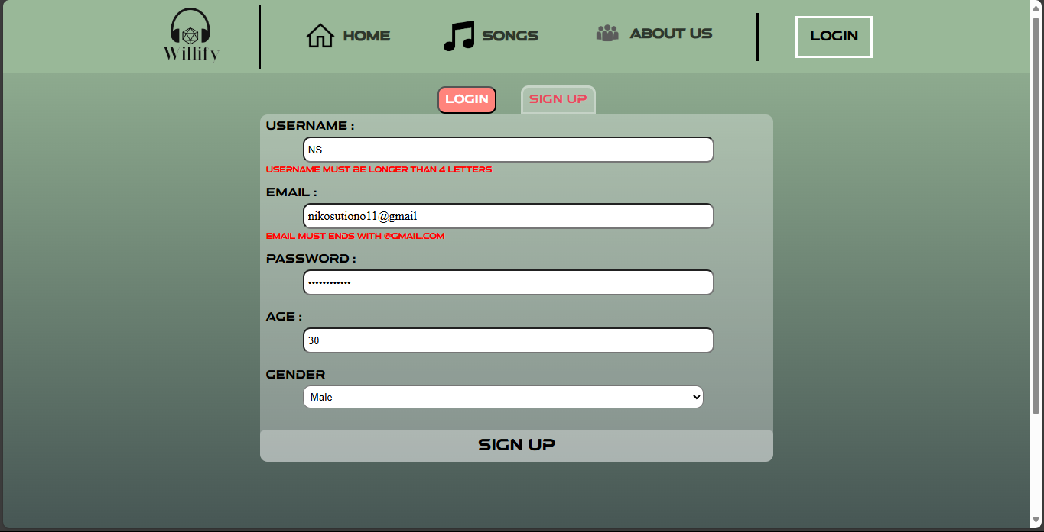

On this page, there are several input fields for the user to fill in. If the user doesn't fill in any fields and clicks the submit button, an alert will warn the user to fill in all the inputs. If the inputs are filled but contain errors, an error message will appear, and the user will need to correct the inputs until they meet the requirements (valid input).

* Link Reference
* <https://www.vecteezy.com/vector-art/424118-headphones-icon-vector-illustration>
* <https://www.flaticon.com/free-icon/icosahedron_274383?term=d20&page=1&position=5&origin=tag&related_id=274383>
* <https://coolors.co/74776b-fe5f55-dfd5a5-dbbbf5-5c574f>
* <https://clipground.com/white-home-icon-transparent-png.html>
* <https://www.onlinewebfonts.com/icon/522856>
* <https://www.pngmart.com/image/tag/about-us#google_vignette>
* <https://icon-library.com/icon/guest-icon-png-6.html>
* <https://www.flaticon.com/free-icon/search_5636698?term=search&page=1&position=5&origin=tag&related_id=5636698>
* <https://genius.com/The-script-hall-of-fame-lyrics>
* <https://images.rapgenius.com/6808b60b427c626b41455ff375bb8b98.600x600x1.jpg>
* <https://th.bing.com/th/id/OIP.N9y1ftYvVifVkSvBJmIekAHaEK?rs=1&pid=ImgDetMain>
* <https://www.letrastraducidas.org/avicii-the-nights/>
* <https://th.bing.com/th/id/OIP.jlW4sDcmsZQ7Cvl0ErpyZAAAAA?rs=1&pid=ImgDetMain>
* <https://th.bing.com/th/id/OIP.8pJqBFFxfpe4cwpBCHmngAHaE7?rs=1&pid=ImgDetMain>
* <https://s3.amazonaws.com/media.thecrimson.com/photos/2019/12/23/140026_1341768.jpg>
* <https://static.stereogum.com/uploads/2021/05/GettyImages-1307116180-1621615655-scaled.jpg>
* <https://th.bing.com/th/id/R.5f9f1cbd25d2a756fe239939d38e63bd?rik=ZigOKnjtfp52JA&riu=http%3a%2f%2fstatic-1.ivooxcdn.com%2faudios%2f7%2f0%2f5%2f3%2f5851505773507_XXL.jpg&ehk=0jEeBVK0k8TARXzOF4qhKjaEelKQZVW5anmk%2fTkzjj8%3d&risl=&pid=ImgRaw&r=0>
* <https://www.flaticon.com/free-icon/goal_3891260?term=goals&page=1&position=5&origin=search&related_id=3891260>
* <https://www.flaticon.com/free-icon/padlock_3064155?term=lock&page=1&position=4&origin=search&related_id=3064155>
* <https://www.flaticon.com/free-icon/history-book_1800109?term=history&page=1&position=6&origin=search&related_id=1800109>
* <https://www.flaticon.com/free-icon/menu_8224703?term=description&page=1&position=12&origin=search&related_id=8224703>
* <https://www.flaticon.com/free-icon/google_300221?term=google&page=1&position=1&origin=search&related_id=300221>
* <https://digitalsynopsis.com/design/minimal-web-color-palettes-combination-hex-code/>
* <https://www.flaticon.com/free-icon/line_3670089?term=line&page=1&position=1&origin=search&related_id=3670089>
* <https://www.flaticon.com/free-icon/gmail_732200?term=email&page=1&position=11&origin=search&related_id=732200>
* <https://www.flaticon.com/free-icon/instagram_2111463?term=instagram&page=1&position=5&origin=search&related_id=2111463>
* <https://www.flaticon.com/free-icon/facebook_5968764?term=facebook&page=1&position=12&origin=search&related_id=5968764>
* <https://www.flaticon.com/free-icon/plus_748113?term=plus&page=1&position=2&origin=search&related_id=748113>
* <https://www.flaticon.com/free-icon/play-button_375?term=play&page=1&position=2&origin=search&related_id=375>
* <https://www.flaticon.com/free-icon/video-pause-button_16427?term=pause&page=1&position=2&origin=search&related_id=16427>
* <https://mp3-convert.org/youtube-to-mp3-converterss/>
* <https://www.youtube.com/watch?v=3Kxf2dHlDpQ>
* <https://www.youtube.com/watch?v=2S0QhGGO1gQ>
* <https://www.youtube.com/watch?v=Q0bnAmfGQC8>
* <https://www.youtube.com/watch?v=qdpXxGPqW-Y>
* <https://www.flaticon.com/free-icon/next_6364389?term=forward&page=1&position=10&origin=search&related_id=6364389>
* <https://www.flaticon.com/free-icon/backward-track_83965?term=backward&page=1&position=3&origin=search&related_id=83965>
* <https://www.flaticon.com/free-icon/heart_833472?term=love&page=1&position=10&origin=search&related_id=833472>
* <https://www.flaticon.com/free-icon/heart_833472?term=love&page=1&position=10&origin=search&related_id=833472>
* <https://www.flaticon.com/free-icon/bookmark_3082331?term=favorite&page=1&position=10&origin=search&related_id=3082331>
* <https://www.flaticon.com/free-icon/bookmark_3082351?term=favorite&related_id=3082351>
* <https://th.bing.com/th/id/OIP.uT7SK9FZ6dcgTGiJhw-9HgAAAA?rs=1&pid=ImgDetMain>
* <https://www.flaticon.com/free-icon/group_921347?term=member&page=1&position=17&origin=search&related_id=921347>
* <https://www.flaticon.com/free-icon/group_921347?term=member&page=1&position=17&origin=search&related_id=921347>
* <https://th.bing.com/th/id/OIP.zKEVxNDYGAGxz89_zhnMSAHaEK?rs=1&pid=ImgDetMain>
* <https://www.youtube.com/watch?v=cHHLHGNpCSA>
* <https://i.ytimg.com/vi/cHHLHGNpCSA/maxresdefault.jpg>
* <https://www.azlyrics.com/lyrics/avicii/waitingforlove.html>
* <https://th.bing.com/th/id/OIP.iJiIFtktXwJ8Jv-K2jNfzAAAAA?w=287&h=180&c=7&r=0&o=5&pid=1.7>
* <https://www.echinesesong.com/tong-hua-%E7%AB%A5%E8%AF%9D-fairy-tale-lyrics-%E6%AD%8C%E8%A9%9E-with-pinyin-by-guang-liang-%E5%85%89%E8%89%AF-michael-wong/#google_vignette>
* <https://www.youtube.com/watch?v=IBTmypxD2mU>
* <https://i.ytimg.com/vi/Z6XDJpaC7cI/maxresdefault.jpg>
* <https://genius.com/Genius-romanizations-yuuri-betelgeuse-romanized-lyrics>
* <https://www.youtube.com/watch?v=3Bf4_AbDj3Q>
* <https://th.bing.com/th/id/OIP.OvlcIhPPb6QrAj5iTfxvQAAAAA?rs=1&pid=ImgDetMain>
* <https://www.youtube.com/watch?v=QAOMYGG7QC0>
* <https://genius.com/Nidji-laskar-pelangi-lyrics>