1. The following Python code computes the reproduction number (r0) of the coronavirus. The reproduction number is a dimensionless number that is useful in determining whether or not a virus can spread in a population. Answer the following questions:

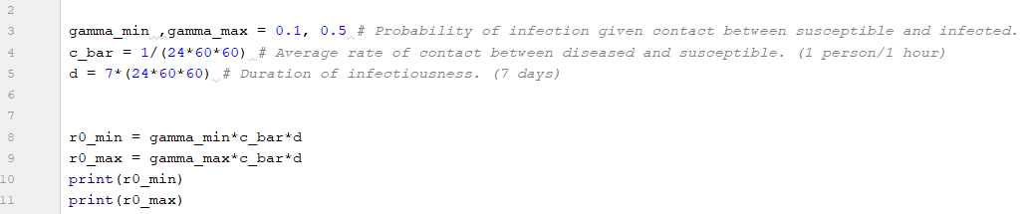

* If r0 < 1 the infection will die out; whereas, if the r0 > 1 the virus will propogate in a population. Should we be concerned about the spread of the coronavirus if the reproduction number (r0) is found to be r0_max?
* The duration of infectiousness for the coronavirus was recently found to be up to 2 weeks (the duration of the incubation period). What effect does this have on the viruses reproduction number **r0**?
* Calculate r0_avg, which is the average of r0_max and r0_min. Make sure the duration is still set at 2 weeks.