Wildfire disaster exposure and preterm birth analysis plan
Authors:
- Heather – first author, doing most of the things
- Joan
- Tim
- Marianthi
- Dana – last author?
- Ray? (could he be? That would make me happy)
- Allison
- Hallah to code review
- Supervisors are providing advice and feedback by coming to meetings, and reading and revising the manuscript. Is Dana last author?

Study question:
How does wildfire disaster exposure influence risk of preterm birth?
Exposure data:
Lab wildfire dataset covering outcome data period
Outcome data:
Tim data on preterm births at the county level 2000-2017? 2019?

Exposure assessment plan:
- Aim is to capture stress, evacuation, smoke, community disruption, power outage, healthcare disruption, housing issues related to wildfire disaster exposure.
- Need exposure at county level
- Going to use different buffers and popexposure to determine how much of each county population is exposed
- Buffer distances 5km, 10km, 20km from fire boundary
- Primary analysis 10km buffer
- If >50% of pop is exposed, 20% of pop is exposed, consider a county exposed
- Do sensitivity analyses on buffer distance
- Option to change buffer distances to get enough people exposed to do the study; tbh in EDA
- Exposure is going to be monthly. County-level monthly isn’t going to be great resolution, but it we do not have dates when the wildfire ends, and exposure to huge disasters likely doesn’t really ever end. So we’re going to have monthly exposure. Weekly exposure seems to fine a resolution. Also we want to have good outcome counts that are non-zero so doing things monthly will help with that
- Once exposed, exposed for two years
- Need to vary the washout period in a sensitivity analysis
Optional:
- Consider co-exposure to wildfire smoke and power outage along with disaster exposure
- Could look at places co-exposed to both a threshold of wf pm or county-level power outage co-occurring with the wildfire disaster. But that might be outside the scope of this paper
- Could also analyze only the top 100 most destructive fires or something

Outcome assessment:
- Pretty simple
- PTB rate
- Could also consider early preterm
- County-level monthly rate should be fine
- Need to consider any data issues with the birth dates/conception cohort issues where earlier shocks can influence PTB rate later
Optional:
- Disparities/SVI secondary analysis
Confounders:
- Heat, and maybe severe weather. We can use PRISM to estimate this but should talk to make sure we have data for Alaska and Hawaii since they are so exposed
- Day of week effects, population changes, changes in evacuation and warning procedures, changes in fire size and severity, and other things could affect the effect of wf on hospitalizations but none of these things do so differentially across the treatment timing, so they shouldn’t bias estimates

Analysis:
- DID analysis, staggered multi-region setup
- Estimate the group-time ATT with R package did
- Aggregate group ATTs to look for dynamic effects 1, 2, and 3 months after wildfire disaster exposure
- CIs are corrected for multiple comparisons + autocorrelation within region
- Three-month follow-up period (run sensitivity analyses on that, make it one vs three months as well)
- Two-year washout period (sensitivity on that as well, make it one and three years)

Analytic concerns and how we will address them:
Assumptions of staggered, multi-region DID:
- On average, trends in untreated or not-yet-treated regions are parallel to treated regions after controlling for confounders
- No anticipation
- No coincident changes
- No interference
- Correct model spec

Parallel trends:
- DID package has a thing built in where we will be able to test this assumption in the pre-treatment periods which is the best we can do
- I think that average parallel trends after controlling for temperature is plausible
- Will test using the DID built in pre-testing
No anticipation:
- I think this is a fair assumption and I can’t think of a way to test it besides looking to see if there seem to be effects of the treatment before the treatment happens post-hoc
- DID has a way of relaxing this if it’s super important to us but idk I think it’s fine. I don’t think people are anticipating the majority of our exposure
- Marianthi does though so we can discuss
No coincident changes:
- For this to cause problems in the staggered multi-region DID analysis, you need something that is causing systematic changes in your outcome in the same direction in every treated region at the same time as the treatment
- These are ‘confounders’
- Like temperature
- Which we are controlling for
- And I can’t think of another
Correct model spec:
- The model is pretty flexible and doubly-robust
- Need to learn more about what’s going on with this

No interference:
- Here I think we can do a sensitivity analysis where we exclude neighboring counties that were next to an affected county and see how this changes results

Other considerations:
- Might have issues with effect heterogeneity between regions or the affected regions being systematically different from those unaffected (this would be an exchangeability issue)
- Need to be careful to acknowledge that it’s the ATT
- Also might want to analyze things separately for different eras (2000-2005, 2006-2010, etc). if we’re interested in heterogeneity as fires got larger and smoke etc. is a bigger issue later in the study period
- What if we randomly assigned exposure as a negative control? That might be interesting
- Need to chop up the data into cross-sections with pre-treatment time, at least three months post treatment, and then a washout period. Should think about how to do this.

TO-DOs:
- Think about PTB rate stuff and birthday stuff and make sure there are no issues
- Make a dag?
- Decide what optional and sensitivity analyses to do. There are like 15 possible analyses laid out here. We do not want all of them!
- Learn about model
- What about regions next to each other having similar outcomes? Does that matter?

Hospitalization:
- Main differences are that things are at the ZCTA level, and we need to categorize hospitalizations
Original table from vivian’s analysis plan:
Analysis type | Treated status | Spatial definition
Primary | Treated | - ≥10% population that overlaps with dynamic buffer  - 5km for <1000 acres burned  -10 km for >1000 acres burned
 | Untreated | - 0% population that overlaps with dynamic buffer
Sensitivity | Treated #1 | - ≥50% population that overlaps with normal buffers that dynamically vary by wildfire size
 | Treated #2 | - ≥10% population that overlaps with different buffer size (working with distance and method)  - 3km, 5km (going closer)  -10km, 20km (going farther)
 | Treated #3 | - ≥20% population that overlaps with dynamic buffer
 | Treated #4 | - Restrict to the first wildfire a ZCTA experiences
 | Untreated | - 0% population that overlaps with dynamic buffer

Outcome data:
- Going to opt for hypothesis-driven approach where we think that wf will affect certain types of hospitalizations
- Cardio, resp, injuries, kidney, diabetes, dementia, and cancer
- Going to study EMERGENCY hospitalizations, so acute not planned
- Hypothesis is that CVD, resp, injuries will increase due to exacerbations and evacuation/disaster related injuries. Kidney, diabetes may increase due to care interruptions
- Going to measure these by looking at first five ICD codes
- Going to capture all hospitalizations that start with the relevant letters, and not distinguish further within these categories. Will be ICD 9 and 10 because of the time period
- Outcome data and exposure are at ZCTA level
- Messaged Danielle to figure out which ZCTAs to use for relevant years
- Really important to do EDA because weird stuff has happened with the data before

CVD | I codes
Resp | J codes
injury | S00-T88
Kidney disease
Diabetes
Dementia
Cancer

Writing this out I’m thinking maybe we should limit to CVD, resp, and injury, since I really don’t know how we hypothesize these other hospitalizations would be changed at a monthly level and don’t know a lot about them. If we’re thinking that care interruption would lead to more emergency hosp later then that’s a lagged effect and I don’t think that we’re trying to capture lagged effects, so….maybe leave them out?
Confounders:
Made this dag for posterity
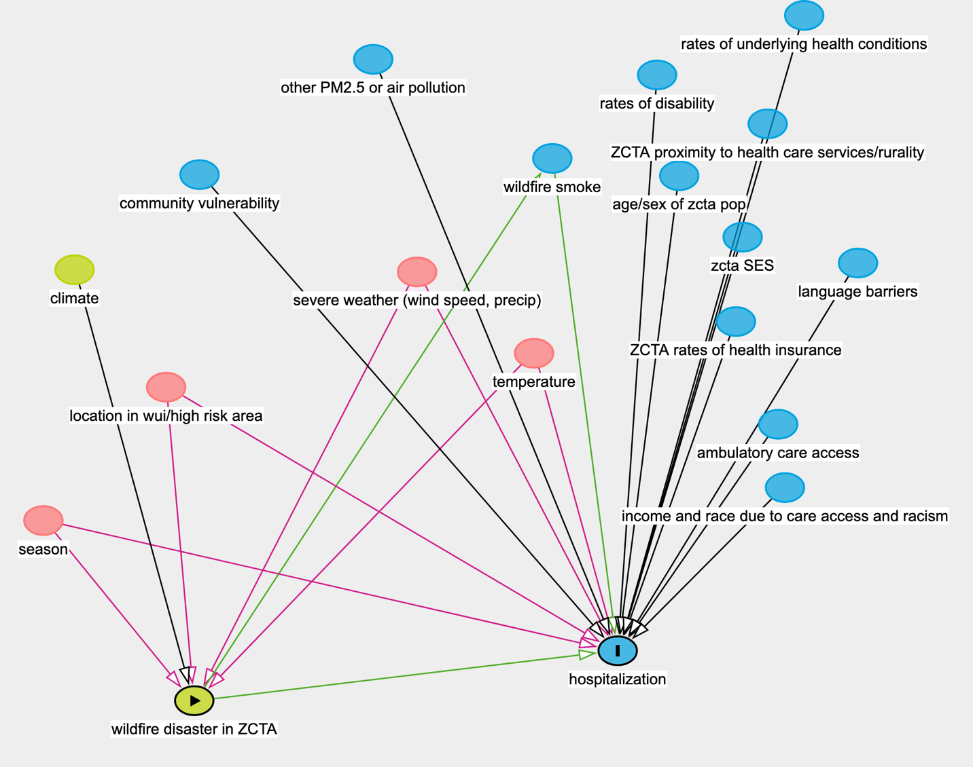
- Temperature and severe weather might be confounders
- Temperature and severe weather might be confounders
- Definitely seasonality
- And location

- Temp and severe weather need to be controlled for in the DID model, but location and season are already controlled for by modelling procedure

- Can use monthly ZCTA prism or gridmet for this
- Small issue is that if we want to include HI and AK, which have a lot of wfs, then we might need to find data sources for those too

EDA plots to make:
- Number of exposures by zcta over the 20 year period
- Number of exposures by zcta by year
- Hospitalizations by year by zcta
- Trend of total hosps by year

