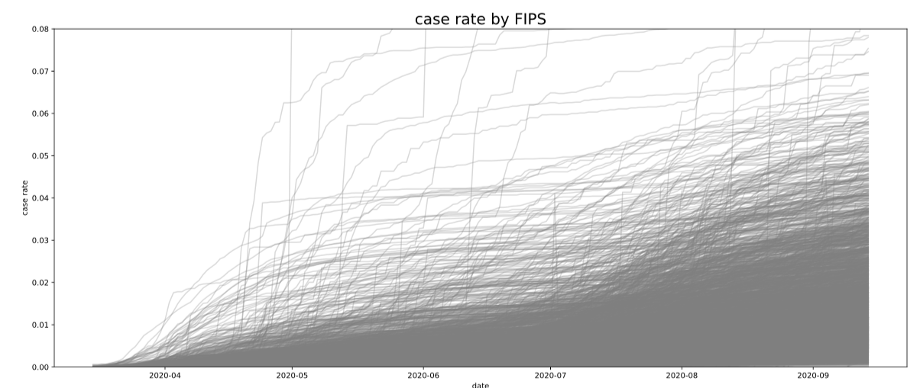

Date without adjustment 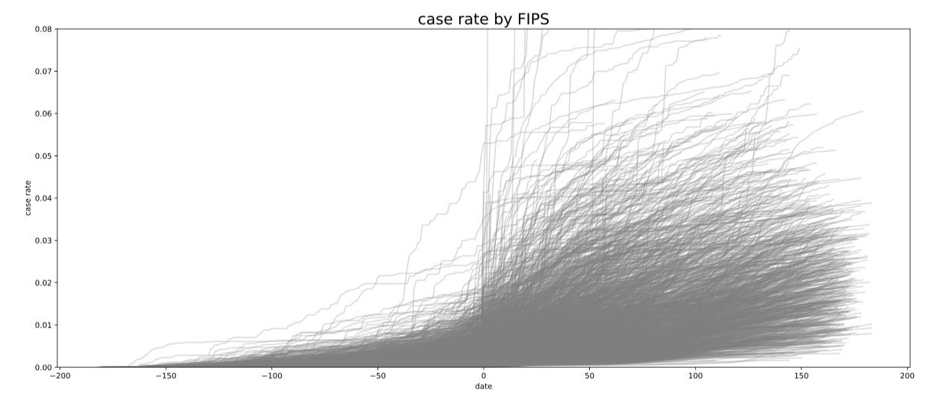

Day0 = 100 cumulative cases

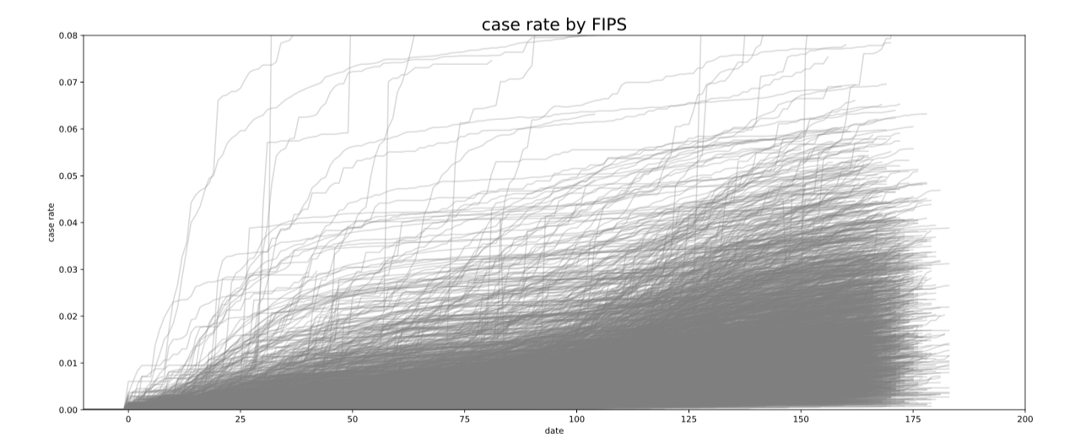

Day0 = 0.0001 cumulative case rate

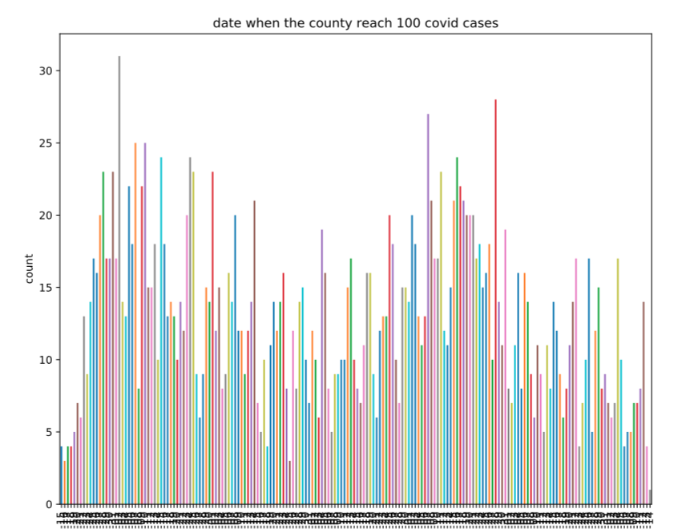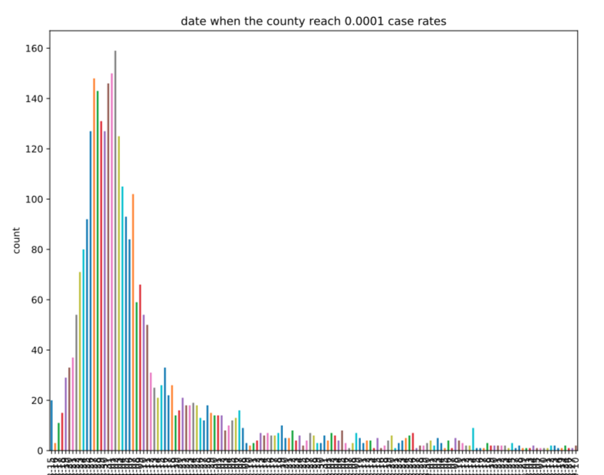

Date reaching 100 cases Date reaching 0.0001 case rate

Areas with 10000 people only need the first case to pass the criteria.