MBM: A toolbox for Mode-Based Morphometry
MBM is a toolbox for analysing anatomical variations at multiple spatial scales by using the fundamental, resonant modes—eigenmodes—of brain anatomy. The goal is to characterize a group average or group difference at multiple spatial scales by obtaining the spatial frequency spectrum, called beta spectrum, and patterns of its statistical map.

Installation
Download the package and use the Matlab functions according to your need as described below.

Compatibility
Tested on Matlab 2021a and Matlab 2019b.

File descriptions
In this package, we provide the following a main functions, demo script to run it, and complement folders:
- mbm_mbm.m: main function to obtain the spatial frequency spectrum, called beta spectrum, the significant pattern and the most influential modes of the statistical map representing the group average or group difference.
- mbm_demo.m: demo script to run mbm_mbm.m.
- utils: dependent packages comprising of gifti-matlab (to read GIFTI file), PALM (to estimate a distribution tail), and fdr_bh (to use fdr correction). If you already have these packages in your computer, you can replace paths to this folder by paths to the packages in your computer.
- data: demo data to run the codes.
- func: functions used in the main code for analysis and visualization.
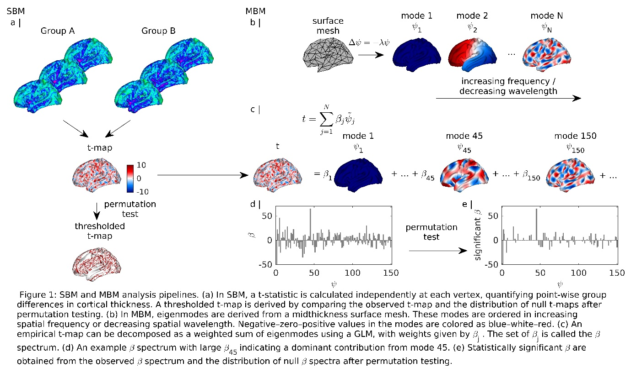

Calculating the spatial spectrum, i.e., beta spectrum, by mbm_mbm.m
mbm_mbm.m executes the pipelines in Fig. 1. The input to mbm_mbm.m is the structure mbm including:
- a path to a text file listing all the anatomical maps to be analysed and a path to a mask to exclude elements of the maps from the analysis. Anatomical maps are expected as GIFTI files and projected on an average surface. In the example given in the demo code, the left fsaverage midthickness surface with 32492 vertices is used as an average template.
- Parameters specifying the statistical test and an indicator matrix whose elements in each column indicate subjects belonging to a group. One-sample t-test, two-sample t-test, and one-way ANOVA are supported.
- The eigenmodes (ψ_{j} in Fig. 1) calculated from a surface mesh (a .vtk file) by surface_eigenmodes.py (developed by J. Pang et. al. 2022) and saved as a text file. Eigenmodes should be derived from the same average surface that the maps are projected on.
- Parameters specifying the visualisation of the results.
The output of mbm_mbm.m are included in the struture mbm: the statistical map, its p-values, thresholded statistical map, beta spectrum, its p-values, significant beta spectrum, the significant patterns, and the most influential modes. Visualisation of the results are provided.

Additional functions
Useful functions relating to eigenmodes may be found at https://github.com/BMHLab/BrainEigenmodes, including:
For calculating eigenmodes from a surface or a volume, use surface_eigenmodes.py or volume_eigenmodes.py. See demo_eigenmode_visualization.m for a demo.
For visualising an eigenmode or a map, see demo_eigenmode_visualization.m for a demo.

Citation
If you use our code in your research, please cite the following papers:

References
J. C. Pang, K. M. Aquino, M. Oldehinkel, P. A. Robinson, B. D. Fulcher, M. Breakspear, A. Fornito, Geometric constraints on human brain function, bioRxiv (Oct. 2022).

